# AQA Computer Science (7517)

The Car Parking Allocation Project

Contents

AQA Computer Science (7517) 1

Introduction and Initial Research 11

Introduction 11

Investigating the Problem 11

Preliminary interview with client 11

What types of vehicles could I add to a configurable system? 12

How should the areas of land be defined by the user and will they be just rectangles? 13

Are there any needs for pedestrian paths? 13

Research into Regulations 13

Research into layout of carpark. 13

British Parking’s online advice (British Parking, 2016) 13

Whipple’s Research (Whipple, 2016) 15

Abdelfatah and Taha’s Research (Abdelfatah & Taha, 2014) 16

Optimisation of Car park design by Bristol University Study Group (J. Billingham) (Wise & Trim, n.d.) 16

Tapestry and Trim 17

Tile and Trim 18

Secondary interview with client about the GUI 23

Algorithms 23

Knapsack problem 23

Bin packing 25

Linear Programming 26

Abdelfatah and Taha’s constraints 27

Simplex Method 27

Conclusion 28

Specifying the requirements 29

Outputs 29

Inputs 29

Processes 29

Feasibility study 29

Programming language 29

Python modules 30

Linear programming - simplex method 30

Simpy (saswatraj, n.d.) 30

Display 30

Tkinter 30

Pygame 30

Available computing power 30

Security 32

User’s data 32

My program 33

Computer systems 33

Design 34

Critical Path 34

Data Flow Diagram 36

Design of user interface 36

Version 1 36

Version 2 40

More detailed frame design 42

Choosing a final design 43

Programming the Solution 45

1. Taking user input from when clicking on an image 46

1.0 Description of process 46

1.1 Input/Process/Output/Storage 46

1.2 Data Dictionary 46

1.3 Test Plan 46

1.4 Implementation 47

1.5 Programming the solution 49

1.5.1 First Attempt 49

1.5.1.1 Code 49

1.5.1.2 Testing 49

1.5.2 Fixing image displaying properly 50

1.5.2.1 Code 50

1.5.2.2 Testing 51

1.5.3 Allowing all coordinates clicked so far to be stored and shown 53

1.5.3.1 Code 53

1.5.3.2 Testing 54

1.5.4 Stopping erroneous data 57

1.5.4.1 Code 57

1.5.4.2 Testing 57

1.6 Summary and Extras 61

2. Manipulating shapes defined by coordinates 63

2.0 Description of process 63

2.1 The vertex class 63

2.1.1 Data Dictionary 63

2.1.2 Class Subroutines 63

2.1.3 Test Plan 64

2.1.4 Implementation 67

2.1.5 Programming the solution 67

2.1.5.1 First Attempt 67

2.1.5.1.1 Code 67

2.1.5.1.2 Testing 69

2.2 The shape class 75

2.2.1 Data Dictionary 75

2.2.2 Class Subroutines 75

2.2.3 Test Plan 77

2.2.5 Programming the solution 79

2.2.5.1 First attempt 79

2.2.5.1.1 Code 79

2.2.5.1.1.1 Menu for testing Code 79

2.2.5.1.1.2 Vertex and Shape code 82

2.2.5.1.2 Testing 86

3. Applying the tile and trim algorithm. 96

3.0 Description of what I am about to do. 96

3.1 Table of input, process, storage and output 96

3.2 Data dictionary 96

3.3 Pseudo code and diagrams 96

3.3.1 Diagram for size of spaces 96

3.3.2 Pseudo Code 98

3.3.2.1 Pseudo code for how to place tiles 98

3.3.2.2 Expanding on how to see if placing a car park tile is valid 99

3.3.2.2.1 Ray casting algorithm 99

3.3.2.2.2 Installing the Shapely module 100

3.3.2.2.3 Pseudo code for finding if a tile is within the car park or not 100

3.3.2.2.4 Test plan for using shapely 100

3.3.2.2.5 Python code for testing using shapely 101

3.3.2.2.6 Testing my python code 102

3.5 Programming the tile and trim algorithm 103

3.5.1 First stage, doing a basic, grid style tile and trim. 103

3.5.1.1 Pseudo Code 103

3.5.1.2 Test plan 103

3.5.1.3 Python Code 103

3.5.1.5 Conclusion 105

4. The Graphical User Interface 106

4.0 Description of process 106

4.1 Window design 106

4.2 Implementation 106

4.3 Programming the solution 107

4.3.1 Adding and packing the frames. (GUIv2.py) 107

4.3.1.1 Code 107

4.3.1.2 Screenshots 118

4.3.2 Adding the image element (GUIv3.py) 118

4.3.2.1 Code 119

4.3.2.1.1 Resizing the image 119

4.3.2.1.2 Image element 120

4.3.2.2 Screenshots 121

4.3.3 Adding the two different views (GUIv4.py) 121

4.3.3.1 Code 122

4.3.3.1.1 The global variables 122

4.3.3.1.2 The Combobox 122

4.3.3.1.3 The reset button 122

4.3.3.1.4 The procedures for refreshing the window and also creating the window using multiple frames 123

4.3.3.2 Screenshots 124

4.3.4 Adding support for disabling elements when designing or not designing the layout of the car park. (GUIv5.py) 125

4.3.4.1 Code 125

4.3.4.1.1 Go Button 125

3.4.4.2 Screenshots 126

4.3.5 Adding the tileScrollBox (GUIv5.py) 127

4.3.5.1 Initial setup 127

4.3.5.1 Code 127

4.3.5.2 Connecting with my main program 128

4.3.5.2.1 Code 128

4.3.5.2.2 Screenshot 129

4.3.6 Joining the main processing code and the GIU together (GUIv6.py) 129

4.3.6.1 How I import my processing code 129

4.3.6.1.1 Code 129

4.3.6.2 Global variables in the GUI program 130

4.3.6.3 The change in look of the program 130

4.3.6.4 Examples of how the processing code and GUI code link together 132

4.3.6.4.1 How I modified the mapImage Class 133

4.3.6.4.1.1 Previous mapClicked method code 133

4.3.6.4.1.2 New mapClicked method code 133

4.3.6.4.2 How I draw the car park shape outline onto the map 133

4.3.6.4.2.1 Commented code for drawing map image 134

4.3.6.4.3 The shapeVertexRemoveButton 135

4.3.6.4.3.1 removeLastVertex method code 135

4.3.6.4.3.2 shapeVertexRemoveButton’s buttonClicked method code 135

4.3.6.4.4 The shapeResetButton 135

4.3.6.4.4.1 new line added to shapeResetButton’s method code 135

4.3.6.4.5 The tileScrollBox 135

4.3.6.4.6 The tileTypeComboBox 135

4.3.6.4.7 the tileNumbericStepper 135

4.3.6.4.7.1 tileNumericStepper code 136

4.3.6.4.8 tileAddButton 136

4.3.6.4.9 tileResetButton 136

4.3.6 Initial attempt of drawing the car park (GUIv7.py) 136

4.3.6.1 Minor changes to how the program looks 136

4.3.6.2 Stretching the shape 137

4.3.6.3 drawing the car park spaces. 138

4.3.6.3.1 goButton’s buttonClicked method code 138

4.3.6.4 Processing code for initial attempt of drawing car park 138

5. Optimising the tile and trim algorithm now that I have a working GUI and further additions to the GUI 141

5.1 What we are starting out with (v17.py) 141

5.1.1 getEdgesOfShapes procedure code 141

5.1.2 GetCarParkPixelLinesToDrawFromPixelShape procedure code 141

5.1.3 Code for converting between the two units (pixels and meters) 142

5.2 Rotating the car parking spaces (v18.py) 143

5.2.1 Rotating so the longest side is on the bottom, not just horizontal 143

5.2.1.1 Rotating car park shape code 143

5.2.1.2 Rotating car park tiles back code 144

5.2.2 Drawing car parking spaces 144

5.2.2.1 Code for finding fraction of side of tile to be drawn 144

5.2.2.2 Code for finding new vertices 144

5.2.2.3 Screenshots showing current progress 146

5.3 Fixing problems caused by rotating the spaces and showing spaces more clearly (v19.py) 147

5.3.1 The program left an empty row where there should have been spaces (v19.py) 147

5.3.1.1 Code for defining placement buffer 148

5.3.1.2 Code for implementing placement buffer 148

5.3.2 Implementing drawing car park spaces, not just tiles 148

5.3.2.1 Code 148

5.3.2.1.1 Old 148

5.3.2.1.2 New 148

5.3.2.2 Screenshots 149

5.3.2.2.1 Original 149

5.3.2.2.2 After trying to rotate the points 180 degrees 150

5.3.2.2.3 After properly rotating them 180 degrees. 150

5.3.2.2.4 Final fix 151

5.4 Adding a feedback message box (v20.py, v21.py and GUIv8.py) 152

5.4.1 Initial attempt (v20.py and GUIv8.py) 153

5.4.1.1 Screenshot 153

5.4.1.2 Passing back the message to the GUI 153

5.4.1.2.1 Passing from tileAndTrim to GetCarParkPixelLinesToDrawFromPixelShape 153

5.4.1.2.1.1 tileAndTrim return code 153

5.4.1.2.1.2 GetCarParkPixelLinesToDrawFromPixelShape code 153

5.4.1.2.2 Passing from GetCarParkPixelLinesToDrawFromPixelShape to the goButton’s buttonClicked method 154

5.4.1.2.2.1 GetCarParkPixelLinesToDrawFromPixelShape code 154

5.2.1.2.2.2 goButtons’s buttonClicked method code 154

5.4.1.2.3 displaying the message box code in the goButton’s buttonClicked method 154

5.4.2 Fixing the messages to appear on new lines (v21.py) 154

5.4.2.1 Adding to the message to print code 154

5.4.2.2 Screenshot of working message box 154

5.4.3 Other changes made in GUIv8.py 154

5.4.3.1 Screenshot of before 155

5.4.3.2 Screenshot of after 155

5.4.4 Other changes made in v20.py 155

5.4.4.1 Dictionary of fractions of side to be drawn for car park tiles code 155

5.5 Adding the sharing options (GUIv9.py) 156

5.5.1 Adding a menu bar 156

5.5.1.1 Adding the help button 156

5.5.1.2 Adding the share drop down menu with the share buttons 157

5.5.2 Allowing the user to save their car park image (saveImageToFile) 158

5.5.2.1 saveImageToFile Code 158

5.5.2.2 Screenshots 158

5.5.3 Allowing the user to open an email draft to send their car park image (emailCarParkImage) 162

5.5.3.1 Installing the win32 module screenshots 162

5.5.3.2 Code 163

5.5.3.3 Screenshots of draft email and proof of receiving the image 163

5.5.4 Other changes in GUIv9.py 164

5.5.4.1 Checking if car park shape is valid 164

5.5.4.1.1 Code 164

5.5.4.1.2 Screenshots 165

5.5.4.2 Copying the shape before it is passed to the processing code 165

6. Asking for client feedback and making further improvements 166

6.1 Adding a perimeter road (v22.py and GUIv11.py) 169

6.1.1 Thinking about how to implement this 169

6.1.2 Adding the checkbox to control adding the perimeter road 173

6.1.2.1 Adding the checkbox 173

6.1.2.1.1 mapPerimeterRoadCheckBox Class definition 173

6.1.2.2 Getting the value of the checkbox 173

6.1.3 First attempt of coding the inner border in python 173

6.1.3.1 Code 173

6.1.3.2 Screenshots 175

6.1.4 Fixing the issue of some vertices being in the wrong place 175

6.1.4.1 Code 176

6.1.4.2 Screenshots 177

6.2 Removing the word tile from what the user sees (v23.py and GUIv12.py) 178

6.2.1 Changing terminology 178

6.2.1.1 GUI 178

6.2.1.2 Processing code 178

6.3 Adding the single space tile (v23.py) 179

6.3.1 TileAndTrimAlgorithm 179

6.3.2 creating the new tiles in the tiles dictionary 179

6.3.3 supporting drawing them in getLinesToDrawFromTiles 180

6.4 Showing user area of the car park (v24.py) 181

6.4.1 Function Code 181

6.4.2 Calling my function in TileAndTrim 181

6.4.3 Screenshot 181

Testing the final program 182

Test Plan 182

Testing 189

Compiling program as an executable file 235

Making an installer for the executable program 237

Technical Specification 240

Evaluation 241

Did I meet my targets? 241

Outputs 241

Inputs 241

Processes 242

My thoughts 242

Final Client Feedback 242

Code Listing 244

myVertexAndShapeClasses.py 244

Processing code 250

v2.py 250

v17.py 254

v24.py 261

v25.py 273

v26.py 285

Graphical User Interface 297

GUIv2.py 297

GUIv6.py 307

GUIv7.py 321

GUIv12.py 334

GUIv13.py 351

GUIv14.py 366

Bibliography 380

# Introduction and Initial Research

## Introduction

My client, Mr Holmes, oversees all the building work that takes place at QES. There is currently a crisis of an extreme shortage of car parking in school. Because of this, school is wanting to make more car parking space.

After extensive building work over a few years at school, which has included building an extension on top of a previous car park, the school is short on car parking spaces. There are different sites around school that would be suitable for a car park and Mr Holmes needs to find out which could hold the most cars.

The program I have been tasked to create should be able to take a plot of land and calculate the most efficient way to turn it into a car park with the most car parking places as possible, and output the number as well as a diagram of the layout. The program should accept different plots of land so that it can be used to test out where would be best to turn into a car park.

## Investigating the Problem

### Preliminary interview with client

I interviewed Mr Holmes with a series of questions to get a brief overview of the problem he currently has.

How do you currently choose the layout of car parking spaces?

We decide where we want a car park to be and we tell the architect this. The architect then chooses how the car park will be layed out with no system apart from trial and error. After the tarmac is layed, the paper plans are given to the school site staff who paint the lines.

Plan of school

Area of school chosen by team of staff

Architects draw plan

Potentially inefficient car park plan

Plan passed onto contractors to build the car park

School grounds staff paint lines from paper plan

Does architect think it is an efficient design?

Architect redraws plan

Yes

No

What issues do you currently have with this method?

Most importantly, we are certain that this does not yield the most efficient result. We have a growing car parking problem as throughout the year more and more sixth formers start to drive to school.

Should I have a configurable system or do you want a set number of spaces for different types of vehicles?

A configurable system would be ideal, but your main focus is to maximise ordinary car parking spaces.

#### What types of vehicles could I add to a configurable system?

We may need options for one or more minibus, moped and disabled spaces. There is no need for spaces for full sized buses or coaches.

#### How should the areas of land be defined by the user and will they be just rectangles?

It is essential that the program can deal with areas of land such as trapeziums. It would be ideal if you could select the shape by clicking on a map but it is completely up to you and how you think it could be done best.

#### Are there any needs for pedestrian paths?

There is no need for paths, it’s just about finding the best allocation of spaces in a closed space bounded by straight lines.

### Research into Regulations

I believe it to be essential that my program will follow any set parking regulations by the government. If my program did not, then the car park it generated would be substandard and would never be able to be implemented.

From the UK Government’s Planning Service, an Agency within the Department of the Environment, I have found a breakdown of the legal requirements for car parking spaces’ sizes.

* “the recommended minimum dimensions for a car space are 4.8 meters by 2.4 meters” (The Planning Service (UK Government)). But this is a minimum size, so I will need to go out and measure some car parking space to find more generally used measurements.

For other vehicles I found this table:

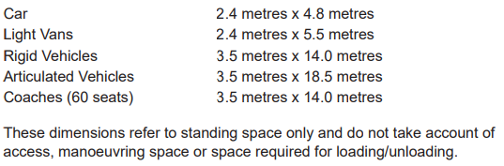

(The Planning Service (UK Government))

I have found documentation referring to mini-buses and this has led me to think about raising the question of whether I need to cater for mini-buses, or at least add an option to the program that places a given number of larger spaces.

### Research into layout of carpark.

#### British Parking’s online advice (British Parking, 2016)

I have learnt that it is beneficial for a car park to be designed in straight rows as this can help avoid any blind spots. “Parking spaces should be arranged, where possible, in straight rows to aid surveillance and avoid blind spots” (British Parking, 2016). Also, I imagine this would be a much more complicated algorithm as it deals with curves. Below is an example of the allegedly dangerous curved parking design compared to an angled one that follows straight lines and a more traditional style.

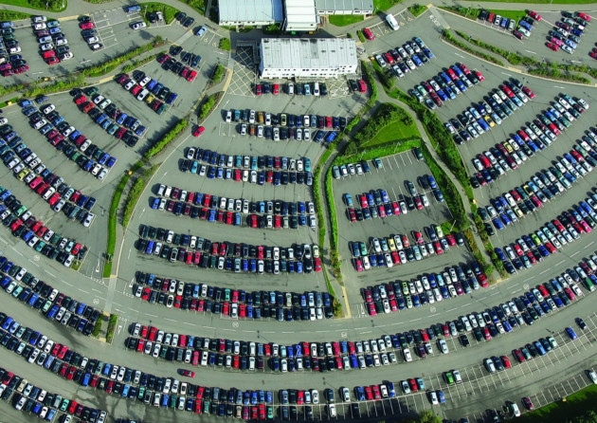 (Page)

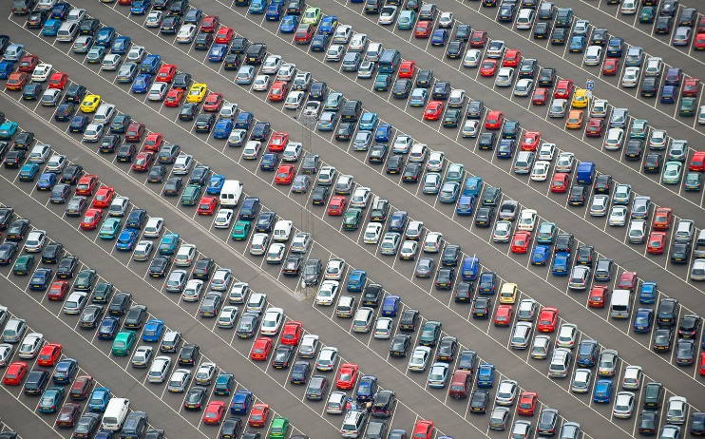 (Whipple, 2016)

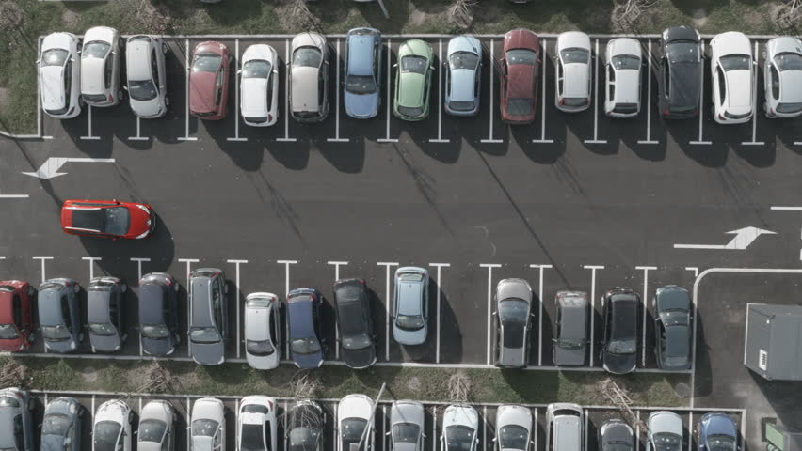 (VideoAir)

It is much safer to have a one-way car park as there is less chance of cars getting congested, this is especially important where a lot of the drivers will be students who have been driving less than two years and may be inexperienced. “Facilities should, wherever possible, incorporate the one-way circulatory movement of traffic around the parking areas. Clear directional arrows or signage must be visible to avoid confusion, and contra-flow lanes, where vehicles are driven on the right-hand side of a lane, should be avoided” (British Parking, 2016). As well as this it could be beneficial to add pedestrian walkways, such as this below.

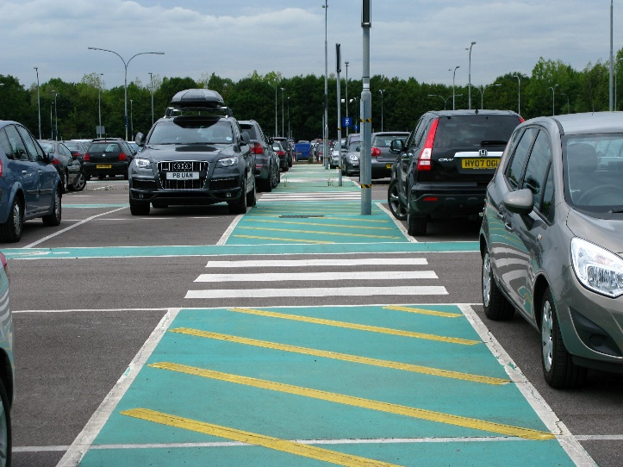

(PARKING4LESS, n.d.)

#### Whipple’s Research (Whipple, 2016)

From Whipple’s article on the “new” trend of slanted car parks, as pictured earlier, I have learnt that these styles are often more efficient as less space is required for an access lane. (Whipple, 2016) “For a 45 degree bay angle it was a 23% saving, for 36 degrees it was 24%, but the difference is marginal and it is easier to draw lines at 45 degrees.” (Percy, ANGLED BAYS PUT A NEW SLANT ON THE PERFECT CAR PARK, 2016) However, “The system only works in large car parks — in smaller ones the wasted space at the edges may negate the savings in the lanes” which would mean it may not be worth it in a school situation so my algorithm could test multiple angle options.

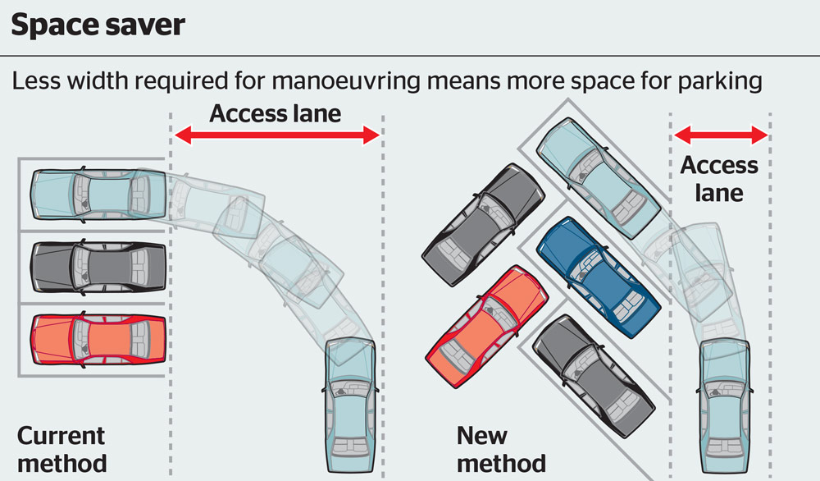 (Whipple, 2016)

I have also found that the direction of the road makes a huge difference, when car parks are just one way it is true that angled parking may be slightly more efficient for a very large car park, but when traffic flow is in two directions (and consequently cars need to turn around) the access lanes need to be wider. Another factor which some of these papers seems to have missed out is that cars are able to perform multiple point turns as well as being able to reverse into spaces, so the access lanes do not actually have to be as large as proposed by Whipple.

#### Abdelfatah and Taha’s Research (Abdelfatah & Taha, 2014)

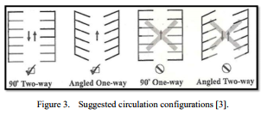 (Taha, 2014)

Above you can see part of the conclusion proposed by Akmal S. Abdelfatah and MahmoudA. Taha. When you think about these diagrams they actually make a lot of sense, since it may be difficult to reverse out of an angled bay when you also need to turn around. And, the angled one way not only saves space but also makes it easier to park in spaces and get out of them facing in the correct direction.

Abdelfatah and Taha’s article has provided to be incredibly inspiring. They describe a methodology of working involving linear programming, which is a technique of maximising a ‘profit’ while taking into account other constraints. Abdelfatah and Taha’s technique maximises spaces through using three separate attempts and then taking the best solution (as I originally thought would be a way to find the optimal solution).

I will not go into detail now, but they compare integer number of inner rows, and outer rows, while considering different angles of each row to find the optimum. “Mixing angles within the same row is not practical. On the other hand, allowing different parking angles within the same parking facility should be considered. Having different angles within the parking facility might improve the design and make it more efficient.” (Taha, 2014)

An explanation of their approach will be covered in the algorithms section.

#### Optimisation of Car park design by Bristol University Study Group (J. Billingham) (Wise & Trim, n.d.)

I have read most of the full report by the study group about how they came to their conclusions on their attempt at the car parking problem.

They also have a presentation report which summarises their findings. I have copied their most important slides below which demonstrate their findings.

##### Tapestry and Trim

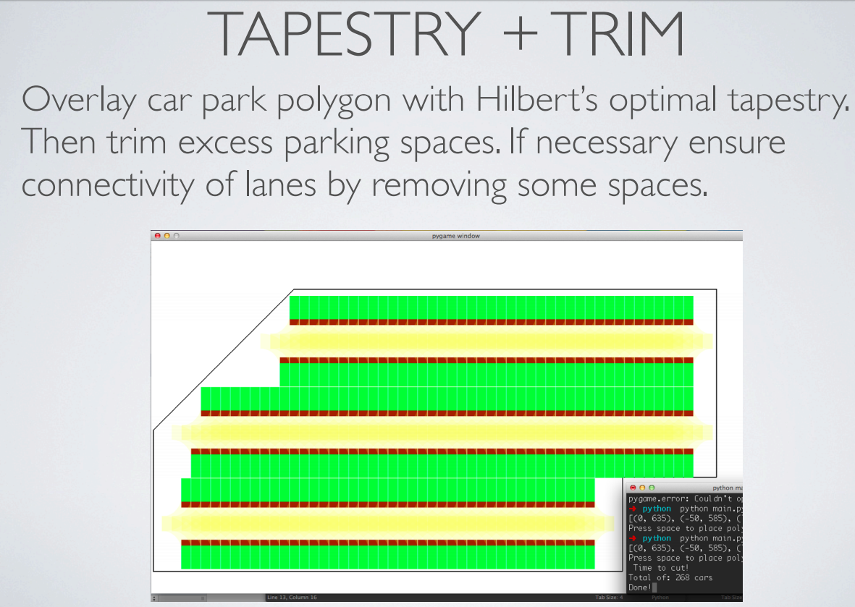Tapestry and Trim is when you simply cut down from an ‘infinite’ car park to fit into the car park shape given, aligning along one horizontal line.

##### Tile and Trim

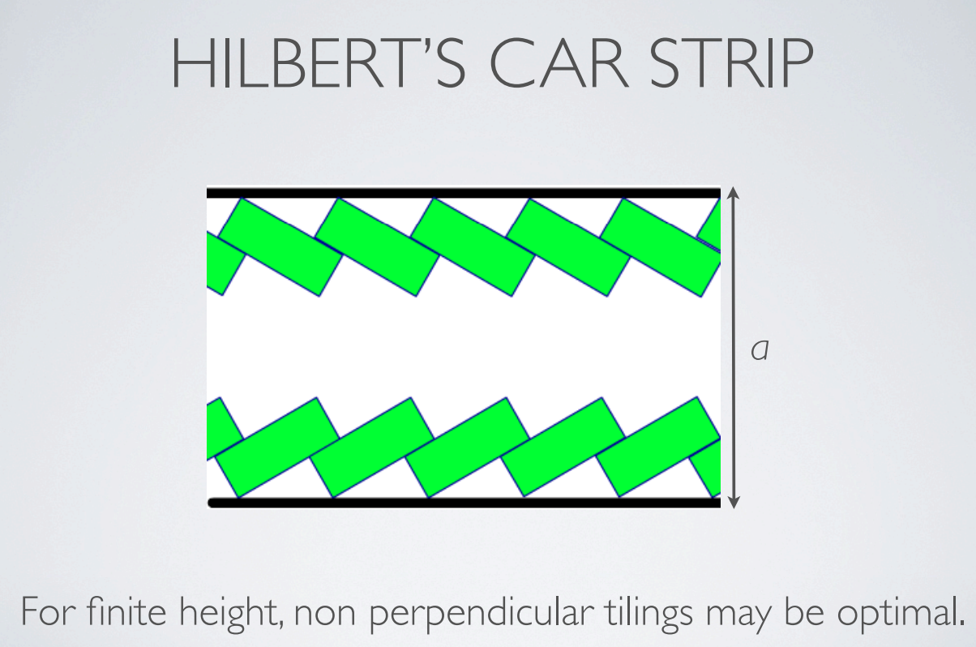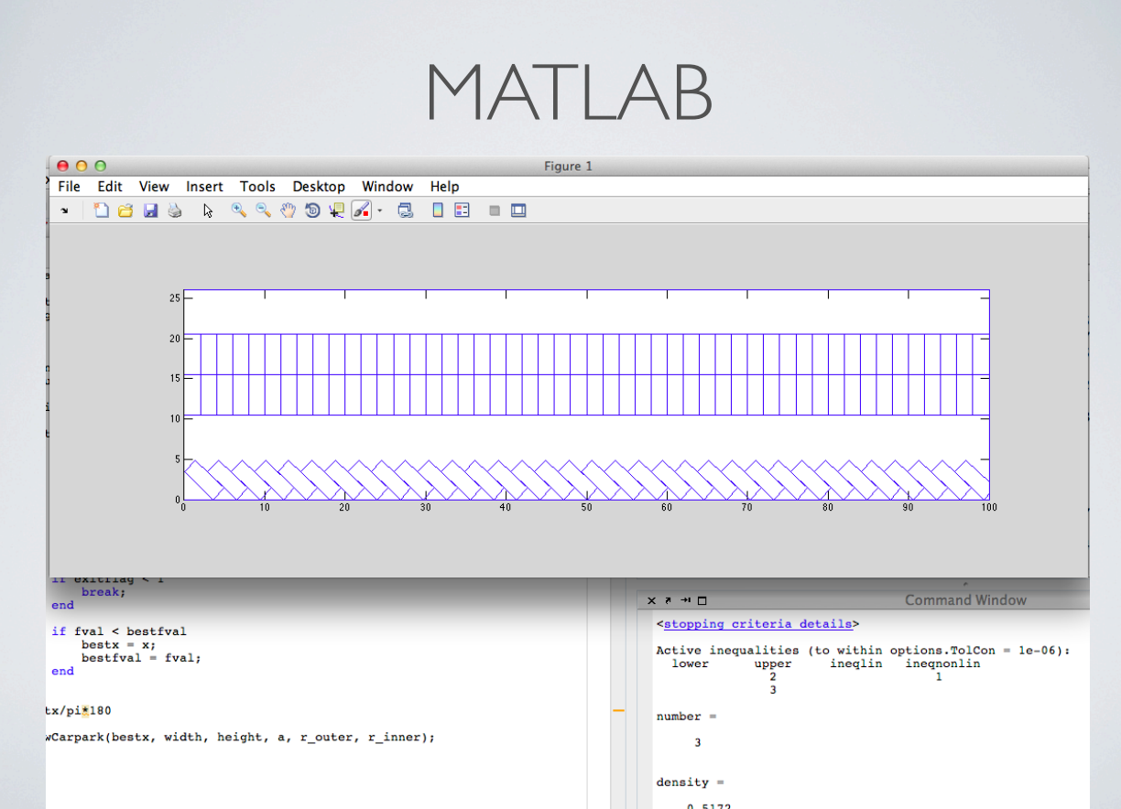

Tile and Trim is like tapestry and trim, but it builds up the car park one row at a time, from a horizontal edge. It then fills the remaining space however it can, in the above case with non-perpendicular parking bays, as these are the only shape that would fit. I will likely use tile and trim in my method.

Below this point are some example of what their coded solution was able to output. My program will be improving on this by more clearly showing where the spaces will be.

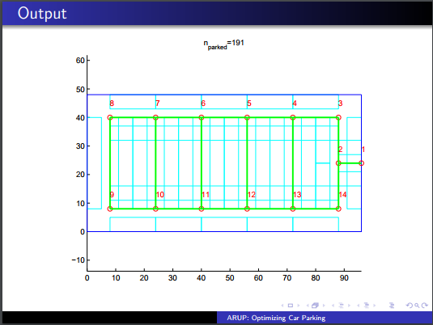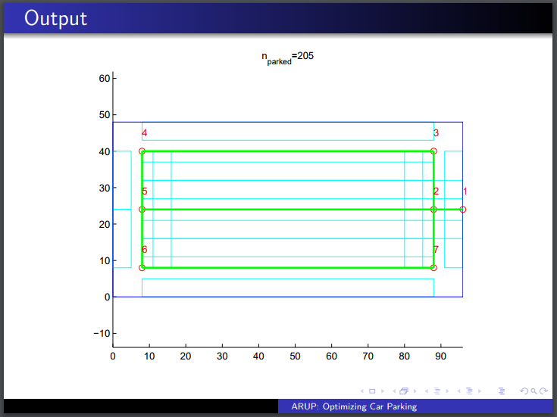

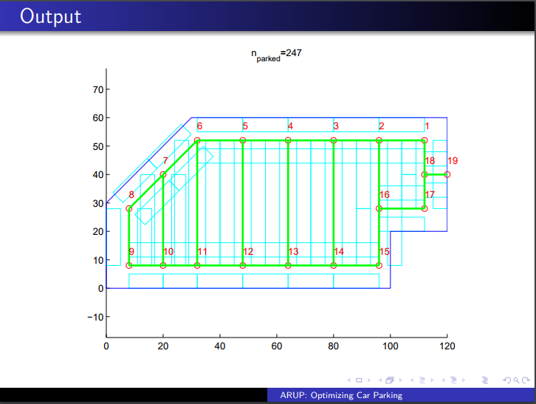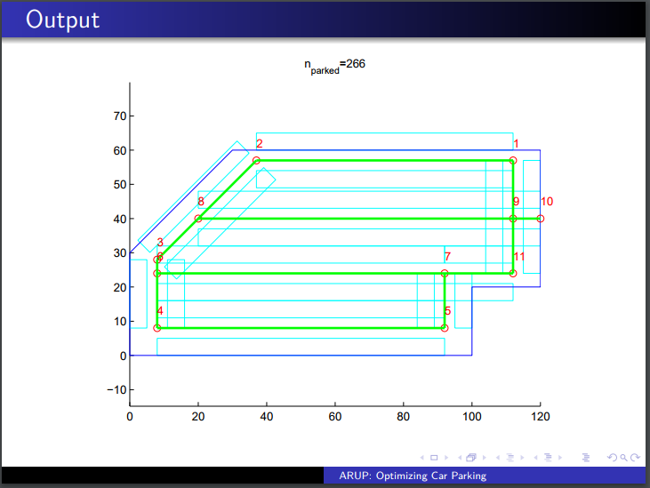

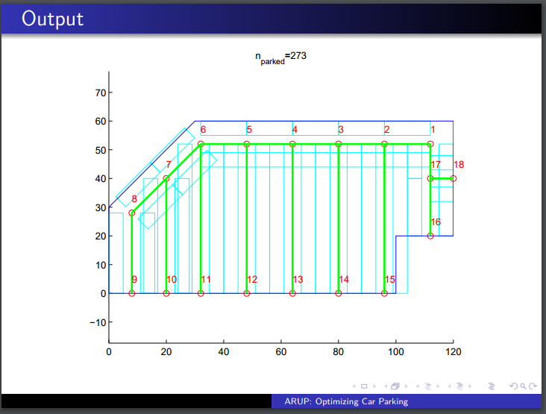

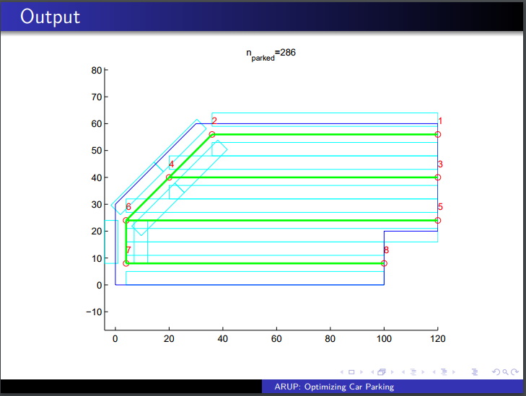

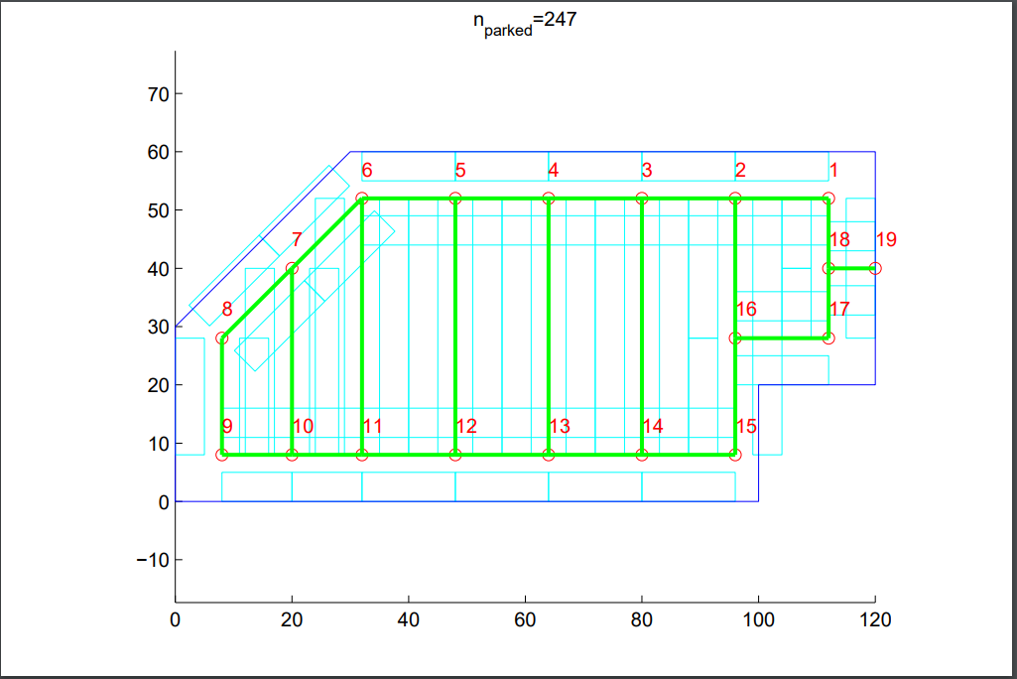

From these diagrams, we see that they trial different road orientations and layouts and presumably output all possibilities to the user. My program might have this ability, but its primary focus is to output just the most efficient solution.

It is most likely that I will use this solution.

### Secondary interview with client about the GUI

I contacted Mr Holmes with a request for a to-scale plan of the school which I could use as a focus for the GUI. Unfortunately, Mr Holmes does not have such a map, so I am now looking into other ways I can help the user input where the car park will be.

I looked into downloading google maps images from MapsEasy.com (MapsEasy.com, 2012) but they have a limited resolution and do not have a set scale. Ideal I would want to know how far each pixel represents.

### Algorithms

I am now starting to hunt for known solutions to the car parking solution. I will start by looking at non-specific algorithms.

#### Knapsack problem

This is an optimisation problem where you have a list of items each with two values. You have a set limit of the amount of one of the values.

For example, you might have a bag which can hold 10kg. You would choose the optimal items to fit in the bag to maximise the second value, e.g. profit for each item you take.

The problem breaks down to:

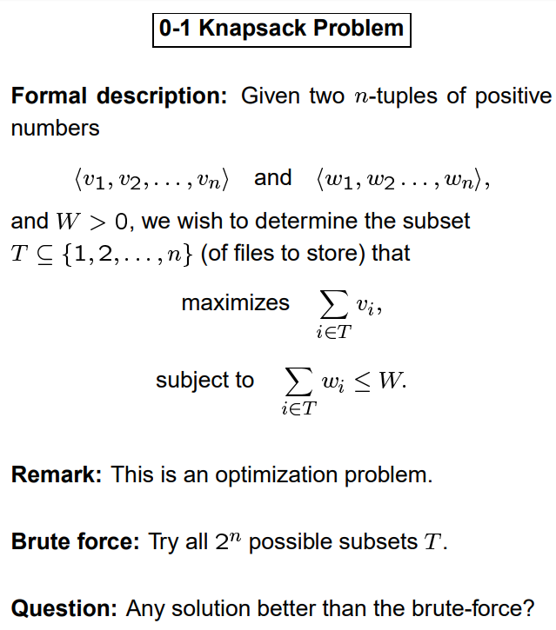 (Ralph Otten)

Basically, in order to brute force this problem it would take 2^n attempts, which can become very time consuming. Therefore a more efficient algorithm needed to be made.

The general solution to this problem uses a technique called dynamic programming. This is similar to recursion in the way that you break down a problem into similar sub problems, and through solving these you lead towards solving the primary problem. The difference is that when you solve a sub-problem, you store the calculated result in order to save time next time. “We trade space for time.” (Ralph Otten)

Where v is the list of bad values while w is the list of good values, n is the length of both these lists (how many items) and W is the maximum ‘weight’ (the maximum sum of all the bad values): the complete algorithm is:

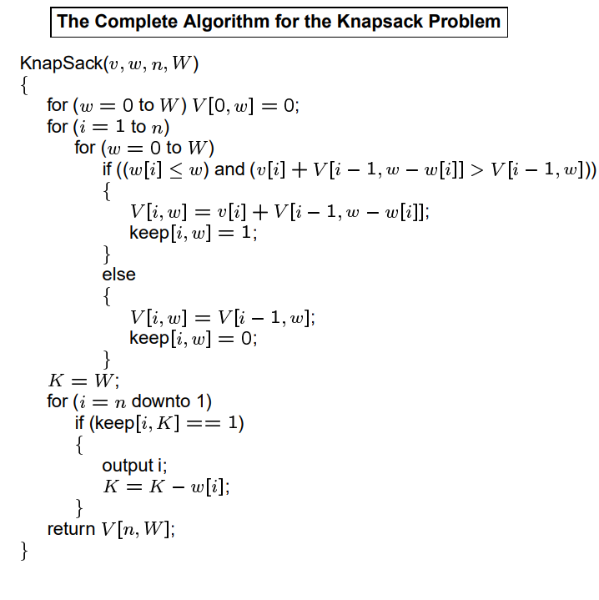

This algorithm could be useful for when choosing the number of each type of car park place to put in the car park, but at the moment I can’t comprehend exactly how I could implement it.

#### Bin packing

A bin packing algorithm is a simple algorithm where, generally, you pack the highest number of set length into a number of other set lengths, e.g. how many cars/vans/lorries can you fit inside a Eurotunnel train?

The other option of this algorithm is finding the minimum number of set lengths needed to ‘cut’ out other set lengths, e.g. a builder needs to cut lengths of 8m, 6m, 1m, 1.5m, 5.5m, 7m, 4m and 5m out of 10m length of wood, what is the minimum number of lengths he needs?

The way we have been taught to do this in D1 Maths is by using a ‘greedy algorithm’. This packs/cuts the largest items first and the smallest last.

#### Linear Programming

From Abdelfatah and Taha’s article (Taha, 2014), I will explain how they used linear programming in optimising the spaces available. I will then continue to explain one method of linear programming, the simplex method.

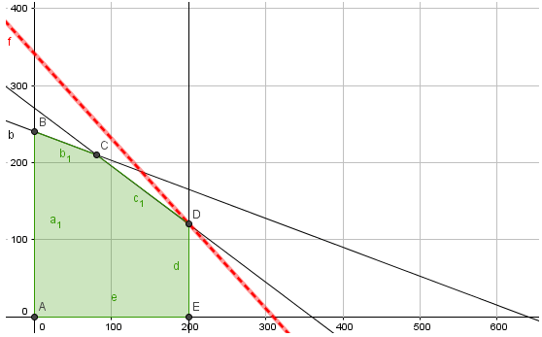

(My Maths, n.d.)

Linear Programming is a method of optimising one value while following other constraints. For the example above, there the black lines on the graph represent constraints; these are the limitations on the values, such as you cannot have negative x or negative y, or in this case, x cannot be greater than 200.

The shaded green space represents the ‘feasible region’, this is where the values of x and y fit into the constrains. As this is an optimisation problem, you want to optimise the number of x compared to a certain number of y. For example, profit might equal £2 for every pineapple sold and £3 for every apple sold. The red line in this diagram represents the profit line, basically you want to more this as far to the right as possible while a point (or part) of it is still in the feasible region. Normally this is when the profit line touches just one corner of the feasible region but it could also be along one edge of the region.

Below is a screenshot of mymaths, demonstrating the profit line.

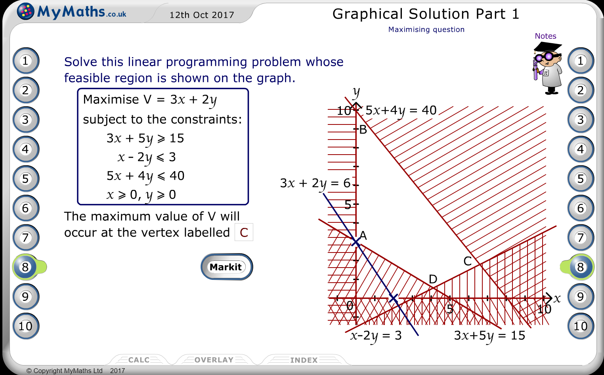

(My Maths, n.d.)

##### Abdelfatah and Taha’s constraints

Unfortunately, by reading further into the constraints set by this approach, I have found that this can only give solutions for rectangular car parks. I have been told by my client that the car parks must be able to be any polygon. Therefore, I will stop researching into this exact method.

##### Simplex Method

The beauty of the simplex method is that you can complete a linear programming problem that has more than two variables. This wouldn’t be able to be completed on paper as it would require a more than two-dimensional graph and would be incomprehensible to humans as soon as it has more than three dimensions.

The simplex method will be the easiest solution of the linear programming task to code. It is rather complicated to do by hand but thankfully I had to learn how to do it as part of my maths D1 exam, so I know how it works.

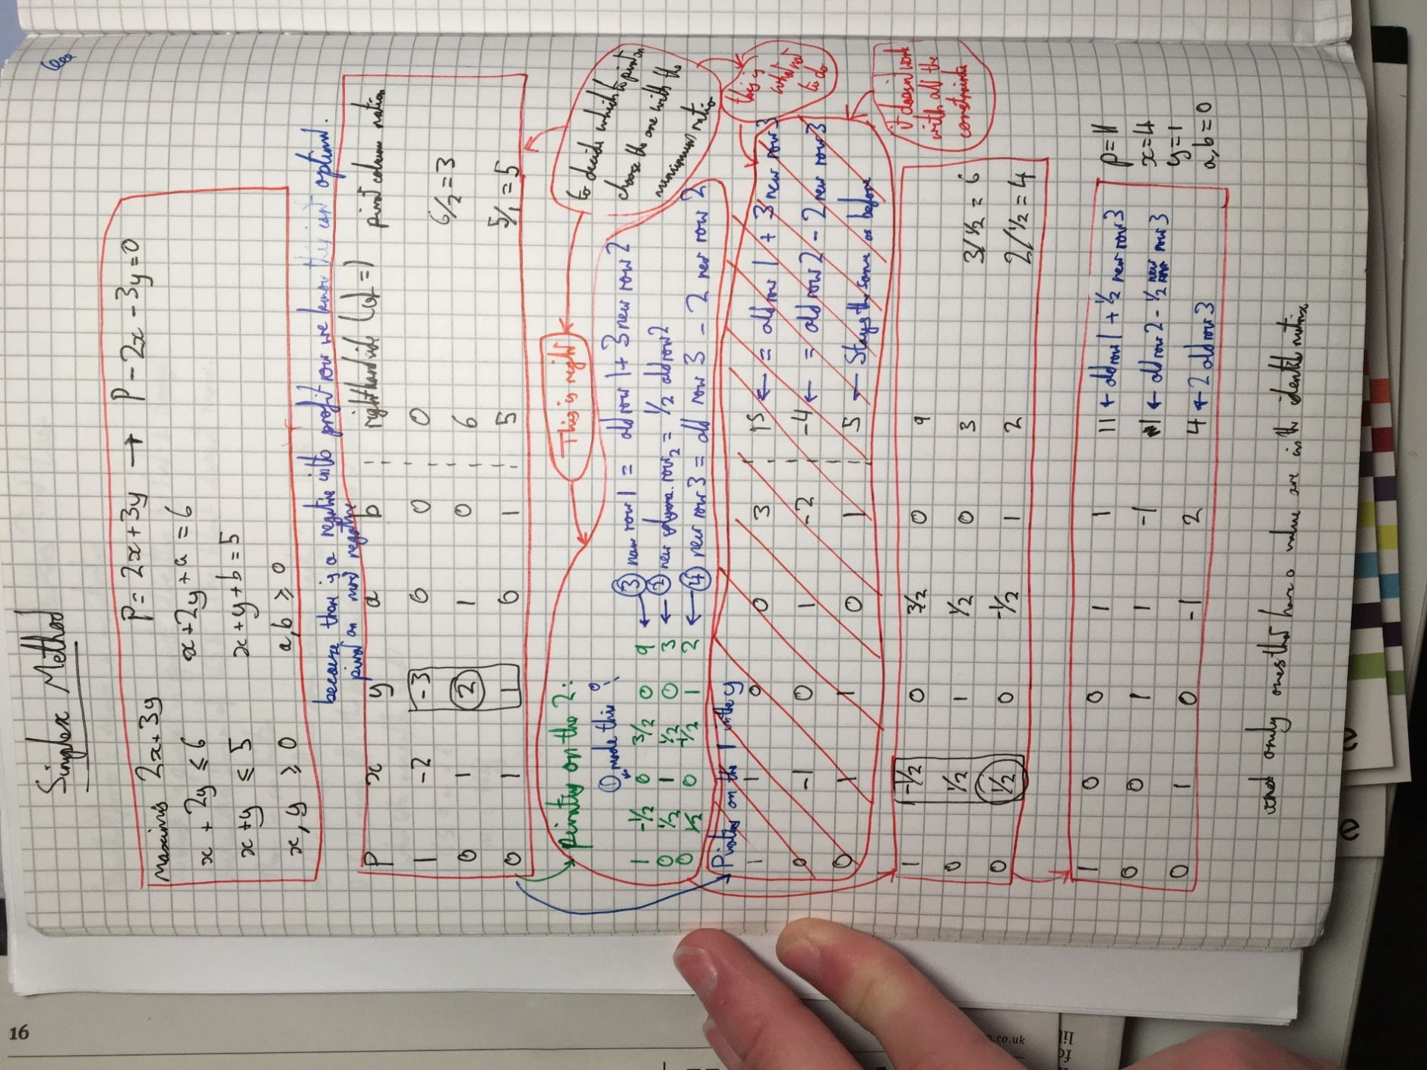

### Conclusion

I will primarily focus on the technique of rotating the given polygon so that one side sits horizontal then using tapestry and trim to fill the car park before removing spaces in order to link all the roads and the entrance/exit.

## Specifying the requirements

### Outputs

* Will output to the user the visual layout of the car park
* Will show the area of land on an aerial photo.
* Will clearly show where the entrance/exit of the car park is
* Will clearly show where the border of the car park is
* A scale should be shown with the outputted design
* Will output to the user the count of how many different vehicles fit in the car park design
* The car park will accommodate cars, minibuses, disabled spaces and/or motorcycles
* If no spaces fit in the area defined by the user, then an error message will be presented explaining the issue.

### Inputs

* Will allow the user to input an area of land for which they want a car park to fit in
* Will allow the user to input the area of land in under 60 seconds
* Will support this area having any number of straight sides, up to 8.
* Should output an error if the shape is unfit.
* Does not need to support curved edges
* Will give the user the option to specify spaces for a set number of minibuses, disabled spaces and/or motorcycles

### Processes

* Will allocate spaces for standard sized cars by default
* Will give the user the option to save the outputted design as an image.
* Will give the user the option to create an email with the attached car park design

## Feasibility study

### Programming language

It is likely that this problem could be tackled in a large variety of programming languages.

One such language could be Scratch, it would be easy enough for the user to input their shape by simply moving their mouse to draw and then a sprite could simply fill it in with rectangular boxes. The problem with this approach would not only be that it would not give the most efficient solution but also that there would be no way to output the final design as an image or to create a draft email with it.

One of the only other programming languages I am confident in using is python. Python would be an adapt language for the solution as it is famous for having a vast selection of modules coded by other people freely available to use. This would be very useful for things such as having a base to display the drawn car park on.

### Python modules

#### Linear programming - simplex method

##### Simpy (saswatraj, n.d.)

I have found a python module that applies the simplex method. This would be useful if I were to persue the route taken by Abdelfatah and Taha’s research.

#### Display

##### Tkinter

Tkinter is a very quick and easy way of displaying interactive GUI windows that can contain a large veriety of items, from buttons to labels to scroll boxes. This would allow me to create everything I need for the window that allows the user to configure the number of car parking spaces for each vehicle type.

Tkinter is “the most commonly used” GUI toolkit. (Python, 2016)

##### Pygame

Pygame is an alternative way to display data in a GUI to the user. I read (Wise & Trim, n.d.) that the Bristol university study group decided to use pygame as the way to display their car park. Having looked into this module further I believe that to be because you can easily draw onto a canvas with it. This would obviously be essential for my project, so I will include pygame as module I may use.

Pygame would also be a viable way for outputting the image of the car park design, it has a built in function “pygame.image.save(window, "screenshot.jpeg")”

### Available computing power

I have emailed the IT Support Team at my school requesting both the specifications of the most powerful computer available at school as well as that of the least powerful computers. Ideally my program will run on every computer in the school. I will also be able to show the how efficient my code is by the difference in time it takes to run on the two systems.

As discussed earlier, the user should be able to input their selected area in no more than 60 seconds.

I should be able to calculate the uncompressed image size of the outputted car park:

A standard HD image is 1920x1080 pixels.

I will not need full 32 bit colour depth, I will need a maximum of 8 colours. However, in order to get the outputted image to look ‘nice’ I may choose to use colours other than the 8 colours below, the standard 3 bit colour palette:

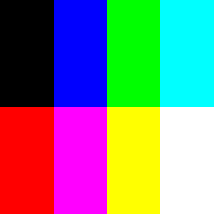 (Void, 2015)

Instead I will want either 8 bit depth or 16 bit depth, examples of both are shown below respectively.

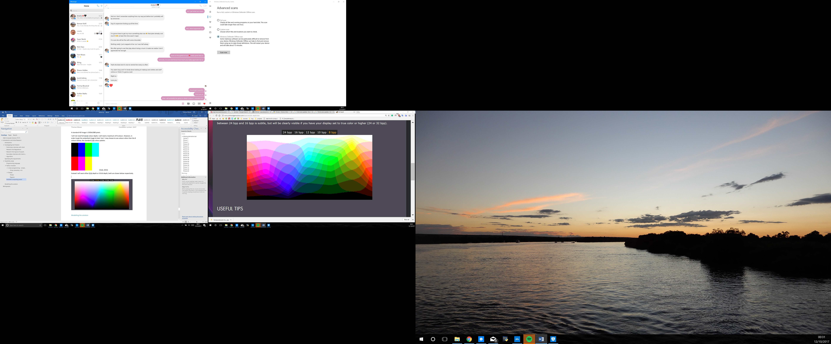 (Cambridge in Colour, 2005)

8 bit colour depth gives you 2^8 = 256 colours.

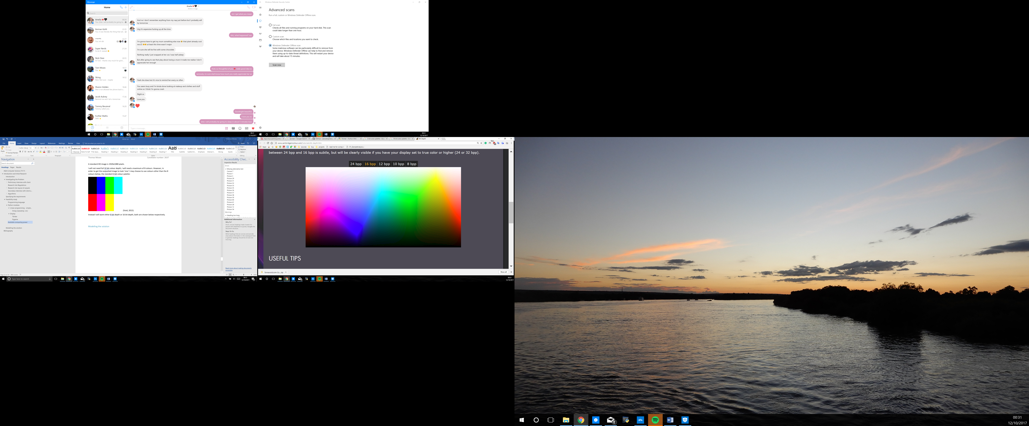 (Cambridge in Colour, 2005)

16 bit colour depth gives you 2^16 = 65536 colours.

A 1080p (1920x1080) image where each pixel uses 8 bits, uncompressed will equal 16588800 bits, or roughly 16.6 mb.

A 1080p (1920x1080) image where each pixel uses 16 bits, uncompressed will equal 33177600 bits, or roughly 33.2 mb.

A 4K (3840x2160) image where each pixel uses 8 bits, uncompressed will equal 66355200 bits, or roughly 66.4 mb.

A 4K (3840x2160) image where each pixel uses 16 bits, uncompressed will equal 132710400 bits, or roughly 132.7 mb.

I might also be able to output the image as a vector graphic, which uses mathematical equations to store shapes. This would result in a very low uncompressed image file. This would be an ideal solution. I don’t think it would matter which option I choose to follow because I have found a python module which compresses images. Ideally my program would be able to output the image in both file formats.

### Security

#### User’s data

If the client was working on a confidential project I might want to consider encrypting all the data in the save file or configuration file. However, the user will be using this program in their own private logon area, so their files should be safe anyway. Therefore I do not need to encrypt any of the user’s data.

#### My program

I will want to protect my source code by giving this program to the client as an executable file instead of the python code. This will also make it easier for my client to run the program as they will not need to mess around with installing a python IDE.

### Computer systems

I contacted my school IT support in order to find out the minimum specifications of computers that the program may be ran on.

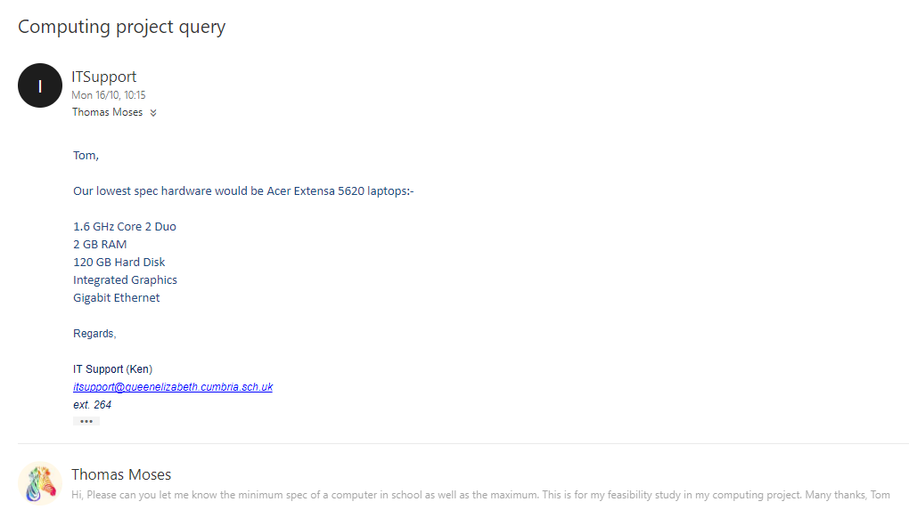

There is effectively no limit to storage because at school files are all stored on the main sever, unless I have a file more than 14 TB which I won’t.

The hardware of even this lowest spec computer system should still be able to run any of the algorithms I have looked at in a reasonably quick time.

# Design

## Critical Path

Below is a hierarchy chart of the critical path for developing the program.

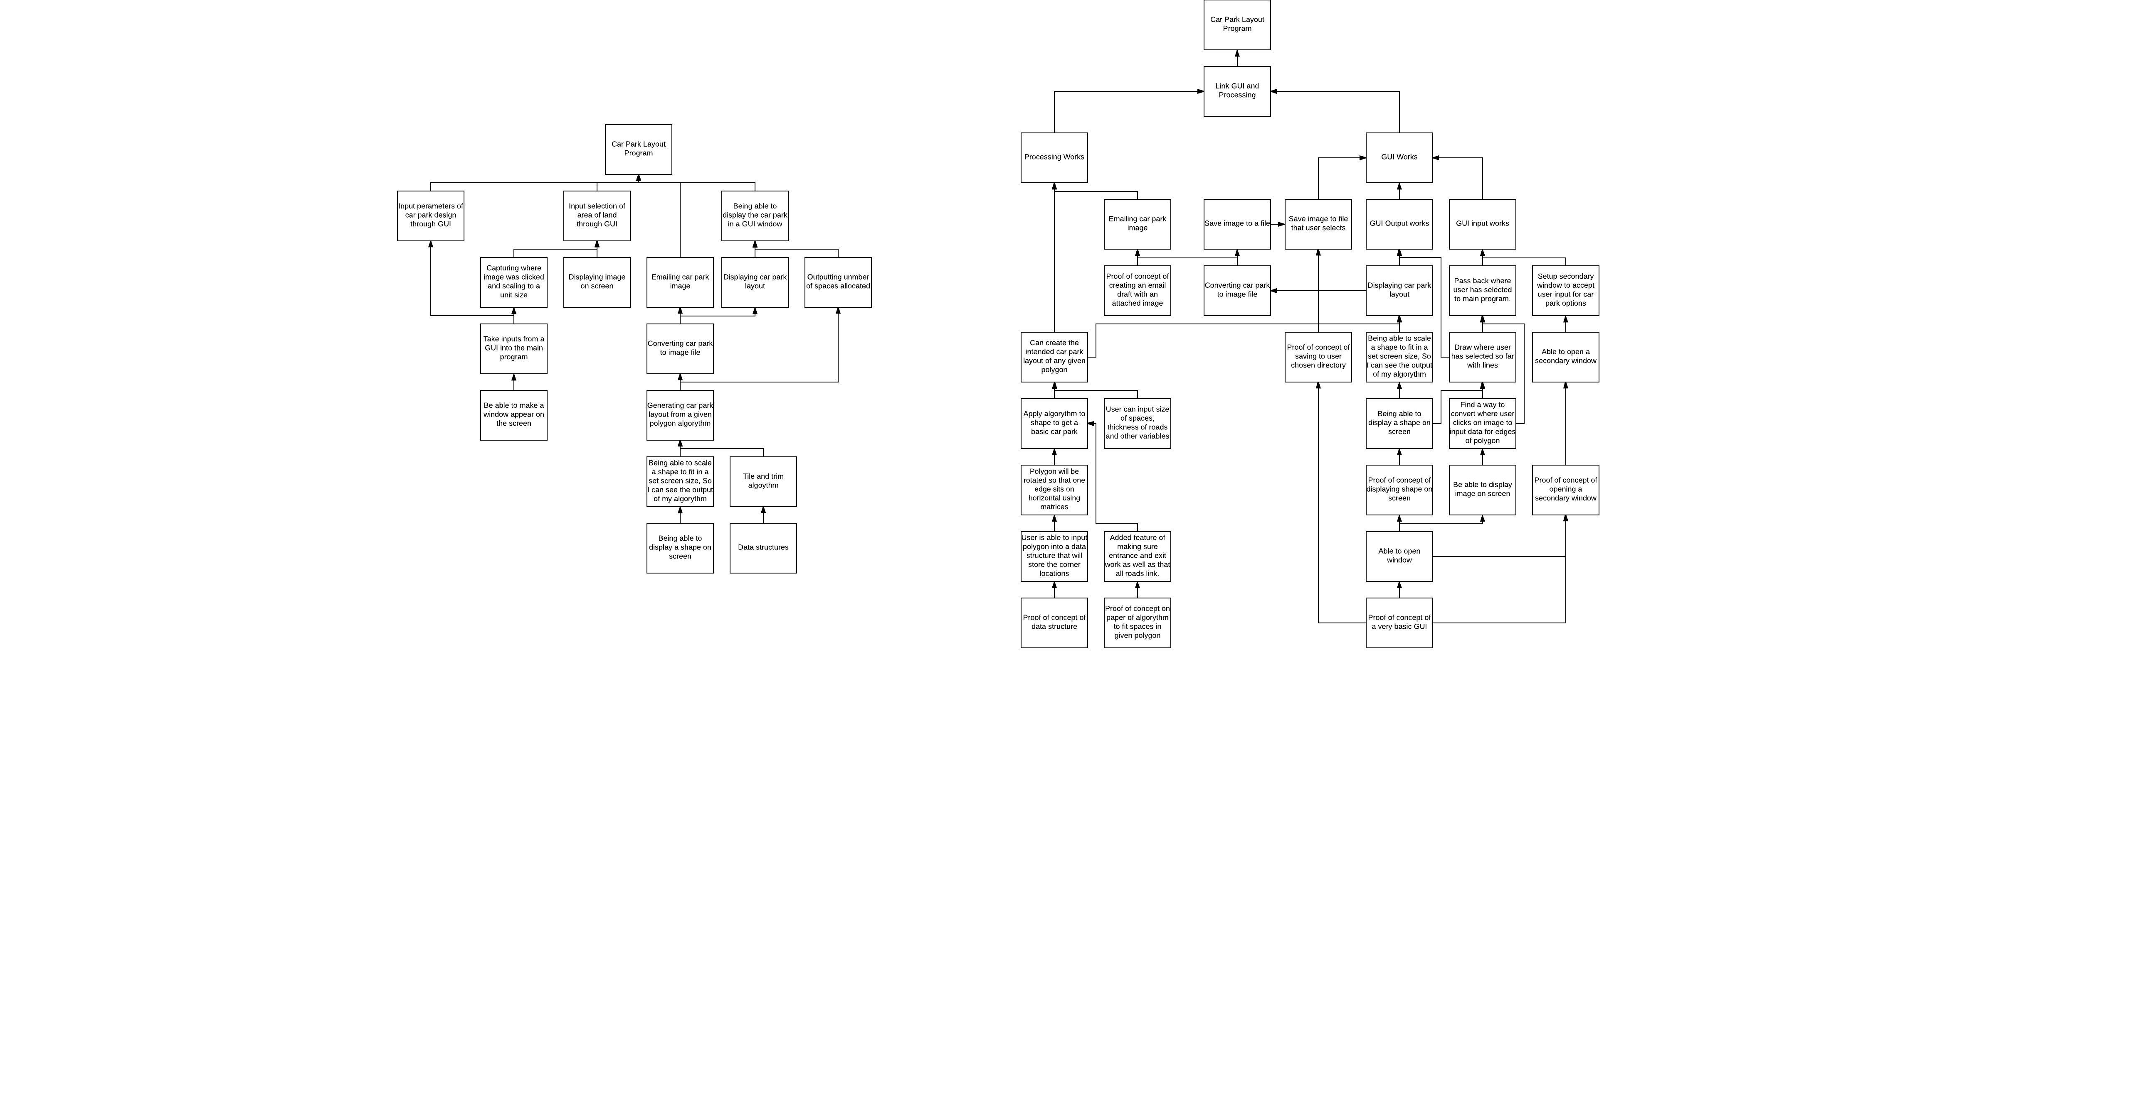

I first plan to make a CLI program. Here are the steps I have outlined which this first program will do.

1. User will input some x,y coordinate points (in meters)
   1. These points will be stored as vertex objects
2. These vertices will be made into a shape object named carparkOutline
3. An algorithm will be used to find the longest side of this shape.
   1. Through comparing pairs of vertices
4. From this longest side the standard car park tapestry will be placed
5. An algorithm will then remove any car parking spaces which are outside the carparkOutline boundary.
6. The positions of each note can be given back to the user.
   1. In later versions this will be used to display the car park as an image.

## Data Flow Diagram

I have identified the flow of data through my program and have represented this below.

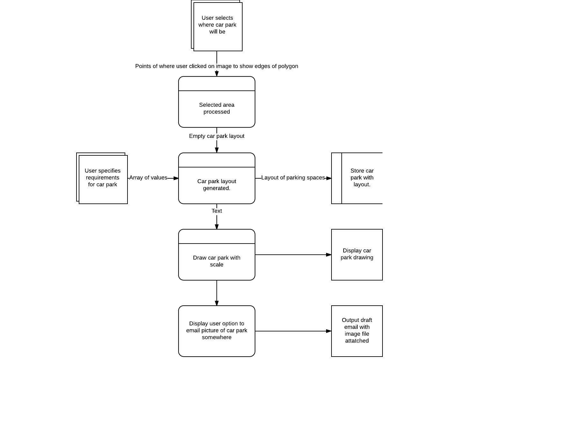

## Design of user interface

### Version 1

In this version I planned to have one main window with a loading bar underneath it along with some text helping the user see what the program is doing.

There will be a second window which the user can use to specify how many of each car parking space should be in the carpark. You can see some mock-ups of the design below.

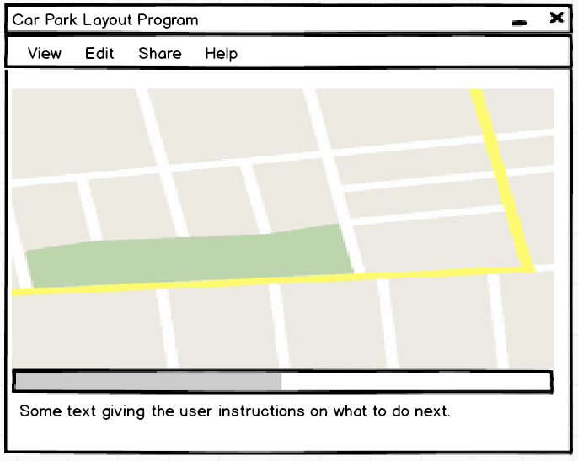

This is a mock-up of the main window. The user would be able to also open the menu to choose how many spaces from the edit menu and be able to share the car park design from the share menu.

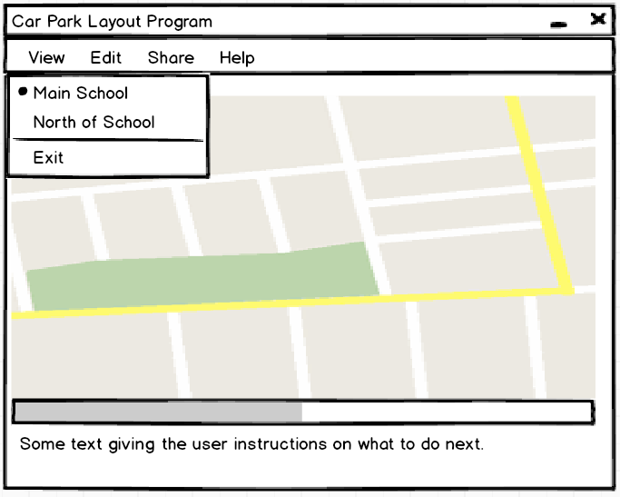

Here you can see an example of the view menu in action, which allows the user to choose which map is displayed.

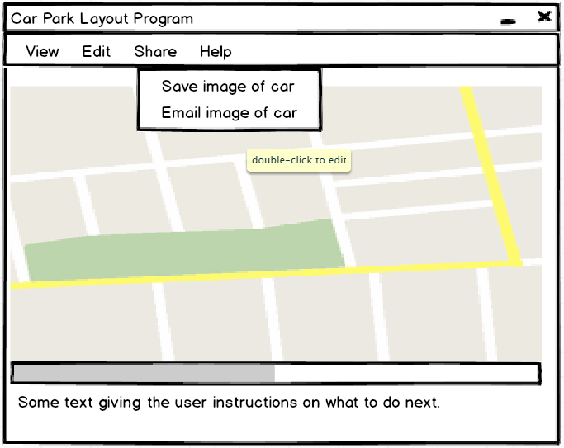

Here you can see the share menu in action.

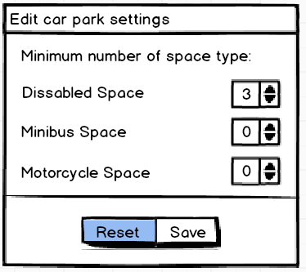

Here you can see my design for the car park settings panel.

### Version 2

In this revised version I have chosen to fit it all into one window to make the program simpler for the user. I have added a few colours as well as a better way of choosing which spaces are in the car park.

I use a priority queue which the user can add certain numbers of certain car park space types to.

I have also implemented an easier way of changing which map is displayed through the use of a combo box. As well as this, I have now added buttons to help the user place and remove the corners of the car park.

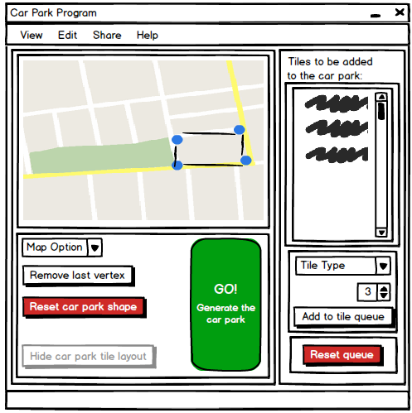

This is how the window will look when the user first opens the program. The hide layout button will be disabled as there is no layout to hide.

I have added an example drawing to the example map showing that the user will be able to see their current car park shape as they draw it in real time. The new buttons to remove the last added vertex will also cause the car park to be redrawn and re-displayed.

The use of colours helps the user identify buttons that may have bad outcomes, such as resetting all work they have done so far. The large green button will cause the car park to be generated.

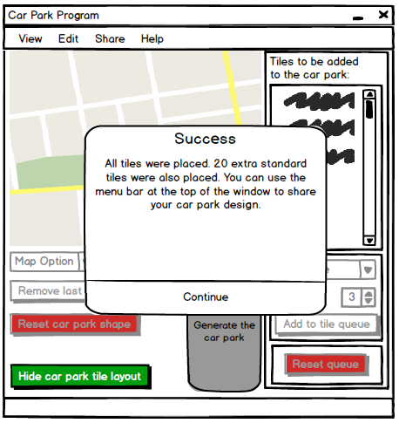

This is how the program will look after the car park was generated. The large popup shows the user how the car park generation turned out. I will give detailed feedback to the user here about how many car parking spaces were placed and other details that may be useful, such as the area of the car park.

This time more buttons will be disabled as they would not be able to be pressed until the layout is hidden. And the user goes back the previous window setting. This will be controlled by a Boolean variable.

#### More detailed frame design

Since I will be using Tkinter for GUI, I will need to make use of frames. Frames are used to break up parts of the window for easy formatting. Each frame will need a name so I can refer to it so I have gone ahead and names all items that will exist within my GUI:

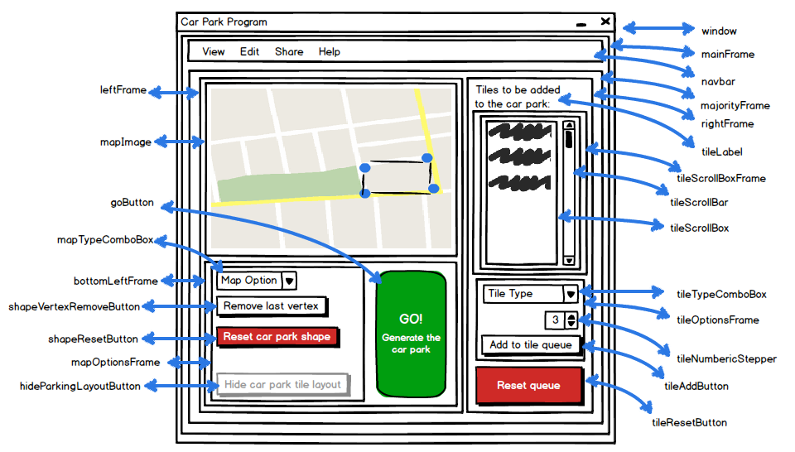

### Choosing a final design

I was partial towards the second design I made as I felt even though it would be more challenging to create, it would leave my client with a higher quality program.

I decided that I should check with my client which design they would prefer I make.

I sent this email:

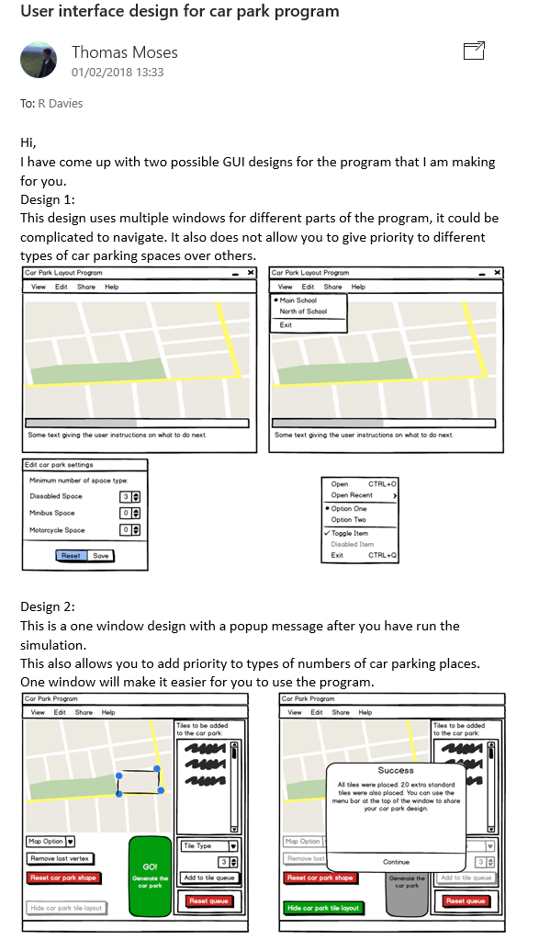

And I received this reply: (communication was carried out through my computing teacher as they were able to show the designs to my client in the staff room)

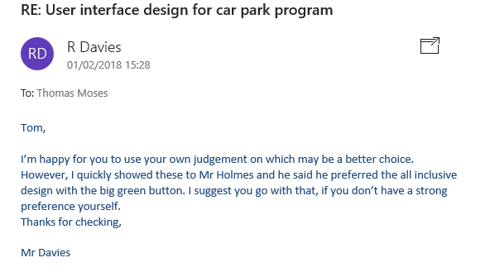

Since both my client and myself agreed on this design, Version 2 of the design will be the design I go with.

# Programming the Solution

I have split the programming of the solution into four clear steps. I will plan, execute and test each of the steps sequentially.

1. The input from a user clicking on points of a picture

2. Manipulating shapes defined by coordinates

3. Tile and Trim Algorithm

4. Pulling everything together with a GUI

5. Optimising the tile and trim algorithm now that I have a working GUI and further additions

6. Asking for client feedback and making further improvements

## 1. Taking user input from when clicking on an image

### 1.0 Description of process

This will take the place the user clicks on an image. I will use this when designing the car park to get where the boundaries of the car park are. In my design specification my client decided that this should be an easy process that can be completed to some accuracy in under 60 seconds, so my testing should reflect this.

### 1.1 Input/Process/Output/Storage

|  |  |  |  |
| --- | --- | --- | --- |
| Input | Process | Storage | Output |
| User runs program | Program loads image and gets the image width and height in pixels. | Image is opened as an instance | The program will output to the user the dimentions of the image to make testing easier. |
| User clicks anywhere on a picture that is show in a window | The program can capture which pixel the user clicked on | This pixel identifier is then stored as a tuple in a list that contains all the locations the user has clicked on so far sequentially. | At this stage the user will simply be told in the command line the coordinates of where the program thinks they clicked. |

### 1.2 Data Dictionary

|  |  |  |  |
| --- | --- | --- | --- |
| Data Name | Data Type | Default Value | Description |
| Image | An instance of an image | It will be set to the background image used, for testing this will be a 500px by 500px image. | From this instance of an image I will be able to open a Tkinter window and display it |
| coordsClicked | A list (will become a list of tuples) | An empty list. | All coordinates clicked will be stored in this list. |

### 1.3 Test Plan

|  |  |  |  |
| --- | --- | --- | --- |
| Number | Type and Reason | Action | Expected Result |
| 1 | NORMAL: To check that the user has opened the correct image | User will run program | The program should output that the image is 500px by 500 px |
| 2 | NORMAL: To check image displays properly | The user will run the program | This full image should be displayed: |
| 3 | NORMAL: To check that the program gives correct output of where the user clicked | User will click in the top left corner of the image | The program should output coordinates close to (0,0), I do expect these numbers to be within a range of 50 pixels or so since it would be impossible for me to click the very corner of the image. |
| 4 | Same as previous | User will click in the top right corner of the image | The program should output coordinates close to (500,0) |
| 5 | Same as previous | User will click in the bottom right corner of the image | The program should output coordinates close to (500,500) |
| 6 | Same as previous | User will click in the bottom left corner of the image | The program should output coordinates close to (0,500) |
| 7 | NORMAL: To check all positions were stored | In the command line the user will call for the list of all coordinates clicked to be printer using “print coordsClicked” | A list of the above 4 coordinates will be printed, they should be in the correct order too. |
| 8 | ERRONOUS: To check clicks outside of the image are not captured. | Try to click outside the image and return a number that is <0 or >500 | I should only be able to get number in the limit 0 ≤ x ≤ 500 |

### 1.4 Implementation

I have found that through Tk, which I already have experience in, and an image library called PIL (python imaging library) I can easily display an image and get feedback from where the user clicked.

I have found this 500x500px image for testing:

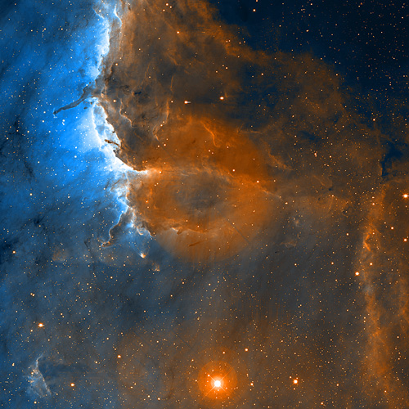 (University of Colorado, University of Hawaii and NOAO/AURA/NSF)

### 1.5 Programming the solution

#### 1.5.1 First Attempt

##### 1.5.1.1 Code

import Tkinter #for opening window

from PIL import Image, ImageTk #for opening file

def callback(event):

print "coords: " + str(event.x) + "," + str(event.y)

window = Tkinter.Tk() #creates window

image = Image.open("test.jpg") #creates an instance of an image class

canvas = Tkinter.Canvas(window, width=image.size[0], height=image.size[1]) #image.size gives you the width and depth

canvas.pack()

image_tk = ImageTk.PhotoImage(image)

canvas.create_image(image.size[0], image.size[1], image=image_tk)

canvas.bind("<Button-1>", callback) #<Button-1> is the left mouse button

print "image size: " + str(image.size)

Tkinter.mainloop()

##### 1.5.1.2 Testing

For nicer formatting I have removed the Reason column from this test plan, although for reference the test numbers coincide with that of my previous test plan.

All images that are on new rows relate as evidence to the previous test.

|  |  |  |  |  |
| --- | --- | --- | --- | --- |
| Number | Action | Expected Result | Actual result | Changes to be made |
| 1 | User will run program | The program should output that the image is 500px by 500 px | Correct image size is shown | None |
| Screen Clipping | | | |
| 2 | The user will run the program | This full image should be displayed: | The image is not shown correctly | I need to open the image using its center’s coordinates rather than the total size of the image |
| Screen Clipping | | | |

#### 1.5.2 Fixing image displaying properly

##### 1.5.2.1 Code

import Tkinter #for opening window

from PIL import Image, ImageTk #for opening file

def callback(event):

print "coords: " + str(event.x) + "," + str(event.y)

window = Tkinter.Tk() #creates window

image = Image.open("test.jpg") #creates an instance of an image class

canvas = Tkinter.Canvas(window, width=image.size[0], height=image.size[1]) #image.size gives you the width and depth

canvas.pack()

image_tk = ImageTk.PhotoImage(image)

canvas.create_image(image.size[0]//2, image.size[1]//2, image=image_tk) #//2 needed in order to center the image

canvas.bind("<Button-1>", callback) #<Button-1> is the left mouse button

print "image size: " + str(image.size)

Tkinter.mainloop()

##### 1.5.2.2 Testing

|  |  |  |  |  |
| --- | --- | --- | --- | --- |
| Number | Action | Expected Result | Actual Result | Changes To be Made |
| 1 | User will run program | The program should output that the image is 500px by 500 px | It does | None |
|  | | | |
| 2 | The user will run the program | This full image should be displayed: | The image is displayed correctly | None |
|  | | | |
| 3 | User will click in the top left corner of the image | The program should output coordinates close to (0,0), I do expect these numbers to be within a range of 50 pixels or so since it would be impossible for me to click the very corner of the image. | The correct coordinates are outputted when clicked. There also is no delay, which is good as it will not effect the 60 second limit set by the client. | None |
|  | | | |
| 4 | User will click in the top right corner of the image | The program should output coordinates close to (500,0) |  | None |
|  | | | |
| 5 | User will click in the bottom right corner of the image | The program should output coordinates close to (500,500) |  | None |
|  | | | |
| 6 | User will click in the bottom left corner of the image | The program should output coordinates close to (0,500) |  | None |
|  | | | |
| 7 | In the command line the user will call for the list of all coordinates clicked to be printer using “print coordsClicked” | A list of the above 4 coordinates will be printed, they should be in the correct order too. | I can try printing this list but the list doesn’t exist so it won’t print. | I need to add this list feature as I forgot to add it. |
|  | | | |

#### 1.5.3 Allowing all coordinates clicked so far to be stored and shown

##### 1.5.3.1 Code

import Tkinter #for opening window

from PIL import Image, ImageTk #for opening file

coordsClicked = []

def callback(event):

print "coords: " + str(event.x) + "," + str(event.y)

coordsClicked.append([event.x,event.y]) #appends the clicked coordinates as a tuple to the list

window = Tkinter.Tk() #creates window

image = Image.open("test.jpg") #creates an instance of an image class

canvas = Tkinter.Canvas(window, width=image.size[0], height=image.size[1]) #image.size gives you the width and depth

canvas.pack()

image_tk = ImageTk.PhotoImage(image)

canvas.create_image(image.size[0]//2, image.size[1]//2, image=image_tk) #//2 needed in order to center the image

canvas.bind("<Button-1>", callback) #<Button-1> is the left mouse button

print "image size: " + str(image.size)

Tkinter.mainloop()

##### 1.5.3.2 Testing

Tests 1-6 are the same as previously, just 7 has been re-documented.

|  |  |  |  |  |
| --- | --- | --- | --- | --- |
| Number | Action | Expected Result | Actual Result | Changes To be Made |
| 1 | User will run program | The program should output that the image is 500px by 500 px | It does | None |
|  | | | |
| 2 | The user will run the program | This full image should be displayed: | The image is displayed correctly | None |
|  | | | |
| 3 | User will click in the top left corner of the image | The program should output coordinates close to (0,0), I do expect these numbers to be within a range of 50 pixels or so since it would be impossible for me to click the very corner of the image. | The correct coordinates are outputted when clicked. There also is no delay, which is good as it will not effect the 60 second limit set by the client. | None |
|  | | | |
| 4 | User will click in the top right corner of the image | The program should output coordinates close to (500,0) |  | None |
|  | | | |
| 5 | User will click in the bottom right corner of the image | The program should output coordinates close to (500,500) |  | None |
|  | | | |
| 6 | User will click in the bottom left corner of the image | The program should output coordinates close to (0,500) |  | None |
|  | | | |
| 7 | In the command line the user will call for the list of all coordinates clicked to be printer using “print coordsClicked” | A list of the above 4 coordinates will be printed, they should be in the correct order too. | The list is printed (the numbers are different as I did not re-do the screenshots for the above tests) | None |
|  | | | |
| 8 | Try to click outside the image and return a number that is <0 or >500 | I should only be able to get number in the limit 0 ≤ x ≤ 500 | I am able to get numbers outside of this limit by clicking on the white border at the bottom. | I should stop these number being added to the list of clicked points and instead return an error. |
|  | | | |

#### 1.5.4 Stopping erroneous data

##### 1.5.4.1 Code

import Tkinter #for opening window

from PIL import Image, ImageTk #for opening file

coordsClicked = []

def callback(event):

print "coords: " + str(event.x) + "," + str(event.y)

if ( 0 <= event.x <= image.size[0] ) and ( 0 <= event.y <= image.size[1] ):

coordsClicked.append([event.x,event.y]) #appends the clicked coordinates as a tuple to the list

else:

print "Coordinates out of range and were not added to list"

window = Tkinter.Tk() #creates window

image = Image.open("test.jpg") #creates an instance of an image class

canvas = Tkinter.Canvas(window, width=image.size[0], height=image.size[1]) #image.size gives you the width and depth

canvas.pack()

image_tk = ImageTk.PhotoImage(image)

canvas.create_image(image.size[0]//2, image.size[1]//2, image=image_tk) #//2 needed in order to center the image

canvas.bind("<Button-1>", callback) #<Button-1> is the left mouse button

print "image size: " + str(image.size)

Tkinter.mainloop()

##### 1.5.4.2 Testing

Tests 1-7 are the same as previously, just 8 has been re-documented.

|  |  |  |  |  |
| --- | --- | --- | --- | --- |
| Number | Action | Expected Result | Actual Result | Changes To be Made |
| 1 | User will run program | The program should output that the image is 500px by 500 px | It does | None |
|  | | | |
| 2 | The user will run the program | This full image should be displayed: | The image is displayed correctly | None |
|  | | | |
| 3 | User will click in the top left corner of the image | The program should output coordinates close to (0,0), I do expect these numbers to be within a range of 50 pixels or so since it would be impossible for me to click the very corner of the image. | The correct coordinates are outputted when clicked. There also is no delay, which is good as it will not effect the 60 second limit set by the client. | None |
|  | | | |
| 4 | User will click in the top right corner of the image | The program should output coordinates close to (500,0) |  | None |
|  | | | |
| 5 | User will click in the bottom right corner of the image | The program should output coordinates close to (500,500) |  | None |
|  | | | |
| 6 | User will click in the bottom left corner of the image | The program should output coordinates close to (0,500) |  | None |
|  | | | |
| 7 | In the command line the user will call for the list of all coordinates clicked to be printer using “print coordsClicked” | A list of the above 4 coordinates will be printed, they should be in the correct order too. | The list is printed (the numbers are different as I did not re-do the screenshots for the above tests) | None |
|  | | | |
| 8 | Try to click outside the image and return a number that is <0 or >500 | I should only be able to get number in the limit 0 ≤ x ≤ 500 | An error message is displayed when the coordinates are out of range. | None |
|  | | | |

### 1.6 Summary and Extras

Since I now have this working I can move onto the processing of the car park and leave this for later when I work on the GUI.

When I implement the GUI I will want a way to change the pixel numbers to values in metres.

I will also need some more suitable images for the user to choose from. I have looked online at finding a high quality aerial picture as well as asking my client if they have any up to date maps of the school grounds, neither searching gave me any result. I have now found a satellite website where you can save a screenshot, similar to google maps but with less watermarks:

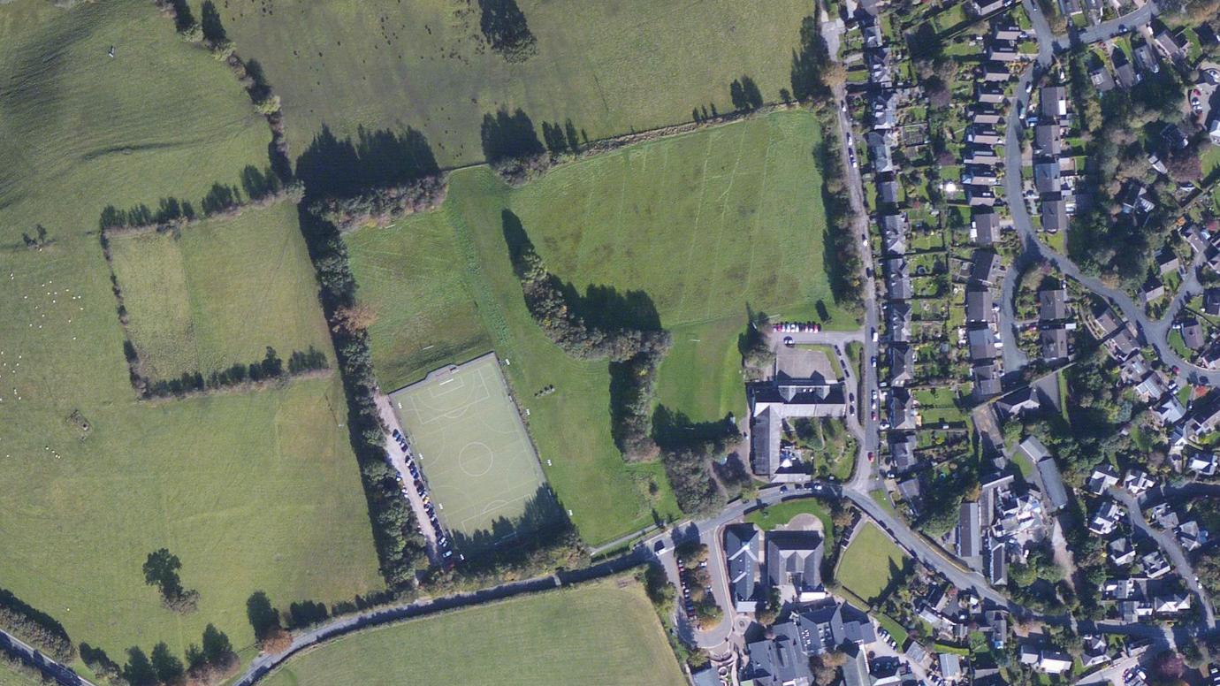

This image is of the upper side of school, where we have an AstroTurf and currently a slim car park up the side. School owns the field in the centre of this image. This image is from Zoom Earth (DigitalGlobe, CNES, Airbus, Microsoft Corporation, 2017).

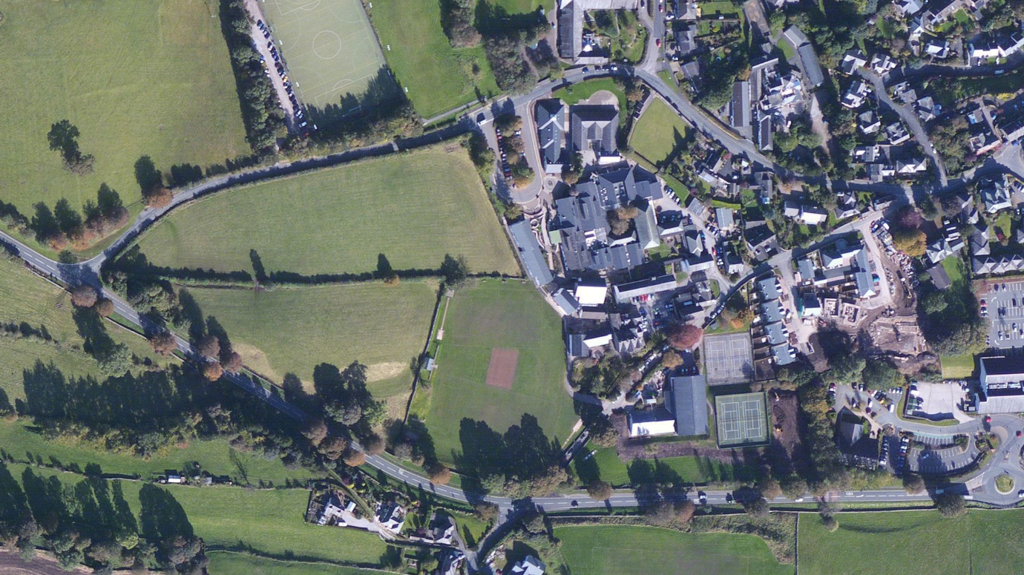

This is the image of the main school site. Again, this image is sourced from Zoom Earth (DigitalGlobe, CNES, Airbus, Microsoft Corporation, 2017).

## 2. Manipulating shapes defined by coordinates

### 2.0 Description of process

I am now going to create classes that allow me to create instances of vertices (or a vertex), a single point, or a shape, which will be an ordered collection of vertices.

I should then be able to rotate and translate these shapes.

I should also be able to find the longest edge and be able to rotate the shape nicely to sit flat with its longest line along the x-axis and its left most point on the y-axis.

I am deciding to split this into two parts since I will be making two classes, my first class will be a vertex class and the second will then be the shape class. I can only work on the shape class when the vertex class is done, so I will make the vertex class and test it first.

### 2.1 The vertex class

A vertex is defined as:

A point where two or more line segments meet. A corner. (Pierce, Definition of Vertex, 2017)

So this means I can use this class to make shapes.

I am going to have my primary data structure as a vertex class. This will simply store an x and y coordinate for the position of a point. This point may be used to make up the corners of the boundary edge of the car park.

#### 2.1.1 Data Dictionary

|  |  |  |  |
| --- | --- | --- | --- |
| Data Name | Data Type | Default Value | Description |
| x  (self.x) | A floating point number | None (a null value) | This is going to be the x coordinate of the vertex, it needs to be floating point so that rotation works properly. |
| y  (self.y) | A floating point number | None (a null value) | This is going to be the y coordinate of the vertex |

#### 2.1.2 Class Subroutines

Some cells are merged if the same text applies to both as it looks nicer and saves confusion.

|  |  |  |  |  |
| --- | --- | --- | --- | --- |
| Number | Name | Input | Process/Purpose | Storage/Output |
| 1 | __init__ | x is optional, y is optional | The instance of the class is initialised | |
| 2 | getX | None | So that the user can have access to reading the x value of the vertex | Will return the value of x from the vertex instance. |
| 3 | getY | None | So that the user can have access to reading the y value of the vertex | Will return the value of y from the vertex instance. |
| 4 | getCoordinates | None | To return the coordinates as a tuple to the user | Will return the x coordinate and the y coordinate as a tuple, with x first then y. |
| 5 | setX | x | Will set the x coordinate to the number supplied | This value will be stored in the vertex instance |
| 6 | setY | y | Will set the y coordinate to the number supplied | This value will be stored in the vertex instance |
| 7 | setXY | A tuple containing x and y | Will call setX and setY with the x and y coordinates given | None |
| 8 | rotateAbout  AnotherVertex | A vertex instance which is to be the center of rotation, the angle to rotate in radians | Using an equasion I put together from my maths work in school I am able to rotate a point (the vertex) about another point (the one that was given as input). | The new position of the vertex is stored using the self.setXY routine. |
| 9 | translateXY | A tuple containing x and y | The values of x and y will be added to the vertex’s current values and then set as the new x and y | The new x and y are set using self.setX and self.setY routines. |

#### 2.1.3 Test Plan

|  |  |  |  |
| --- | --- | --- | --- |
| Number | Type and Reason | Action | Expected Result |
| 1 | NORMAL: Test that an instance of a vertex class can be created | User will enter the following in the command line: “myVertex = vertex()”, “print myVertex” | The user should be told that there is an instance of a vertex class at a certain memory location, the memory location does not matter. |
| 2 | NORMAL: Test that an instance of vertex can be created, and its coordinates can be set at the same time | For testing a standard vertex will have the coordinates x = 2 and y = 1. From the command line the user will enter: “myVertex = vertex(2,1)”, ”print myVertex.getCoordinates()” | “[2,1]” will be printed |
| 3 | NORMAL: Test that the getX routine works | From the command line the user will enter: “myVertex = vertex(2,1)”, ”print myVertex.getX()” | “2” will be printed |
| 4 | NORMAL: Test that the getY routine works | From the command line the user will enter: “myVertex = vertex(2,1)”, ”print myVertex.getY()” | “1” will be printed |
| 5 | NORMAL: Test that the getCoordinates routine works | From the command line the user will enter: “myVertex = vertex(2,1)”, ”print myVertex.getCoordinates()” | “[2,1]” will be printed |
| 6 | NORMAL: test that the setX routine works | From the command line the user will enter: “myVertex = vertex(2,1)”,  ”print myVertex.getCoordinates()”,  “myVertex.setX(5)”,  “print myVertex.getCoordinates()” | “[2,1]  [5,1]” will be printed |
| 7 | NORMAL: test that the setY routine works | From the command line the user will enter: “myVertex = vertex(2,1)”,  ”print myVertex.getCoordinates()”,  “myVertex.setY(5)”,  “print myVertex.getCoordinates()” | “[2,1]  [2,5]” will be printed |
| 8 | NORMAL: test that the setXY routine works | From the command line the user will enter: “myVertex = vertex(2,1)”,  ”print myVertex.getCoordinates()”,  “myVertex.setXY([4,5])”,  “print myVertex.getCoordinates()” | “[2,1]  [4,5]” will be printed |
| 9 | NORMAL: test that the rotateAboutAnotherVertex routine works about the origin | The user will create two vertices and then call for one to rotate 90° (pi/2 radians) around the other. From the command line the user will enter: “myVertex = vertex(2,1)”, “origin = vertex(0,0)”,  ”myVertex. rotateAboutAnotherVertex(origin,(math.pi/2))”,  “print myVertex.getCoordinates()” | The coordinate will have been rotated 90°.  “[1,-2]” will be printed |
| 10 | NORMAL: test that the rotateAboutAnotherVertex routine works about another position | The user will create two vertices and then call for one to rotate 270° (3pi/2 radians) around the other. | The vertex will have the correct position for the rotation. |
| 11 | BOUNDARY: test how accurate rotation is by rotating a set amount and then the same but negative to see how much the two values changed. | The user will create two vertices, one being the origin. They will then rotate their vertex 86° about the origin followed by -86° about the origin. | The original coordinates should be outputted. |
| 12 | NORMAL: test that the translateXY | Make a vertex with coordinates (2,1), translate it by (4,7) | The new vertex position should be (6,8) |
| 13 | ERRONEOUS: check that setX and setY error checking works. | Try setting X and Y positions as: “A”, ”@”, ”.” And ” ” | An error message should be told to the user |
| 14 | ERRONEOUS: check that setXY error checking works | Test using the following: “[A,B]”, ”[1]”, “[5,@]” | Each time the user should be told the appropriate error message |
| 15 | ERRONEOUS: check that rotation error checking works with the center of rotation | Try to rotate using a non vertex as the center of rotation, such as “[0,0]” | The user should be given an appropriate error message. |
| 16 | ERRONEOUS: check that rotation error checking works with the angle | Try to rotate using “ten” as the rotation amount, an error message should be given | The user should be given an appropriate error message. |
| 17 | ERRONEOUS: check that translation error checking works | Try to translate a vertex with something other than a tuple of numbers, such as “twenty” | The user should be given an appropriate error message. |
| 18 | ERRONEOUS: check that error checking works when initialising a vertex instance and setting coordinates straight away. | Try initialising a vertex with “’eight’,’ten’” | The user should be given an appropriate error message and the vertex should be created anyway with None values as the locations. |

#### 2.1.4 Implementation

From class I know how to make classes. When the vertex is instantiated, it will be set the x and y values as either valid values or as None values.

#### 2.1.5 Programming the solution

##### 2.1.5.1 First Attempt

I have decided that there was no point programming most of the validation that I originally thought would be necessary as the user will never be able to enter numbers directly as vertex points, it will all be captured by clicking on a picture.

I have also negated to include validation for the rotation and translation routines as these will never be done by the user, only I will use them to rotate and translate the car park.

###### 2.1.5.1.1 Code

import math

#-------------------------------------------------------------------------------

# Defining a vertex class. This is just a point. (Plural = vertices)

#-------------------------------------------------------------------------------

class vertex():

def __init__(self,x = None, y = None):

if (bool(x == None) != bool(y == None)): #if just one of them is a None value they will both be set as None values

self.x = None

self.y = None

print "Both x and y were set as None, since only one was a None value"

elif x == None and y == None:

self.x = None

self.y = None

else:

try:

self.x = float(x)

self.y = float(y)

except:

print "there was an error changing the x or y to float values, check what was inputted"

print "they have both been set as None Values"

self.x = None

self.y = None

def getX(self):

return self.x

def getY(self):

return self.y

def getCoordinates(self):

return [self.x,self.y]

def setX(self,x):

self.x = round(float(x),5)

# the round function removes uneeded accuracy that could cause problems

def setY(self,y):

self.y = round(float(y),5)

def setXY(self,both): #both will become the standard name for a tuple of an X and Y coordinate

self.setX(both[0])

self.setY(both[1])

def rotateAboutAnotherVertex(self,about,angle): #the position it rotates clockwise about will be passed in as a vertex class.

#the angle will be given in radians

#print "angle", angle

angle = -angle #I realised the matrix i used was to rotate anticlockwise, so this fixes that problem.

newX = (self.x-about.x)*(math.cos(angle)) - (self.y-about.y)*(math.sin(angle)) + about.x

newY = (self.y-about.y)*(math.cos(angle)) + (self.x-about.x)*(math.sin(angle)) + about.y

self.setXY([newX,newY])

def translateXY(self,translationXY): #translation should be passed in the form [X,Y]

self.setX(self.x + translationXY[0])

self.setY(self.y + translationXY[1])

###### 2.1.5.1.2 Testing

For nicer formatting I have removed the Reason column from this test plan, although for reference the test numbers coincide with that of my previous test plan.

Again, all images that are on new rows relate as evidence to the previous test.

|  |  |  |  |  |
| --- | --- | --- | --- | --- |
| Number | Action | Expected Result | Actual Result | Changes to be made |
| 1 | User will enter the following in the command line: “myVertex = vertex()”, “print myVertex” | The user should be told that there is an instance of a vertex class at a certain memory location, the memory location does not matter. | The expected result was achieved. | None |
|  | | | |
| 2 | For testing a standard vertex will have the coordinates x = 2 and y = 1. From the command line the user will enter: “myVertex = vertex(2,1)”, ”print myVertex.getCoordinates()” | “[2,1]” will be printed | The expected result was achieved, except that it was “[2.0,1.0]” because they are floating point numbers. | None |
|  | | | |
| 3 | From the command line the user will enter: “myVertex = vertex(2,1)”, ”print myVertex.getX()” | “2” will be printed | (I did not re-assign the myVertex as I had just already assigned it)  I got the expected result. | None |
|  | | | |
| 4 | From the command line the user will enter: “myVertex = vertex(2,1)”, ”print myVertex.getY()” | “1” will be printed | I got the expected result. | None |
|  | | | |
| 5 | From the command line the user will enter: “myVertex = vertex(2,1)”, ”print myVertex.getCoordinates()” | “[2,1]” will be printed | The expected result was achieved, except that it was “[2.0,1.0]” because they are floating point numbers. | None |
|  | | | |
| 6 | From the command line the user will enter: “myVertex = vertex(2,1)”,  ”print myVertex.getCoordinates()”,  “myVertex.setX(5)”,  “print myVertex.getCoordinates()” | “[2,1]  [5,1]” will be printed | I got the expected result. | None |
|  | | | |
| 7.1 | From the command line the user will enter: “myVertex = vertex(2,1)”,  ”print myVertex.getCoordinates()”,  “myVertex.setY(5)”,  “print myVertex.getCoordinates()” | “[2,1]  [2,5]” will be printed | There was an error in my code that meant the value could not be set, I have highlighted it below. | I have changed the uppercase Y to a lower case y. |
| Here was the error:    I have changed it to this: | | | |
| 7.2 | From the command line the user will enter: “myVertex = vertex(2,1)”,  ”print myVertex.getCoordinates()”,  “myVertex.setY(5)”,  “print myVertex.getCoordinates()” | “[2,1]  [2,5]” will be printed | I achieved the expected result. | None |
|  | | | |
| 8 | From the command line the user will enter: “myVertex = vertex(2,1)”,  ”print myVertex.getCoordinates()”,  “myVertex.setXY([4,5])”,  “print myVertex.getCoordinates()” | “[2,1]  [4,5]” will be printed | I got the expected result. | None |
|  | | | |
| 9 | The user will create two vertices and then call for one to rotate 90° (pi/2 radians) around the other. From the command line the user will enter: “myVertex = vertex(2,1)”, “origin = vertex(0,0)”,  ”myVertex. rotateAboutAnotherVertex(origin,(math.pi/2))”,  “print myVertex.getCoordinates()” | The coordinate will have been rotated 90°.  “[1,-2]” will be printed | I got the expected result. | None |
|  | | | |
| 10.1 | The user will create two vertices and then call for one to rotate 270° (3pi/2 radians) around the other. | The vertex will have the correct position for the rotation.  I will be using (2,1) as the vertex to rotate and I will rotate it around (2,0) so my vertex’s new position should be (1,0). | I got the expected result, with a little bit of a surprise…  Python is not entirely accurate and ended up with the numbers pretty much right but not exactly, e.g instead of 0 it was negative 0.00000000000000018369701… | Because the difference in the numbers is so small it should not make a difference to the program. But I am actually going to change it to be accurate to only 5 decimal places, so I will test this again… |
| Original:    New with limit of 5 decimal places: | | | |
| 10.2 | The user will create two vertices and then call for one to rotate 270° (3pi/2 radians) around the other. | The vertex will have the correct position for the rotation.  I will be using (2,1) as the vertex to rotate and I will rotate it around (2,0) so my vertex’s new position should be (1,0). | I got the expected result. | None |
|  | | | |
| 11 | The user will create two vertices, one being the origin. They will then rotate their vertex 86° about the origin followed by -86° about the origin. | The original coordinates should be outputted.  I am going to use (43.43,787.123) as the original coordinates.  86° = pi*86/180 radians  -86° = pi*-86/180 radians | I got the expected result, showing that my code is accurate enough. | None |
|  | | | |
| 12 | Make a vertex with coordinates (2,1), translate it by (4,7) | The new vertex position should be (6,8) | I got the expected result | None |
|  | | | |
|  |  |  |  |  |

I did not do the remaining tests since I did not need to implement error checking.

### 2.2 The shape class

A shape is defined as:

The form of an object - how it is laid out in space (not what it is made of, or where it is). (Pierce, Definition of Shape, 2017)

A shape will be an ordered collection of vertices.

#### 2.2.1 Data Dictionary

|  |  |  |  |
| --- | --- | --- | --- |
| Data Name | Data Type | Default Value | Description |
| vertices  (self.vertices) | A list  It is an array of vertices | []  An empty list | This is going to contain all the vertices of the shape, in order. |

#### 2.2.2 Class Subroutines

Some cells are merged if the same text applies to both as it looks nicer and saves confusion.

|  |  |  |  |  |
| --- | --- | --- | --- | --- |
| Number | Name | Input | Process/Purpose | Storage/Output |
| 1 | __init__ | None | The instance of the class is initialised | |
| 2 | addVertex | A vertex instance | Will add this vertex instance to the list vertices | |
| 3 | addVerticesXY | A list of tuples of x,y coordinates | Will go through the list and separate each tuple and for each add it to the list of vertices | |
| 4 | getVertices | None | Will return the list of vertices | |
| 5 | getVerticesCoordinates | None | Will go through the list of vertices, and for each vertex it will add it’s coordinates to the list of coordinates as a tuple | It will return this list |
| 6 | getDistanceToNextVertex | vertexNumber (a integer number) | It will find the distance from this specified vertex to the next one. | It will return this distance or a None value if there was an error, alongside an error message. |
| 7 | getLongestSide | None | Will find the longest side | Will return the number of which the first vertex is of the longest side. |
| 8 | rotateAboutAVertex | A vertex to rotate about, the angle to rotate in radians | For each vertex in the shape it will call rotateAboutAnotherVertex with the correct parameters | The new positions will be stored in the existing vertices. |
| 9 | translateXY | A tuple with the x,y to translate | For each vertex in the shape it will call translateXY with the correct parameters | The new positions will be stored in the existing vertices. |
| 10 | makeLongestSideFlat | None | Will make the longest side of the shape sit flat with 0 gradient through calling makeSideAfterVertexFlat combined with getLongestSide. | The new positions will be stored in the existing vertices. |
| 11 | makeSideAfterVertexFlat | The vertex number | Will make the side after this vertex sit flat and have a gradient of 0 through rotating the entire shape. | The new positions will be stored in the existing vertices. |
| 12 | translateShapeToFitNicely | None | This will translate the shape so that the longest side sits on the x axis and the furthest left vertex sits on the y axis. | The new positions will be stored in the existing vertices. |
| 13 | getFurthestLeftVertex | None | Will find the vertex that is furthest left | Will return the vertex that is furthest left |

#### 2.2.3 Test Plan

I have decided that I will make a menu system for testing this time, since it will make it much easier than testing in the command line with commands.

|  |  |  |  |
| --- | --- | --- | --- |
| Number | Type and Reason | Action | Expected Result |
| 1 | NORMAL: Test that a shape can be made | Make a shape and print it to check it exists as an instance | The user will be told that an instance of a shape exists at a memory location. |
| 2 | NORMAL: Test I can add one vertex to a shape and that I can see which vertices are in a shape | Add the vertex (2,1) and then check that it is there | I will be told that a vertex exists with the coordinates (2,1) |
| 3 | BOUNDARY: Test I can add multiple vertices at once to a shape (I don’t imagine I would use this later in my code so it is optional) | Try adding multiple vertices and check they are there by printing them | I will be told that the vertices exist with the coordinates I chose. |
| 4 | NORMAL: Check I can rotate the shape about the origin | Add some vertices to a shape, then rotate it about the origin. Use an online tool to visually check that it rotated them to the correct place. | I will see that the object was rotated the correct amount about the origin. |
| 5 | NORMAL: check that I can rotate the shape about a vertex other than the origin | Get a shape with multiple vertices and rotate it about one if its vertices, again use an online graphing tool to check that it was rotated correctly. | I will see that the object was rotated correctly |
| 6 | NORMAL: check that translating a shape works correctly | Get a shape with more than one vertex and translate it to check all vertices are translated | I will see that it was translated correctly, by looking at the new positions |
| 7 | NORMAL: Check it prints the longest side number correctly | Make a triangle shape for which I know which side is the longest and get the program to tell me which is the longest side. | I should be told the correct side |
| 8 | NORMAL: Check it prints the longest side number correctly when the longest side is the last side | Make a triangle for which the program should output the longest side as being the side for which it has to compare the vertices at the start and end of the list to check that it works properly | I should be told the correct side |
| 9 | NORMAL: Make the longest side of a shape sit flat | Make a shape with 5 sides where none of the sides are parallel to the x-axis and get the program to make the longest side sit flat | I should use an online plotter to check compare with the original shape that it rotated properly. |
| 10 | NORMAL: Test translating a shape to fit nicely | Translate any shape that contains more than two vertices to fit nicely | Use an online plotter to check that the longest side touches the x-axis and that the shape touches the y-axis but does not go any further left. |
| 11 | NORMAL: Test getting distance to next vertex from the first vertex to the next | Have a shape with more than two vertices, ask for the distance after the first vertex to the next.  Print the vertex positions to be able to calculate by hand the correct distance. | The correct distance will be shown, I should also calculate this to check it is correct. |
| 12 | BOUNDARY: Test getting the distance from the last vertex in a shape | Have a shape with more than two vertices, ask for the distance after the last vertex to the next.  Print the vertex positions to be able to calculate by hand the correct distance. | The correct distance will be shown, I should also calculate this to check it is correct. |
|  |  |  |  |
|  |  |  |  |
|  |  |  |  |

#### 2.2.5 Programming the solution

###### 2.2.5.1 First attempt

2.2.5.1.1 Code

2.2.5.1.1.1 Menu for testing Code

#-------------------------------------------------------------------------------

# Main Menu definition

#-------------------------------------------------------------------------------

menuText ="""

Welcome to the car park layout generator program.

1. Make new empty shape

2. Add vertices to shape

3. Print shape vertices

4. Rotate shape about origin

5. Rotate shape about a vertex

6. Translate shape

7. Print longest side number of shape

8. Make longest side sit flat

9. translateShapeToFitNicely

10. getDistanceToNextVertex

"""

def mainMenu(menuText):

repeatMenu = True

myShape = shape()

origin = vertex(0,0)

while repeatMenu == True:

print menuText

menuChoice = askMenuChoice(["1","2","3","4","5","6","7","8","9","10",”11”])

if menuChoice == "1":

myShape = shape()

elif menuChoice == "2":

try:

myShape.addVerticesXY(getListOfListOfXY())

except:

print "there was an error adding those vertices"

elif menuChoice == "3":

print myShape.getVerticesCoordinates()

elif menuChoice == "4":

myShape.rotateAboutAVertex(origin,getAngle())

elif menuChoice == "5":

myShape.rotateAboutAVertex(myShape.getVertices()[getVertexNumber()],getAngle())

elif menuChoice == "6":

myShape.translateXY(getXY())

elif menuChoice == "7":

print myShape.getLongestSide()

elif menuChoice == "8":

myShape.makeLongestSideFlat()

elif menuChoice == "9":

myShape.translateShapeToFitNicely()

elif menuChoice == "10":

print myShape.getDistanceToNextVertex(getVertexNumber())

elif menuChoice == "11":

return

else:

print "invalid menu choice"

def askMenuChoice(acceptedChoices,stringToAsk = "Please enter your menu choice: ",errorMessage = "Sorry, that is not an accepted answer, please try again."):

menuChoice = ""

while menuChoice not in acceptedChoices or menuChoice == "":

menuChoice = raw_input(stringToAsk)

if menuChoice not in acceptedChoices:

print errorMessage

return menuChoice

def getXY():

return [float(raw_input("Enter the value for x: ")),float(raw_input("Enter the value for y: "))]

def getAngle():

return toRadians(float(raw_input("enter how many degrees to rotate the shape clockwise: ")))

def toRadians(degrees):

return degrees*((2*math.pi)/360)

def getVertexNumber():

return int(raw_input("enter a vertex number (they start at 0): "))

def getListOfListOfXY():

verticesXY = [[]]

commaCount = 0

stringOfVertices = raw_input("enter your coords in the following way 'x1,y1,x2,y2,x3,y3...': ")

currentItem = ""

for eachChar in stringOfVertices: #this will add anything but not including the last number to the list

#print "char: " + eachChar

if eachChar == ",":

commaCount += 1

#print commaCount

#print (commaCount-1)/2

#print verticesXY

#print verticesXY[(commaCount-1)/2]

verticesXY[(commaCount-1)/2].append(int(currentItem))

if commaCount%2 == 0:

verticesXY.append([])

#print "new XY space added"

#print verticesXY[(commaCount-1)/2]

#print ""

currentItem = ""

else:

currentItem = currentItem + eachChar

verticesXY[(commaCount-1)/2].append(int(currentItem)) #this adds the final number, it was not added before as there is no comma after it

#print verticesXY

return verticesXY

2.2.5.1.1.2 Vertex and Shape code

import math

#-------------------------------------------------------------------------------

# Defining a vertex class. This is just a point. (Plural = vertices)

#-------------------------------------------------------------------------------

class vertex():

def __init__(self,x = None, y = None):

if (bool(x == None) != bool(y == None)): #if just one of them is a None value they will both be set as None values

self.x = None

self.y = None

print "Both x and y were set as None, since only one was a None value"

elif x == None and y == None:

self.x = None

self.y = None

else:

try:

self.x = float(x)

self.y = float(y)

except:

print "there was an error changing the x or y to float values, check what was inputted"

print "they have both been set as None Values"

self.x = None

self.y = None

def getX(self):

return self.x

def getY(self):

return self.y

def getCoordinates(self):

return [self.x,self.y]

def setX(self,x):

self.x = round(float(x),5)

# the round function removes uneeded accuracy that could cause problems

def setY(self,y):

self.y = round(float(y),5)

def setXY(self,both): #both will become the standard name for a tuple of an X and Y coordinate

self.setX(both[0])

self.setY(both[1])

def rotateAboutAnotherVertex(self,about,angle): #the position it rotates clockwise about will be passed in as a vertex class.

#the angle will be given in radians

#print "angle", angle

angle = -angle #I realised the matrix i used was to rotate anticlockwise, so this fixes that problem.

newX = (self.x-about.x)*(math.cos(angle)) - (self.y-about.y)*(math.sin(angle)) + about.x

newY = (self.y-about.y)*(math.cos(angle)) + (self.x-about.x)*(math.sin(angle)) + about.y

self.setXY([newX,newY])

def translateXY(self,translationXY): #translation should be passed in the form [X,Y]

self.setX(self.x + translationXY[0])

self.setY(self.y + translationXY[1])

#-------------------------------------------------------------------------------

# Defining a shape class.

# This is just a collection of vertices in a specific order.

#-------------------------------------------------------------------------------

class shape():

def __init__(self):

self.vertices = []

def addVertex(self,vertex):

self.vertices.append(vertex)

def addVerticesXY(self,verticesXY): #vertices should be as lists within lists

for each in verticesXY:

temp = vertex()

temp.setXY(each)

self.addVertex(temp)

def getVertices(self):

return self.vertices

def getVerticesCoordinates(self):

listOfCoordinates = []

for eachVertex in self.vertices:

listOfCoordinates.append(eachVertex.getCoordinates())

return listOfCoordinates

def getDistanceToNextVertex(self,vertexNumber): #will return the first vertex from the longest line.

if len(self.vertices) < vertexNumber: #checks the vertex will exist

print "Error, vertex does not exist"

elif len(self.vertices) < 2:

print "Error, not enough vertices to find distance"

else:

vertex1 = self.vertices[vertexNumber]

vertex2 = self.vertices[(vertexNumber+1)%(len(self.vertices))]

differenceInX = vertex1.getX() - vertex2.getX()

differenceInY = vertex1.getY() - vertex2.getY()

distance = math.sqrt( differenceInX**2 + differenceInY**2 )

return distance

return None #if the distance was not retuned it will return a null value

def getLongestSide(self): #will return the first vertex from the longest line.

longestVertextNumber = None

if len(self.vertices) < 2:

print "Error, not enough vertices to find distance"

elif len(self.vertices) == 2:

longestVertextNumber = 0

else:

longestVertextNumber = 0

for count in range(len(self.vertices)):

if self.getDistanceToNextVertex(count) > self.getDistanceToNextVertex(longestVertextNumber):

longestVertextNumber = count

return longestVertextNumber #will return the number of the first vertex of the longest edge of the shape.

def rotateAboutAVertex(self,about,angle):

for eachVertex in self.vertices:

eachVertex.rotateAboutAnotherVertex(about,angle)

def translateXY(self,translationXY):

for eachVertex in self.vertices:

eachVertex.translateXY(translationXY)

def makeLongestSideFlat(self):

self.makeSideAfterVertexFlat(self.vertices[self.getLongestSide()])

def makeSideAfterVertexFlat(self,vertex1):

for count in range(len(self.vertices)):

if self.vertices[count] == vertex1:

vertex2 = self.vertices[(count+1)%(len(self.vertices))]

differenceInX = float(float(vertex1.getX()) - float(vertex2.getX())) # I needed to add in these float bit so that the devision later is not floor devision.

differenceInY = float(float(vertex1.getY()) - float(vertex2.getY()))

print "X:",differenceInX

print "Y:",differenceInY

angle = (math.atan((differenceInY)/(differenceInX))) #this finds the angle from horizonal of the line connecting the first vertex to the next

#when we have this anlgle, we can turn the entire shape by the same angle rotating about

print "angle:",angle

self.rotateAboutAVertex(vertex1,angle) #the first vertex in order to make this side lay flat.

def translateShapeToFitNicely(self): #this will get the longest side along the x axis after it has been rotated and the furthest left vertex to be on the y axis.

longestVertexNumber = self.getLongestSide()

furthestLeftVertex = self.getFurthestLeftVertex()

tranlationXY = [(-(furthestLeftVertex.getX())),(-(self.vertices[longestVertexNumber].getY()))]

self.translateXY(tranlationXY)

def getFurthestLeftVertex(self):

furthestLeftVertex = self.vertices[0]

for each in self.vertices:

if each.getX < furthestLeftVertex.getX:

furthestLeftVertex = each

return furthestLeftVertex

2.2.5.1.2 Testing

|  |  |  |  |  |
| --- | --- | --- | --- | --- |
| Number | Action | Expected Result | Actual Result | Changes to be made |
| 1 | Make a shape and print it to check it exists as an instance | The user will be told that an instance of a shape exists at a memory location. | Expected result was achieved | None |
|  | | | |
| 2 | Add the vertex (2,1) and then check that it is there | I will be told that a vertex exists with the coordinates (2,1) | Expected result was achieved | None |
|  | | | |
| 3 | Try adding multiple vertices and check they are there by printing them | I will be told that the vertices exist with the coordinates I chose. | I achieved the expected result | None |
| For saving space in the document I have missed out of the screenshot where it asks me for a menu input. | | | |
| 4 | Add some vertices to a shape, then rotate it about the origin. Use an online tool to visually check that it rotated them to the correct place. | I will see that the object was rotated the correct amount about the origin. | I rotated the triangle I already had entered 270° about the origin, as expected. I used an online plotter (Discovery Education, 2013) to check, as can be see below. | None |
| Original points:    Rotating 270° clockwise:    New points:    Original points plotted:    New points plotted with my annotation showing the rotation: | | | |
| 5 | Get a shape with multiple vertices and rotate it about one if its vertices, again use an online graphing tool to check that it was rotated correctly.  I will use a triangle with points (2,1)(5,1)(5,5) and I will rotate it 90° about its 2nd vertex. | I will see that the object was rotated correctly. | I achieved the expected result | None |
| Original vertex positions:    Rotating:    New vertex positions:      I have circled the vertex that stayed stationary and shown the rotation above. | | | |
| 6 | Get a shape with more than one vertex and translate it to check all vertices are translated | I will see that it was translated correctly, by looking at the new positions | The expected result was achieved | None |
| Original vertex positions:      Command:    New vertex positions:      The red dot and green path shows that the translation was followed correctly. | | | |
| 7 | Make a triangle shape for which I know which side is the longest and get the program to tell me which is the longest side.  I will use a triangle with points (5,5) (2,1)(5,1) and I know its longest side is the first. | I should be told the correct side | the expected result was achieved | none |
|  | | | |
| 8 | Make a triangle for which the program should output the longest side as being the side for which it has to compare the vertices at the start and end of the list to check that it works properly.  I will use a triangle with points (2,1)(5,1)(5,5) and I know the longest side is the last. | I should be told the correct side | the expected result was achieved | none |
|  | | | |
| 9.1 | Make a shape with 5 sides where none of the sides are parallel to the x-axis and get the program to make the longest side sit flat.  I am going to use a shape with vertices:  (2,0), (4,1), (4,4), (2,3), (1,1) | I should use an online plotter to check compare with the original shape that it rotated properly. | I was met with an error where the program could not find the angle to rotate because it could not divide by 0 to use tan to find the angle. | I will add some code to get around this problem. |
| X shows that the difference in x was 0    Old code:    New code: | | | |
| 9.2 | Make a shape with 5 sides where none of the sides are parallel to the x-axis and get the program to make the longest side sit flat.  I am going to use a shape with vertices:  (2,0), (4,1), (4,4), (2,3), (1,1) | I should use an online plotter to check compare with the original shape that it rotated properly. | I got the expected results this time, as can be seen below in the evidence provided. | None |
| As you can see the angle of pi/2 rads was used this time    Original vertex positions:    New vertex positions:    As you can see, the longest side now sits flat. | | | |
| 10 | Translate any shape that contains more than two vertices to fit nicely | Use an online plotter to check that the longest side touches the x-axis and that the shape touches the y-axis but does not go any further left. | I got the expected result | None |
| Original vertex positions:      Command:    New vertex positions: | | | |
| 11 | Have a shape with more than two vertices, ask for the distance after the first vertex to the next.  Print the vertex positions to be able to calculate by hand the correct distance. | The correct distance will be shown, I should also calculate this to check it is correct.  I used an online calculator called Mathway (Mathway, 2018) for easy screenshotting. | I achieved the expected result | None |
|  | | | |
| 12 | Have a shape with more than two vertices, ask for the distance after the last vertex to the next.  Print the vertex positions to be able to calculate by hand the correct distance. | The correct distance will be shown, I should also calculate this to check it is correct.  I used an online calculator called Mathway (Mathway, 2018) for easy screenshotting. | I achieved the expected result | None |
|  | | | |
|  |  |  |  |  |
|  |  |  |  |  |

I have realised there might be an issue of sometimes when I rotate a shape to have the longest side sit flat, that it may be the case that it rotates to be upside down compared to where I want it to be. This is not a problem, I just need to factor this in for the next stage when I apply the tile and trim algorithm.

## 3. Applying the tile and trim algorithm.

### 3.0 Description of what I am about to do.

I am now going to be working with the assumption that the points I have for the car park size are all in metres.

I need to first plan this algorithm in pseudo code and draw out some examples of car parks and car parking spaces.

The tile and trim algorithm implements the use of several ‘standard’ layout tiles and can place many together to form a car park. I am going to use tiles that have a road running down the middle and car parking spaces on either side. The idea is that each tile is very efficient on its own.

### 3.1 Table of input, process, storage and output

|  |  |  |  |
| --- | --- | --- | --- |
| Input | Process | Storage | Output |
| Into this process will be passed the values in metres of the boundary of the car park, it will already have been rotated and translated so that it’s longest side sits on the x-axis and the furthest left vertex sits on the y- axis. I need to consider that it could have vertices both above and below the x-axis. | This part of the program will add the car park tiles to the car park in a way that that every car park space can be accessed by a road. I will be using the tile and trim algorithm for this process. | The program will store the finalised shape as a file after it has generated the car park. | It will output the new collection of shapes to the GUI.  For my testing of this stage it will just print it in a way I can read and understand. |

### 3.2 Data dictionary

I am going to use a dictionary to contain the different types of standard tiles.

### 3.3 Pseudo code and diagrams

#### 3.3.1 Diagram for size of spaces

From my research I have found the standard sizes of car parking spaces as well as the road widths. Below you can see some of the standard space designs I have made:

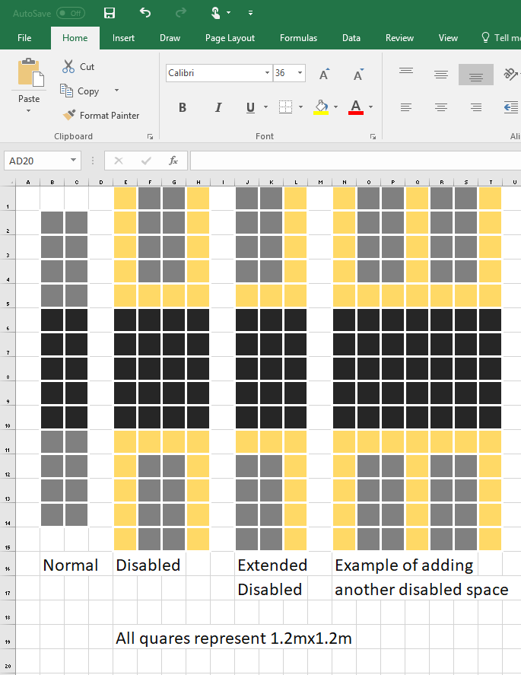

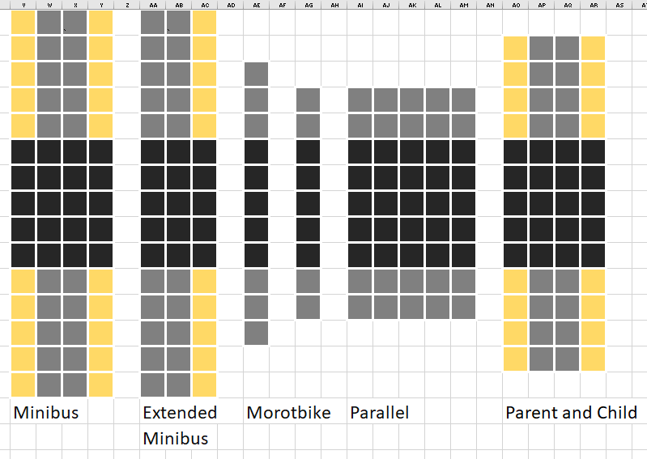

For these examples I have used the standard 6m road width, with the standard 2.4m wide and 4.8m deep spaces. The yellow around some of the spaces shows the extra space required for some vehicles. The black is the road, and the grey shows the car parking space itself.

It may be useful that both disabled spaces and minibus spaces are the same size.

#### 3.3.2 Pseudo Code

##### 3.3.2.1 Pseudo code for how to place tiles

After trying the car park problem on paper, I came up with this simple algorithm that should work for car parks where all coordinates are positive.

nextPositionToTry = furthest left point of longest line

thereIsSpace = TRUE

WHILE thereIsSpace = TRUE DO:

Check that there is space to put a car park tile

IF there is space DO:

Place the car park tile using bottom left corner

nextPositionToTry = bottom right of car park tile

add top left of car park tile to queue positionsToTry

ELSE:

nextPositionToTry = pop from queue positionsToTry

##### 3.3.2.2 Expanding on how to see if placing a car park tile is valid

To see if a tile placing is valid, I want to be able to check that all four corners of the tile are within the car park boundary shape.

###### 3.3.2.2.1 Ray casting algorithm

After being completely confused about this problem I did some research and found that there are two main algorithms that can be used to find if a point is within a shape. These are called the Winding number algorithm (Revision history statistics, 2017) and the Ray casting algorithm (GeeksforGeeks, n.d.).

I have chosen to use the ray casting algorithm as it is the most popular and least complicated algorithm of the two. I have also found there are a few python modules that I can use to do this for me, which could save a lot of headache!

The ray casting algorithm works on a principle show below. If you fire out an imaginary ray from the point in any direction, the number of times it intersects the shape boundary shows you if it is within or outside the shape.

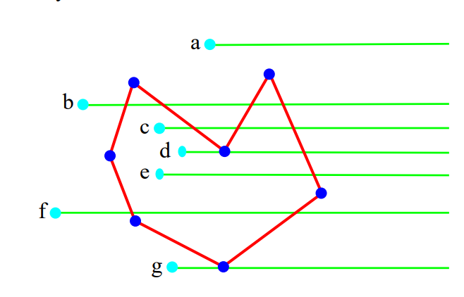 (University of Glasgow, 2000)

If the ray intersects the shape an odd number of times it is within the shape. There is an exception for the corners of the shape, so basically those intersections are ignored.

The python module I will use is called Shapely (Gillies, 2013) and I have found useful documentation (Tenkanen, 2017) for it for finding if a point is within a shape.

###### 3.3.2.2.2 Installing the Shapely module

I now had to find how to install Shapely. I had this link (Toblerity, 27) to the GitHub repository. From here I read the ReadMe file and found I had to install a python wheel, which is a compiled module. I was able to download the file from a website called ‘Unofficial Windows Binaries for Python Extension Packages’ (Christoph Gohlke, n.d.) where I downloaded the correct file for my system and python version ‘Shapely‑1.6.3‑cp27‑cp27m‑win_amd64.whl’. I then found how to install a python wheel from a python and pip user guide website (PyPA, The Python Software Foundation, 1).

I followed the guide:

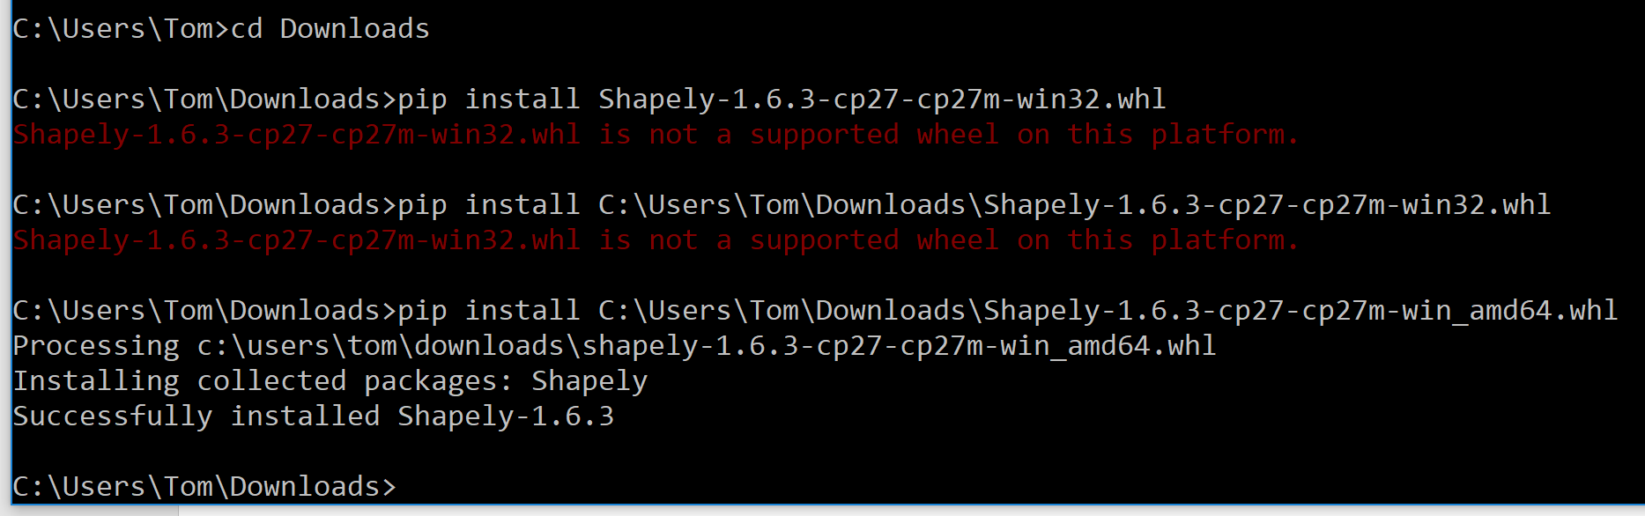

As you can see above, I started in the command line by changing directory to where I had downloaded the file. I then tried to install the wheel but realised I had downloaded the wrong file accidentally. After downloading the correct file I tried installing it and it installed this time with no errors.

For use in school, I emailed my teacher requesting for the python module to be installed in school.

###### 3.3.2.2.3 Pseudo code for finding if a tile is within the car park or not

outline = shape of outline of carpark

validPlacement = TRUE

FOR currentVertex = each vertex of the corners of the tile DO:

IF outline.contains(currentVertex) = FALSE THEN:

validPlacement = FALSE

RETURN validPlacement

###### 3.3.2.2.4 Test plan for using shapely

|  |  |  |  |
| --- | --- | --- | --- |
| Number | Type and reason | Action | Expected Result |
| 1 | NORMAL: I will test that a point outside of a shape is reported to be outside of the shape and check that shapely works with decimal coordinates | Make a shape that has vertices with coordinates: (1,1),(1,2),(2,2),(2,1)  Make a vertex with the position (0.5,0.5)  Ask the program if the vertex is in or out of the shape. | I will be told that the vertex is outside of the shape. |
| 2 | NORMAL: I will test that a point inside of a shape is reported to be inside of the shape | Make a shape that has vertices with coordinates: (1,1),(1,2),(2,2),(2,1)  Make a vertex with the position (1.5,1.75)  Ask the program if the vertex is in or out of the shape. | I will be told that the vertex is inside the shape. |
| 3 | BOUNDARY: I will test that a point that is on the boundary of a shape is still classed as being within the shape | Make a shape that has vertices with coordinates: (1,1),(1,2),(2,2),(2,1)  Make a vertex with the position (1.5,2)  Ask the program if the vertex is in or out of the shape. | I will be told that the vertex is inside the shape, even though it is on the boundary. |

###### 3.3.2.2.5 Python code for testing using shapely

#===============================================================================

# Testing if a Vertex is within the boundary of a Shape

#

# v1

#

#===============================================================================

import math

from myVertexandShapeClasses import * #this imports my vertex and shape classes

from shapely.geometry import Point, Polygon #this imports the required classes from shapely

#-------------------------------------------------------------------------------

# Defining the test to see if the Vertex is with the Shape

# I will be using the Shapely module

#-------------------------------------------------------------------------------

def testIfVertexIsWithinShape(shape,vertex):

shapelyShape = Polygon(shape.getVerticesCoordinates()) #creates an instance of a Shapely Polygon that is identicle to the shape inputted

shapelyPoint = Point(vertex.getCoordinates()) #creates an instance of a Shapely Point which is identicle to the vertex inputted

return shapelyShape.intersects(shapelyPoint) #tests and returns if the Point is within or on the boundary of the Polygon

###### 3.3.2.2.6 Testing my python code

|  |  |  |  |  |  |  |
| --- | --- | --- | --- | --- | --- | --- |
| Number | Action | Expected Result | | Actual Result | | Changes Needed |
| 1 | Make a shape that has vertices with coordinates: (1,1),(1,2),(2,2),(2,1)  Make a vertex with the position (0.5,0.5)  Ask the program if the vertex is in or out of the shape. | | I will be told that the vertex is outside of the shape. | I was told that is it False that the vertex is in the shape, so it is outside the shape. | | None. |
|  | | | | | |
| 2 | Make a shape that has vertices with coordinates: (1,1),(1,2),(2,2),(2,1)  Make a vertex with the position (1.5,1.75)  Ask the program if the vertex is in or out of the shape. | I will be told that the vertex is inside the shape. | | | I was told that is it True that the vertex is in the shape. | None. |
|  | | | | | |
| 3 | Make a shape that has vertices with coordinates: (1,1),(1,2),(2,2),(2,1)  Make a vertex with the position (1.5,2)  Ask the program if the vertex is in or out of the shape. | I will be told that the vertex is inside the shape, even though it is on the boundary. | | | Thankfully, I was told that is it True that the vertex is in the shape. | None! |
|  | | | | | |

### 3.5 Programming the tile and trim algorithm

#### 3.5.1 First stage, doing a basic, grid style tile and trim.

##### 3.5.1.1 Pseudo Code

get all points of edge of the car park

rotate so longest side is flat

translate so is closest to the origin but all positive coordinates

row-by-row place tiles (by adding them to a list), starting in bottom left

then make sure road works

##### 3.5.1.2 Test plan

I have decided to not test my code until I have made the Graphical User Interface. This is because it would be extremely difficult to comprehend the coordinates that the program outputs as the edges of car parking spaces.

##### 3.5.1.3 Python Code

def tileAndTrim(carParkShape,tiles,listOFTuplesOfNamesOfTilesInListAndHowManyOfEach):

print "Starting tile and trim"

fill = False

carParkFull = False

bottomLeftVertex = vertex(0,0)

placedTiles = []

furthestRightVertex = carParkShape.getFurthestRightVertex()

print "furthest right: " + str(furthestRightVertex.getCoordinates())

furthestUpVertex = carParkShape.getFurthestUpVertex()

for count in range(len(listOFTuplesOfNamesOfTilesInListAndHowManyOfEach)):

tileLabel = listOFTuplesOfNamesOfTilesInListAndHowManyOfEach[count][0]

currentTile = tiles[tileLabel]

howMany = listOFTuplesOfNamesOfTilesInListAndHowManyOfEach[count][1]

howManyLeft = howMany

if count == (len(listOFTuplesOfNamesOfTilesInListAndHowManyOfEach) -1): #if it is final item i will fill car park with this tile

fill = True

while (howManyLeft > 0 or fill == True) and (carParkFull == False):

#print "-------"

print bottomLeftVertex.getCoordinates()

#we will start testing at 0,0 then move right, then move onto a new row up when the current layer has been filled.

#print "stub for placing the tile as a shape and testing if all of its vertices are within the car park shape"

#makeShapeFromTile

tileShape = makeShapeFromTile(bottomLeftVertex,tileLabel,tiles)

validTilePlacement = testIfOneShapeIsWithinAnotherShape(tileShape,carParkShape)

#print "stub for if tile was placed and is in boundary, add this shape to a list of car parking tiles created. Then reduce howManyLeft by 1."

if validTilePlacement:

print "valid " + tileLabel + " tile placement."

howManyLeft = howManyLeft - 1

placedTiles.append(tileShape)

bottomLeftVertex.translateXY([ tiles[tileLabel].getWidth() , 0 ]) #moved bottom left vertex to the right

#will see if bottom left vertex needs resetting

#print "stub for testing if placing x is out of range, will then move y up the right height and reset x"

if bottomLeftVertex.getX() > furthestRightVertex.getX():

#print "out of range"

bottomLeftVertex.setX(0)

#print bottomLeftVertex.getCoordinates()

bottomLeftVertex.translateXY([ 0 , tiles[tileLabel].getDepth() ]) #moved bottom left vertex up

#print "stub for testing if placing y is out of range, if y was just change, if it is filledCarPark will be set to True"

if bottomLeftVertex.getY() > furthestUpVertex.getY():

#print "Tried placing tiles in all spaces = true"

carParkFull = True

#print "in range: " + str(furthestRightVertex.getX())

if howManyLeft == 0:

#was sucessful

print "Placed all " + tileLabel + " spaces sucessfully"

if carParkFull:

print "Car park was filled. I filled it up with " + str(-howManyLeft) + " extra " + tileLabel + " spaces."

else:

print "car park was full and ran out of space to place what you wanted"

return placedTiles

##### 3.5.1.5 Conclusion

Now that I have this basic version working I will work on the Graphical User Interface so that I can more easily see the output from the tile and trim algorithm.

## 4. The Graphical User Interface

### 4.0 Description of process

The graphical user interface is an essential part of this program. Once I have it working it will allow me to develop my tile and trim algorithm further.

I will be using the tkinter module in python to create the GUI as this is what we have briefly covered in lessons last year. A lot of research will still be needed in order to get it working properly, e.g. I do not currently know how to destroy and redraw parts of a window.

### Window design

As covered in the design section of this document, I have settled on a one windows design for the GUI. To refresh your memory, here is the design mockup:

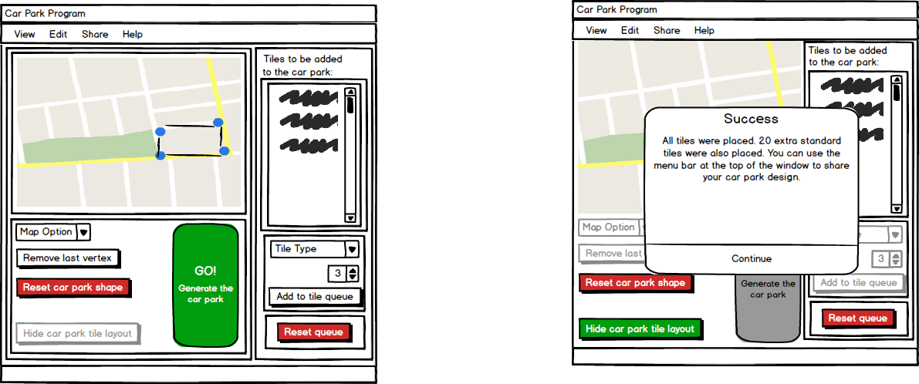

The first window will be displayed when the variable designingCarPark = True and the second when designingCarPark = False

### Implementation

When using Tkinter and the pack function it is advisable to have as many frames as possible in the design so that you can correctly lay elements out. Below I have the labelled diagram of all the elements within the GUI.



### Programming the solution

#### Adding and packing the frames. (GUIv2.py)

I will create the GUI program with just the frames, so that I can then later work on adding each individual element.

Using classes to define the containers will mean I can easily destroy and redraw them... I think.

I have made each element as a class, which is a frame with the element inside of it. You cannot go wrong by having too many frames, better safe than sorry.

At first, I planned to use help from this (Kinsley, n.d.) tutorial but then found it was made for Python 3, so I had to look for another source.

I used this (Oakley, 2013) example for help with how to create GUI windows with classes and objects. I also used documentation from effbot.org (Lundh, effgot.org, 2009) for help with Tkinter:

* Menu Widget (Lundh, The Tkinter Menu Widget, n.d.)
* Button Widget (Lundh, The Tkinter Button Widget, n.d.)
* Frame Widget (Lundh, The Tkinter Frame Widget, n.d.)

##### 4.3.1.1 Code

#===============================================================================

# GUI - Version 2

#

# Starting out adding basic frames

#

#===============================================================================

#-------------------------------------------------------------------------------

# Importing required modules

# PIL: For opening and editing image (will use this in a later version)

# Tkinter: Provides UI framework (will use this in a later version)

#-------------------------------------------------------------------------------

from PIL import Image, ImageTk, ImageDraw

import Tkinter as tk

LARGE_FONT= ("Verdana", 12)

frameBorderWidth = 5

#-------------------------------------------------------------------------------

# Frames defined

#

# mainFrame, majorityFrame, leftFrame, bottomLeftFrame, mapOptionsFrame,

# tileScrollBoxFrame, tileOptionsFrame

#

#-------------------------------------------------------------------------------

class templateFrame(tk.Frame): #progress

def __init__(self, parent, designingCarPark):

tk.Frame.__init__(self, parent)

self.parent = parent

self.frames = {}

self.items = {}

#add label

label = tk.Label(self, text="templateFrame", font=LARGE_FONT)

label.pack(pady=10,padx=10)

#add frames and items

#pack frames and items

class mainFrame(tk.Frame): #need to add navbar

def __init__(self, parent, designingCarPark):

tk.Frame.__init__(self, parent, bg='green', bd = frameBorderWidth)

self.parent = parent

self.frames = {}

self.items = {}

#add label

label = tk.Label(self, text="mainFame", font=LARGE_FONT)

label.pack(pady=10,padx=10)

#add frames and items

#self.items['navBar'] = navBar(self)

self.frames['majoirtyFrame'] = majorityFrame(self, designingCarPark)

#pack frames and items

#self.items['navBar'].pack(side="top", fill="both", expand=True)

self.frames['majoirtyFrame'].pack(side="top", fill="both", expand=True)

class majorityFrame(tk.Frame): #done

def __init__(self,parent, designingCarPark):

tk.Frame.__init__(self, parent, bg='blue', bd = frameBorderWidth)

self.parent = parent

self.frames = {}

self.items = {}

#add label

label = tk.Label(self, text="majorityFame", font=LARGE_FONT)

label.pack(pady=10,padx=10)

#add frames and items

self.frames['leftFrame'] = leftFrame(self, designingCarPark)

self.frames['rightFrame'] = rightFrame(self, designingCarPark)

#pack frames and items

self.frames['leftFrame'].pack(side="left", fill="both", expand=True)

self.frames['rightFrame'].pack(side="left", fill="both", expand=True)

class leftFrame(tk.Frame): #done

def __init__(self,parent, designingCarPark):

tk.Frame.__init__(self, parent, bg='red', bd = frameBorderWidth)

self.parent = parent

self.frames = {}

self.items = {}

#add label

label = tk.Label(self, text="leftFrame", font=LARGE_FONT)

label.pack(pady=10,padx=10)

#add frames and items

self.items['mapImage'] = mapImage(self, designingCarPark)

self.frames['bottomLeftFrame'] = bottomLeftFrame(self, designingCarPark)

#pack frames and items

self.items['mapImage'].pack(side="top", fill="both", expand=True)

self.frames['bottomLeftFrame'].pack(side="top", fill="both", expand=True)

class bottomLeftFrame(tk.Frame): #done

def __init__(self, parent, designingCarPark):

tk.Frame.__init__(self, parent, bg='pink', bd = frameBorderWidth)

self.parent = parent

self.frames = {}

self.items = {}

#add label

label = tk.Label(self, text="bottomLeftFrame", font=LARGE_FONT)

label.pack(pady=10,padx=10)

#add frames and items

self.frames['mapOptionsFrame'] = mapOptionsFrame(self, designingCarPark)

self.items['goButton'] = goButton(self, designingCarPark)

#pack frames and items

self.frames['mapOptionsFrame'].pack(side="left", fill="both", expand=True)

self.items['goButton'].pack(side="left", fill="both", expand=True)

class mapOptionsFrame(tk.Frame): #need to find how to pack hideParkingLayoutButton to bottom.

def __init__(self, parent, designingCarPark):

tk.Frame.__init__(self, parent, bg='blue', bd = frameBorderWidth)

self.parent = parent

self.frames = {}

self.items = {}

#add label

label = tk.Label(self, text="mapOptionsFrame", font=LARGE_FONT)

label.pack(pady=10,padx=10)

#add frames and items

self.items['mapTypeComboBox'] = mapTypeComboBox(self, designingCarPark)

self.items['shapeVertexRemoveButton'] = shapeVertexRemoveButton(self, designingCarPark)

self.items['shapeResetButton'] = shapeResetButton(self, designingCarPark)

self.items['hideParkingLayoutButton'] = hideParkingLayoutButton(self, designingCarPark)

#pack frames and items

self.items['mapTypeComboBox'].pack(side="top", fill="both", expand=True)

self.items['shapeVertexRemoveButton'].pack(side="top", fill="both", expand=True)

self.items['shapeResetButton']

self.items['hideParkingLayoutButton'].pack(side="bottom", fill="both", expand=True)

class rightFrame(tk.Frame): #done

def __init__(self,parent, designingCarPark):

tk.Frame.__init__(self, parent, bg='orange', bd = frameBorderWidth)

self.parent = parent

self.frames = {}

self.items = {}

#add label

label = tk.Label(self, text="rightFrame", font=LARGE_FONT)

label.pack(pady=10,padx=10)

#add frames and items

self.items['tileLabel'] = tk.Label(self, text="Tiles to be added to the car park:", font=LARGE_FONT)

self.frames['tileScrollBoxFrame'] = tileScrollBoxFrame(self)

self.frames['tileOptionsFrame'] = tileOptionsFrame(self, designingCarPark)

self.items['tileResetButton'] = tileResetButton(self, designingCarPark)

#pack frames and items

self.items['tileLabel'].pack(side="top", fill="both", expand=True)

self.frames['tileScrollBoxFrame'].pack(side="top", fill="both", expand=True)

self.frames['tileOptionsFrame'].pack(side="top", fill="both", expand=True)

self.items['tileResetButton'].pack(side="top", fill="both", expand=True)

class tileScrollBoxFrame(tk.Frame): #done

def __init__(self, parent):

tk.Frame.__init__(self, parent, bg='grey', bd = frameBorderWidth)

self.parent = parent

self.frames = {}

self.items = {}

#add label

label = tk.Label(self, text="tileScrollBoxFrame", font=LARGE_FONT)

label.pack(pady=10,padx=10)

#add frames and items

self.items['tileScrollBox'] = tileScrollBox(self)

self.items['tileScrollBar'] = tileScrollBar(self)

#pack frames and items

self.items['tileScrollBox'].pack(side="left", fill="both", expand=True)

self.items['tileScrollBar'].pack(side="left", fill="both", expand=True)

class tileOptionsFrame(tk.Frame): #progress

def __init__(self, parent, designingCarPark):

tk.Frame.__init__(self, parent, bg='blue', bd = frameBorderWidth)

self.parent = parent

self.frames = {}

self.items = {}

#add label

label = tk.Label(self, text="tileOptionsFrame", font=LARGE_FONT)

label.pack(pady=10,padx=10)

#add frames and items

self.items['tileTypeComboBox'] = tileTypeComboBox(self, designingCarPark)

self.items['tileNumericStepper'] = tileNumericStepper(self, designingCarPark)

self.items['tileAddButton'] = tileAddButton(self, designingCarPark)

#pack frames and items

self.items['tileTypeComboBox'].pack(side="top", fill="both", expand=True)

self.items['tileNumericStepper'].pack(side="top", fill="both", expand=True)

self.items['tileTypeComboBox'].pack(side="top", fill="both", expand=True)

#-------------------------------------------------------------------------------

# Items defined

#

# mapImage, mapTypeComboBox, shapeVertexRemoveButton,

# shapeResetButton, hideParkingLayoutButton, goButton, tileScrollBox,

# tileScrollBar, tileTypeComboBox, tileNumericStepper, tileAddButton,

# tileResetButton

#

#-------------------------------------------------------------------------------

class mapImage(tk.Frame):

def __init__(self, parent, designingCarPark):

tk.Frame.__init__(self, parent)

self.parent = parent

self.frames = {}

self.items = {}

#add label

label = tk.Label(self, text="mapImage", font=LARGE_FONT)

label.pack(pady=10,padx=10)

#add frames and items

#pack frames and items

class mapTypeComboBox(tk.Frame):

def __init__(self, parent, designingCarPark):

tk.Frame.__init__(self, parent)

self.parent = parent

self.frames = {}

self.items = {}

#add label

label = tk.Label(self, text="mapTypeComboBox", font=LARGE_FONT)

label.pack(pady=10,padx=10)

#add frames and items

#pack frames and items

class shapeVertexRemoveButton(tk.Frame):

def __init__(self, parent, designingCarPark):

tk.Frame.__init__(self, parent)

self.parent = parent

self.frames = {}

self.items = {}

#add frames and items

button = tk.Button(self, text="Remove last vertex")

#pack frames and items

button.pack(pady=10,padx=10)

class shapeResetButton(tk.Frame):

def __init__(self, parent, designingCarPark):

tk.Frame.__init__(self, parent)

self.parent = parent

self.frames = {}

self.items = {}

#add frames and items

button = tk.Button(self, text="Reset car park shape")

#pack frames and items

button.pack(pady=10,padx=10)

class hideParkingLayoutButton(tk.Frame):

def __init__(self, parent, designingCarPark):

tk.Frame.__init__(self, parent)

self.parent = parent

self.frames = {}

self.items = {}

#add frames and items

button = tk.Button(self, text="Remove last vertex")

#pack frames and items

button.pack(pady=10,padx=10)

class goButton(tk.Frame):

def __init__(self, parent, designingCarPark):

tk.Frame.__init__(self, parent)

self.parent = parent

self.frames = {}

self.items = {}

#add frames and items

button = tk.Button(self, text="goButton")

#pack frames and items

button.pack(pady=10,padx=10)

class tileScrollBox(tk.Frame):

def __init__(self, parent):

tk.Frame.__init__(self, parent)

self.parent = parent

self.frames = {}

self.items = {}

#add label

label = tk.Label(self, text="tileScrollBox", font=LARGE_FONT)

label.pack(pady=10,padx=10)

#add frames and items

#pack frames and items

class tileScrollBar(tk.Frame):

def __init__(self, parent):

tk.Frame.__init__(self, parent)

self.parent = parent

self.frames = {}

self.items = {}

#add label

label = tk.Label(self, text="tileScrollBar", font=LARGE_FONT)

label.pack(pady=10,padx=10)

#add frames and items

#pack frames and items

class tileTypeComboBox(tk.Frame):

def __init__(self, parent, designingCarPark):

tk.Frame.__init__(self, parent)

self.parent = parent

self.frames = {}

self.items = {}

#add label

label = tk.Label(self, text="tileTypeComboBox", font=LARGE_FONT)

label.pack(pady=10,padx=10)

#add frames and items

#pack frames and items

class tileNumericStepper(tk.Frame):

def __init__(self, parent, designingCarPark):

tk.Frame.__init__(self, parent)

self.parent = parent

self.frames = {}

self.items = {}

#add label

label = tk.Label(self, text="tileNumericStepper", font=LARGE_FONT)

label.pack(pady=10,padx=10)

#add frames and items

#pack frames and items

class tileAddButton(tk.Frame):

def __init__(self, parent, designingCarPark):

tk.Frame.__init__(self, parent)

self.parent = parent

self.frames = {}

self.items = {}

#add frames and items

button = tk.Button(self, text="Remove last vertex")

#pack frames and items

button.pack(pady=10,padx=10)

class tileResetButton(tk.Frame):

def __init__(self, parent, designingCarPark):

tk.Frame.__init__(self, parent)

self.parent = parent

self.frames = {}

self.items = {}

#add frames and items

if designingCarPark:

button = tk.Button(self, text="tileResetButton")

else:

button = tk.Button(self, text="tileResetButton", state='disabled')

#pack frames and items

button.pack(pady=10,padx=10)

def callback():

print "button pressed"

#-------------------------------------------------------------------------------

# Window created and mainloop started.

#-------------------------------------------------------------------------------

if __name__ == "__main__":

window = tk.Tk()

mainFrame(window,True).pack(side="top", fill="both", expand=True)

window.mainloop()

##### 4.3.1.2 Screenshots

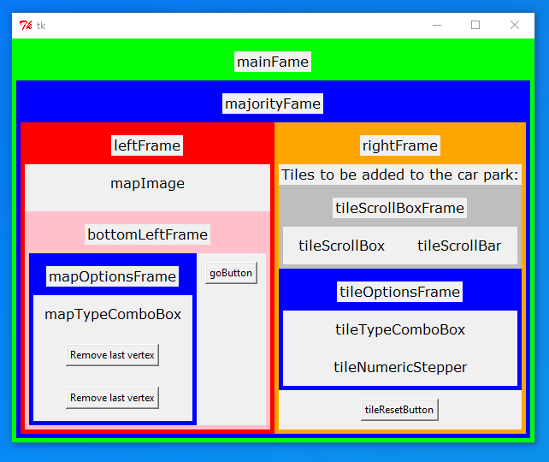

I have added the labels, colours and borders to frames so that while I am developing the GUI I can see where each frame is. These will be removed later.

#### Adding the image element (GUIv3.py)

Since I have already created my image element in a test program I decided I would add it to my program now

I quickly put my existing code into a class format so I can easily later destroy and recreate it.

In order to nicely display the high resolution images I decided to import a module so I can resize the image. I found the module python-resize-image 1.1.11 (TISSIER, 2017).

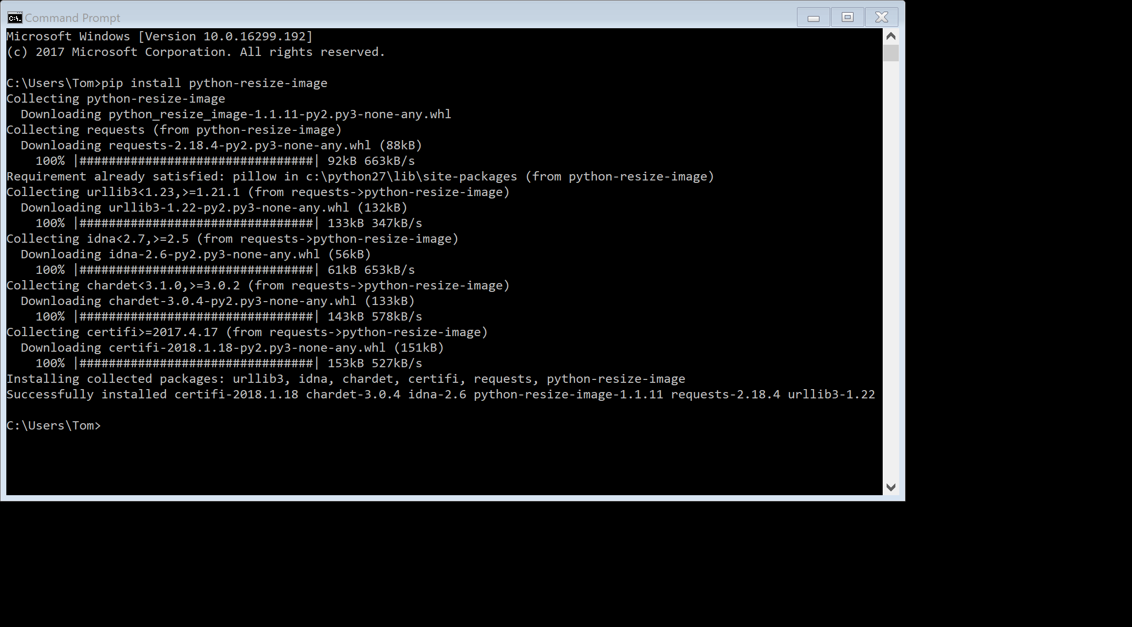

##### 4.3.2.1 Code

###### 4.3.2.1.1 Resizing the image

#-------------------------------------------------------------------------------

# Importing required modules

# PIL: For opening and editing image (will use this in a later version)

# Tkinter: Provides UI framework (will use this in a later version)

# resizeimage: For resizing the images.

#-------------------------------------------------------------------------------

from PIL import Image, ImageTk, ImageDraw

import Tkinter as tk

from resizeimage import resizeimage

LARGE_FONT= ("Verdana", 12)

imageHeight = 500

images = {} #makes dictionary for the images

images['main'] = Image.open("main.png")

images['north'] = Image.open("north.png")

images['main'] = resizeimage.resize_height(images['main'], imageHeight) #resizes the images so they fit on the screen

images['north'] = resizeimage.resize_height(images['north'], imageHeight)

globalImage = images['main'] #sets the current image using a global variable

frameBorderWidth = 5

###### 4.3.2.1.2 Image element

class mapImage(tk.Frame):

def __init__(self, parent, designingCarPark):

tk.Frame.__init__(self, parent)

self.parent = parent

#add image to a canvas

myFrame = tk.Frame(self)

myFrame.pack()

self.image = globalImage

canvas = tk.Canvas(myFrame, width=self.image.size[0], height=self.image.size[1]) #image.size gives you the width and depth

canvas.pack() #packs the canvas so it shows up

self.image_tk = ImageTk.PhotoImage(self.image)

canvas.create_image(self.image.size[0]//2, self.image.size[1]//2, image=self.image_tk) #//2 needed in order to center the image

#binds clicking on image to a procedure called clickedOnImage

canvas.bind("<Button-1>", clickedOnImage) #<Button-1> is the left mouse button

##### Screenshots

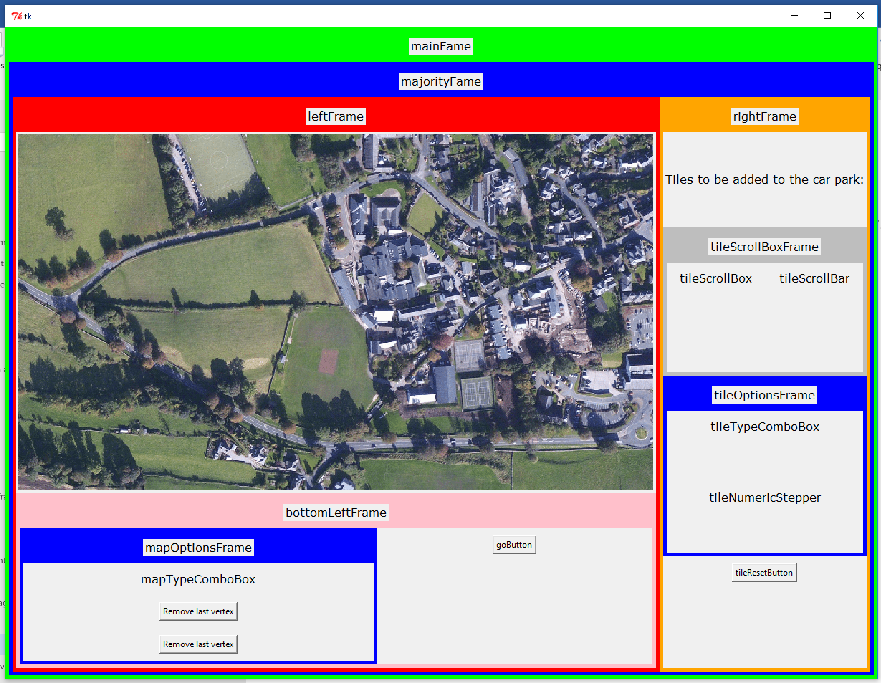

#### Adding the two different views (GUIv4.py)

I will now add support for when the car park is being designed and for when the car park is being shown to the user. Various buttons will be disabled in each view.

To achieve this, I plan to use a global variable that will contain the current map name to be displayed. Since this is part of the GUI, the global variable (and all image manipulation procedures) will be within the GUI program, not the processing program.

I will control which view is displayed through the mapTypeComboBox, here the user will choose which map they want to see, they will then apply their changes (and reset the car park shape) using the shapeResetButton (labelled “Reset car park shape and update map”).

The drop down menu is a Combobox’ from the ttk module. It allows me to set its contents to the values in a global array I named mapNames. I have assigned a procedure to when the shapeResetButton is clicked. This sets a global variable, globalMapName, to the value held within the mapTypeComboBox. I then refresh the window using my procedure refreshWindow. The refreshWindow procedure destroys the master frame within the window and then redraws it.

##### 4.3.3.1 Code

###### 4.3.3.1.1 The global variables

mapNames = ['Main','North']

images = {} #makes dictionary for the images

images[mapNames[0]] = Image.open("main.png")

images[mapNames[1]] = Image.open("north.png")

images[mapNames[0]] = resizeimage.resize_height(images[mapNames[0]], imageHeight) #resizes the images so they fit on the screen

images[mapNames[1]] = resizeimage.resize_height(images[mapNames[1]], imageHeight)

globalMapName = mapNames[0] #images[mapNames[globalMapCount]] #sets the current image using a global variable

###### 4.3.3.1.2 The Combobox

class mapTypeComboBox(tk.Frame):

def __init__(self, parent, designingCarPark):

tk.Frame.__init__(self, parent)

self.parent = parent

#add items

if designingCarPark:

self.comboBox = ttk.Combobox(self, values = mapNames)

else:

self.comboBox = ttk.Combobox(self, values = mapNames, state = 'disabled')

self.comboBox.set(globalMapName)

#pack items

self.comboBox.pack(side="left")

###### 4.3.3.1.3 The reset button

class shapeResetButton(tk.Frame):

def __init__(self, parent, designingCarPark):

tk.Frame.__init__(self, parent)

self.parent = parent

#add items

if designingCarPark:

button = tk.Button(self, text="Reset car park shape and update map", bg='red', command=self.buttonClicked)

else:

button = tk.Button(self, text="Reset car park shape", bg='red', state='disabled')

#pack items

button.pack(side="left")

def buttonClicked(self):

global globalMapName

globalMapName = self.parent.items['mapTypeComboBox'].comboBox.get()

print "shapeResetButton clicked"

print self.parent.items['mapTypeComboBox'].comboBox.get()

refreshWindow()

###### 4.3.3.1.4 The procedures for refreshing the window and also creating the window using multiple frames

#-------------------------------------------------------------------------------

# Functions for certain button clicks

#-------------------------------------------------------------------------------

def refreshWindow():

global godFrame

godFrame.destroy()

godFrame = mainFrame(window,True)

godFrame.pack(side="top", fill="both", expand=True)

def refreshMap():

global godFrame

godFrame.frames['majoirtyFrame'].frames['leftFrame'].refreshMap()

def callback():

print "button pressed"

#-------------------------------------------------------------------------------

# Window created and mainloop started.

#-------------------------------------------------------------------------------

if __name__ == "__main__":

window = tk.Tk()

godFrame = mainFrame(window,True)

godFrame.pack(side="top", fill="both", expand=True)

window.mainloop()

##### 4.3.3.2 Screenshots

This addition to the program is in the GUIv4.py program. In this version I also removed the padding that I had added around some of the elements, such as the buttons. A screenshot can be seen below:

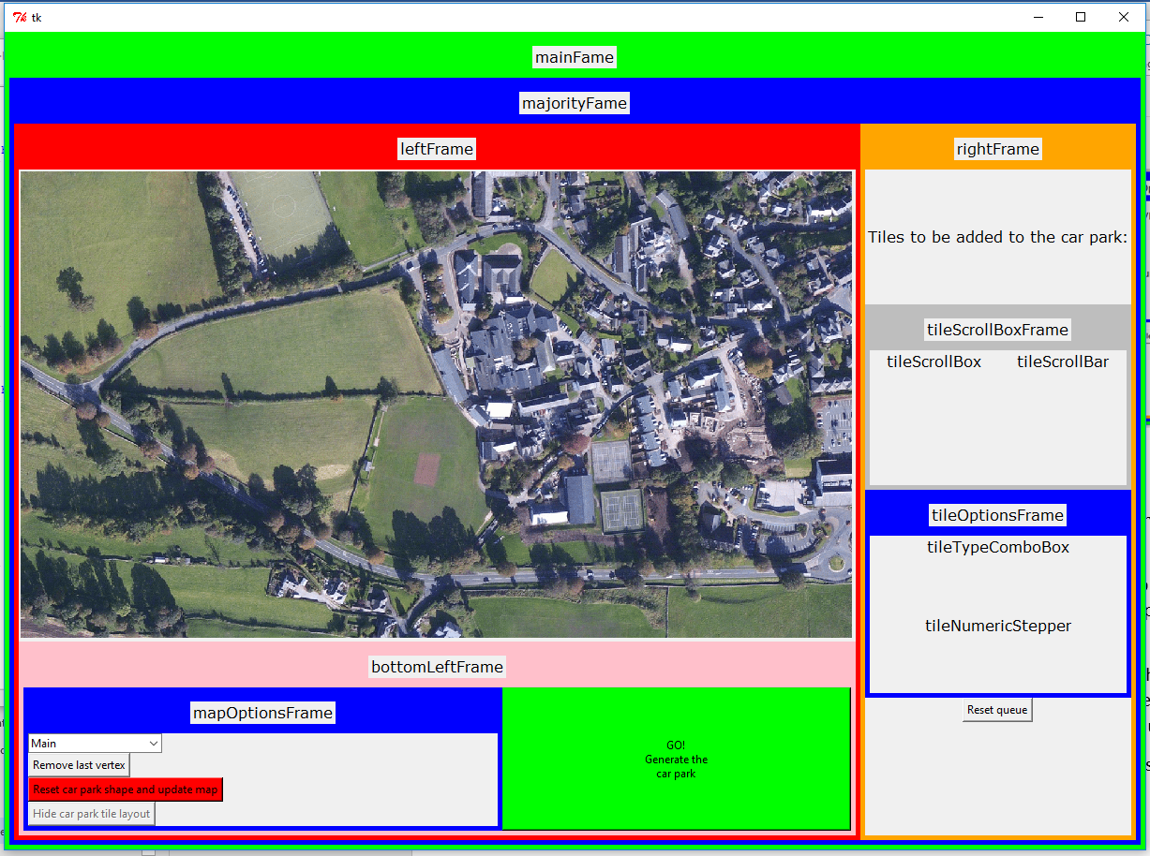

Above is the view of how the program looks when it is first opened, the user can then change the drop-down menu (comboBox) and click the red button to change the map, as shown below:

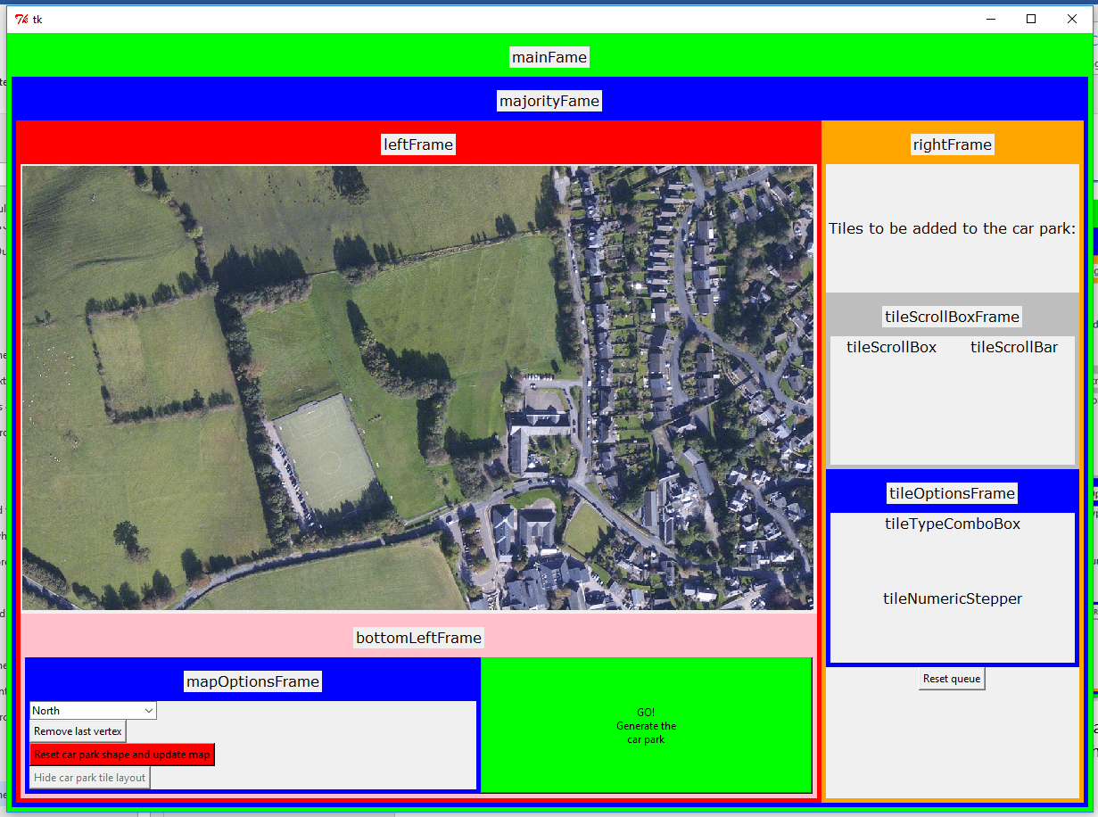

As you can see, I now have a working image element.

#### Adding support for disabling elements when designing or not designing the layout of the car park. (GUIv5.py)

When the car park is being designed I want the user to be able to access most of the elements, such as changing the number of car parking spaces for each type to be put into the car park. However, when the car park is being showed to the user these options should stay fixed and they should not be able to press buttons like the go button again since it would do nothing.

To achieve this, I plan to use a global variable called designingCarPark when the user is in the process of choosing the layout of the shape and how many spaces this will be set to True, when the user is looking at the finished car park it will be set to False.

Note: I am aware this variable was present in the previous version of the code, but it is this version (GUIv5.py) that implements it fully.

To implement this, I am using the state argument, I can pass into this state = 'disabled' when I want the button or other element to be disabled.

##### 4.3.4.1 Code

I will not include all the code, but here is one example from the goButton

###### 4.3.4.1.1 Go Button

class goButton(tk.Frame):

def __init__(self, parent):

tk.Frame.__init__(self, parent)

self.parent = parent

#add items

if designingCarPark:

button = tk.Button(self, text="GO!\nGenerate the\ncar park", bg = "green", command = self.buttonClicked)

else:

button = tk.Button(self, text="GO!\nGenerate the\ncar park", state='disabled')

#pack items

button.pack(fill="both", expand=True)

def buttonClicked(self):

print "goButton clicked"

global designingCarPark

designingCarPark = False

refreshWindow()

##### 3.4.4.2 Screenshots

While editing:

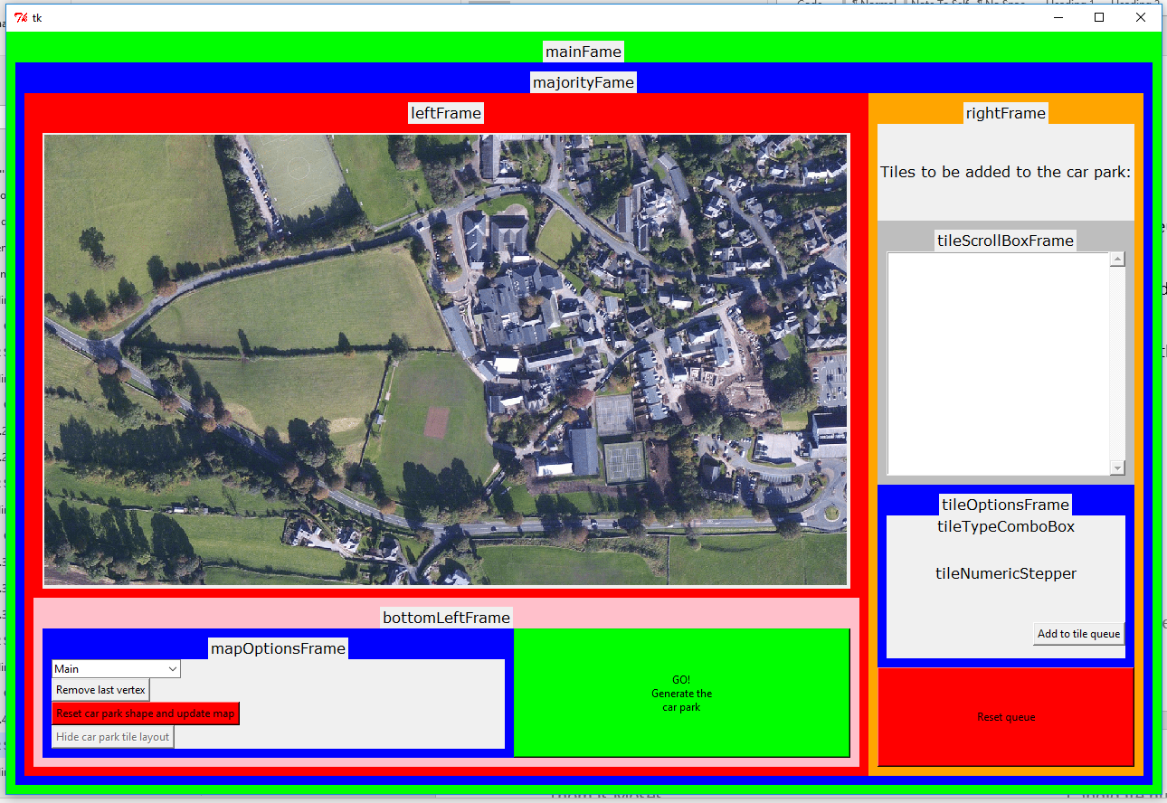

After pressing the go button:

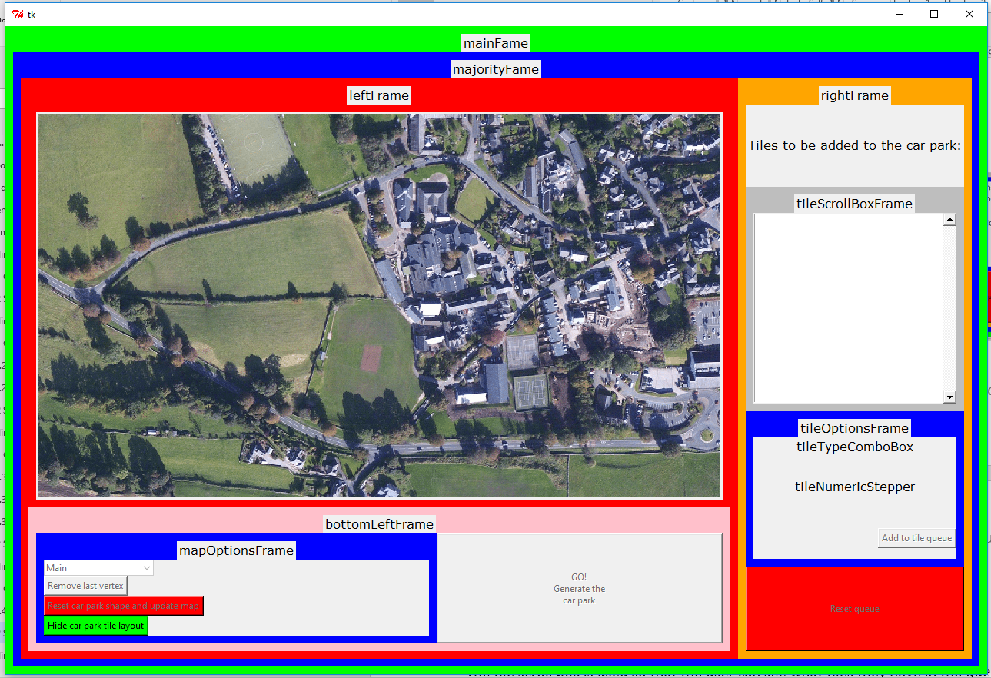

#### Adding the tileScrollBox (GUIv5.py)

##### 4.3.5.1 Initial setup

The tile scroll box is used so that the user can see what tiles they have in the queue to be placed within the carpark shape that they have drawn.

The user may have a very specific order of tiles they want placed so this list could get long, if it does it needs to by scrollable, hence why I am using a scroll box.

Unfortunately, there is no all in one scroll box element, so I am making my own through the combination of a list box and a scrollbar.

Currently the scroll box is empty, as I first worked on it just displaying at all. You can see this in the previous screenshot.

###### 4.3.5.1 Code

class tileScrollBox(tk.Frame):

def __init__(self, parent):

tk.Frame.__init__(self, parent)

self.parent = parent

#add label

#add items

self.scrollbar = tk.Scrollbar(self)

self.scrollbar.pack(side='right', fill='y')

self.listbox = tk.Listbox(self)

self.listbox.pack(side="right", fill="both", expand=True)

# attach listbox to scrollbar

self.listbox.config(yscrollcommand=self.scrollbar.set)

self.scrollbar.config(command=self.listbox.yview)

##### Connecting with my main program

The next step in this process was to connect my GUI with my main program I will cover this in more detail next, but here is the code for connecting the listBox with the global variable from my main program called listOFTuplesOfNamesOfTilesInListAndHowManyOfEach. This long variable name explains exactly what this is for, it is: a list of (tuples of (names of tile type to be added) and (how many of each to be added to the car park)).

###### Code

class tileScrollBox(tk.Frame):

def __init__(self, parent):

tk.Frame.__init__(self, parent)

self.parent = parent

#add label

#add items

self.scrollbar = tk.Scrollbar(self)

self.scrollbar.pack(side='right', fill='y')

self.listbox = tk.Listbox(self)#, values = processingCode.listOFTuplesOfNamesOfTilesInListAndHowManyOfEach)

for each in processingCode.listOFTuplesOfNamesOfTilesInListAndHowManyOfEach:

self.listbox.insert('end', str(each))

self.listbox.pack(side="right", fill="both", expand=True)

# attach listbox to scrollbar

self.listbox.config(yscrollcommand=self.scrollbar.set)

self.scrollbar.config(command=self.listbox.yview)

###### 4.3.5.2.2 Screenshot

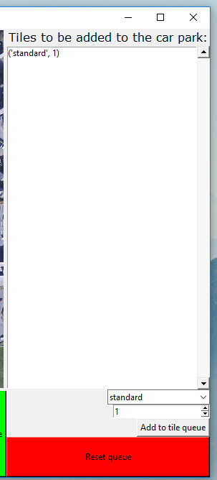

#### 4.3.6 Joining the main processing code and the GIU together (GUIv6.py)

To keep my program as easy as possible to understand, I have decided to split it up into multiple programs. One of them contains my shape and vertex classes, one of them contains the processing code for designing the car park and the last provides the graphical user interface that the user sees.

##### 4.3.6.1 How I import my processing code

I have all my programs in the same directory, I name my processing code versions in the format v[version number].py and I name my GUI code versions in the following way GUIv[version number].py.

This way I am able to leave old versions of the GUI importing the correct older versions of the processing code, and I can easily import a new version of the processing code if I make a change.

I import my processing code under the name of processingCode this means I only need to import which program I import as this name and the rest of my code keeps on working, rather than having to change the name in multiple places.

###### 4.3.6.1.1 Code

#-------------------------------------------------------------------------------

# Importing required modules

# PIL: For opening and editing image (will use this in a later version)

# Tkinter: Provides UI framework (will use this in a later version)

# resizeimage: For resizing the images.

# v17: my processing code for generating the car park layout

#-------------------------------------------------------------------------------

from PIL import Image, ImageTk, ImageDraw

import Tkinter as tk

import ttk as ttk

from resizeimage import resizeimage

import v17 as processingCode

##### 4.3.6.2 Global variables in the GUI program

I decided that the main variables in the program should be global variables in the GUI program, this will make it easier to reference them in the button methods.

For example, I have used a global variable called carParkShape (which is an instance of a shape class) for the main way of storing the shape the user defines. Through having it as a global variable all processes can easily access it. It is okay for this to be a global variable as there will only ever be one instance of it.

Another few examples are the colour global variable, this allows me to change the colour in just one place and it effects all places, the radiusOfCarParkVertices integer variable that allows me to have control over the size of the dots that the program draws showing where the user has clicked, and the showLables Boolean variable, this means I can now easily disable the large labels showing in the GUI.

##### 4.3.6.3 The change in look of the program

Now that I had the ability to easily remove the labels, I also tweaked the layout of the user interface. Below you can see the changes.

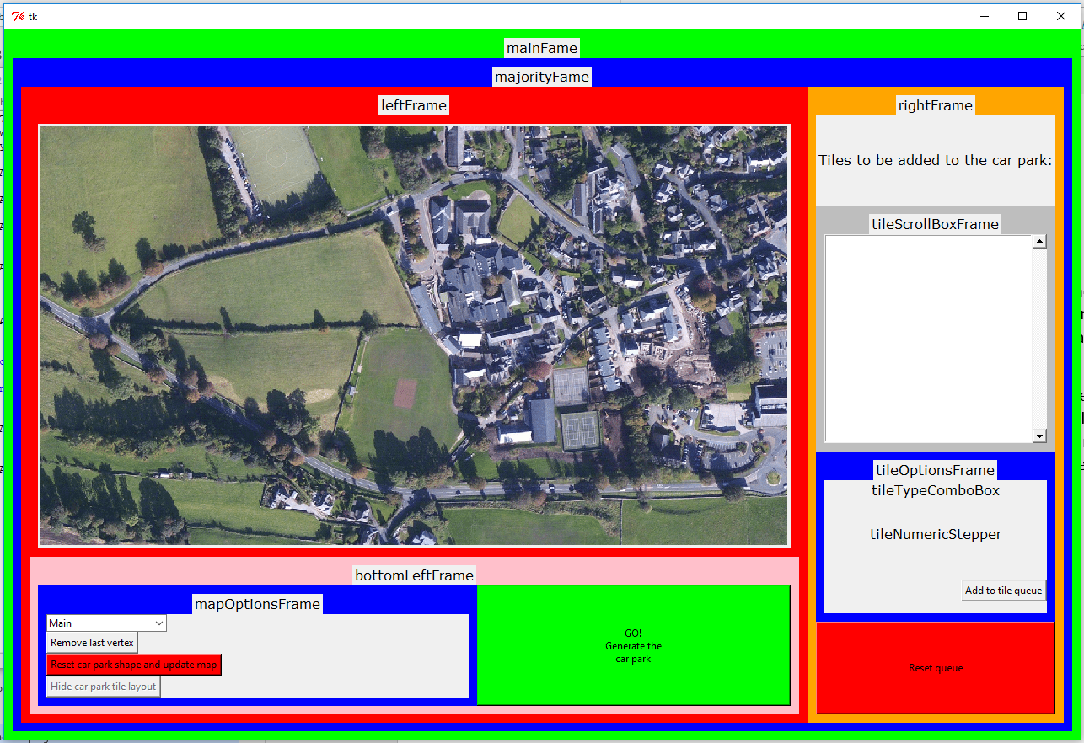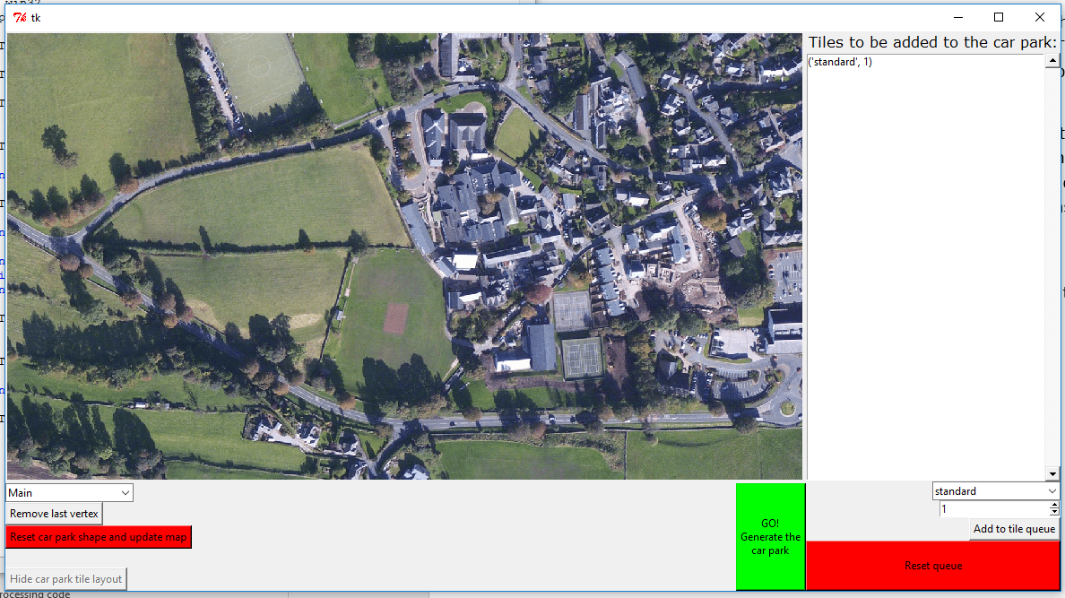

Through research I found Effbot’s article on Pack (Lundh, The Tkinter Grid Geometry Manager, n.d.) , this helped me gain an understanding how pack’s arguments for fill and expand work, I was able to modify the window to have the frames fill the available space in the correct way. An example of this is that before the left frame and the right frame would have equal arguments, allowing them both to expand when the window was resized, instead now only the left frame expands to the right and both frames expand downwards. I decided on this as it would leave the map displaying always at the same size. Examples of how the windows look when expanded can be seen below.

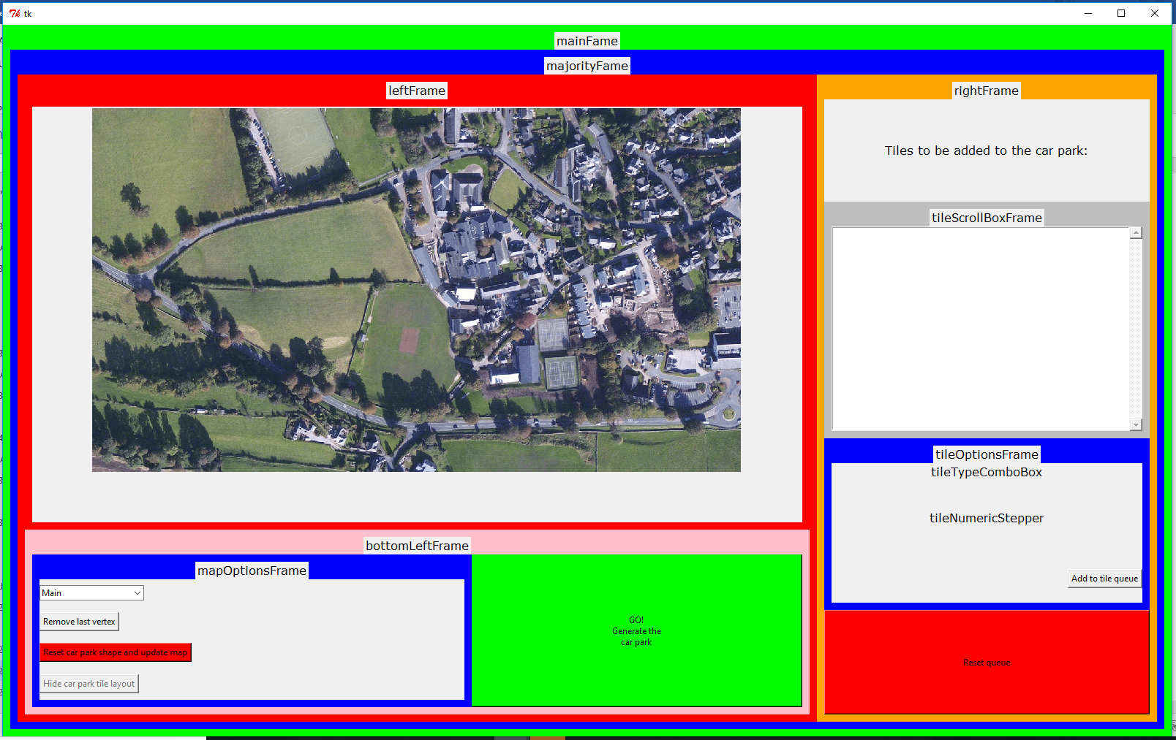

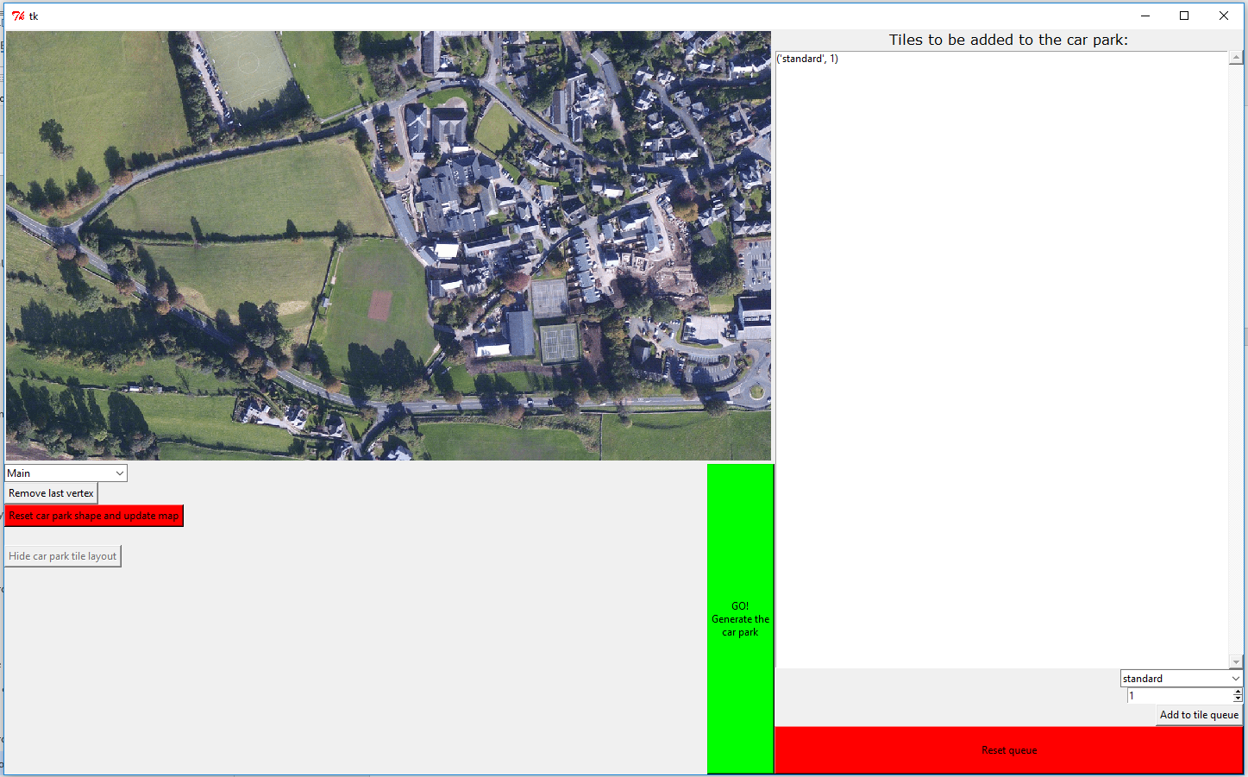

##### 4.3.6.4 Examples of how the processing code and GUI code link together

Since I already had it working that you could click on the map and it would print the coordinates of where you clicked, and I already had set up the carParkShape global shape instance, I decided that it would now be a good time to work on adding the vertices to the car park as the user clicks on the map.

For this I decided I would not convert the values to be in a specific unit of meters, but to instead leave them as pixel values, as for now this would make it easier, especially as I will have to use these values to draw the shape onto the map.

###### 4.3.6.4.1 How I modified the mapImage Class

I modified the mapImage’s mapClicked method so that it no longer printed the coordinates but added a vertex to the carParkShape instance with the required vertices. I then needed to draw the map image and refresh the map.

4.3.6.4.1.1 Previous mapClicked method code

def mapClicked(self,event):

if designingCarPark:

print "coords: " + str(event.x) + "," + str(event.y)

else:

print "clicking the map did nothing because you're looking at the finished car park"

4.3.6.4.1.2 New mapClicked method code

def mapClicked(self,event):

if designingCarPark:

carParkShape.addVertex(processingCode.vertex(event.x,event.y))

#print "coords: " + str(event.x) + "," + str(event.y)

drawMapImage()

refreshMap()

else:

print "clicking the map did nothing because you're looking at the finished car park"

###### 4.3.6.4.2 How I draw the car park shape outline onto the map

I had already some research into this and had found I want to use the ImageDraw Module.

The main resource I used was Effbot’s article on the ImageDraw Module (Lundh, The ImageDraw Module, n.d.). From here I learn the syntax required.

I first implemented drawing a circle at every point the user had clicked on so far, this set a local variable called listOfCoordinates to the coordinates of the carParkShape, using carParkShape.getVerticesCoordinates(). I then implemented a counter-controlled loop that allowed me to traverse the entire list. I needed to give the method two coordinate points of diagonally opposite corners of a square that the circle will be in, therefore for one I needed to take away the radius of the circle for both x and y and for the other I needed to add the radius of the circle for both x and y. e.g.

+r

-r

+r

-r

Where the black dot is the original point, the red circles are the points I find to make the blue square, which is what the green circle is drawn in.

With this successfully completed I needed to now be able to draw lines between each point. To achieved this, I used the draw module’s line function. I drew from the current vertex to the next vertex in the list. In order to draw the last line (from the last vertex in the list to the first vertex in the list) I needed find the remainder of the current item + 1 divided by the numbers of items in the list. To achieve this, I used the modulus operator, %.

I tried changing the colour of the lines that were being drawn and after more than an hour of messing around with syntax trying to get it working I found that PIL version 1.1.4 or greater is required for this to work. If I get time at the end of my project this is something I may put more effort into trying to update, for now I am leaving it how it is as it does not really affect how the user can use the program.

4.3.6.4.2.1 Commented code for drawing map image

def drawMapImage():

global globalMapImage

globalMapImage = resizeimage.resize_height(images[globalMapName], imageHeight)

draw = ImageDraw.Draw(globalMapImage)

listOfCoordinates = carParkShape.getVerticesCoordinates()

for count in range(len(listOfCoordinates)):

#draw.elipse(first point but moved the radius away from the centre, second point but moved the radius away from the centre, fill colour)

draw.ellipse((listOfCoordinates[count][0]-radiusOfCarParkVertices,listOfCoordinates[count][1]-radiusOfCarParkVertices,listOfCoordinates[count][0]+radiusOfCarParkVertices,listOfCoordinates[count][1]+radiusOfCarParkVertices),fill = colour)#fill = 'rgb(0%,0%,100%)' )

#draw.line(first point, second point)

draw.line((listOfCoordinates[count][0],listOfCoordinates[count][1],listOfCoordinates[(count+1)%len(listOfCoordinates)][0],listOfCoordinates[(count+1)%len(listOfCoordinates)][1],))

#I then need to delete the draw instance I created so that the memory can be cleared up to be used by other processes.

del draw

###### 4.3.6.4.3 The shapeVertexRemoveButton

Linking this button with the main code was fairly simple, I wrote a new method for the shape class called removeLastVertex and then added this line to the shapeVertexRemoveButtons’s method buttonClicked: carParkShape.removeLastVertex().

The removeLastVertex method simple slices the list to exclude the last item in it.

4.3.6.4.3.1 removeLastVertex method code

def removeLastVertex(self):

self.vertices = self.vertices[:-1] #removes last item from list

4.3.6.4.3.2 shapeVertexRemoveButton’s buttonClicked method code

def buttonClicked(self):

#print "shapeVertexRemoveButton clicked"

carParkShape.removeLastVertex() #removes last added vertex from the shape

drawMapImage() #updates the window

refreshMap()

###### 4.3.6.4.4 The shapeResetButton

Linking this button was again fairly simple, I just added the following line which overwrites the value held in the carParkShape variable with a new shape instance.

4.3.6.4.4.1 new line added to shapeResetButton’s method code

carParkShape = processingCode.shape()

###### 4.3.6.4.5 The tileScrollBox

I have already covered how I linked this in section 4.3.5.2

###### 4.3.6.4.6 The tileTypeComboBox

This comboBox is how the user chooses what type of tile they want to add to the tile queue.

To link them I set the values of the comboBox to contain the list of valid tile names, this list is called tileNames and is in the processing code, so I needed to use processingCode.tileNames to access it.

From some documentation (Shipman, 2013) on the ttk ComboBox I found there was a state option called “readonly” that allowed me to let the user only choose values from the list, this meant there was no way they could enter an invalid option for this input.

###### 4.3.6.4.7 the tileNumbericStepper

From Effbot’s documentation (Lundh, The Tkinter Spinbox Widget, n.d.) on the Tkinter Spinbox Widget I was able to implement a spinbox that started at one and have a very large upper limit. Realistically there was no need to limit the number the user could add, as it will later just tell them it failed to add their ridiculously large amount of car park spaces. However, I chose to limit it to 1000000000 so that the user cannot try and break the program by entering an enormously large number that could cause an unexpected problem.

I left the Spinbox in a state where the user can click on it to change the value one by one or type in their own number.

The combo box will be read by other button’s methods so it does not need its own method.

4.3.6.4.7.1 tileNumericStepper code

class tileNumericStepper(tk.Frame):

def __init__(self, parent):

tk.Frame.__init__(self, parent)

self.parent = parent

#add items

self.stepper = tk.Spinbox(self, from_=1, to_=1000000000)

#pack items

self.stepper.pack(side = 'right')

###### 4.3.6.4.8 tileAddButton

To link this I added to its method the following line, this appends the current value of the tileTypeComboBox and the tileNumericStepper as a tuple to the processingCode’s queue containing the tiles to be added to the car park.

processingCode.listOFTuplesOfNamesOfTilesInListAndHowManyOfEach.append((self.parent.items['tileTypeComboBox'].comboBox.get(), int(self.parent.items['tileNumericStepper'].stepper.get())))

I then refresh the window to update the tileScrollBox.

###### 4.3.6.4.9 tileResetButton

To link this button, it clears the queue of tiles to be added to the car park by setting it to an empty array, it then refreshes the window.

#### 4.3.6 Initial attempt of drawing the car park (GUIv7.py)

In this version I made some minor changes to the look of the program as well as my first attempt to implement drawing the generated car park.

##### 4.3.6.1 Minor changes to how the program looks

I simply added a line break to the label in the top right of the window:

Screenshot of before:

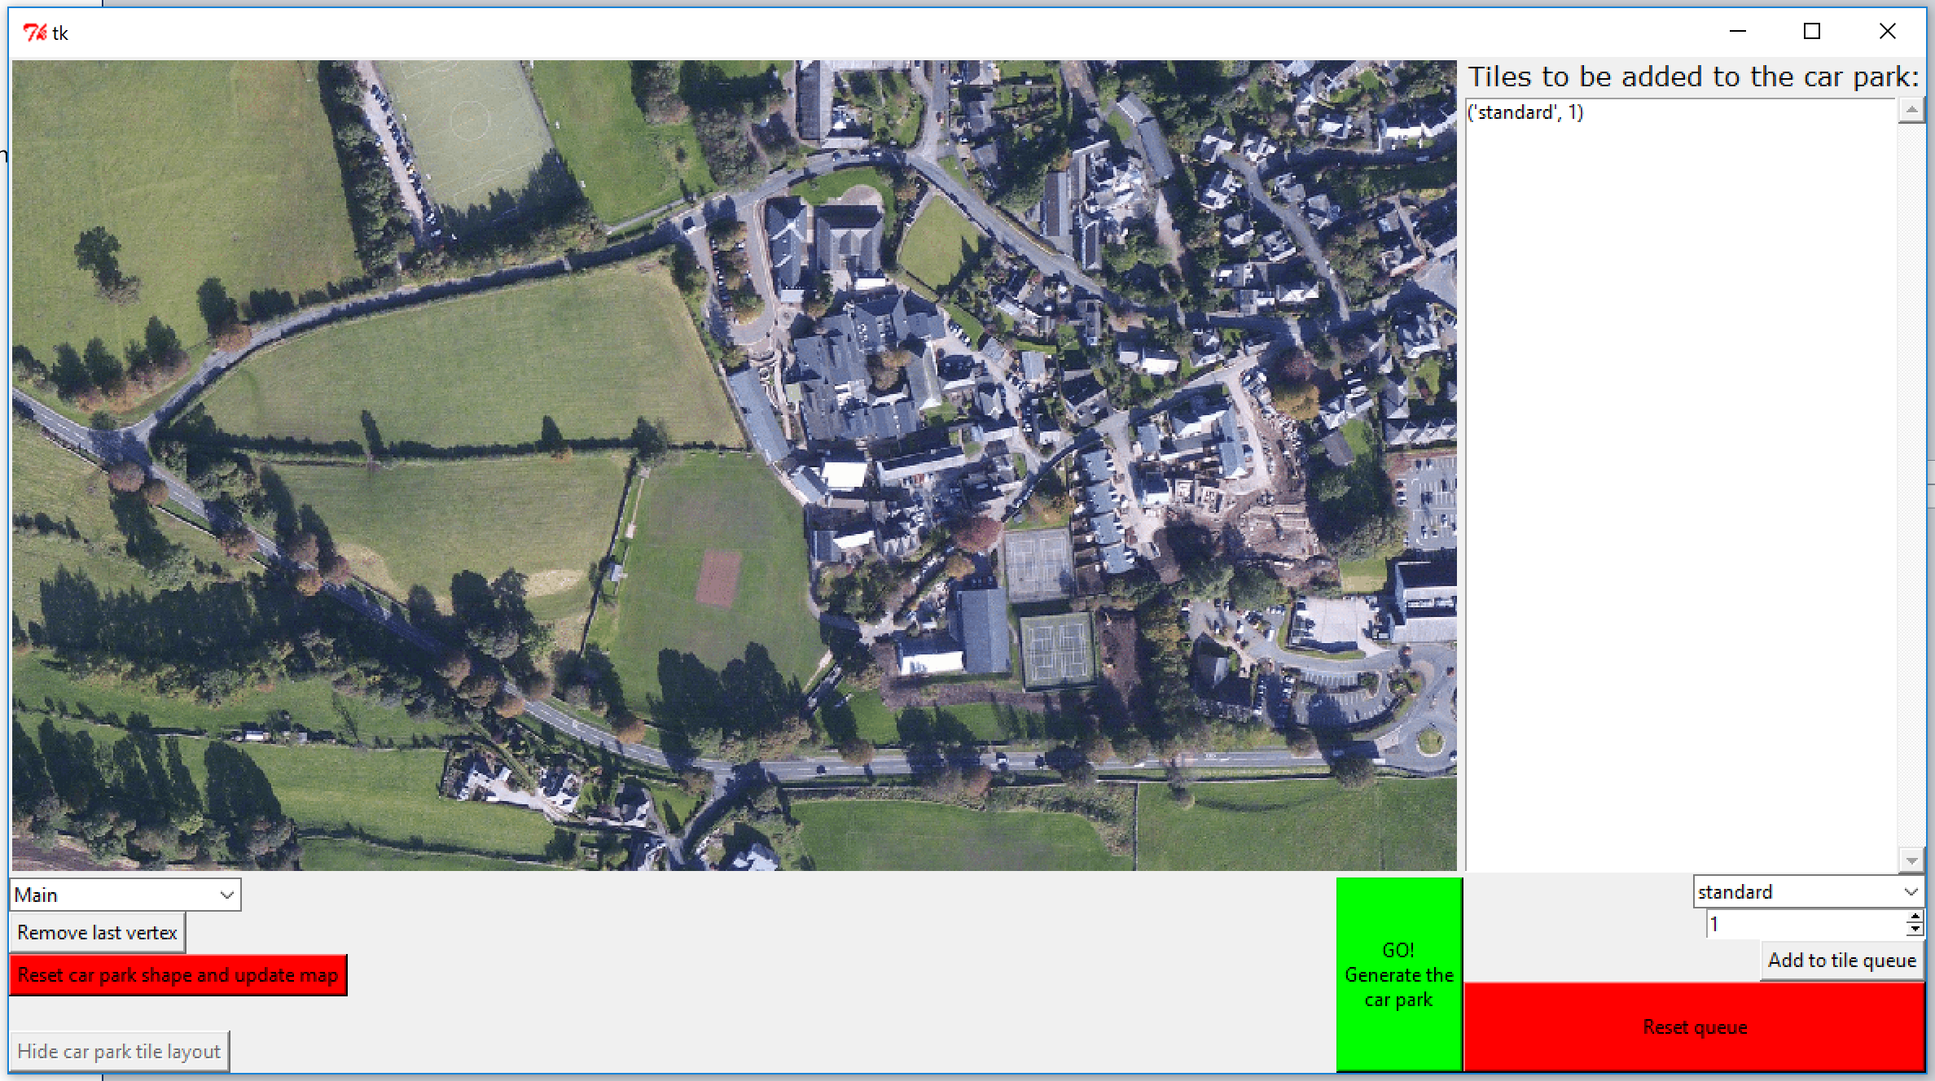

Screenshot of after:

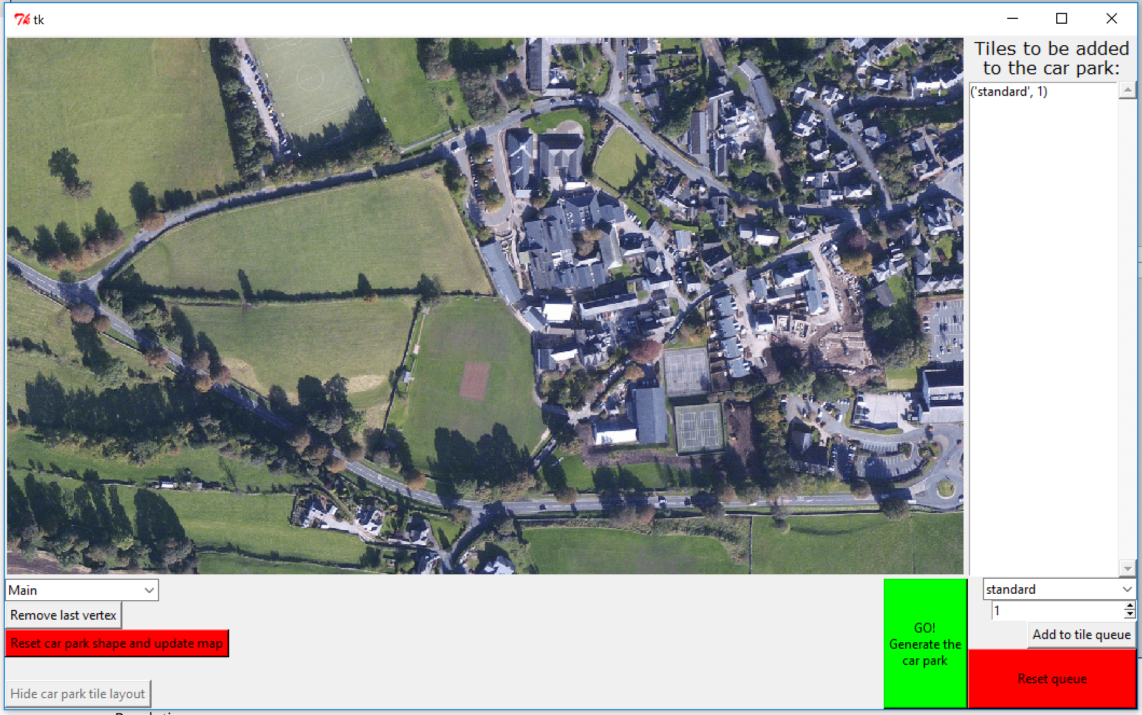

##### 4.3.6.2 Stretching the shape

Before I can do any processing on the shape, I needed to scale it to a sensible unit from pixel values, I chose to use metres. I made a new shape method called stretch that allowed me to easily do this.

##### 4.3.6.3 drawing the car park spaces.

I decided I would split this task between my processing code and my GUI code. Basically, the GUI program will ask the processing code for where it should draw the lines, the lines will be returned in a list and then the GUI code will traverse this list drawing each of the lines onto a blank map.

I found setting up the processingCode’s side of this quite difficult. It took me several hours and several attempts to find a working solution. I ran into problems such as python passing lists (of points) by reference instead of just passing the values. I will go into more detail on the processing code involved later in the document.

I was able to set up the GUI code easily to support this, the goButton’s buttonClicked method is below.

You can see that all it passes into the processing code is the carpark shape and the conversion of how many pixels are in one meter for the image. From this is returned a list of pairs of coordinates, which will be used to draw lines. Using the same ImageDraw module that I used earlier.

###### 4.3.6.3.1 goButton’s buttonClicked method code

def buttonClicked(self): #needs finishing

#print "goButton clicked"

global designingCarPark, globalMapImage

globalMapImage = resizeimage.resize_height(images[globalMapName], imageHeight)

designingCarPark = False

listOfGroupsOfCoordinatesForLines = processingCode.GetCarParkPixelLinesToDrawFromPixelShape(carParkShape,pixelsPerMeter)

draw = ImageDraw.Draw(globalMapImage)

listOfCoordinates = carParkShape.getVerticesCoordinates()

for eachGroupOfCoordinatesForLines in listOfGroupsOfCoordinatesForLines:

print "eachGroupOfCoordinatesForLines:"

print eachGroupOfCoordinatesForLines

draw.line(eachGroupOfCoordinatesForLines)

del draw

refreshWindow()

##### 4.3.6.4 Processing code for initial attempt of drawing car park

First I decided I would try the simplest solution possible so that I could test my GUI program before going back to work more on the processing program. I decided I would simply show where the edges of each tile were. After finally getting it working I was able to achieve this result:

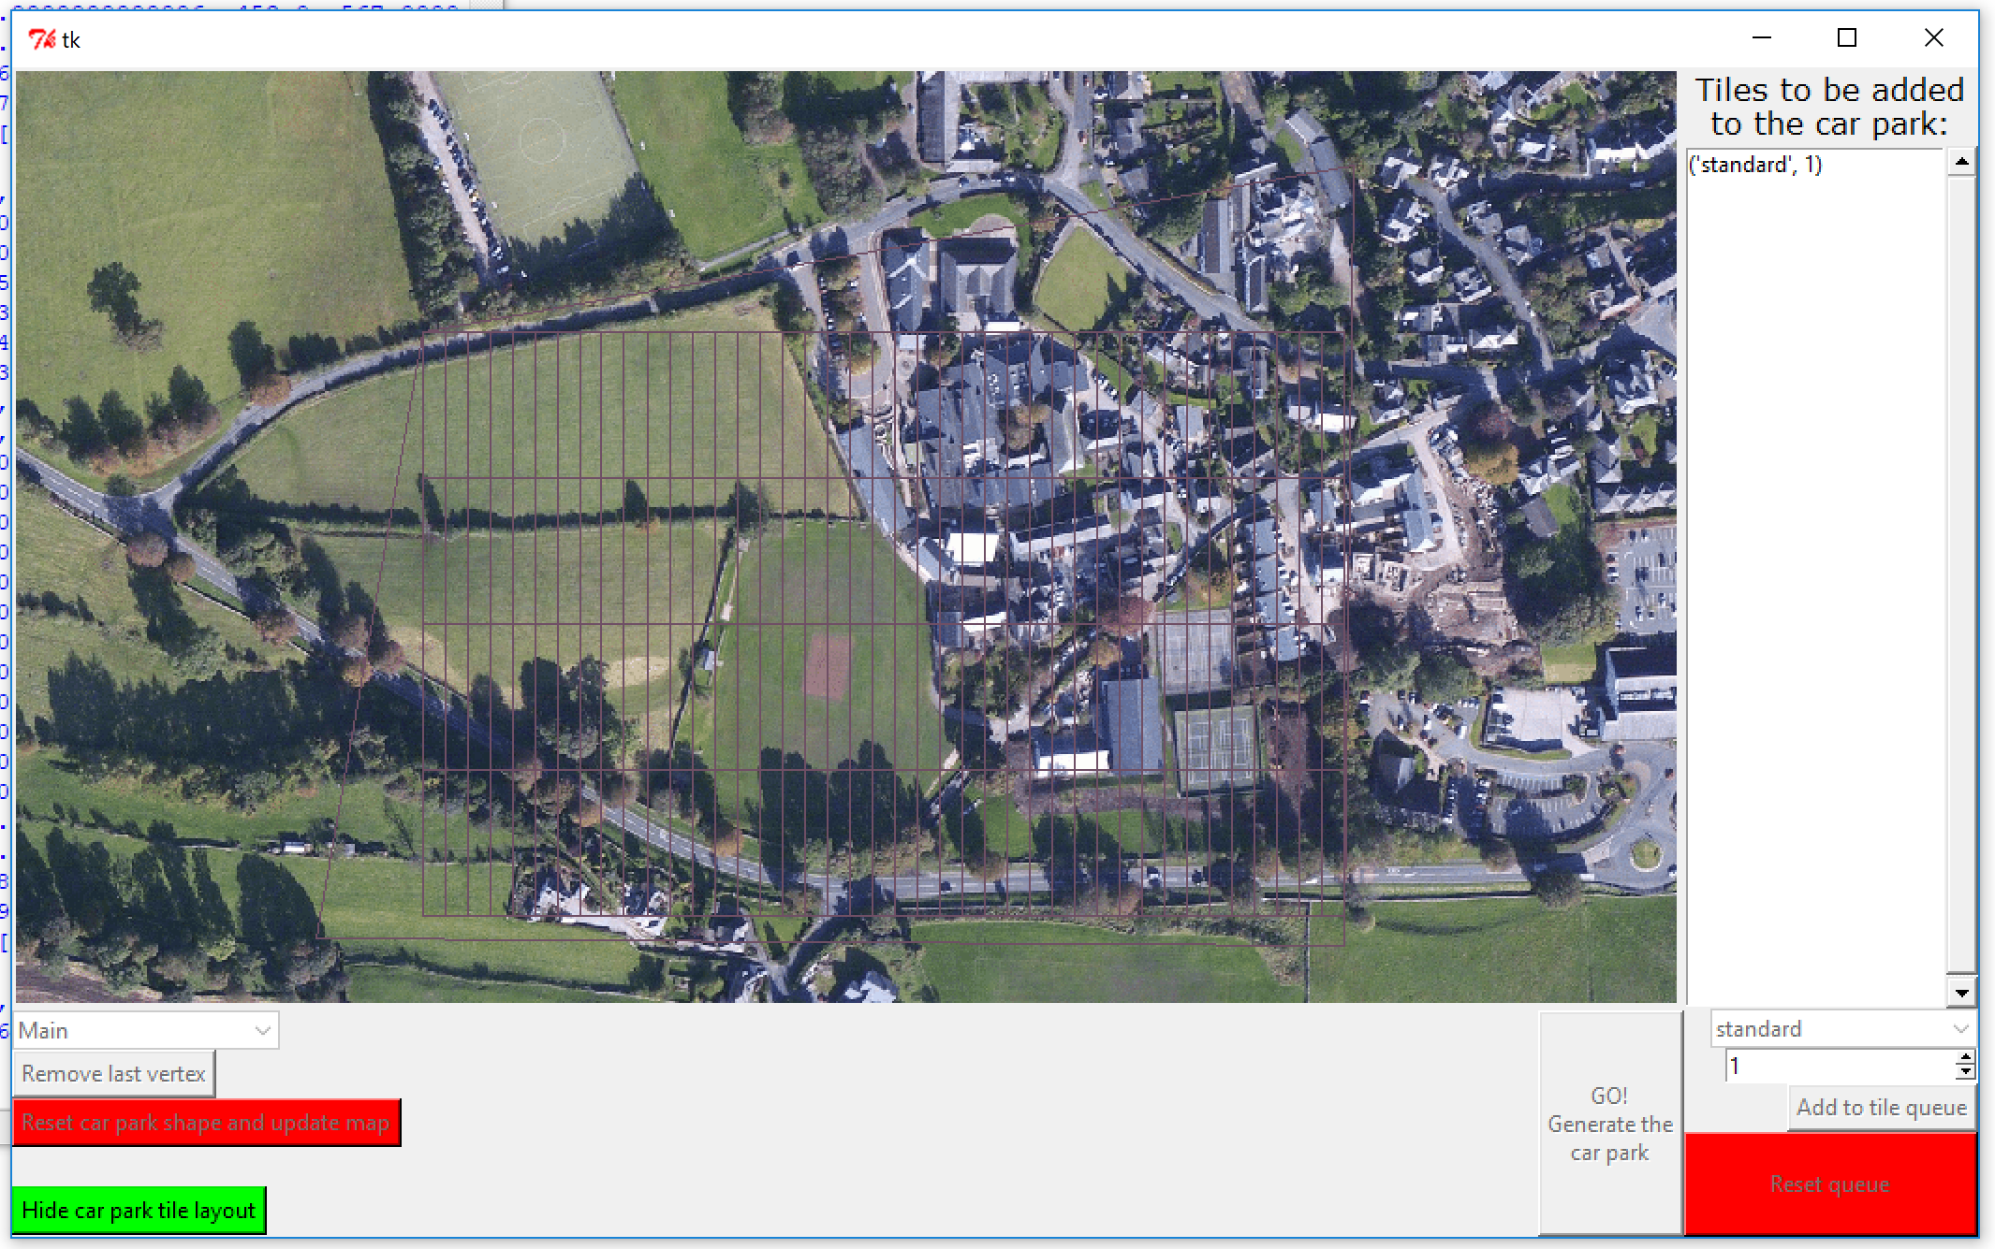

Although I was extremely happy with this I decided I would quickly fix the pixel to meter ratio I had. I ended up producing layouts now looking more sensible like this:

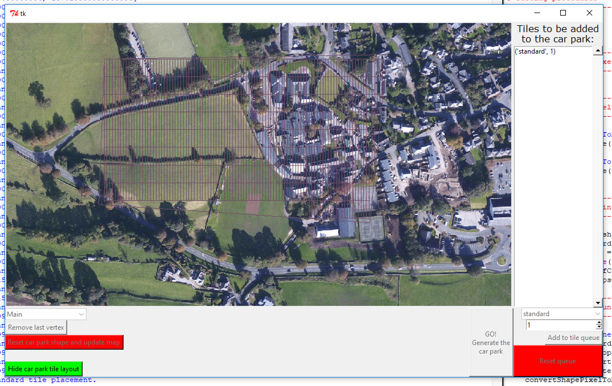

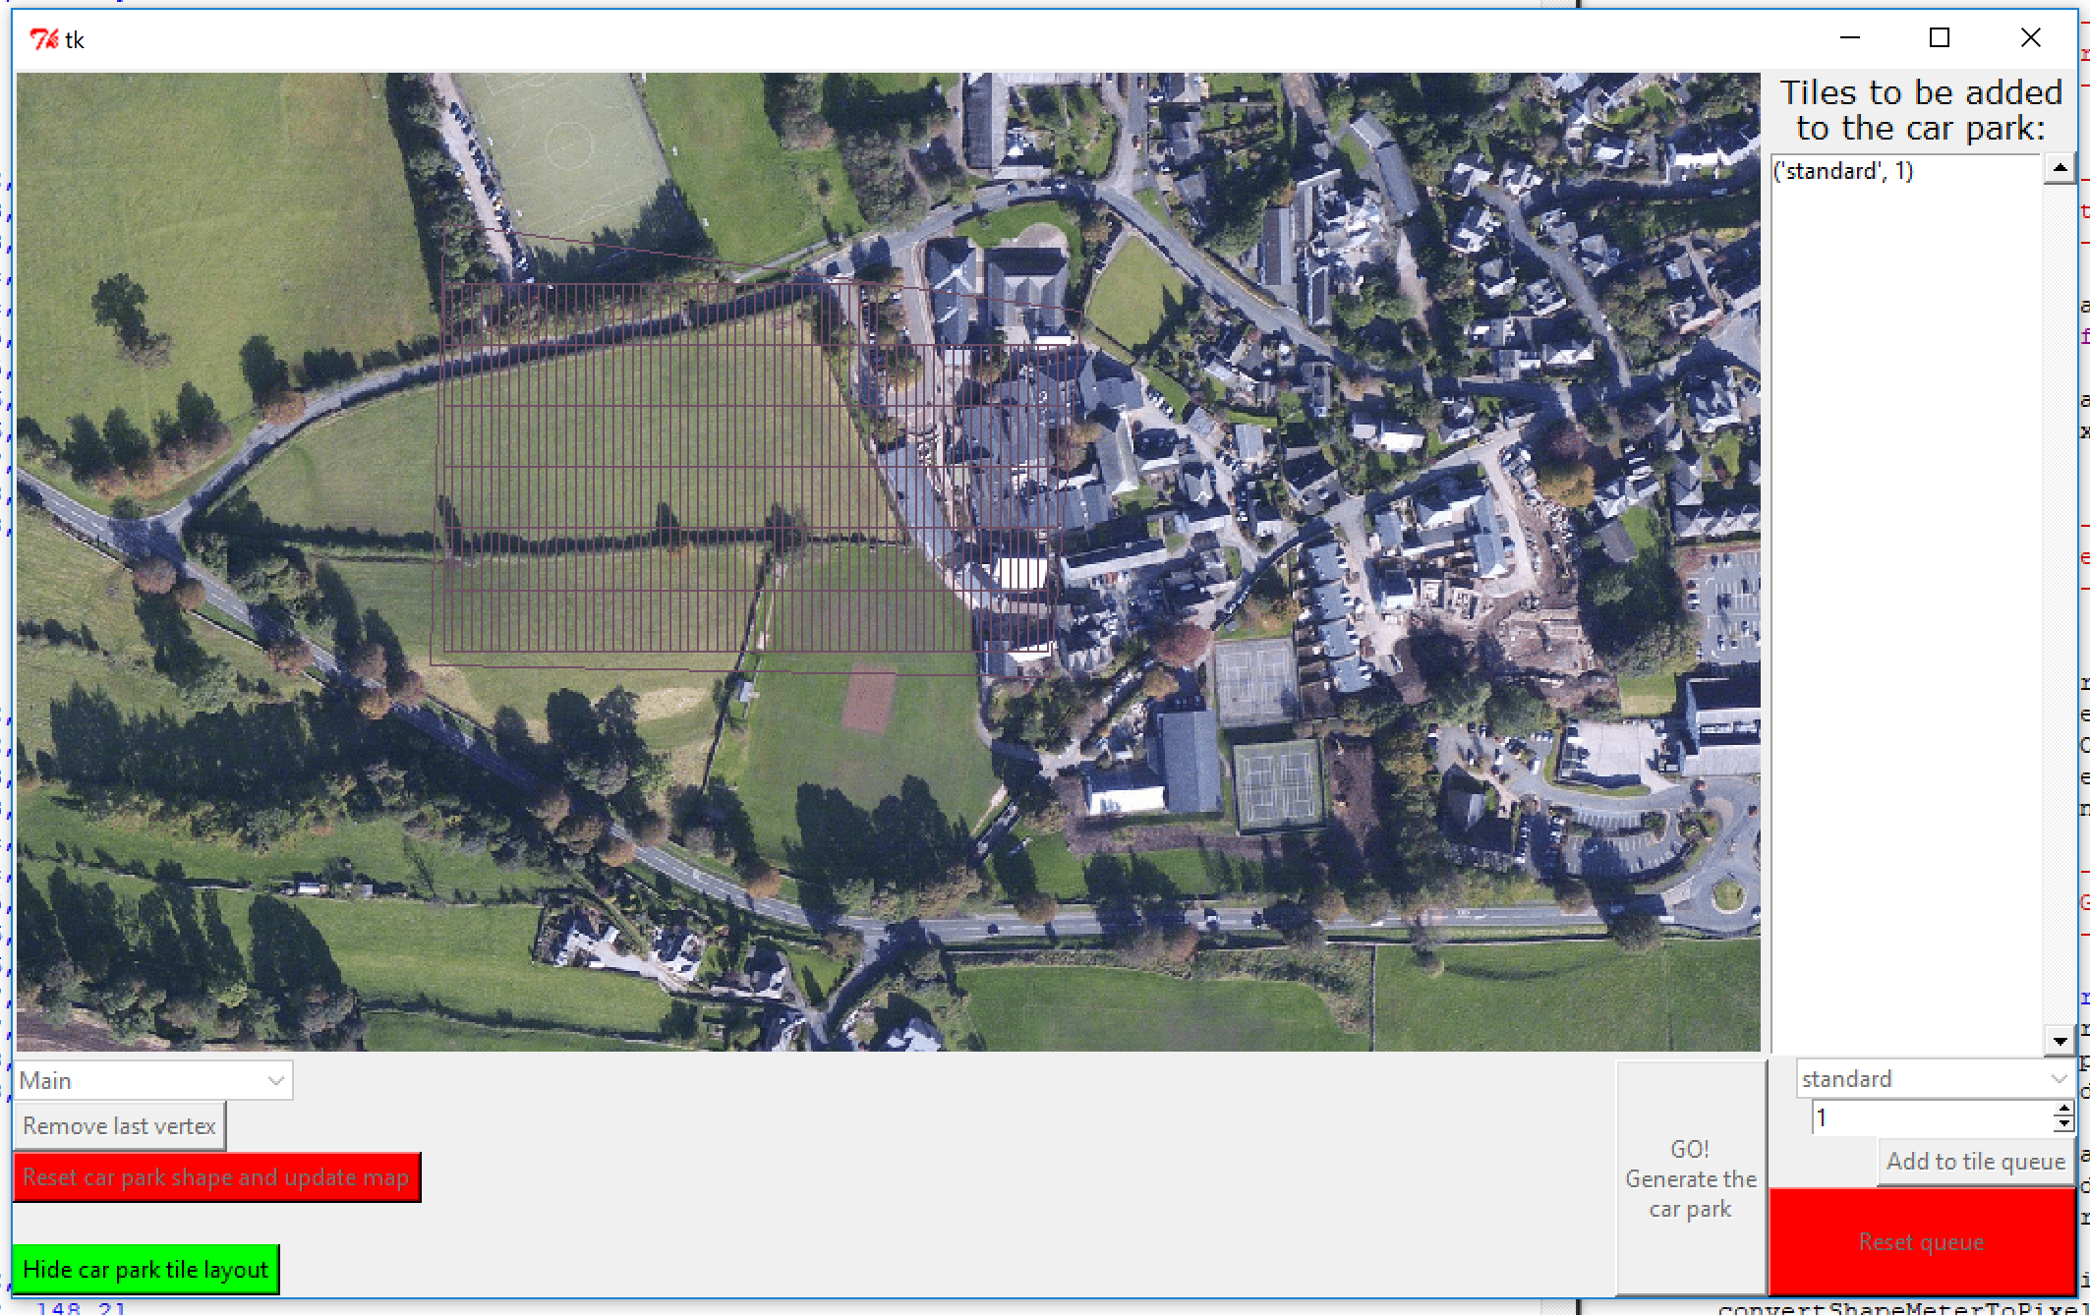

Notice that all these layouts are rotated at the same vertical position. Moving onto the processing code now that I can see the output will allow me to improve my algorithm.

## 5. Optimising the tile and trim algorithm now that I have a working GUI and further additions to the GUI

I will walk you through the changes I made in each version of the processing code, starting from v17 up to the latest version when I test my code.

### 5.1 What we are starting out with (v17.py)

This version was the earliest version of the processing code that worked with the GUI.

This version Follows the algorithm I covered in 3.5, I just removed the menu system and fed the output back to the GUI program in the form of an array of pairs of coordinates which lines will be drawn between.

This version simply passed back the edges of the tile shapes it had created.

To get these pairs I used counter controlled loops to iterate through a list of coordinates.

#### 5.1.1 getEdgesOfShapes procedure code

def getEdgesOfShapes(shape):

listOfGroupsOfCoordinatesForLines = [] #eg: [[x1,y1,x2,y2],[x3,y3,x4,y4]...]

listOfCoordinates = shape.getVerticesCoordinates()

for count in range(len(listOfCoordinates)):# each in carParkShape.getVerticesCoordinates():

listOfGroupsOfCoordinatesForLines.append([listOfCoordinates[count][0],listOfCoordinates[count][1],listOfCoordinates[(count+1)%len(listOfCoordinates)][0],listOfCoordinates[(count+1)%len(listOfCoordinates)][1]])

return listOfGroupsOfCoordinatesForLines

#### 5.1.2 GetCarParkPixelLinesToDrawFromPixelShape procedure code

def GetCarParkPixelLinesToDrawFromPixelShape(shape,pixelsPerMeter):

listOfGroupsOfCoordinatesForLines = [] #eg: [[x1,y1,x2,y2],[x3,y3,x4,y4]...]

originalShape = copy.deepcopy(shape)

print shape.getVerticesCoordinates()

print pixelsPerMeter

convertShapePixelToMeter(shape,pixelsPerMeter)

print shape.getVerticesCoordinates()

parkingTilesMade = tileAndTrim(shape,tiles,listOFTuplesOfNamesOfTilesInListAndHowManyOfEach) #a list of tile shapes generated, currently in meters

for eachCarParkTile in parkingTilesMade: #adds edges of each tile to lines to be drawn

convertShapeMeterToPixel(eachCarParkTile,pixelsPerMeter) #converts the meters unit back to pixels unit.

edgesList = getEdgesOfShapes(eachCarParkTile) #gets lines of edges of each tile

listOfGroupsOfCoordinatesForLines.extend(edgesList) #concatinates the two lists

listOfGroupsOfCoordinatesForLines = listOfGroupsOfCoordinatesForLines + getEdgesOfShapes(originalShape) #adds edge of car park shape to be printed

return listOfGroupsOfCoordinatesForLines

#### 5.1.3 Code for converting between the two units (pixels and meters)

#-------------------------------------------------------------------------------

# code to convert pixel values to meters and back again

#-------------------------------------------------------------------------------

def convertShapePixelToMeter(shape,pixelsPerMeter):

shape.stretchShape(float(1/float(pixelsPerMeter)))

def convertShapeMeterToPixel(shape,pixelsPerMeter):

shape.stretchShape(float(pixelsPerMeter))

### 5.2 Rotating the car parking spaces (v18.py)

It turned out rotating the car park spaces was very complicated, it took me several days working on processing code v18 before I finally got it working. I ran into multiple issues on the way which I will cover now.

In version 18 I also attempted to draw the car park lines, not just the shape of the tiles

#### 5.2.1 Rotating so the longest side is on the bottom, not just horizontal

After my first attempt at rotating the car park so that the longest line was horizontal I found that roughly a quarter of test shapes I used rotated incorrectly and gave the longest line at the top. I saw this as it started packing the car park tiles from the vertex furthest away from the longest line and they did not sit flat on the longest line.

To fix this I implemented a test that would see if the vertex of the longest line’s y position was equal to the y position of the furthest down vertex. If it was not, then I would rotate the shape a further 180° ( π radians). I then double checked if it was on the bottom by querying the same if statement and I found that it was every time, so this fix worked.

To complete this addition to the program I needed to make sure it then rotated back the same amount after the car park was made, so I added 180° ( π radians) onto the angle that it should rotate back at the end of the tile and trim procedure.

Now that I had it rotating so that the longest line was on the bottom, it will rotate the shape, then tile and trim car parking spaces starting at the bottom left and moving across then up, then rotate all the spaces back the original angle the shape was rotated so that they fit the original shape.

Effectively this means the tile and trim starts at one of the vertices of the longest line, then moves across the longest line then up the car park relative to the longest line.

##### 5.2.1.1 Rotating car park shape code

#will rotate car park to make longest side sit flat, then will later rotate everything back

#this should line the spaces up with the longest side.

angle = carParkShape.getAngleForLongestSide()

origin = vertex(0,0)

carParkShape.rotateAboutAVertex(origin,angle)

if carParkShape.getVertices()[carParkShape.getLongestSide()].getY() == carParkShape.getFurthestDownVertex().getY():

print "successfully rotated first time"

else:

print "car park rotated another 180 degrees, so that longest side was on bottom."

carParkShape.rotateAboutAVertex(origin,(math.pi))

print "angle changed"

angle = angle + math.pi

if carParkShape.getVertices()[carParkShape.getLongestSide()].getY() == carParkShape.getFurthestDownVertex().getY():

print "longest line is now on bottom"

else:

print "longest line still not on bottom apparrently :("

##### 5.2.1.2 Rotating car park tiles back code

for eachTile in placedTiles: #finishes by rotating all tiles back so that they will display back in the original shape.

eachTile.rotateAboutAVertex(origin,-angle)

#### 5.2.2 Drawing car parking spaces

I approached this by drawing the bottom and top of the tile the same as before but now leaving a gap in the line where the road between the two spaces should be.

Therefore I needed to find the fraction of the line at the side of the tile that should be drawn for one space. I struggled with this a little and did not fix it until a later version of the program. I will however still show you the incorrect code and what it was displaying.

The thing I had wrong with finding this fraction was I was taking the roads width from the depth of a space when I was actually trying to take it from the depth of the tile.

I then needed to find the x and y coordinates for the new spaces, I have included this code below too. You will notice that this is within an if statement that sees what type of space the tile is. The shape’s label attribute is what I used to determine what type of space I had made earlier in the tile and trim algorithm.

##### 5.2.2.1 Code for finding fraction of side of tile to be drawn

fractionOfLongestLengthWhichIsNotRoad = float(((sizes['standardD']-sizes['roadWidth'])/2)/sizes['standardD'])

##### 5.2.2.2 Code for finding new vertices

def getLinesToDrawFromTiles(tileInstance):

listOfGroupsOfCoordinatesForLines = []

if tileInstance.getLabel() == 'standard' and displayJustTiles == False:

#print "standard tile... making space lines"

#will draw boxes where the car park should be"

fractionOfLongestLengthWhichIsNotRoad = float(((sizes['standardD']-sizes['roadWidth'])/2)/sizes['standardD'])

#first will draw the short lengths (the ends)

tempList = copy.deepcopy(tileInstance.getVerticesCoordinates()[0])

tempList.extend(tileInstance.getVerticesCoordinates()[3])

listOfGroupsOfCoordinatesForLines.append(copy.deepcopy(tempList))

tempList = copy.deepcopy(tileInstance.getVerticesCoordinates()[1])

tempList.extend(tileInstance.getVerticesCoordinates()[2])

listOfGroupsOfCoordinatesForLines.append(copy.deepcopy(tempList))

#will now get the 4 points at the edge of the roads, from bottom left and working clockwise

#will need to move the fraction of each side which is not a road along each of the longest edges in both directions

#makes referancing these numbers shorter and easier to read next

a = fractionOfLongestLengthWhichIsNotRoad

v0 = tileInstance.getVerticesCoordinates()[0] #vertex coords 0,1,2,3 from tile corners

v1 = tileInstance.getVerticesCoordinates()[1]

v2 = tileInstance.getVerticesCoordinates()[2]

v3 = tileInstance.getVerticesCoordinates()[3]

x0 = v0[0] #x coords

x1 = v1[0]

x2 = v2[0]

x3 = v3[0]

y0 = v0[1] #y coords

y1 = v1[1]

y2 = v2[1]

y3 = v3[1]

#gets middle points of parking place for drawing

#extraPoints = [[(x1-x0)*a+x0,(y1-y0)*a+y0], [(x0-x1)*a+x1,(y0-y1)*a+y1], [(x3-x2)*a+x2,(y3-y2)*a+y2], [(x2-x3)*a+x3,(y2-y3)*a+y3]]

#print extraPoints

#going to be a little complicated as the lines could be at angles.

#x=0,y=1

#print "coords"

#print tileInstance.getVerticesCoordinates()

p0 = [(x1-x0)*a+x0,(y1-y0)*a+y0] #new coordinate points that lines need drawing to from corners

p1 = [(x0-x1)*a+x1,(y0-y1)*a+y1]

p2 = [(x3-x2)*a+x2,(y3-y2)*a+y2]

p3 = [(x2-x3)*a+x3,(y2-y3)*a+y3]

v0.extend(p0)

v1.extend(p1)

v2.extend(p2)

v3.extend(p3)

print tileInstance.getVerticesCoordinates()

#listOfGroupsOfCoordinatesForLines.append([orig0,[0,0]])

listOfGroupsOfCoordinatesForLines.append(v0[:])

listOfGroupsOfCoordinatesForLines.append(v1[:])

listOfGroupsOfCoordinatesForLines.append(v2[:])

listOfGroupsOfCoordinatesForLines.append(v3[:])

else:

print "tile type not supported yet, using standard edge of tile instead"

listOfGroupsOfCoordinatesForLines = getEdgesOfShape(tileInstance)

return listOfGroupsOfCoordinatesForLines

##### 5.2.2.3 Screenshots showing current progress

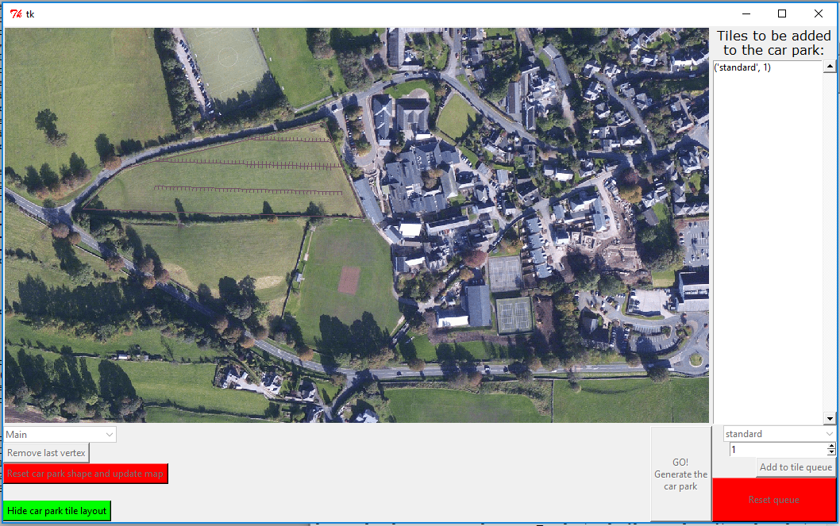

As you can see from this screenshot the parking spaces are being drawn too short and in the wrong direction, all because I was working out the fraction wrong.

### 5.3 Fixing problems caused by rotating the spaces and showing spaces more clearly (v19.py)

In version 19 I added a global variable called printProgress that allows to stop the program printing anything to the command line when it runes but also allows to me see what’s happening in the program to help me debug if I need. I implemented by having if statements checking the global Boolean variable around everywhere I previously had print statements.

I also fixed the problem where there was a missing row where tiles should have been placed. I will go into detail about this in section 5.3.1.

I also fixed the issue I was having with printing car park spaces (not tiles) through working out a correct fraction, I will go into detail about this in section 5.3.2.

#### 5.3.1 The program left an empty row where there should have been spaces (v19.py)

As can be seen in this screenshot, the car park was leaving an empty row where there should have been room for spaces:

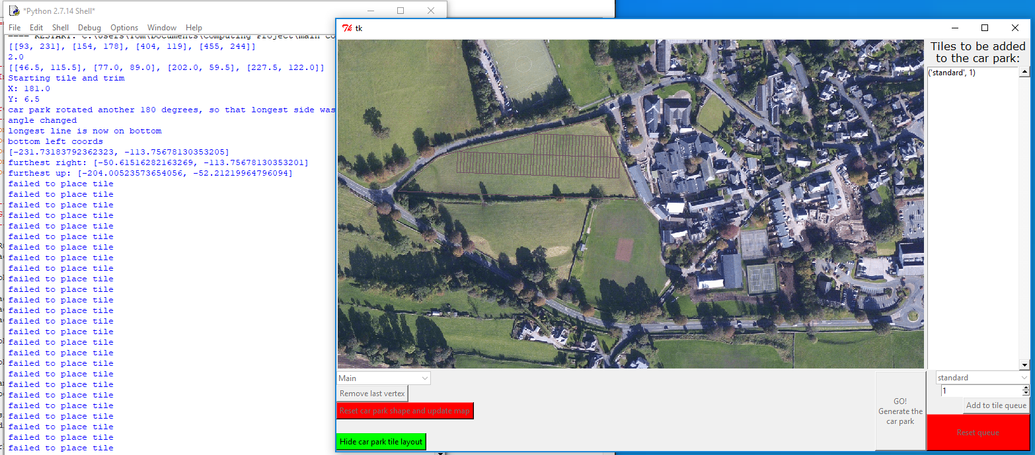

After some testing I found this issue was because the shapely module (which is what I use to test if a point is inside or outside of the car park shape returns that the point is outside the shape if it is on the boundary. As well as this due to slight rounding errors just testing if it was on the boundary could still lead to an error. To fix this I simply moved the starting point of where tiles are placed to be 1mm above the edge of the car park. This tiny amount will not make any difference to the car park design but will allow it to successfully place the first row as shown below:

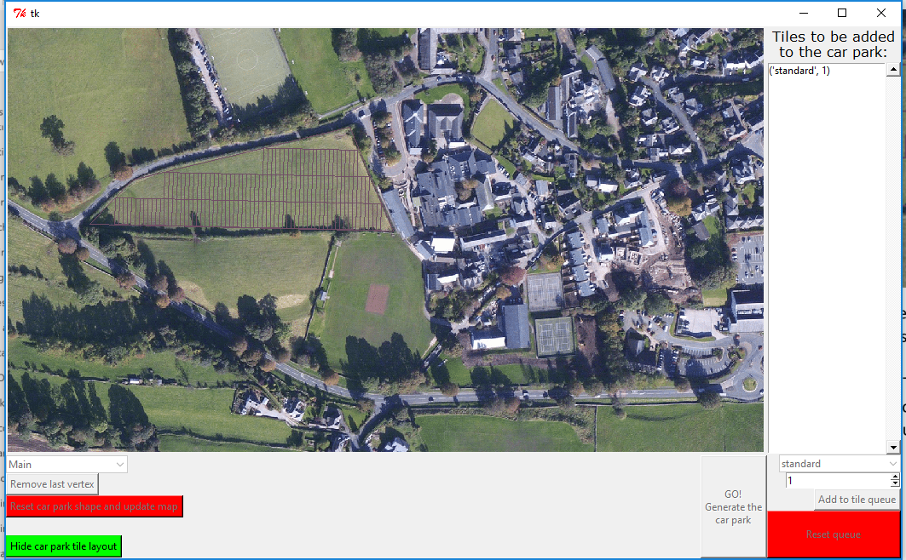

As good practice, I made the amount it moves the starting up a global constant to make it easy to change.

##### 5.3.1.1 Code for defining placement buffer

placementBufferForFirstTiles = 0.001#meters (1mm should fix some problems where the tiles would not be placed)

##### 5.3.1.2 Code for implementing placement buffer

bottomLeftVertex = vertex(carParkShape.getFurthestLeftVertex().getX(),carParkShape.getFurthestDownVertex().getY()+placementBufferForFirstTiles)

#### 5.3.2 Implementing drawing car park spaces, not just tiles

I had already attempted this in section 5.2.2, from there you will remember that it did not work. After trying solutions such as switching the x and y coordinates, rotating the lines 180 degrees and more I found that my sum for finding the length was wrong.

Side note: I was accidentally getting a negative number for the fraction so that was why they were being drawn backwards.

I have included some screenshots with explanations of earlier fixes I attempted before I found the route of the problem

##### 5.3.2.1 Code

###### 5.3.2.1.1 Old

#fractionOfLongestLengthWhichIsNotRoad = float(((sizes['standardD']-sizes['roadWidth'])/2)/sizes['standardD']) <-- old sum

###### 5.3.2.1.2 New

fractionOfLongestLengthWhichIsNotRoad = float((sizes['standardD'])/(sizes['standardD']*2+sizes['roadWidth']))

##### 5.3.2.2 Screenshots

###### 5.3.2.2.1 Original

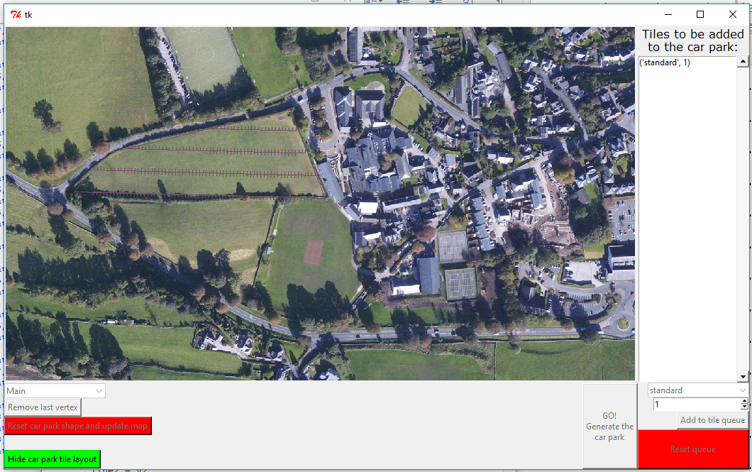

The first window is how the screen looks to the user but for these next few screenshots I will zoom in on the important area.



You can see that the lines for each car park space are pointing in the wrong direction.

###### 5.3.2.2.2 After trying to rotate the points 180 degrees

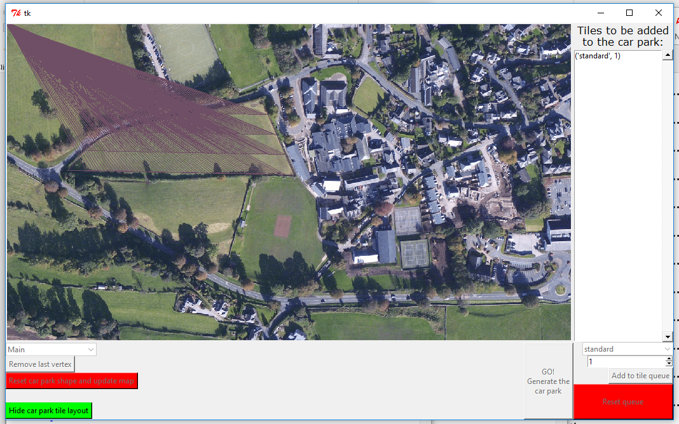

You can see that through rotating the points by 180 degrees I forgot that they were rotated about the origin, so all points were being drawn to the top left of the map, since the origin of an image is in the top left.

###### 5.3.2.2.3 After properly rotating them 180 degrees.

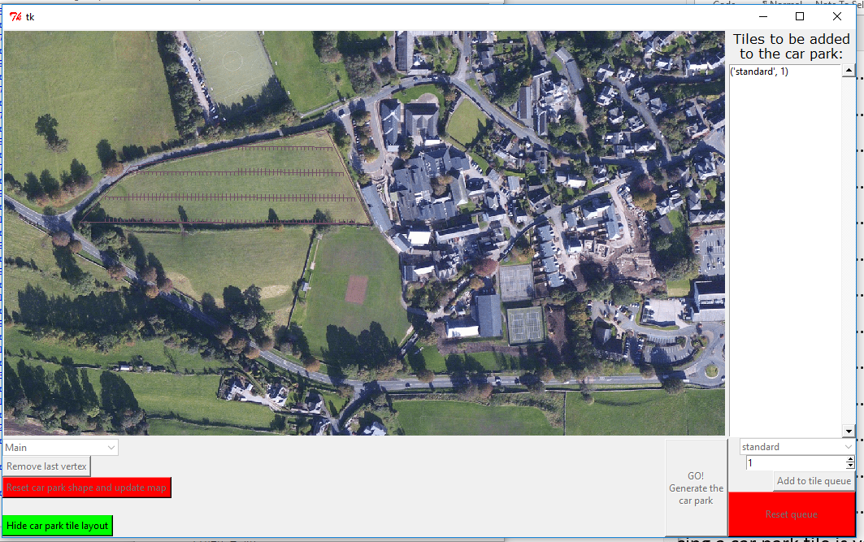

After then rotating the points to be drawn 180 degrees around each of the correct points that the lines were being drawn from I was given this output. It looked better and tricked me into thinking I had found a fix to the problem. I then just believed I had a wrong road width value, so I tried changing that.

Below is the code I used to rotate the points.

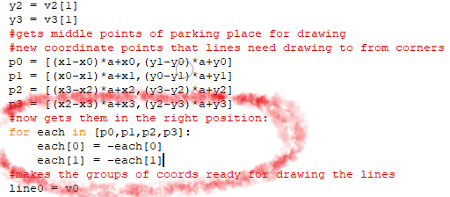

###### 5.3.2.2.4 Final fix

I found that my problem finally when I looked deeper at my code. To help me concentrate on each line and exactly what it was doing I tried explaining my code to a friend not taking Computer Science, during this I spotted my mistake and fixed it with the code in section 5.3.2.1.2.

Here is the screenshot of the final solution:

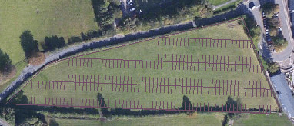

### 5.4 Adding a feedback message box (v20.py, v21.py and GUIv8.py)

In version 19.py the user got feedback from how the creation of the car park went while it was being created and in the command line, this looked as follows:



Since this program is going to be ran by a client, I want them to not to have to interact with the command line at all. This also means nothing can be printed to it, so it does not appear.

Therefor I needed to print a message either in the existing window or make a new window to print the message in. I did have the option to print the message in the space highlighted below but I decided instead to show the message in a new window so that the user will see it clearly and because It would be able to display a message of any length.

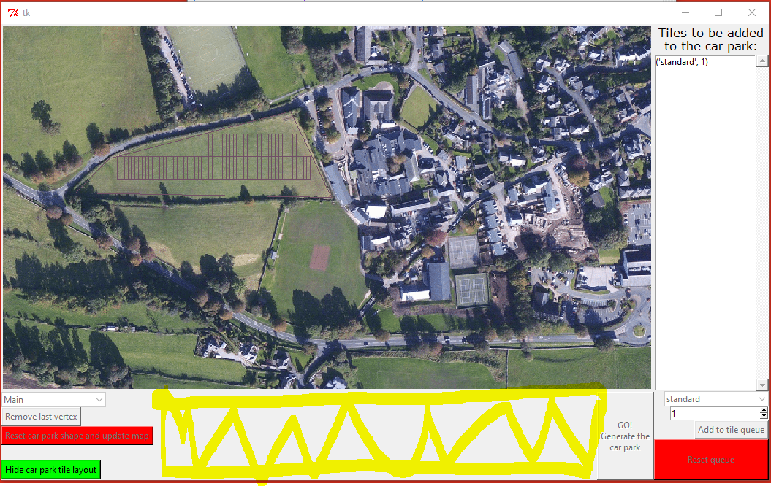

I decided I would try and find a python library that would easily let me open a new window and display a message box in it. After some research I found a python module called tkMessageBox from tutoralpouint (Tutorials Point, n.d.).

I imported this module to the GUI program using:

import tkMessageBox

I decided that it would be nicer to present one message box to the user after it has succeeded or failed to make the car park compared to how it currently gave many messages back in command line. For this I append to a string variable each time the processing code had something to tell the user. This string was then passed back to the GUI code where it is displayed in a message box.

#### 5.4.1 Initial attempt (v20.py and GUIv8.py)

From my previous work in python I knew that appending two strings would lead them to be on the same line, I needed a way to add them with a line break at the end of each using: ”\n”.

The tkMessageBox module has multiple functions for different types of message boxes, I decided to choose one that displayed an information icon on it, as this was a generic image. I also opted to only have an “OK” button, as I did not need any other buttons. I titled the message box window “Report”.

Below you can see the first message box I received, as you can see I had accidentally set it to return all messages without line breaks as I had accidentally typed “/n” instead of “\n” to create a new line.

##### 5.4.1.1 Screenshot

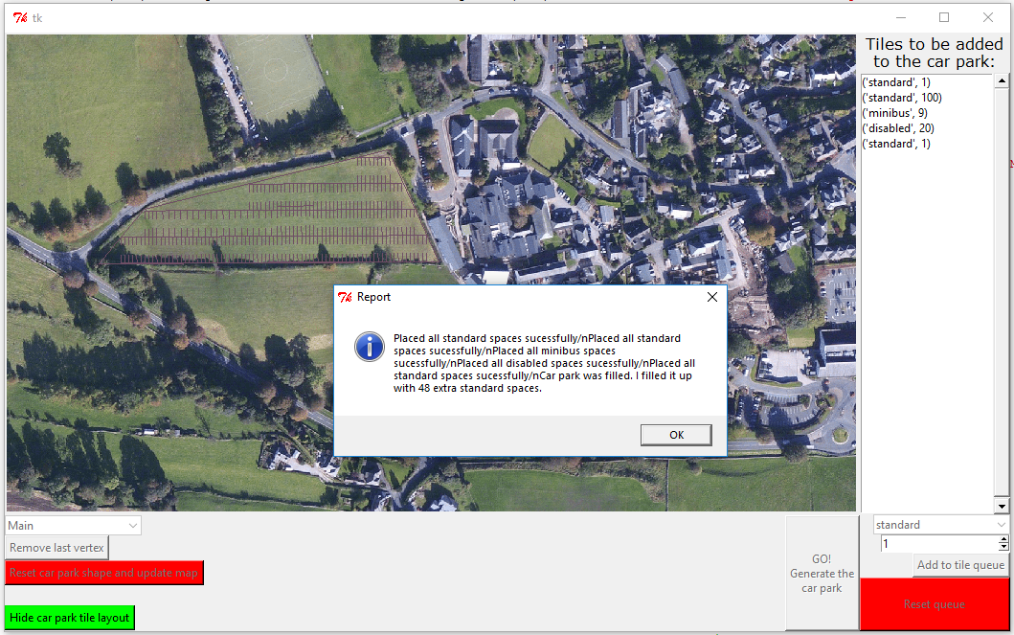

A nice thing about this message box is that it cannot be ignored, you have to close it before you carry on interacting with the main window.

##### 5.4.1.2 Passing back the message to the GUI

To pass back the message to the GUI I made use of the way python can return more than one value from a procedure if you separate them with commas.

###### 5.4.1.2.1 Passing from tileAndTrim to GetCarParkPixelLinesToDrawFromPixelShape

5.4.1.2.1.1 tileAndTrim return code

return placedTiles,messageToPrint

5.4.1.2.1.2 GetCarParkPixelLinesToDrawFromPixelShape code

parkingTilesMade,messageToPrint = tileAndTrim(shape,tiles,listOFTuplesOfNamesOfTilesInListAndHowManyOfEach)

###### 5.4.1.2.2 Passing from GetCarParkPixelLinesToDrawFromPixelShape to the goButton’s buttonClicked method

5.4.1.2.2.1 GetCarParkPixelLinesToDrawFromPixelShape code

return listOfGroupsOfCoordinatesForLines,messageToPrint

5.2.1.2.2.2 goButtons’s buttonClicked method code

listOfGroupsOfCoordinatesForLines,messageToPrint = processingCode.GetCarParkPixelLinesToDrawFromPixelShape(carParkShape,pixelsPerMeter)

###### 5.4.1.2.3 displaying the message box code in the goButton’s buttonClicked method

tkMessageBox.showinfo("Report",messageToPrint)

#### 5.4.2 Fixing the messages to appear on new lines (v21.py)

The only changes I made in version 21 of the processing code was changing the “/n” to a “\n” and removing a print useless print statement I had earlier used for debugging.

##### 5.4.2.1 Adding to the message to print code

messageToPrint = messageToPrint + "Placed all " + str(howMany) + " of " + str(tileLabel) + " spaces sucessfully\n"

##### 5.4.2.2 Screenshot of working message box

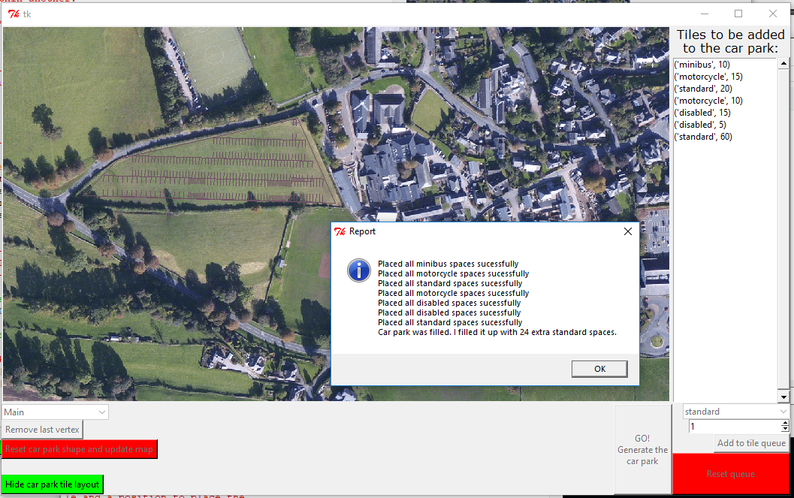

As you can see in the above screenshot, I here noticed that I had an issue when adding minibus spaces that it would then alter add other spaces over the top of it, this is an issue I will fix in later versions.

#### 5.4.3 Other changes made in GUIv8.py

In this version I made a minor change to the view of when the user is designing the car park. I decided the vertices should be shown as hollow circles rather than the solid ones so that the user can easily see exactly where the corners of their car park are.

##### 5.4.3.1 Screenshot of before

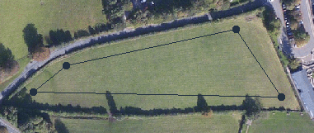

##### 5.4.3.2 Screenshot of after

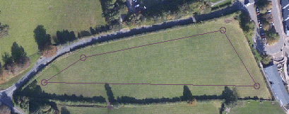

#### 5.4.4 Other changes made in v20.py

I also moved the fractions being calculated for help when drawing the car parking spaces in tiles to be outside of the getLinesToDrawFromTiles subroutine so that they were not re-calculated for every car park tile drawn. They are now stored in a dictionary so they can be easily accessed.

##### 5.4.4.1 Dictionary of fractions of side to be drawn for car park tiles code

#for next subroutine

fractionOfLongestLengthWhichIsNotRoad = {'standard':float((sizes['standardD'])/(tiles['standard'].getDepth())), #gets the fraction of the side of the tile to be drawn as the car park space

'minibus':float((sizes['minibusD'])/(tiles['minibus'].getDepth())), #depth of space divided by depth of tile

'disabled':float((sizes['standardD'])/(tiles['disabled'].getDepth())),

'motorcycle':float((sizes['motorcycleD'])/(tiles['minibus'].getDepth()))}

### 5.5 Adding the sharing options (GUIv9.py)

For adding the sharing options, I needed to implement a menu bar. I decided that while I was adding the menu bar I would also add a help button into this so that the user can easily access some simple instructions about how to use the program.

I was going to add two methods of sharing the car park image: saving the picture to a user defined location and emailing the image.

I decided that I would first tackle saving the image.

#### 5.5.1 Adding a menu bar

I found a helpful document (Lundh, The Tkinter Menu Widget, 2014) from Effbot for adding a menu to my window.

I added the menu bar to my root window as the menu bar did not need to be redrawn at all once the window is created. I decided I would put the creation of the menu bar in a subroutine to keep my code looking tidy.

To add the menu bar I used the following code:

menubar = tk.Menu(window) #creates menubar

window.config(menu=menubar) #adds menubar to the window

##### 5.5.1.1 Adding the help button

For adding the help button I used the following code between the two previous lines:

menubar.add_command(label = "Help", command = showHelpMessageBox)

this added a button with the “Help” text on it and when clicked it would run the procedure showHelpMessageBox.

For the new procedure I decided it would be easiest to read the message to print from a file and then print it. This would make it easier to change the help message if I add new features to the program. I used techniques I already knew to open and read from a file and then close the connection. I then opened an information box (using the tkMessageBox module) with the title "Here's some help" and the content as the content of the text file. Below you can see the code I used for this procedure:

def showHelpMessageBox():

helpFile = open('Help.txt','r')

helpMessage = helpFile.read()

helpFile.close()

tkMessageBox.showinfo("Here's some help",helpMessage)

I tested it and it worked. Below are screenshots of the message box and the text file.

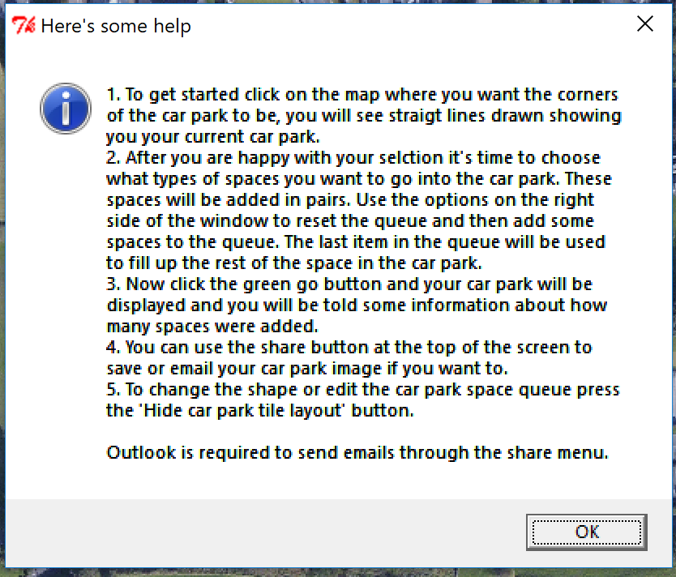

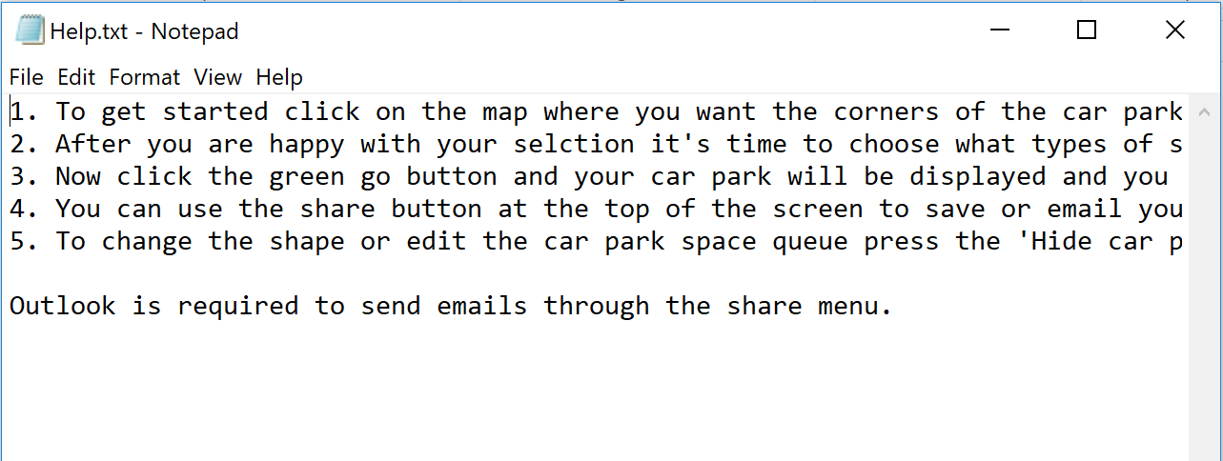

##### 5.5.1.2 Adding the share drop down menu with the share buttons

I added the drop-down menu and its buttons with the below code:

def addMenubar(window):

menubar = tk.Menu(window) #creates menubar

shareMenu = tk.Menu(menubar, tearoff = 0) #adds option to menu bar

shareMenu.add_command(label = 'Save image to file', command = saveImageToFile) #adds option to save image to file

shareMenu.add_command(label = 'Email car park image', command = emailCarParkImage) #adds option to save image to file

menubar.add_cascade(label="Share", menu=shareMenu) #adds share menu to menubar

menubar.add_command(label = "Help", command = showHelpMessageBox)

window.config(menu=menubar) #adds menubar to the window

#### 5.5.2 Allowing the user to save their car park image (saveImageToFile)

I know how to save an image to a file path already but I need an easy way for the user to enter the file path and file name they would like to use. I decided to look for a module that would help me. From research I found this (Lundh, File Dialogs, 2014) Effbot webpage detailing how to use the tkFileDialog. With this is was able to open the default windows explorer file picked view to choose where to save a file and with what name. Calling tkFileDialog.asksaveasfilename([options]) returned a file path.

I decided to use error trapping in me code to help the user, in case they choose an invalid file path.

##### 5.5.2.1 saveImageToFile Code

def saveImageToFile():

#print "stub for saving image to file"

try:

filepath = tkFileDialog.asksaveasfilename(defaultextension = "bmp", title = "Choose where to save the image")

globalMapImage.save(filepath,"bmp")

tkMessageBox.showinfo("Report","Successfully saved image to: " + str(filepath))

except:

tkMessageBox.showinfo("Report","There was an error saving the image")

##### 5.5.2.2 Screenshots

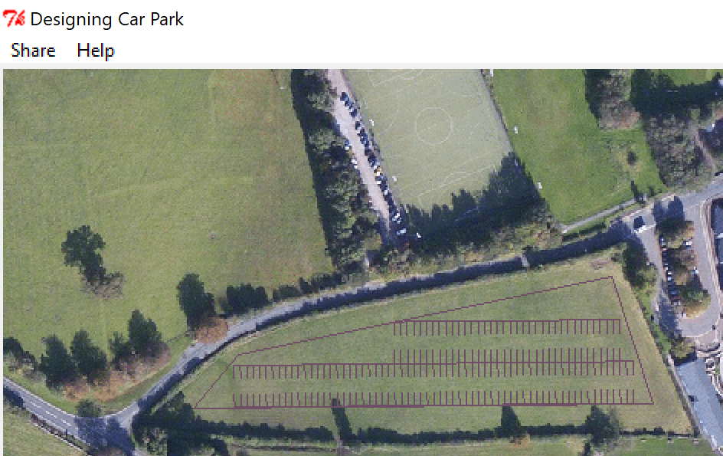

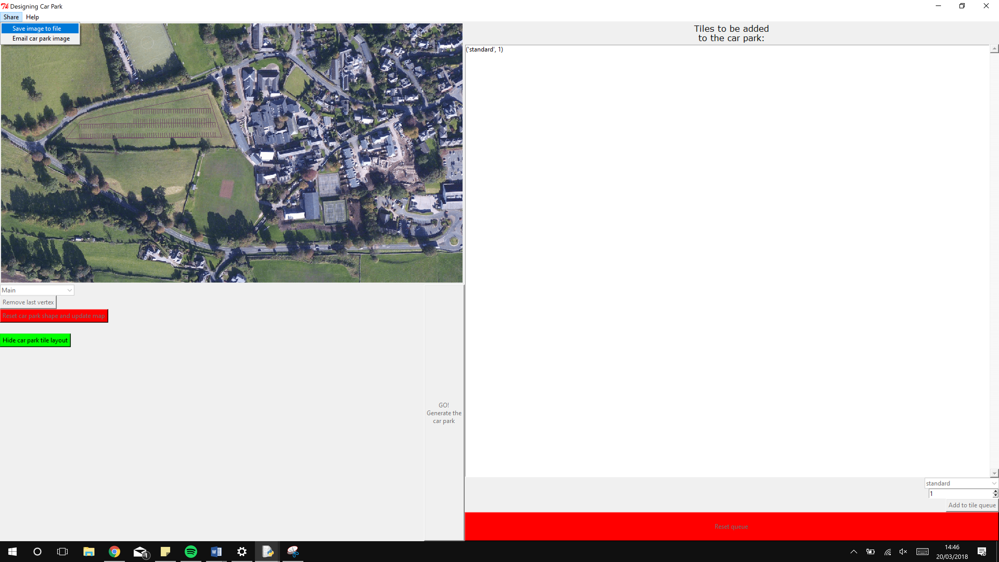

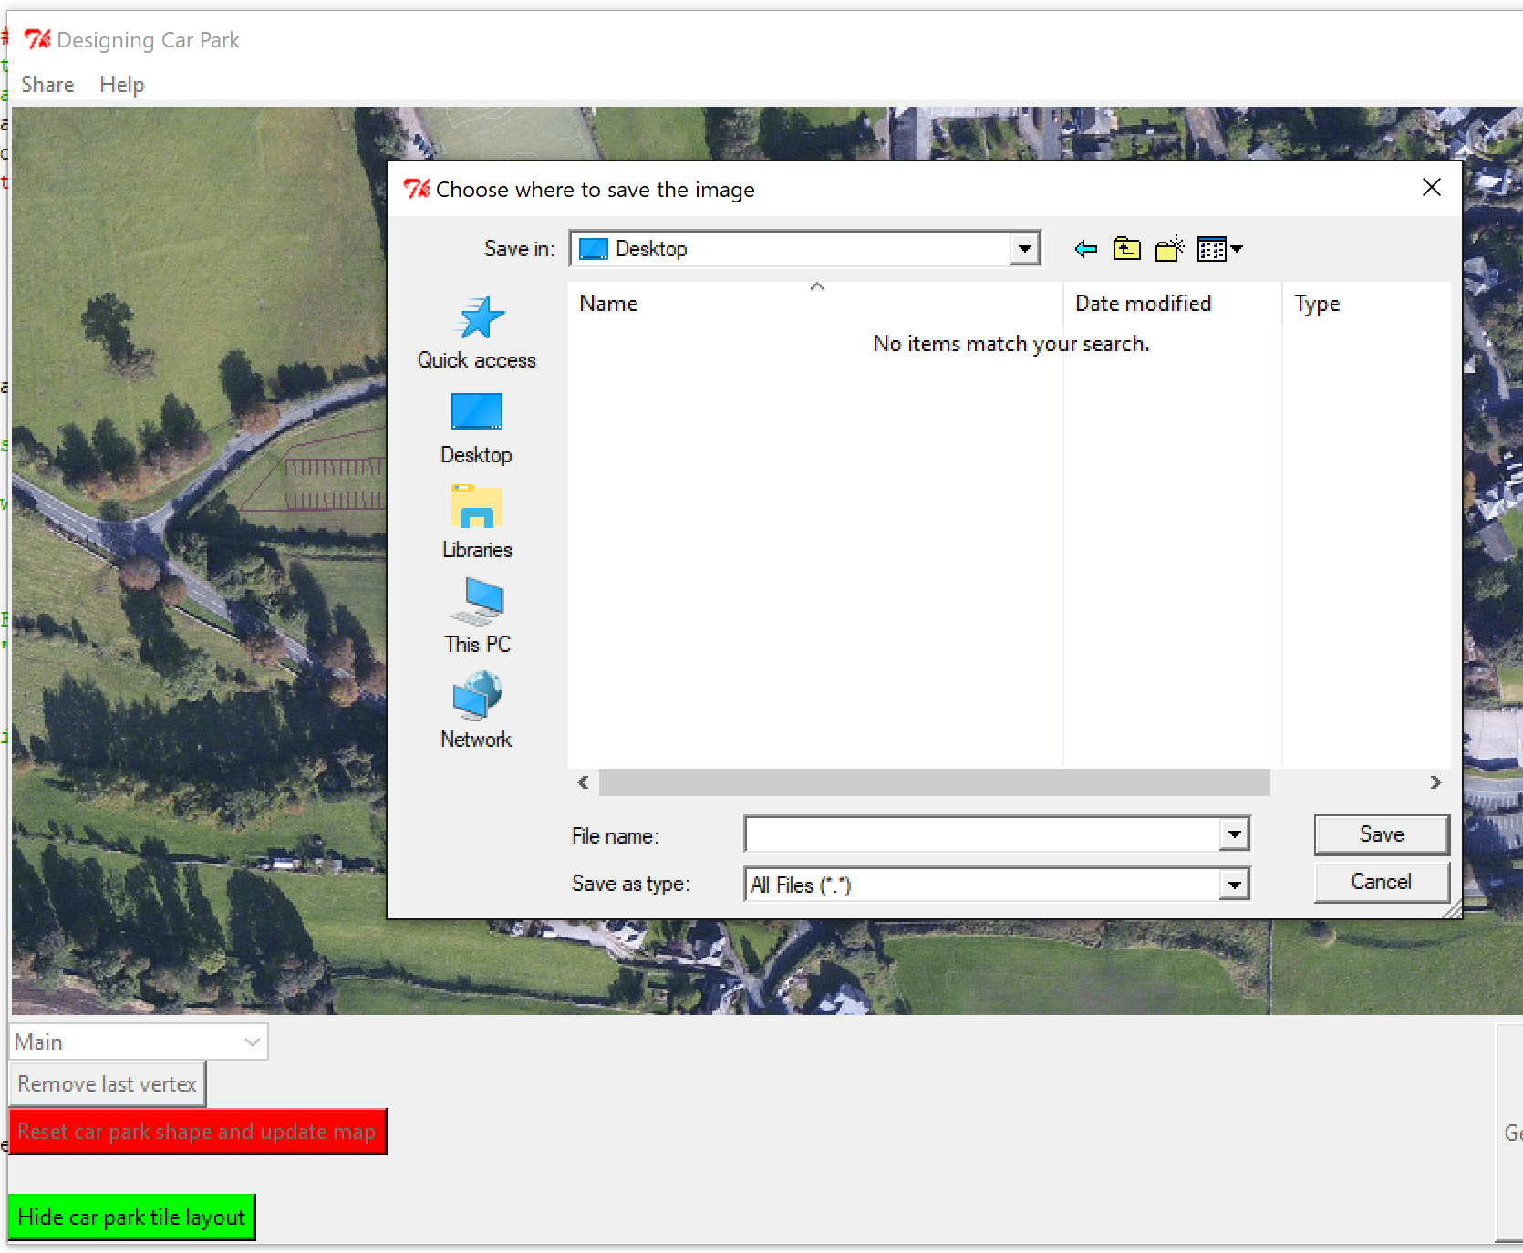

This dialog even lets the user create new folders, rename them and choose the file name. 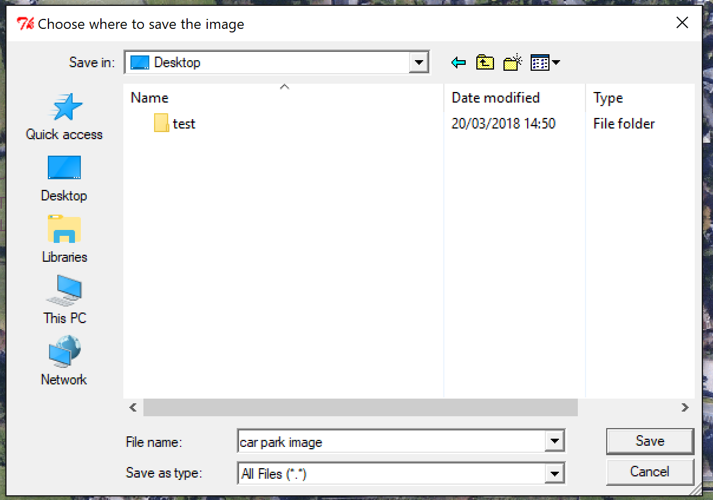

I then clicked save and this message showed:

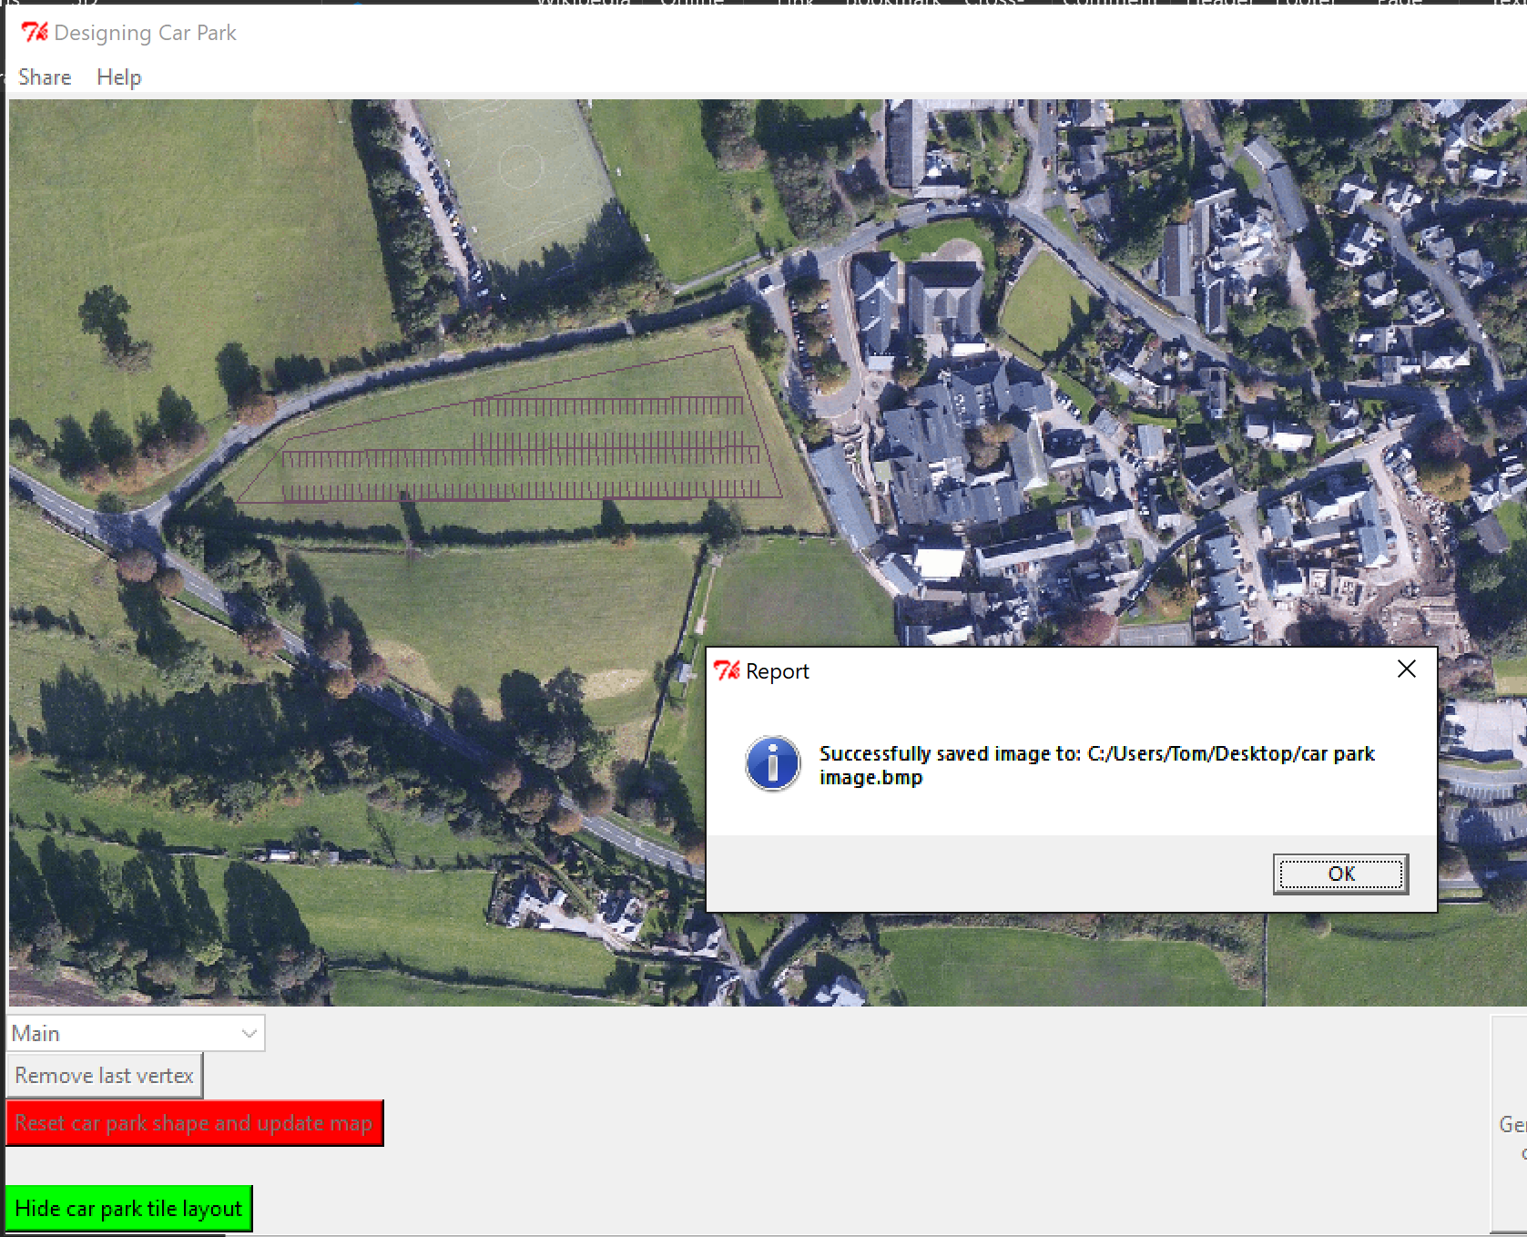

I then checked on my desktop and found the image was there:

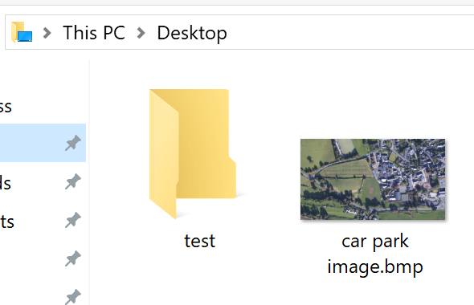

I was also able to open it, here is the image:

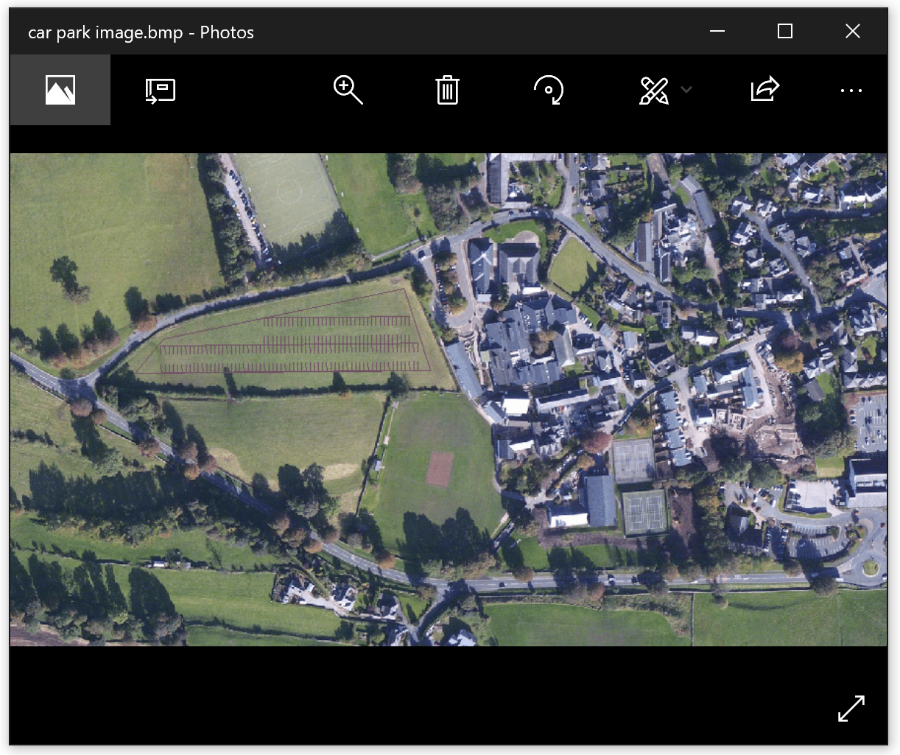

Note that the image just looks small in that screenshot as I am using a high resolution screen. If you can zoom in it still looks okay:

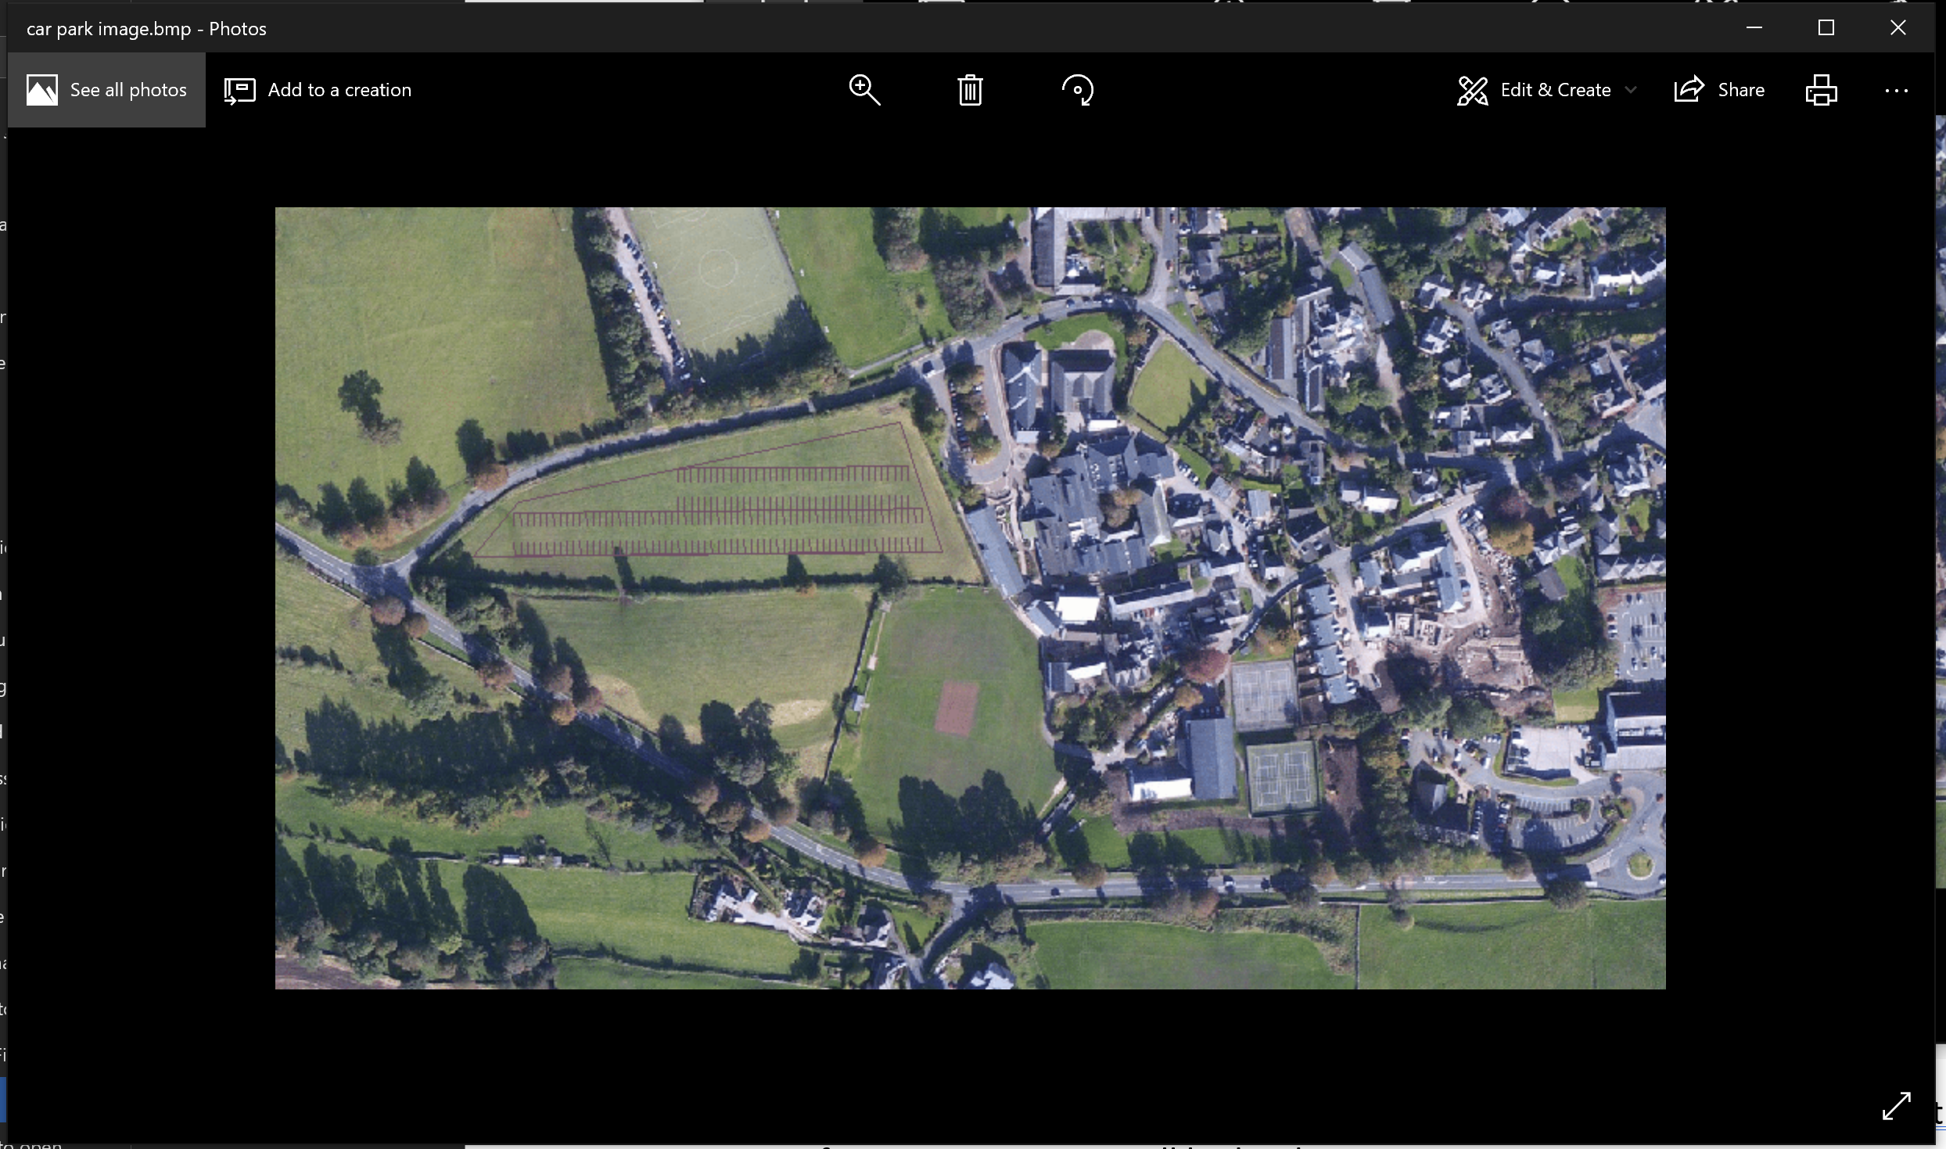

#### 5.5.3 Allowing the user to open an email draft to send their car park image (emailCarParkImage)

From research into how to easily open a draft email from python I found a document (Görmezer, 2017) by Mustafa Görmezer detailing how to use a module called win32 that lets you easily use built in windows features, such as opening another application with various attributes, in this case an email with an attachment added.

Win32’s Dispatch method allows you to interface with an application, in my case, outlook.

##### 5.5.3.1 Installing the win32 module screenshots

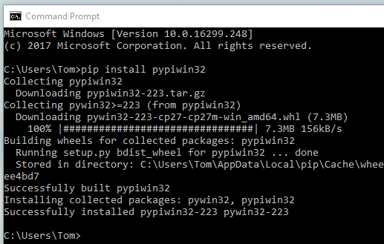

You can see here that it installed correctly using the command I found from Kanguros (Kanguros, 2016) on stack overflow.

You can see from the code below I decided not to include pre-set to and body fields but to include a default draft email subject. In this interim version of code I also printed the file path of the file, I will remove this in a later version.

##### 5.5.3.2 Code

def emailCarParkImage():

#print "stub for emailing car park image"

filepath = os.getcwd() + "\\" +"tempImageForEmail.bmp"

globalMapImage.save("tempImageForEmail.bmp","bmp")

import win32com.client as win32

outlook = win32.Dispatch("outlook.application")

mail = outlook.CreateItem(0)

#mail.To = ""

mail.Subject = "Car Park Image Email"

#mail.HtmlBody = "some text"

print filepath

mail.Attachments.Add(filepath)

mail.Display(False)

##### 5.5.3.3 Screenshots of draft email and proof of receiving the image

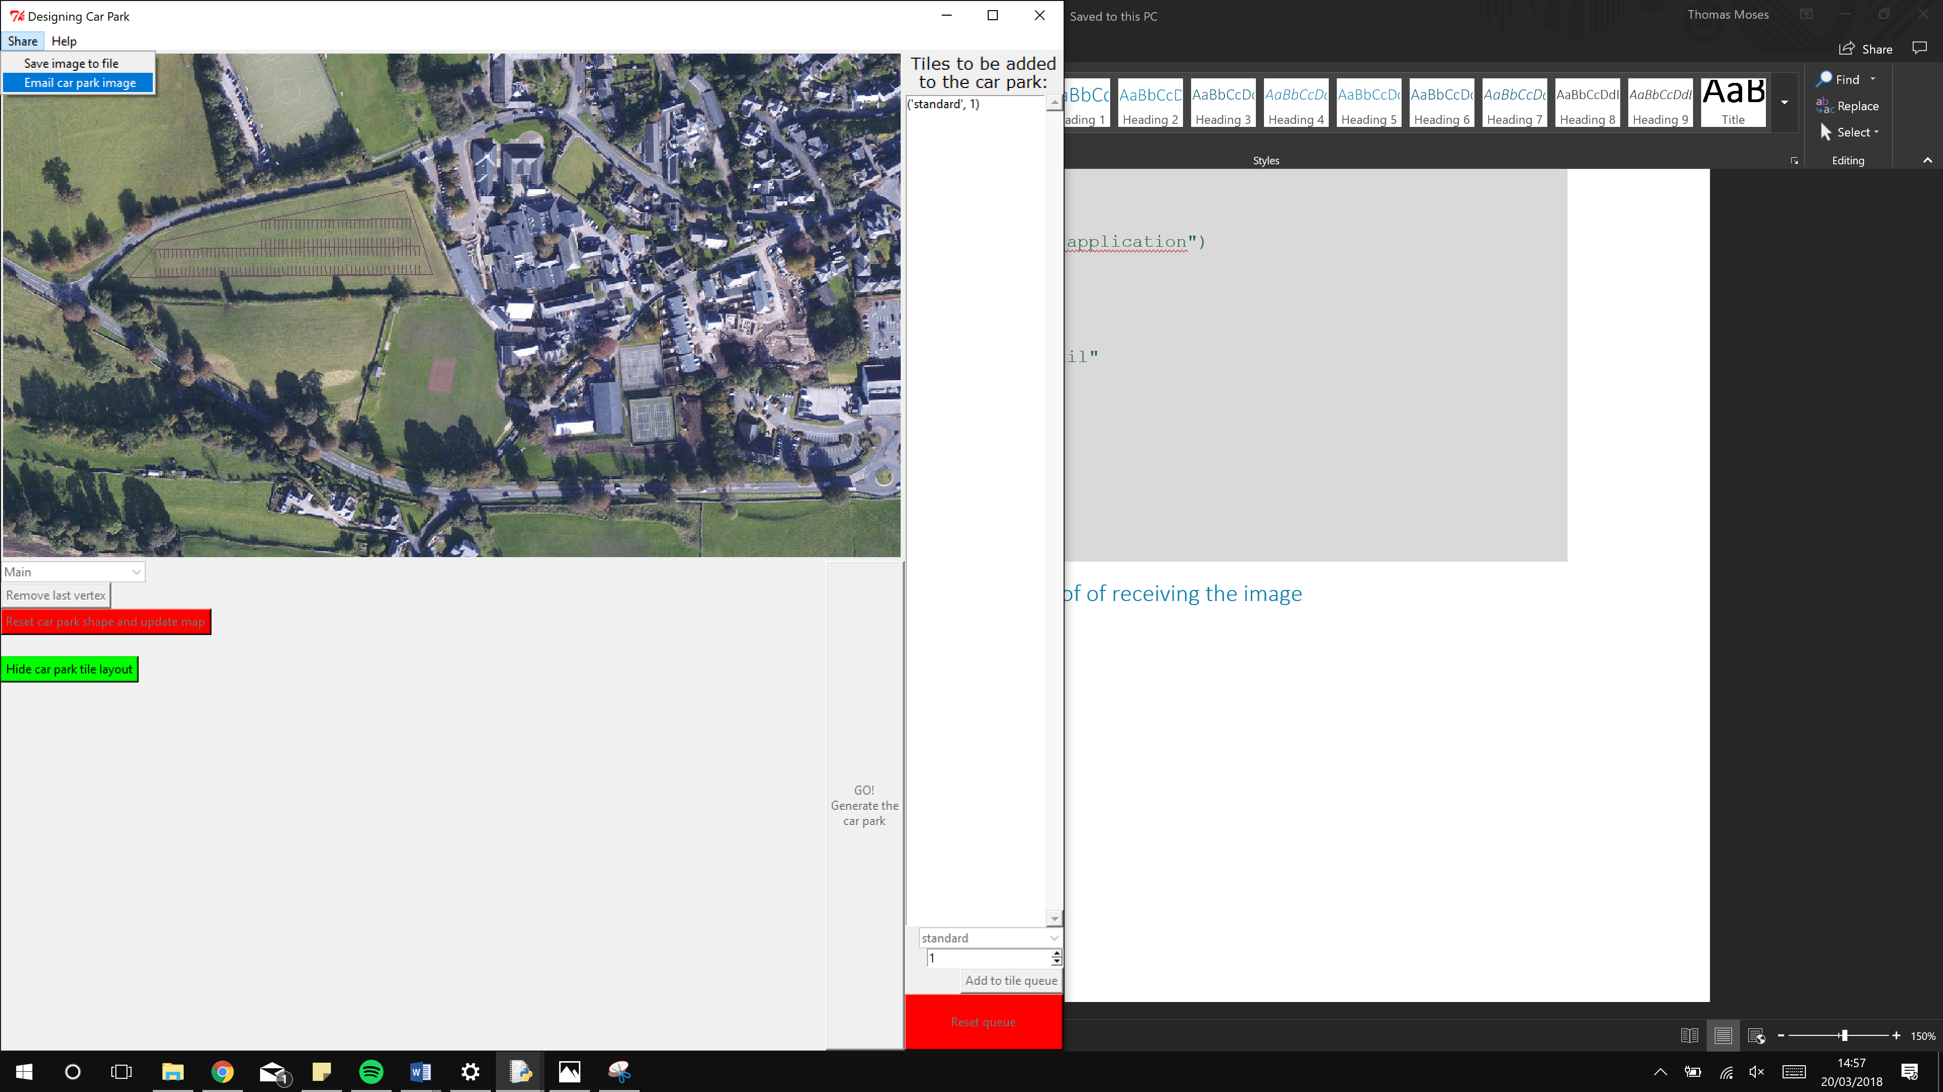

After clicking the button it opened this Microsoft Office Outlook draft email:

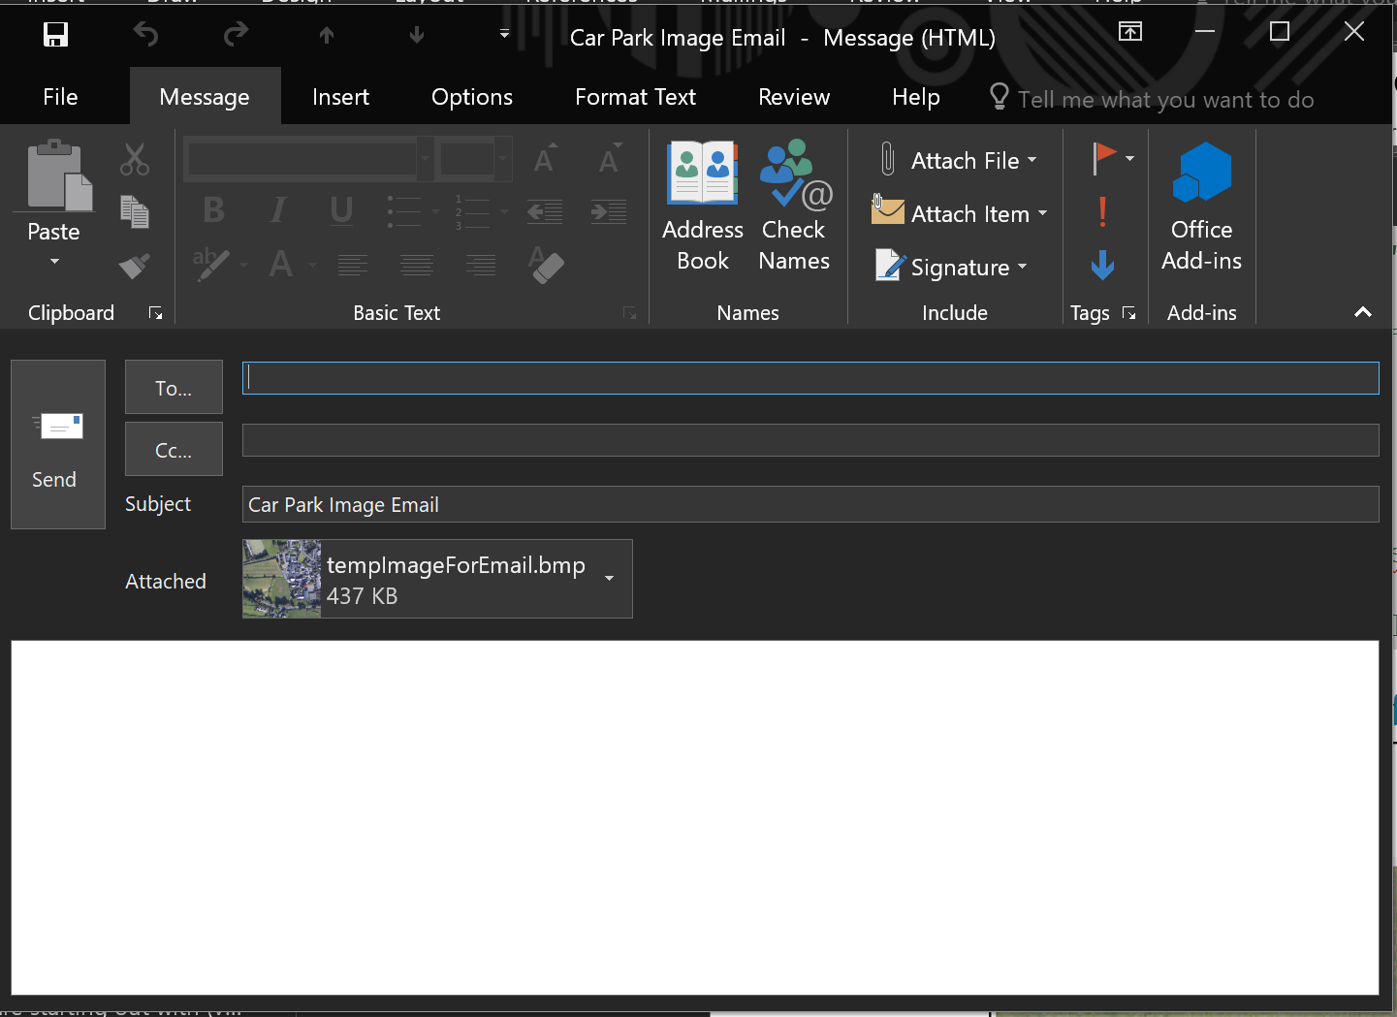

As you can see in the above screenshot it set the subject and attachment to the correct files.

#### 5.5.4 Other changes in GUIv9.py

##### 5.5.4.1 Checking if car park shape is valid

In this version of the GUI program I also added a check that meant if the car park shape wasn’t a valid shape (had less than three vertices) then it would tell the user and refuse to make the car park.

###### 5.5.4.1.1 Code

if len(carParkShape.getVertices()) < 3: #a valid shape can't have less than three vertices

tkMessageBox.showerror("Report","Error: Your car park shape must have more than 2 vertices")

else:

###### 5.5.4.1.2 Screenshots

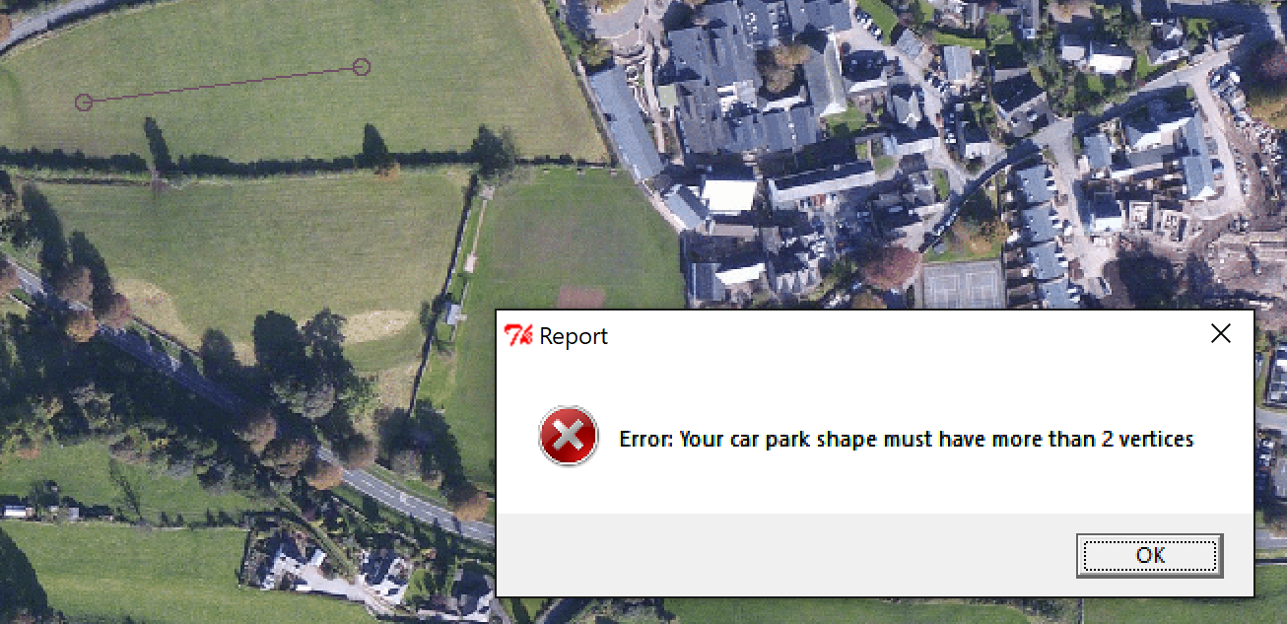

You can see in the top left of this screenshot that my shape had only 2 vertices, so wasn’t valid, and the error message told me so.

##### 5.5.4.2 Copying the shape before it is passed to the processing code

One small change I made while making the GUI that I did not yet mention was that I found a problem where once you have generated the car park, If you click the hide car park tile layout and then try to edit the shape you see that all the original vertices have been edited. Here you can see all the original vertices were moved to the top left corner of the screen:

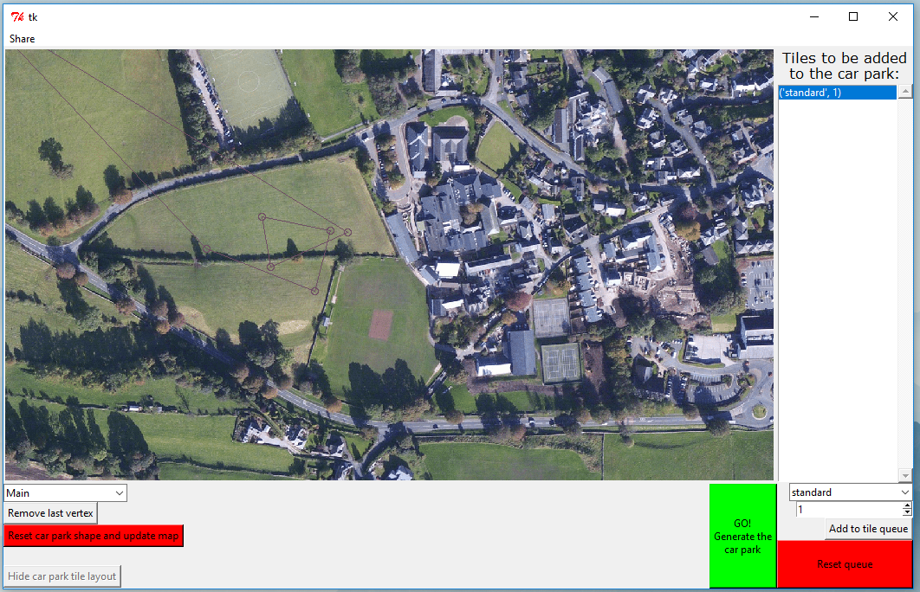

To fix this I implemented use of the copy module to fully copy a shape before I pass it into the processing code.

carParkShapeForUseInProcessing = copy.deepcopy(carParkShape) #because it would otherwise pass my shape instance by referance, I make a copy of it to be passed to the processing code.

This way it guarantees the original shape won’t be destroyed in while it is used in the processing code to generate the car park.

There are no screenshots to show for having fixed this as it doesn’t break any more.

## 6. Asking for client feedback and making further improvements

I showed my client my program and asked for any further ideas they had for the program. I also asked if they had any ideas how I should best link together the rows of car parks that I had made.

This is the email reply I got back summarising their thoughts (I have copied and pasted the content to make it easy to read):

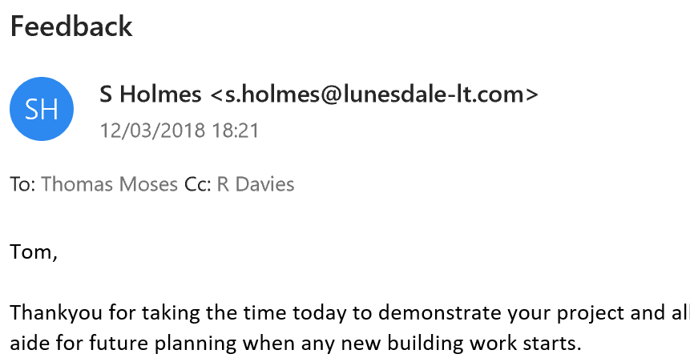

Tom,

Thank you for taking the time today to demonstrate your project and allow me to have a go. It is an impressive piece of work. You’ve produced a working solution which has real potential for us as an aide for future planning when any new building work starts.

The choice of maps is great – it allows me to explore possibilities at both ends of the site.

The ability to choose points on the map (and step back if I’ve made a mistake) makes it very user friendly. The features that let me save the car park design to a file or e-mail it are very professional.

Overall, I found the utility very intuitive to use.

I had a few small issues that you may wish to think about if you have time.

1)      I would like to be able to choose the colour the car park layout is drawn in. I’m not keen on the brown as the contrast with the underlying map isn’t ideal.

2)      I also had a blank box (error message?) pop up when I had cleared the queue and wanted to allocate default spaces. Was this my fault?

3)      I really like the ability to configure the space to a variety of vehicles, but I’m not sure I understand the terminology on the app. What is the tile queue? Is it the same as spaces? When I ran a test it didn’t seem to be, and it left me a bit confused.

A couple of bigger issues to think about if you have time would be a way to specify which way the spaces are laid out. As far as I can see, they always align to one side.

We also talked about the problem of assigning an entry / exit point. I appreciate the difficulty you have here, so any solution that gives me flexibility would be a great help.

Even without this, it is a wonderful tool and will help me enormously for exploring possibilities and options.

Thank you for all the care you have taken with it.

Mr Holmes

In person, Mr Holmes also suggested that I add a feature of a perimeter road, this would allow the entry and exit points to be anywhere around the car park and would also allow easy traffic flow through all of the parallel roads in the car park.

I have investigated changing the colour that the map is drawn in some more since I last looked at it and I have concluded that for this project it would be a waste of time and a high risk to try and uninstall the python library and reinstall the latest version that allows me to draw with specific colours. If this were a real-life project I would make sure this feature worked but for this project, it would not be a sensible use of time.

I plan to fix the error trapping and validation in certain places of the program while I am in the testing phase of this document.

I will add the option to have a perimeter road in this section. I will also fix how the language the program uses to describe car parking tiles and instead talk about them as car park places. (The name tiles were just from the name of the algorithm).

### 6.1 Adding a perimeter road (v22.py and GUIv11.py)

#### 6.1.1 Thinking about how to implement this

(Note: I skipped GUIv10.py as the only change was adding 1 comment)

For adding a perimeter road I was effectively adding a border of a constant width inside the original shape and then filling the car park inside of that border. This is an option that will be toggled with a checkbox underneath the map with the other map options.

I decided the easiest way to do this would be to make a new shape with the new vertices and then draw the car park inside of that new shape.

While thinking how to do this I did consider the idea of just shrinking the car park shape by moving all points towards a centre point, but this would not give the expected outcome that we wanted. As shown by this demo below you change the ratios of the sides when you find the new shape, so shrinking alone would not give you the shape:

You can clearly see that adding the border to the above shape does not give you a shape you could get by shrinking the shape.

What I instead need to do is found the points circled in red (representing the vertices for the new inner car park shape) from the points in green (representing the vertices of the user entered car park).

I did a lot of working on paper to try and find a solution to the problem, it was quite mathematically challenging to be totally honest.

After a lot of work, I figured out that I can deal with one vertex at a time and I was able to simplify the problem down to this diagram below:

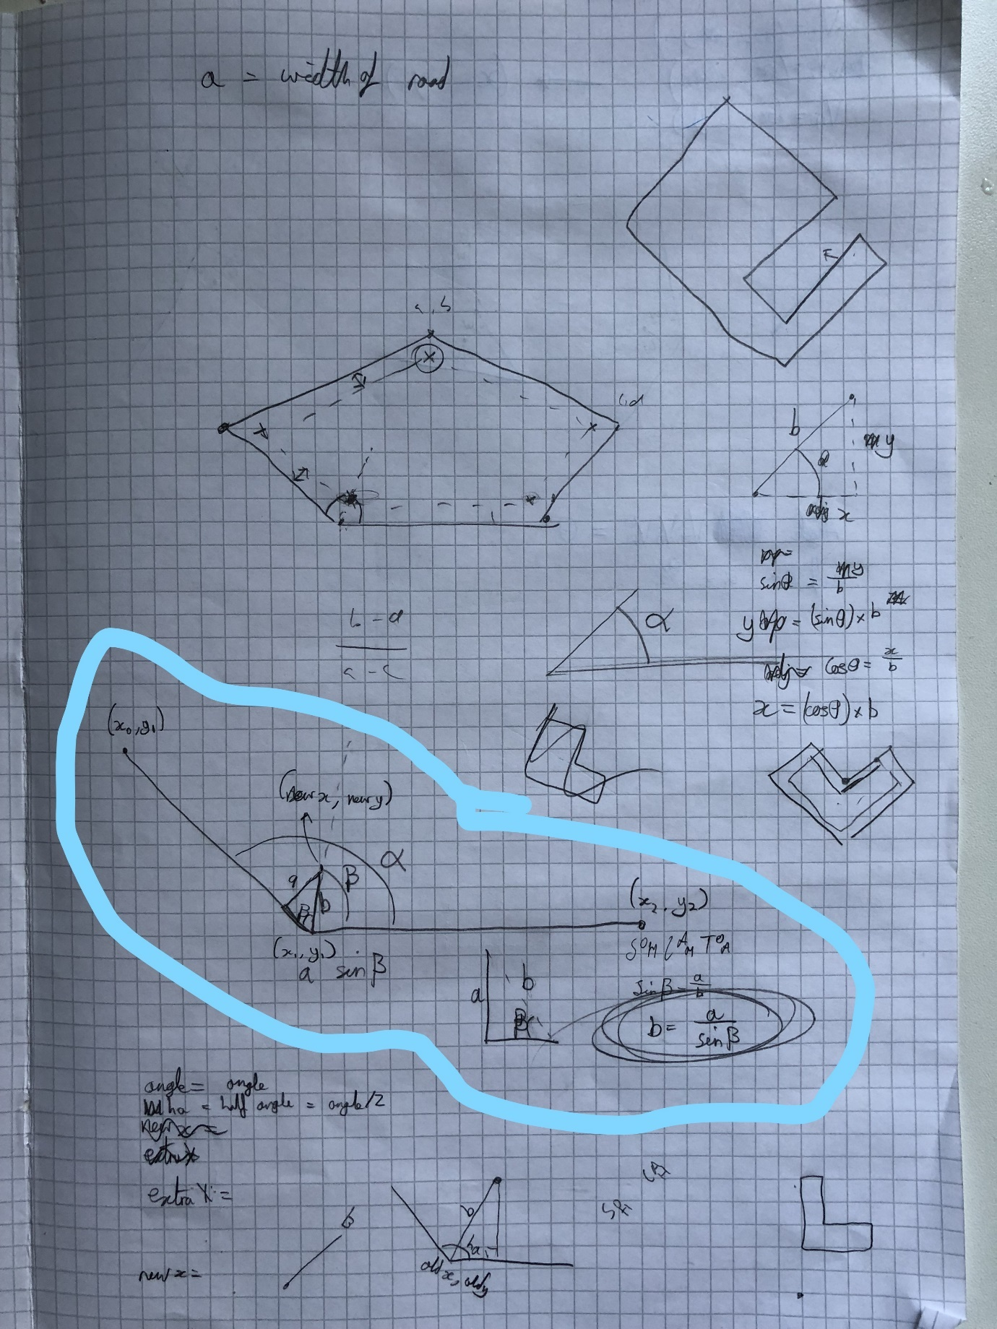

Basically, I would find the new inner vertex for one vertex if I knew the vertex before and after it. I was able to do this be finding the angle between the two lines, then half it and then finding the length is needed to move in this direction to be the correct distance away from both lines. Once I had done this the vertex would be in the correct position.

I was able to calculate the angle between two lines using the cosine rule, as shown below:

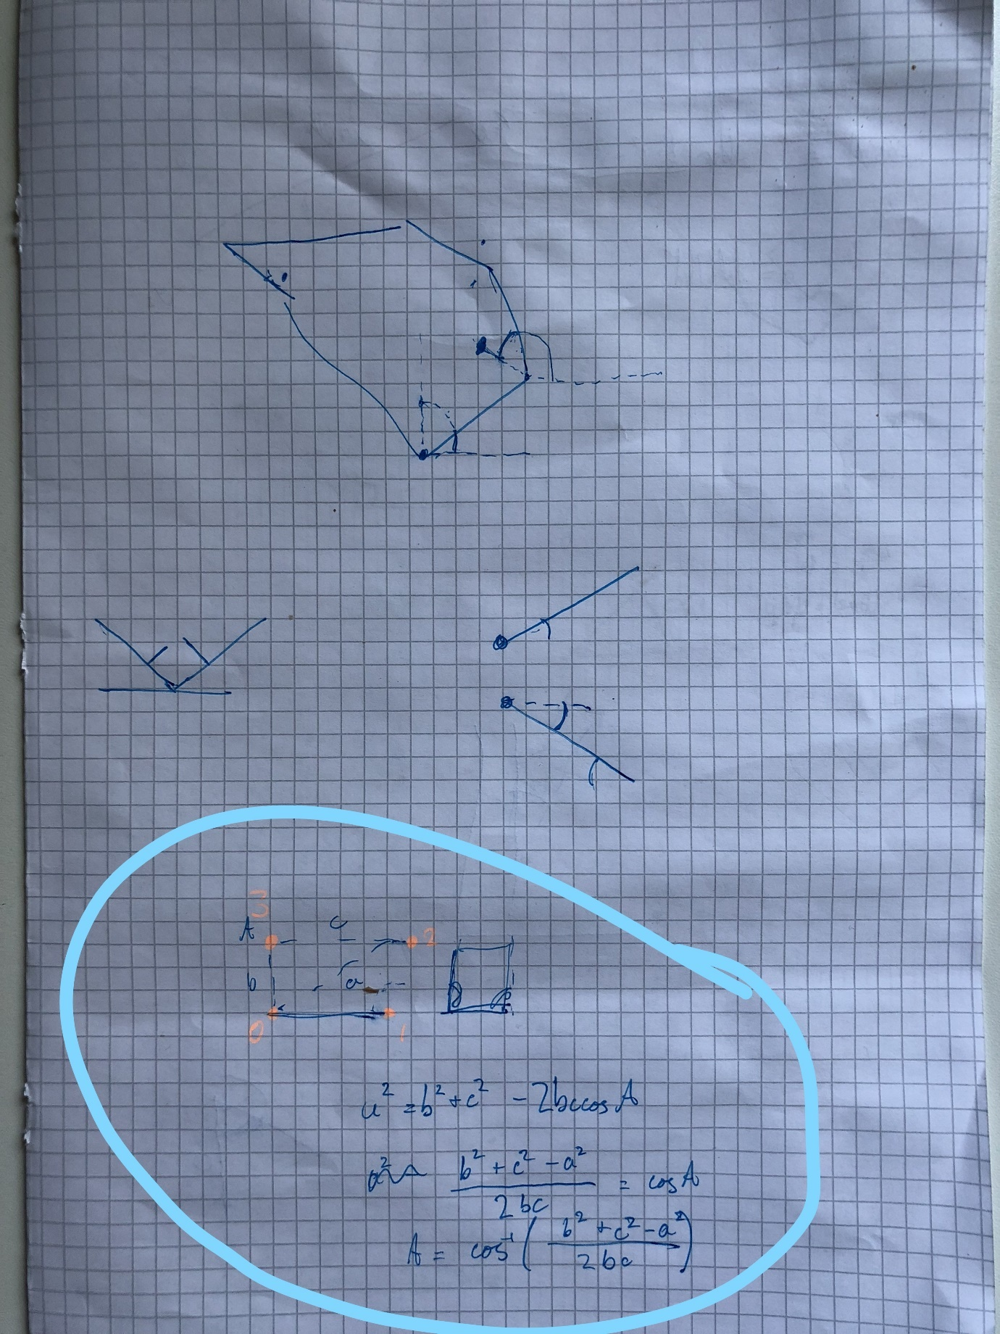

Where a A is the angle.

#### 6.1.2 Adding the checkbox to control adding the perimeter road

##### 6.1.2.1 Adding the checkbox

Again, I was able to find helpful documentation on how to implement a Tkinter Checkbutton from the Effbot website (Lundh, The Tkinter Checkbutton Widget, 2014).

I added the item mapPerimeterRoadCheckBox as an instance of the mapPerimeterRoadCheckBox class to the mapOptionsFrame and packed it.

###### 6.1.2.1.1 mapPerimeterRoadCheckBox Class definition

class mapPerimeterRoadCheckBox(tk.Frame):

def __init__(self, parent):

tk.Frame.__init__(self, parent)

self.parent = parent

self.addPerimeterRoad = tk.BooleanVar()

if designingCarPark:

checkBox = tk.Checkbutton(self, text="Add Perimeter Road", variable=self.addPerimeterRoad, onvalue = True, offvalue = False)

else:

checkBox = tk.Checkbutton(self, text="Add Perimeter Road", variable=self.addPerimeterRoad, onvalue = True, offvalue = False, state='disabled')

#pack items

checkBox.pack(side="left")

##### 6.1.2.2 Getting the value of the checkbox

I made a simple function that returned the current value of the checkbox.

def getAddPerimeterRoad():

return godFrame.frames['majorityFrame'].frames['leftFrame'].frames['bottomLeftFrame'].frames['mapOptionsFrame'].items['mapPerimeterRoadCheckBox'].addPerimeterRoad.get()

#### 6.1.3 First attempt of coding the inner border in python

##### 6.1.3.1 Code

I was able to implement this in python in my processing code (v22.py) with the following code:

def getDistanceBetweenTwoVertices(vertex2,vertex1):

#vertex1 = self.vertices[vertexNumber]

#vertex2 = self.vertices[(vertexNumber+1)%(len(self.vertices))]

differenceInX = vertex1.getX() - vertex2.getX()

differenceInY = vertex1.getY() - vertex2.getY()

distance = math.sqrt( differenceInX**2 + differenceInY**2 )

return distance

def getAngleBetweenThreeVertices(vertexC,vertexA,vertexB): #will return angle at vertexA using cosine rule

a = getDistanceBetweenTwoVertices(vertexB,vertexC)

b = getDistanceBetweenTwoVertices(vertexA,vertexC)

c = getDistanceBetweenTwoVertices(vertexA,vertexB)

#print a,b,c

angle = math.acos(((b*b+c*c-a*a)/(2*b*c)))

return angle

I then needed to find a way to move the correct distance away from the vertex in the correct direction. One thing that made this more complicated to deal with was that I was dealing with only x and y coordinates.

After a long time of trying to code a solution I had a program that worked about half of the time:

Basically, for each vertex it finds the angle it needs to move by finding half the angle between two of the vertices either side of the vertex I am using, then adding this angle to the angle of the line following the current vertex from horizontal. This should have given me the correct result every time.

def getInsideBorderFromShape(carParkShape,width):

oldShape = carParkShape

newShape = shape()

verticesCoordinates = oldShape.getVerticesCoordinates()

vertices = oldShape.getVertices()

noOfCoordinates = len(verticesCoordinates)

for count in range(noOfCoordinates):

#get angle of the three vertices

angle = getAngleBetweenThreeVertices(vertices[(count-1)%noOfCoordinates],vertices[(count)%noOfCoordinates],vertices[(count+1)%noOfCoordinates])

halfAngle = angle/2

angleFromHorizontal = halfAngle + oldShape.getAngleOflineAfterVertexFromHorizontal(count)

lengthBetweenNewAndOldVertex = width/(math.sin(halfAngle))

extraX = (math.cos(angleFromHorizontal)*lengthBetweenNewAndOldVertex)

extraY = (math.sin(angleFromHorizontal)*lengthBetweenNewAndOldVertex)

newX = vertices[count].getX() + extraX

newY = vertices[count].getY() + extraY

newShape.addVerticesXY([[newX,newY]])

return newShape

##### 6.1.3.2 Screenshots

I was getting results like this:

For showing you this I have used the school cricket square as a base car park shape every time, this useful background will help you easily see the original shape vs the new shape.

Original shape:

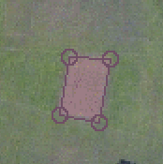

Original shape with border:

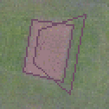

As you can see, for some reason it only works with two of the vertices.

At this point I did more research (IronRule, 2015) (Houx, 2013) online but did not find any useful sources.

#### 6.1.4 Fixing the issue of some vertices being in the wrong place

I eventually figured out that there must be a problem with the way I was finding the angle from horizontal of a line. This code was processing in myShapeAndVertexClasses.py. I realised that a the inverse tan function only returns certain angles and that you have to check that the angle is in the correct quadrant. I realised this while in a maths lesson covering Polar Coordinates.

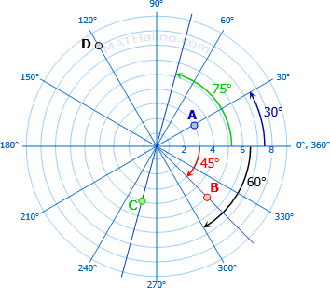 (MATHalino, n.d.)

You can see in the above screenshot the way angles work around a point.

##### 6.1.4.1 Code

Here is the solution I added:

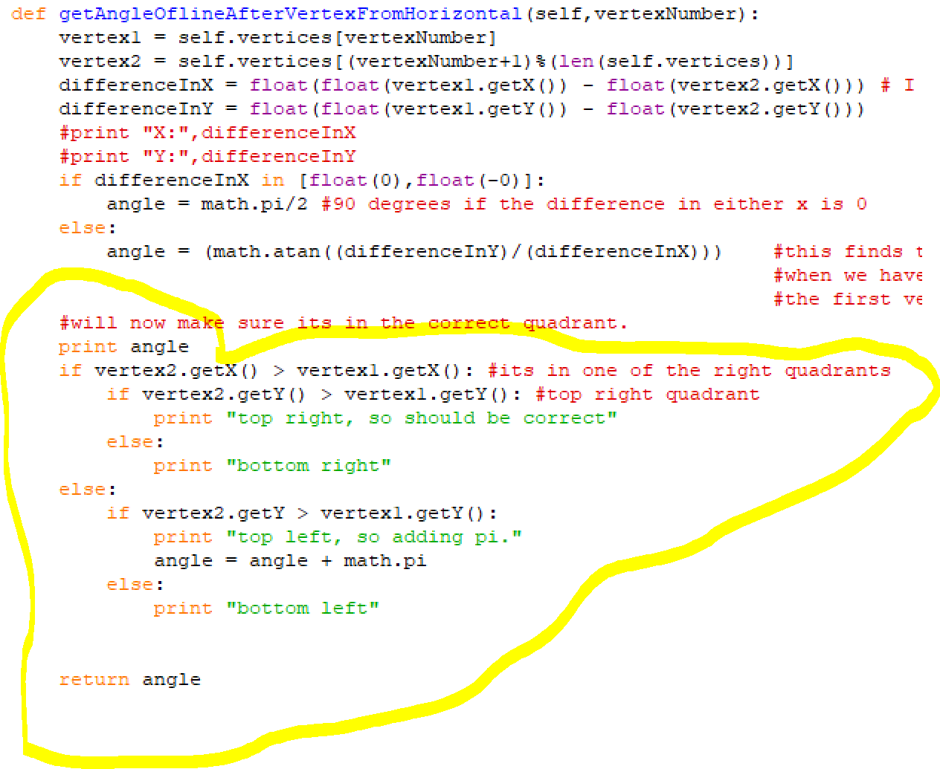

##### 6.1.4.2 Screenshots

Original shape:



Original shape with fixed border:

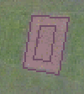

It was such a relief that I finally got this working after a few days of working on it. I think this feature will be really useful to the client too as they can now have car parks such as this (notice the perimeter road so that all car parking places can be accessed):

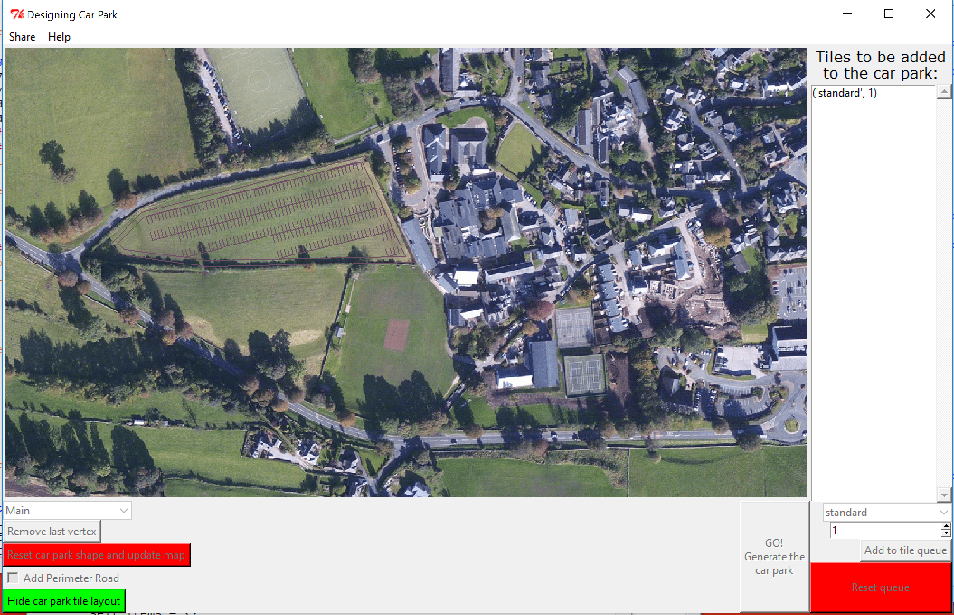

### 6.2 Removing the word tile from what the user sees (v23.py and GUIv12.py)

I will set it up so that the user only interacts with the term spaces, as my client was confused by the term tile (a group of two spaces).

#### 6.2.1 Changing terminology

I have also decided to stop using the name listOFTuplesOfNamesOfTilesInListAndHowManyOfEach and instead replace it with spaceQueue as it is easier to read.

##### 6.2.1.1 GUI

In the GUI program I used the find function built into the IDE to find all places where the word tile was. I did not replace class or function names with the word tile in them as this could have risked causing issues, I instead just replaced it where they were shown to the user, e.g: t

* The label at the top of the right frame was changed:

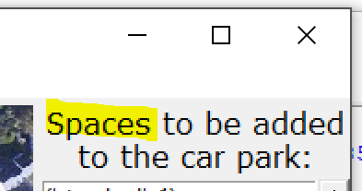

* The hide carpark tile layout button:

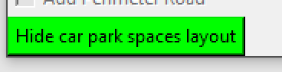

* The tile add button

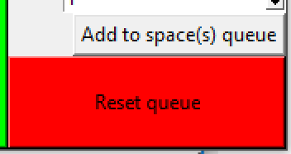

In the GUI program I used a find and replace tool online (Advameg, Inc, 2018) to replace listOFTuplesOfNamesOfTilesInListAndHowManyOfEach with spaceQueue.

##### 6.2.1.2 Processing code

I first used my IDE’s find tool to find where I used the listOFTuplesOfNamesOfTilesInListAndHowManyOfEach name and I found it in tile and trim, this is where I started making changes.

I replace it with spacesQueue and changed the algorithm so that if it placed a tile it would remove two from the count of howManyLeft since a tile contains two spaces.

### 6.3 Adding the single space tile (v23.py)

#### 6.3.1 TileAndTrimAlgorithm

I decided that if it failed to place a full tile it would fall back to try and place to tile containing only one parking space.

tileShape = makeShapeFromTile(bottomLeftVertex,tileLabel,tiles)

validTilePlacement = testIfOneShapeIsWithinAnotherShape(tileShape,carParkShape)

#print "stub for if tile was placed and is in boundary, add this shape to a list of car parking tiles created. Then reduce howManyLeft by 1."

if validTilePlacement:

if printProgress:

print "valid " + tileLabel + " tile placement."

howManyLeft = howManyLeft - 2 #it places a full tile so I remove two spaces from the queue

placedTiles.append(tileShape)

else:

if printProgress:

print "failed to place double space tile, trying to place single tile..."

#will now try and place a single space tile

tileShape = makeShapeFromTile(bottomLeftVertex,singleTileLabel,tiles)

validTilePlacement = testIfOneShapeIsWithinAnotherShape(tileShape,carParkShape)

if validTilePlacement:

if printProgress:

print "valid " + singleTileLabel + " tile placement."

howManyLeft = howManyLeft - 1 #it places a single tile so I remove just one spaces from the queue

placedTiles.append(tileShape)

As you can see it follows a similar prodecure of trying to make a shape from the tile then testing if it is a valid placement.

I decided to make new tiles with the postfix _single.

#### 6.3.2 creating the new tiles in the tiles dictionary

I created the new tiles at the same place I defined the existing tiles

#### 6.3.3 supporting drawing them in getLinesToDrawFromTiles

I then modified the getLinesToDrawFromTiles to test if the tile label contained _single, if it did then it would only add half of the lines (since there is only 2 lines now instead of 4, being one for each side of the car parking space).

I was able to test if the string was contained in the other by using in.

I actually tested if it was not a single car parking tile first using:

if "_single" not in tileInstance.getLabel(): #if it is a full tile add all 4 lines for the 2 parking spaces (one at each side of each space)

### 6.4 Showing user area of the car park (v24.py)

I read back on my clients initial wishes for the program and saw that they wanted the program to output the area of the car park that was generated.

I quickly made a function to find the area of a shape in my processing code program (still v24.py), and then called it when I first made the string that was to be displayed in the report box after the car park had been generated.

#### 6.4.1 Function Code

def getAreaOfShape(myShape,pixelsPerMeter):

convertShapePixelToMeter(myShape,pixelsPerMeter)

shapelyShape = Polygon(myShape.getVerticesCoordinates()) #creates an instance of a Shapely Polygon that is identicle to the shape inputted

return shapelyShape.area

#### 6.4.2 Calling my function in TileAndTrim

messageToPrint = "Your car park shape has an area of: " +str(round(getAreaOfShape(copy.deepcopy(carParkShape),pixelsPerMeter),1))+ " square metres.\n"

Here you can see that I copied the shape before passing it into the function and I then rounded the number to one decimal place.

#### 6.4.3 Screenshot

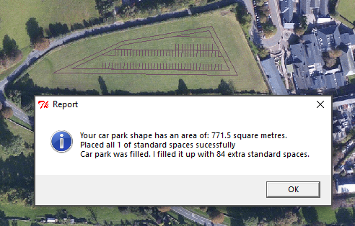

# Testing the final program

Now that I have finished adding all the required features to my program I plan to do a final test of my code to double check that I have implemented all features well. This test will be thourough to try and find any potential issues that my client could run into.

The numbers of the tests in the test plan correlate to the tests in the Testing section.

If I have a test with letters after it, it means the first time my code failed the test and I am now retesting it with the fixed code, e.g if test 1 fails, it become test 1a and I then carry out test 1b

## Test Plan

|  |  |  |  |
| --- | --- | --- | --- |
| Number | Type and Reason | Action | Expected Result |
| 1 | NORMAL: To check that program can open and looks as expected | User will run program | The program should open and display a window to the user. This window will contain a menu bar, display a map image, and have a range of other buttons. |
| 2 | NORMAL: The user can switch between the two different maps | Select a different map name from the drop-down menu. Click the button to update the map | The user can see the new map replace the original one. |
| 3 | ERRONEOUS: The user cannot enter a custom map name or crash the program from the drop-down menu | Try and enter a custom map name and then click the update map button | The user cannot enter a custom string as the map name. |
| 4 | NORMAL: The user can draw a car park shape by clicking on the map to place vertices | Draw a car park shape with 5 sides | Circles are drawn around each vertex, and the vertices relate to lines. |
| 5 | NORMAL: The user can use the ‘Remove last vertex’ button to remove the most recently added vertex. | Draw a shape with 5 vertices (starting from the top left moving clockwise), then click the ‘Remove last vertex’ button | The most recently added vertex is removed and then the map is updated, and the shape is redrawn with only the first 4 vertices. |
| 6 | NORMAL: The user can use the ‘Reset car park shape and update map’ button to reset the shape to have no vertices | Draw a shape with 5 vertices then click the ‘Reset car park shape and update map’ button | The shape should be removed |
| 7 | NORMAL: The user can draw a valid shape and generate a car park within it by clicking the ‘GO!’ button. | Draw a shape with 5 vertices on the main map and click the go button | The car park shape will be filled with standard car parking spaces |
| 8 | BOUNDARY: The user is told there is a problem with their shape if it is invalid and is only a line (has two vertices) | Draw a shape with only 2 vertices and then click the go button | An error dialog will be shown telling the user that there is an error. |
| 9 | ERRONEOUS: The user is told there is a problem with their shape if it is invalid and is only a single vertex | Click on the map once to draw just one vertex and then click the go button | An error dialog will be shown telling the user that there is an error. |
| 10 | ERRONEOUS: The user is told there is a problem with their shape if it has no vertices | Reset the shape or launch the program so there is no current shape, then click the go button. | An error dialog will be shown telling the user that there is an error. |
| 11 | NORMAL: The user can have a shape with a minimum of three vertices | Draw a triangle on the main map then click the go button | A car park layout will be drawn within the shape |
| 12 | NORMAL: The user can have a shape with 8 vertices | Draw an 8-sided shape on the main map then click the go button | A car park layout will be drawn within the shape |
| 13 | NORMAL: The user can have a shape with a lot of vertices | Draw a shape with over 15 sides and then click the go button | A car park layout will be drawn within the shape |
| 14 | NORMAL: The user can add a perimeter road to the car park | Draw a shape with 4 vertices, check the perimeter road option and click the go button | A car park layout will be drawn within a perimeter road within the shape. |
| 15 | NORMAL: The user can add a perimeter road to a complicated car park | Draw a shape with 6 vertices, check the perimeter road option and click the go button | A car park layout will be drawn within a perimeter road within the shape. |
| 16 | NORMAL: The user can queue different types of spaces at once | Try filling the car park with disabled spaces as well as standard ones | The car park will be filled with a layout made up of first standard places then disabled spaces |
| 17 | NORMAL: The user can queue different types of spaces | Try filling the car park with minibus spaces instead of standard ones | The car park will be filled with a layout made up of minibus spaces |
| 18 | NORMAL: The user can queue different types of spaces | Try filling the car park with motorbike spaces instead of standard ones | The car park will be filled with a layout made up of motorbike spaces |
| 19 | NORMAL: The user can queue different types of spaces | Try filling the car park with disabled spaces instead of standard ones | The car park will be filled with a layout made up of dissabled spaces |
| 20 | NORMAL: The user can queue different types of spaces at once with the correct quantities (sometimes one more will be generated than wanted due to a double tile being placed by default, this is okay as it is using up otherwise unused space) | Try filling the car park with 10 disabled, then 26 motorbike spaces then the rest as standard spaces. | The car park will be filled with the required spaces. |
| 21 | NORMAL: The user is told when the car park was too small to have all the spaces they wanted | Try filling the car park with 1000 standard spaces. | The user will be told how many spaces were added, and that the rest failed. |
| 22 | NORMAL: The user is told when the car park was too small to have all the spaces they wanted, but that some were successfully placed | Try filling the car park with 10 minibus spaces then 1000 standard spaces. | The user will be told that all of the minibus spaces will be added, then that some of the standard spaces were added but not all of them were. |
| 23 | NORMAL: The user can hide the car park spaces using the “Hide car park spaces layout” button | Draw a car park and click the go button, then click the “Hide car park spaces layout” button | You will see the car park layout has disappeared and the car park shape remains |
| 24 | NORMAL: The user can continue to edit the car park shape after pressing the “Hide car park spaces layout” button | Draw a car park and click the go button, then click the “Hide car park spaces layout” button, then add another vertex to the car park shape | The additional vertex will be added properly, and the shape will be drawn properly. |
| 25 | NORMAL: The user can generate a new car park after editing the shape. | Draw a car park and click the go button, then click the “Hide car park spaces layout” button, then add another vertex to the car park shape, then click the go button | The new car park layout will be drawn within the new shape. |
| 26 | NORMAL: The user can reset the car park queue to clear it | Click the “Reset queue” button | The car park queue will be cleared, as shown by the list box on the right side of the screen. |
| 27 | ERRONEOUS: The user is told there was a problem if they try to generate a car park with an empty spaces queue | Draw a valid car park shape, click the “Reset queue” button then click the go button | The user will be told that there was an error, in the work of an error dialog |
| 28 | BOUNDARY: The user cannot add a space to the queue with count of 0 | Try to add 0 disabled spaces to the space queue | The user will not be able to do this |
| 29 | ERRONEOUS: The user cannot enter an extremely large number to the queue, such as 10^100 | Enter the number “10000000000000000000000000000000000000000000000000000000000000000000000000000000000000000000000000000” as the number for how many standard spaces to the queue | The upper limit of 1,000,000 will be added instead. |
| 30 | NORMAL: The user can resize the window | Drag the bottom right of the window to resize it and make it bigger | It will be resized, and the map image will stay the same size |
| 31 | NORMAL: The user can use the full screen button on the window | Click the fullscreen button for the window | It will be resized, and the map image will stay the same size |
| 32 | ERRONEOUS: The user cannot make the window smaller than set limit (no buttons can be hidden) | Drag the bottom right of the window to resize it and make it smaller | The user cannot make the window smaller than set limit |
| 33 | NORMAL: The user can minimise the window and launch it again | Minimise the window and relaunch it, then check it still works by adding a new vertex to the car park shape | The user will be able to add the new vertex successfully. |
| 34 | NORMAL: The user can use the help menu to show a help dialog | Click the help menu button | The user will be shown a help dialog with a list of instructions about how to use the program |
| 35 | NORMAL: The user can save an image with a file name | Generate a car park layout and click the save to file button from the share menu. Then choose a location and save the image. | The user will be shown a file dialog and saving the file can be successful. |
| 36 | BOUNDARY: The user can try to save the image with a different file extension, but it will still use .bmp | Generate a car park layout and click the save to file button from the share menu.  Save the image as “image.png” | The image will still be able to be opened as it will be saved as “image.png.bmp” |
| 37 | NORMAL: The user can cancel saving the image | Generate a car park layout and click the save to file button from the share menu.  Click the cancel button | The user will be told there was an error saving the image. |
| 38 | NORMAL: The saved image can be opened and contains the correct image (whatever the image was on the screen) | Generate a car park layout and click the save to file button from the share menu. Then choose a location and save the image.  Open the image | The image will be opened and show the same car park that was in the window. |
| 39 | NORMAL: Another image can be saved and have a different file name | Generate a car park layout and click the save to file button from the share menu. Then choose a location and save the image.  Then save the image another time with a different file name | There will be two identicle image files |
| 40 | BOUNDARY: Another image can be saved with the same file name and the user will be warned, if they choose to, then can overwrite the file | Generate a car park layout and click the save to file button from the share menu. Then choose a location and save the image.  Generate a different car park layout  Then save the image another time with the same file name  Accept the warning and continue to save the image. | The image will be overwritten |
| 41 | NORMAL: Email draft can be opened and then sent with the attached image. The image can then be opened | Generate a car park layout, from the share menu click the “Email car park image” button, enter a valid email as the recipient that you have access to (different to the sender email) then open the sent email and the attached image | The email will be sent and the attached image will show the car park design. |
| 42 | NORMAL: When the car park is generated the area of the car park is shown. | Generate a new car park layout. | The user will be shown the area of their car park in the report dialog |
| 43 | NORMAL: When two identical car parks are generated, but one with a perimeter road they show the same area. | Generate a new car park layout without a perimeter road, note the area stated, then use the same shape to generate a layout with a perimeter road, check the areas are the same | The two reported areas are the same. |
| 44 | NORMAL: Generating the car park will not print anything to the command line. | Try and generate a car park layout. | Nothing will be printed to the command line |
| 45 | ERRONEOUS: What happens if you try to email the car park but the user does not have the email client installed? | Uninstall Microsoft office outlook.  Generate a car park layout.  From the share menu click the email button. | An error message should be disaplyed. |
| 46 | ERRONEOUS: Can you add a non-integer to the tile queue? | Try adding the word “test” as the numeric input for the tile queue stepper. | An error message should be displayed. |

## Testing

After I find an issue with a test I will make the changes to fix the issues in either GUIv13.py or processing code v25.py or both.

|  |  |  |  |  |
| --- | --- | --- | --- | --- |
| Number | Action | Expected Result | Actual result | Changes to be made |
| 1 | User will run program | The program should open and display a window to the user. This window will contain a menu bar, display a map image, and have a range of other buttons. | As expected | None |
|  | | | |
| 2 | Select a different map name from the drop-down menu. Click the button to update the map | The user can see the new map replace the original one. | As expected | None |
|  | | | |
| 3 | Try and enter a custom map name and then click the update map button | The user cannot enter a custom string as the map name. | As expected, you cannot type in this field. Clicking it just opens the drop down menu | None |
|  | | | |
| 4 | Draw a car park shape with 5 sides | Circles are drawn around each vertex, and the vertices relate to lines. | As expected | None |
|  | | | |
| 5 | Draw a shape with 5 vertices (starting from the top left moving clockwise), then click the ‘Remove last vertex’ button | The most recently added vertex is removed and then the map is updated, and the shape is redrawn with only the first 4 vertices. | As expected | None |
|  | | | |
| 6 | Draw a shape with 5 vertices then click the ‘Reset car park shape and update map’ button | The shape should be removed |  |  |
|  | | | |
| 7 | Draw a shape with 5 vertices on the main map and click the go button | The car park shape will be filled with standard car parking spaces | As expected | None |
|  | | | |
| 8 | Draw a shape with only 2 vertices and then click the go button | An error dialog will be shown telling the user that there is an error. | As expected | None |
| (The blue pen mark was added after the screenshot was taken) | | | |
| 9 | Click on the map once to draw just one vertex and then click the go button | An error dialog will be shown telling the user that there is an error. | As expected | None |
|  | | | |
| 10 | Reset the shape or launch the program so there is no current shape, then click the go button. | An error dialog will be shown telling the user that there is an error. | As expected | None |
|  | | | |
| 11 | Draw a triangle on the main map then click the go button | A car park layout will be drawn within the shape | As expected | None |
|  | | | |
| 12 | Draw an 8-sided shape on the main map then click the go button | A car park layout will be drawn within the shape | As expected | None |
|  | | | |
| 13 | Draw a shape with over 15 sides and then click the go button | A car park layout will be drawn within the shape | As expected | None |
|  | | | |
| 14 | Draw a shape with 4 vertices, check the perimeter road option and click the go button | A car park layout will be drawn within a perimeter road within the shape. | As expected | None |
|  | | | |
| 15 | Draw a shape with 6 vertices, check the perimeter road option and click the go button | A car park layout will be drawn within a perimeter road within the shape. | As expected | None |
|  | | | |
| 16a | Try filling the car park with disabled spaces as well as standard ones | The car park will be filled with a layout made up of first standard places then disabled spaces | As expected but there was a graphical error with displaying the single disabled space tile. | Fix single disabled car park tiles displaying lengths shorter than they should be |
| If you are eagle eyed, you will see in the above screenshot that there was actually 27 standard spaces added because there was space for one in the bottom left of the car park, it will only ever add one extra car parking space.  Also in this screenshot I saw that the single disabled spaces were having their lines drawn the wrong length, I fixed this in my new version (v25.py)  (Note: I am moving the report window box to make the screenshots less wide so you can read them more easily) | | | |
| 16b | Try filling the car park with disabled spaces as well as standard ones | The car park will be filled with a layout made up of first standard places then disabled spaces | As expected | None |
| As you can see above, the spaces now display properly. | | | |
| 17 | Try filling the car park with minibus spaces instead of standard ones | The car park will be filled with a layout made up of minibus spaces | As expected | None |
| (Note that the area is different as I forgot to screenshot this and then screenshotted it after I had found a problem with how the area was calculated.) | | | |
| 18 | Try filling the car park with motorbike spaces instead of standard ones | The car park will be filled with a layout made up of motorbike spaces | As expected | None |
|  | | | |
| 19 | Try filling the car park with disabled spaces instead of standard ones | The car park will be filled with a layout made up of disabled spaces | As expected | None |
| The changes I already made in test 16b will fix this issues shown in the above screenshot, below is a screenshot using the latest version: | | | |
| 20 | Try filling the car park with 10 disabled, then 26 motorbike spaces then the rest as standard spaces. | The car park will be filled with the required spaces. | As expected | None |
|  | | | |
| 21 | Try filling the car park with 1000 standard spaces. | The user will be told how many spaces were added, and that the rest failed. | As expected | None |
|  | | | |
| 22a | Try filling the car park with 10 minibus spaces then 1000 standard spaces. | The user will be told that all the minibus spaces will be added, then that some of the standard spaces were added but not all of them were. | I found that my program gave the correct count of spaces that it placed, but that it did not display the disabled places properly. | I need to fix how the program deals with tiles of different heights in the same row in processing code v25.py. |
|  | | | |
| 22b | Try filling the car park with 10 minibus spaces then 1000 standard spaces. | The user will be told that all the minibus spaces will be added, then that some of the standard spaces were added but not all of them were. | As expected | None |
| As you can see, it now leaves a gap so that there is room for the minibus spaces. | | | |
| 23 | Draw a car park and click the go button, then click the “Hide car park spaces layout” button | You will see the car park layout has disappeared and the car park shape remains | As expected | None |
| Before:    After: | | | |
| 24 | Draw a car park and click the go button, then click the “Hide car park spaces layout” button, then add another vertex to the car park shape | The additional vertex will be added properly, and the shape will be drawn properly. | As expected | None |
| Original car park design:    After hiding layout:    After adding new vertex: | | | |
| 25 | Draw a car park and click the go button, then click the “Hide car park spaces layout” button, then add another vertex to the car park shape, then click the go button | The new car park layout will be drawn within the new shape. | As expected | None |
| Original car park design:    After hiding layout:    After adding new vertex:    New car park design: | | | |
| 26 | Click the “Reset queue” button | The car park queue will be cleared, as shown by the list box on the right side of the screen. | As expected | None |
|  | | | |
| 27a | Draw a valid car park shape, click the “Reset queue” button then click the go button | The user will be told that there was an error, in the work of an error dialog | The program returned an empty car park but still ran the tile and trim algorithm as can be seen by the report with the area of the car park. No error dialog was displayed. | Add an error dialog to be displayed if the tile queue is empty in GUIv13.py. |
|  | | | |
| 27b | Draw a valid car park shape, click the “Reset queue” button then click the go button | The user will be told that there was an error, in the work of an error dialog | As expected | None |
|  | | | |
| 28a | Try to add 0 disabled spaces to the space queue | The user will not be able to do this | I was able to do this | I need to add validation when adding a number of spaces to the queue. |
|  |  |  |  |
| 28b | Try to add 0 disabled spaces to the space queue | The user will not be able to do this | As expected | None |
|  | | | |
| 29 | Enter the number “10000000000000000000000000000000000000000000000000000000000000000000000000000000000000000000000000000” as the number for how many standard spaces to the queue | The upper limit of 1,000,000 will be added instead. | As expected and I also have the feature where it asks the user if they want to and 1,000,000 spaces or not. | None |
| Clicking the no button left the queue empty, I will now try clicking the yes button.    It successfully added them to the queue. | | | |
| 30 | Drag the bottom right of the window to resize it and make it bigger | It will be resized, and the map image will stay the same size | As expected | None |
| Original:    New:    Dragging down worked, as you can see in the above screenshot.    Dragging across worked, as you can see in the above screenshot.    Draggin making the window larger in both directions also worked. | | | |
| 31 | Click the fullscreen button for the window | It will be resized, and the map image will stay the same size | As expected | None |
| The map did stay the same size on my screen. | | | |
| 32 | Drag the bottom right of the window to resize it and make it smaller | The user cannot make the window smaller than set limit | As expected | None |
| No screenshots for this test, but you are unable to resize the window and make ii smaller than its limit. | | | |
| 33 | Minimise the window and relaunch it, then check it still works by adding a new vertex to the car park shape | The user will be able to add the new vertex successfully. | As expected | None |
| No screenshots for this test, but it did work. | | | |
| 34 | Click the help menu button | The user will be shown a help dialog with a list of instructions about how to use the program | As expected | None |
|  | | | |
| 35 | Generate a car park layout and click the save to file button from the share menu. Then choose a location and save the image. | The user will be shown a file dialog and saving the file can be successful. | As expected | None |
| The file dialog opens correctly and allows you to navigate to any directory. (it shows ‘no items match your search’ because I have no items on my desktop)    I entered the file name as image and clicked save.    I was shown this report saying where the image was saved.    I could see that the image did save to my desktop | | | |
| 36a | Generate a car park layout and click the save to file button from the share menu.  Save the image as “image.png” | The image will still be able to be opened as it will be saved as “image.png.bmp” | The image could be saved in a different format | Force the image to be saved as a bitmap. |
| I saved the image to my desktop with the above file name.    I was told it was saved as a png file.    It was saved as a png file, when it shouldn’t have been, I will now fix this | | | |
| 36b | Generate a car park layout and click the save to file button from the share menu.  Save the image as “image.png” | The image will still be able to be opened as it will be saved as “image.png.bmp” | As expected | None |
| I attempted to save the image as a .png type.    But the program forced it to save as a bitmap still. I decided not to remove the previous extension incase the user for some reason used dot notation when naming files. I also made sure not not add a second .bmp if the user did already add it.    As you can see in the above screenshot, it shows the image saved as intended. | | | |
| 37 | Generate a car park layout and click the save to file button from the share menu.  Click the cancel button | The user will be told there was an error saving the image. | As expected | None |
| I can also confirm that no image was saved to the directory that I was in before I cancelled the save dialog. | | | |
| 38 | Generate a car park layout and click the save to file button from the share menu. Then choose a location and save the image.  Open the image | The image will be opened and show the same car park that was in the window. | As expected | None |
| How the window looked:    How the file looked: | | | |
| 39 | Generate a car park layout and click the save to file button from the share menu. Then choose a location and save the image.  Then save the image another time with a different file name | There will be two identicle image files | As expected | None |
| The image was able to be saved twice. | | | |
| 40 | Generate a car park layout and click the save to file button from the share menu. Then choose a location and save the image.  Generate a different car park layout  Then save the image another time with the same file name  Accept the warning and continue to save the image. | The image will be overwritten | As expected | None |
| First car park layout:    First saved image:    Second car park layout:    Asking if I want to overwrite the file:    After clicking yes:    And the replaced image: | | | |
| 41 | Generate a car park layout, from the share menu click the “Email car park image” button, enter a valid email as the recipient that you have access to (different to the sender email) then open the sent email and the attached image | The email will be sent, and the attached image will show the car park design. | As expected | None |
| Generated car park:    Email draft opened:      Email sent:    Email received:      The spam at the bottom of the email is added automatically by my school , this will not be added to the clients emails.  The image that was attached to the email can also be opened: | | | |
| 42a | Generate a new car park layout. | The user will be shown the area of their car park in the report dialog | It did display an area but I noticed it was smaller than it should be. I realised it was because I was converting the shape from pixel units to metres twice before getting the area | In processing code v25.py I changed the getAreaOfShape subroutine so that it did not convert the shape a second time |
| Before:    After: | | | |
| 42b | Generate a new car park layout. | The user will be shown the area of their car park in the report dialog | As expected | None |
| (you may notice that that change actually took place before some of the previous tests were taken, this is because I noticed this problem while testing something else so skipped ahead to this planned test.) | | | |
| 43a | Generate a new car park layout without a perimeter road, note the area stated, then use the same shape to generate a layout with a perimeter road, check the areas are the same | The two reported areas are the same. | Different areas were reported | I need to move where I calculate the area of the car park shape to be outside of the tile and trim algorithm. This will also lead to cleaner code as the algorithm it self will not be doing multiple things. |
| Generated first car park:    Generated second car park with perimeter road:    They report different area. | | | |
| 43b | Generate a new car park layout without a perimeter road, note the area stated, then use the same shape to generate a layout with a perimeter road, check the areas are the same | The two reported areas are the same. | As expected | None |
| Layout without perimeter road:    Layout with perimeter road:    They give the same correct area. | | | |
| 44 | Try and generate a car park layout. | Nothing will be printed to the command line | As expected | None |
| As you can see nothing is printed to the command line. | | | |
| 45 | Uninstall Microsoft office outlook.  Generate a car park layout.  From the share menu click the email button. | An error message should be disaplyed. | Unknown | Unknown |
| First task was uninstalling Outlook, without uninstalling word!    I found office listed in my list of apps in windows settings and tried using the modify button.    This needed to close word.  A screenshot of a cell phone  Description generated with very high confidence  This ended up just reinstalling all Microsoft software.    I then found that in my start menu I had the option to uninstall Outlook.  Clicking this brought me into the Control Panel > Programs > Programs and Features page. From here I was able to select Microsoft Office and click ‘Change’.    Unfortunately this just brought me back to the same menu I accessed earlier, which lead to repairing office programs by reinstalling them with no options on which to install.    At this point I am giving up on testing this option as I do not want to risk uninstalling word completely and losing my sources list for this document. | | | |
| 46 | Try adding the word “test” as the numeric input for the tile queue stepper. | An error message should be displayed. | As expected | None |
|  | | | |

# Compiling program as an executable file

I decided the easiest way to give my program to my client would be compile it as an executable program.

From a very useful list of possible options from Austin Henley (Henley, 2013) on Stack Overflow, I found that I can use py2exe (py2exe, n.d.) to convert this, this will mean my client does not need to install python to run my program. I tried this but ran into issues where it did not recognise that I have python 2.7 installed.

I then decided to try and use PyInstaller (PyInstaller, n.d.).



I navigated to where my program was installed and tried to turn it into an executable but it failed saying it could not find a file required for Shapely.



This was weird because I was able to see the file when I looked for it:

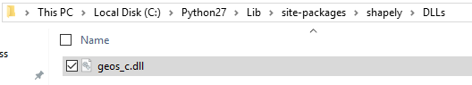

I then tried compiling a simpler program such as my GUIv2.py program, this worked:





And when I ran the program it worked too.

I decided to try running it as an administrator:

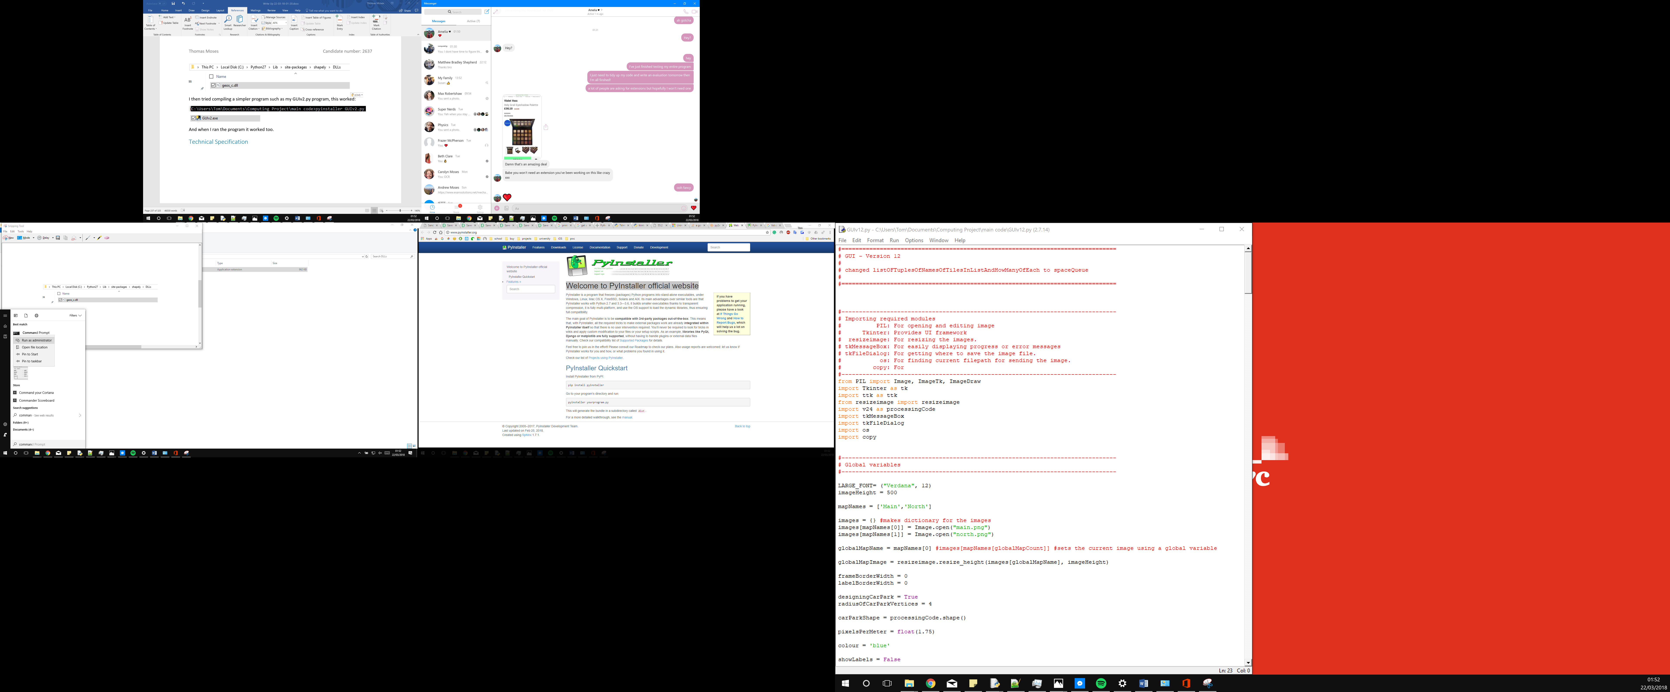

This did not help.

I then decided to try and change the capitalisation of the python ‘Lib’ folder to ‘lib’ since this seemed to be what pyinstaller was looking for. Turns out capitalisation of directories doesn’t matter.

I then tried to use cx_Freeze (cx_Freeze, n.d.).

I was able to successfully compile GUIv2.py and when I ran the executable it loaded the window. However after compiling GUIv13.py the executable did not open anything, even though it ran successfully when ran from my IDE.

I then decided to start trying to find why this error occurred. I found that I can run pyinstaller GUIv3.py --log-level DEBUG –debug to compile the next version of my GUI with debugging turned on from the help website (PyInstaller, n.d.) for pyinstaller. After launching this executable file a terminal window opened very quickly with lots of text and then crashed and closed itself. I decided to try and use a slow motion camera to see what was on the screen just before it crashed, this is the image I was able to get:

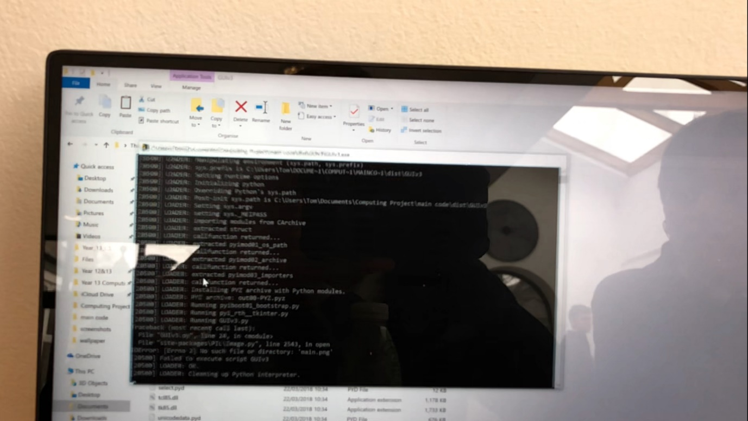

I apologise for the low image quality but this was the best I was able to get since the text was constantly moving and then disappeared when the window crashed.

From this I noticed that it was having an error while looking for the image file, on the fourth to last line. I suddenly realised this why why my program was crashing, it was trying to open a file that didn’t exist in the same directory as the executable file. I pasted the image into the directory and was able to launch GUIv3 from the executable file.

I then re-compiled GUIv13.py and pasted the three needed files into the same directory, the two car park images and the text file for the help menu.

I then ran the executable and it worked!

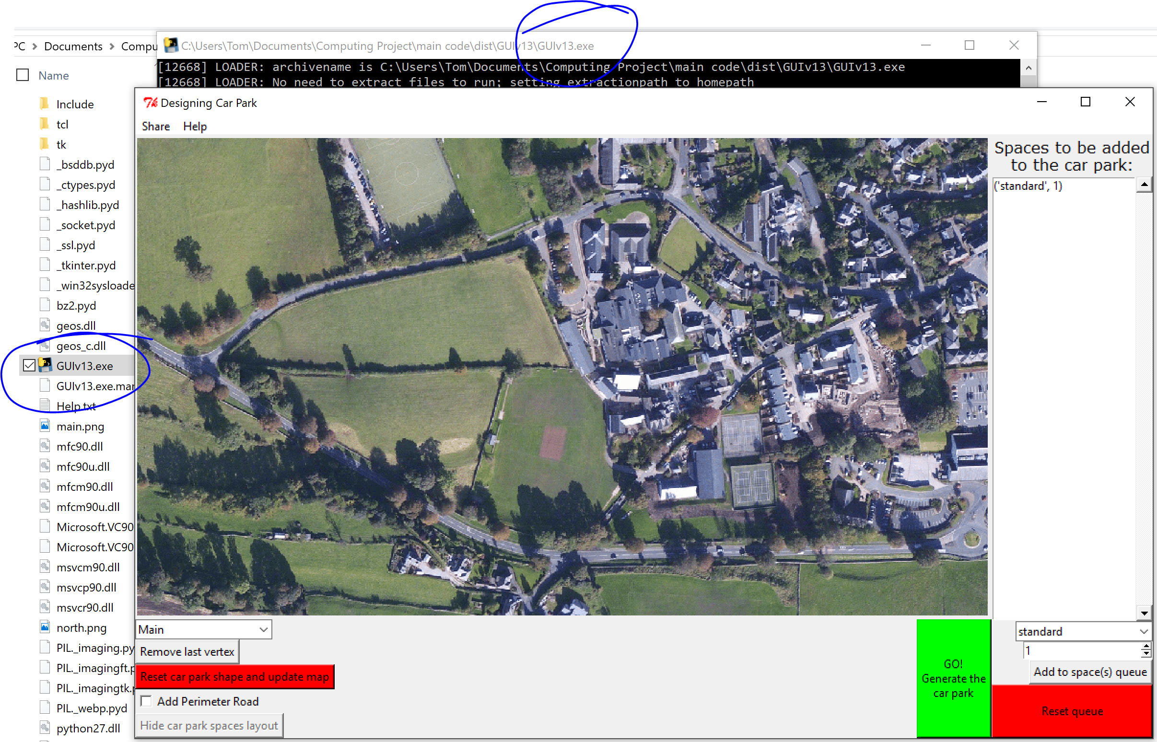

I quickly tested the main parts of my program again and they worked.

After making some final changes to my code and commenting it I had GUIv14.py and processing code v26.py, I compiled my user interface program using pyinstaller, this time without debugging turned on as this could confuse my client.

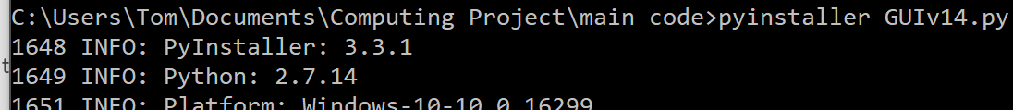

I moved my 2 image files and the text file into the directory containing the executable file and checked it worked, it did. I then tested moving the folder containing the program to another directory to see if it would still work. I moved the folder to my desktop and ran the executable file, it still worked. I also tested renaming the folder and the executable file, both caused no issues.

## Making an installer for the executable program

Since there are files that are required for the program to run, I decided to make an installer for the program. I used this (advancedinstaller, n.d.) website to help me. I was able to use a trial msi converted as it was for educational purposes. If I were to make this for a real life client I would need to purchase the full version of the EXE to MSI program called Advanced Installer.

I was able to package my entire program as this executable:

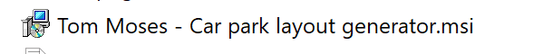

I tested installing my program on a different laptop that had never had python installed on it before. After installing the program I was successfully able to run it, this means that my client will very easily be able to use the program that they requested for me to make for them. You can see some screenshots below of the installer and of the program it then launched.

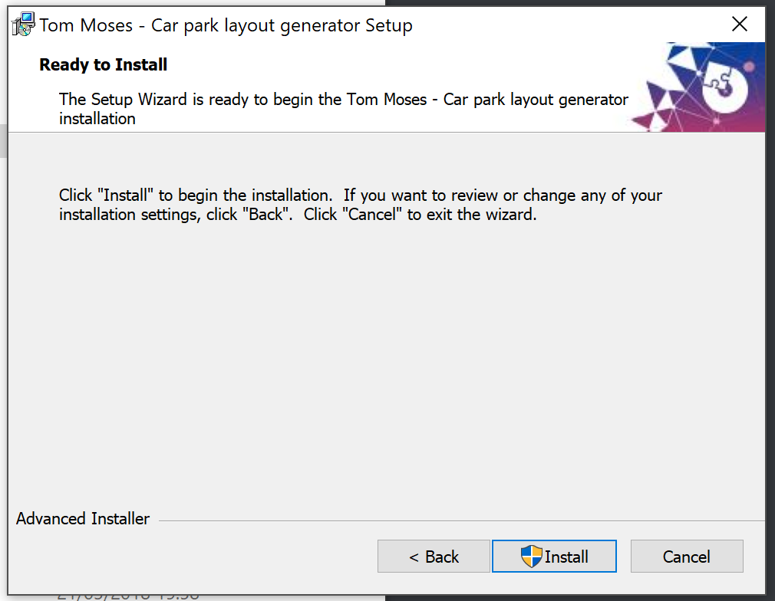

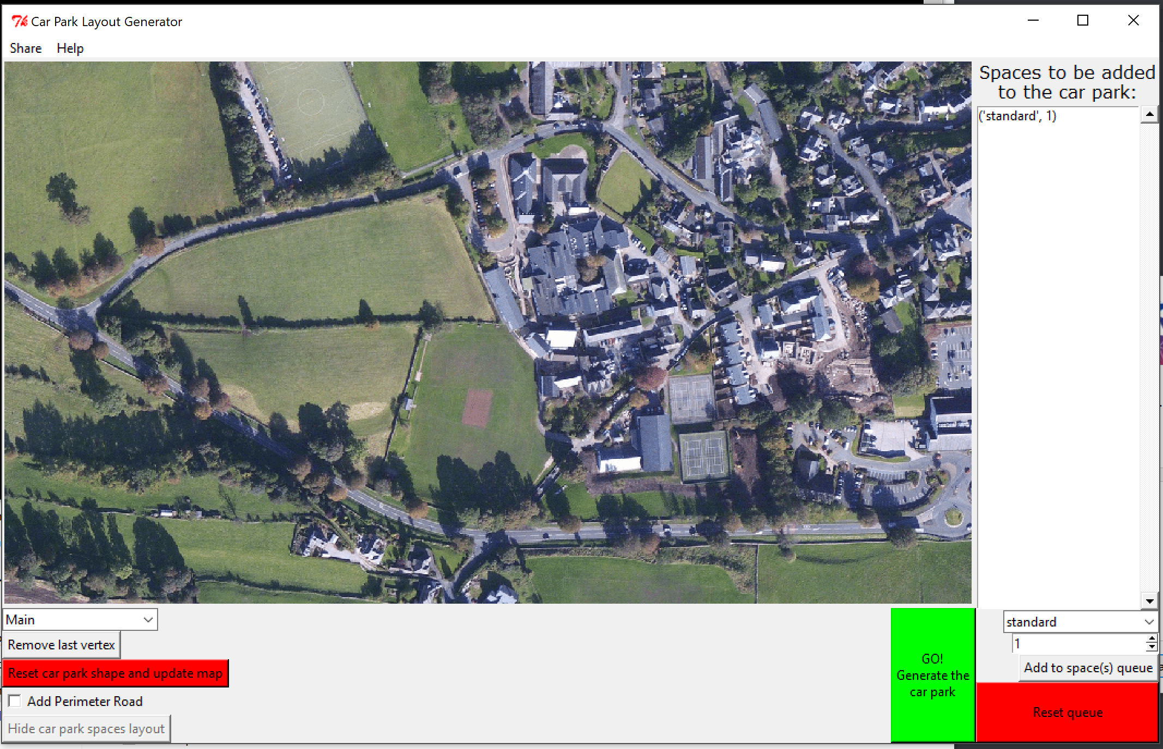

# Technical Specification

I split my car park layout generator into three separate code files. The first was the myVertexAndShapeClasses.py file, within this I defined the classes for my vertices and shapes. A shape is made up of a group of ordered vertices. Both the shape and class definitions contain many methods to allow easy manipulation of the shapes. I also includeded procedures that I needed later while programming the processing code, such as getFurthestRightVertex.

On line 6 there is the start of defining the vertex class. On line 48 I define one preceduere that helps me convert anges from degrees to radians, this was especially useful while testing my code. On line 57 there is the start of defining the shape class.

The second code file is the processing code file, these were named v[version number].py where [version number] ranged from 1 to 26. In this I included all the code for processing the car park once the user has given the program a shape from the GUI, it then returns to the GUI the lines to draw to show the generated car park.

On line 20 I import all required modules. On line 35 I define the constants for the sizes of car park spaces in a dictionary. On line 57 I define the car parking tile class which is what I use for storing template car park tiles in, before they become spaces. On line 70 I start to define the car parking tiles. On line 87 I define the tileAndTrim algorithm used to fill a given car park shape with car park spaces. On line 232 and 250 I define the functions used to get the lines the GUI should draw to represent the car parking spaces made. On lines 312 to 357 I define the procedures used to get the perimeter road for a shape. On line 362 is the only procedure that will be ran directly from the GUI code, into this is passed the outline shape of the car park and returned from this is the lines that the GUI needs to draw to represent the car park and a report message to be displayed.

The final code file is the Graphical User Interface code file, these were named GUIv[version number].py where [version number] ranged from 1 to 14. This includes all the code for launching a graphical userinterface that helps the user choose their car park shape, choose how they want it filled and then gives them ways to share the final car park once it is generated.

On line 20 I import all of the required modules for the User Interface (except for the module required for email as the user may not always send an email). On line 31 to 62 I define the global variables and constants I need to use. On lines 63 to 193 I define the frames I will use in my GUI as classes. On lines 194 to 442 I define the elements I will use in my GUI (they still inherit the frame class to make them easy to use). On lines 443 to 472 I define the procedures that I use for refreshing the window. On line 473 to 530 I define the procedures for adding the menu bar and the procedures for the buttons on the menu bar. On the 531 onwards is the code that runs initially when the program is ran, this creates the window and then launches its main loop.

# Evaluation

## Did I meet my targets?

Here I will copy out the requirements then I will reference how I met them

### Outputs

* Will output to the user the visual layout of the car park
  + My program met this target, when you run the program it displays the current view of the car park in the top left of the window as part of the map image view object class thingy
* Will show the area of land on an aerial photo.
  + When you generate a new car park, you are told the area of the car park in a report box
* Will clearly show where the entrance/exit of the car park is
  + After talking with my client we aggreed that having a perimeter road would mean that the car park can be entered or exited anywhere instead of the program having to choose where the entrance/exit is. Furthermore, not giving the user an option to show where the entrance or exit is makes the program much simpler to use.
* Will clearly show where the border of the car park is
  + The border of the car park is shown when it is drawn and is updated automatically
* A scale should be shown with the outputted design
  + I did not add this option because it could potentially obscure the view of the car park from the client.
* Will output to the user the count of how many different vehicles fit in the car park design
  + The user is told this information in the report box after they generate the car park.
* The car park will accommodate cars, minibuses, disabled spaces and/or motorcycles
  + The user has this option through the use of the space queue
* If no spaces fit in the area defined by the user, then an error message will be presented explaining the issue.
  + This user is told this is an issue in the report box.

### Inputs

* Will allow the user to input an area of land for which they want a car park to fit in
  + The user can do this by clicking the car park image placing the vertices of their car park outline while the window is in ‘designing mode’ which it is when the program first launches.
* Will allow the user to input the area of land in under 60 seconds.
  + This requirement was met, it is easy to input the area of land as you just click on the map image.
* Will support this area having any number of straight sides, up to 8.
  + I did not add a limit to the number of sides of the car park, as this could limit the client from using the program in the way they want. They may in the future want to design a complicated car park layout that has 20 sides for example.
* Should output an error if the shape is unfit.
  + The user is told in the report box that there we car park spaces added if the shape was unfit to enclose them.
* Does not need to support curved edges
  + There is now way to draw curved edges in my program, but you can have lots of small edges making up a fake curve.
* Will give the user the option to specify spaces for a set number of minibuses, disabled spaces and/or motorcycles
  + The user can achieve this through the use of the spaces queue on the right side of the window.

### Processes

* Will allocate spaces for standard sized cars by default
  + This requirement was implemented by setting the default contents of the queue to a single standard car parking space. Since the program fills the remaining space in the car park with the last added car park space, this means the entire car park will be filled with standard spaces.
* Will give the user the option to save the outputted design as an image.
  + The user can save the image through the share menu and clicking the save image to file option
* Will give the user the option to create an email with the attached car park design
  + The user can email the image through the share menu and clicking the email option.

## My thoughts

I am extremely proud of this project work, and I am very happy with the outcome of the program. It works in the way the client wants it to and I went above and beyond to please the client by making it easy for them to install it by saving it as both an executable file and making an installer to install the program to their computer.

If I were to do it again, I would have tried to find a way to link the map to a google maps API, this would mean that the client would be using more accurate distances and they would to place the car park anywere in the world, as well as being able to zoom in and out. I would say I would add a feature where the client can choose where they want the entrance/exit of the car park to be but my client said that they did not want this feature. I would also try and update my installed version of PIL so I would be able to allow the user to change the colour of the lines that are drawn.

## Final Client Feedback

I was unable to contact my client due to them being exceptionally busy, so instead of final client feedback I asked for some final feedback from my computing teacher, Mr Davies, who was overseeing my project work. This is the email response I received back from him after showing him my final project alongside the goals set out for it (I copied and pasted the text from the email to make it easier to read):

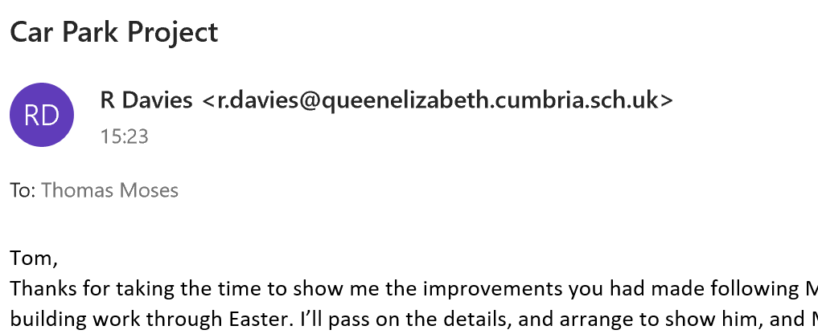

Tom,

Thanks for taking the time to show me the improvements you had made following Mr Holmes suggestions. This is excellent work. I appreciate you want to show Mr Holmes, but he is tied up with building work through Easter. I’ll pass on the details, and arrange to show him, and Mr Rowlands at a time convenient to them later. Thankyou for providing both an executable and an installer. That makes the task of handing it over to Mr Holmes so much easier.

Well done – I know he will be very pleased.

Mr Davies

I am satisfied that I have met the initial goals set out for the program and that I have gone above and beyond to add anitionally requested features to the program. As you can see from the above email, my supervisor is also sure that my client will be pleased with the program as well.

# Code Listing

I recommend that you use the contents page to skip to latest versions of the code. I included multiple versions to prove that I coded in versions.

## myVertexAndShapeClasses.py

|  |  |
| --- | --- |
| 1 | **import** math |
| 2 |  |
| 3 | **#-------------------------------------------------------------------------------** |
| 4 | **# Defining a vertex class. This is just a point. (Plural = vertices)** |
| 5 | **#-------------------------------------------------------------------------------** |
| 6 | **class** **vertex**(): |
| 7 | **def** **__init__**(self,x = **None**, y = **None**): |
| 8 | self.x = x |
| 9 | self.y = y |
| 10 |  |
| 11 | **def** **getX**(self): |
| 12 | **return** self.x |
| 13 |  |
| 14 | **def** **getY**(self): |
| 15 | **return** self.y |
| 16 |  |
| 17 | **def** **getCoordinates**(self): |
| 18 | **return** [self.x,self.y] |
| 19 |  |
| 20 | **def** **setX**(self,x): |
| 21 | self.x = float(x) |
| 22 |  |
| 23 | **def** **setY**(self,Y): |
| 24 | self.y = float(y) |
| 25 |  |
| 26 | **def** **setXY**(self,both): **#both with become the standard name for a tuple of an X and Y coordinate** |
| 27 | self.x = both[0] |
| 28 | self.y = both[1] |
| 29 |  |
| 30 | **def** **rotateAboutAnotherVertex**(self,about,angle): **#the position it rotates clockwise about will be passed in as a vertex class.** |
| 31 | **#the angle will be given in radians** |
| 32 | **#print "angle", angle** |
| 33 | angle = -angle **#I realised the matrix i used was to rotate anticlockwise, so this fixes that problem.** |
| 34 | newX = (self.x-about.x)*(math.cos(angle)) - (self.y-about.y)*(math.sin(angle)) + about.x |
| 35 | newY = (self.y-about.y)*(math.cos(angle)) + (self.x-about.x)*(math.sin(angle)) + about.y |
| 36 | self.setXY([newX,newY]) |
| 37 |  |
| 38 | **def** **translateXY**(self,translationXY): **#translation should be passed in the form [X,Y]** |
| 39 | self.x = (self.x + translationXY[0]) |
| 40 | self.y = (self.y + translationXY[1]) |
| 41 |  |
| 42 | **def** **stretchVertex**(self,scale): **#will stretch the position of the vertex about the origin** |
| 43 | self.x = (self.x * scale) |
| 44 | self.y = (self.y * scale) |
| 45 |  |
| 46 |  |
| 47 |  |
| 48 | **def** **toRadians**(degrees): |
| 49 | **return** degrees*((2*math.pi)/360) |
| 50 |  |
| 51 |  |
| 52 | **#-------------------------------------------------------------------------------** |
| 53 | **# Defining a shape class.** |
| 54 | **# This is just a collection of vertices in a specific order.** |
| 55 | **#-------------------------------------------------------------------------------** |
| 56 |  |
| 57 | **class** **shape**(): |
| 58 | **def** **__init__**(self,label = ""): |
| 59 | self.vertices = [] |
| 60 | self.label = label |
| 61 |  |
| 62 | **def** **getLabel**(self): |
| 63 | **return** self.label |
| 64 |  |
| 65 | **def** **addVertex**(self,vertex): |
| 66 | self.vertices.append(vertex) |
| 67 |  |
| 68 | **def** **addVerticesXY**(self,verticesXY): **#vertices should be as lists within lists** |
| 69 | **for** each **in** verticesXY: |
| 70 | temp = vertex() |
| 71 | temp.setXY(each) |
| 72 | self.addVertex(temp) |
| 73 |  |
| 74 | **def** **removeLastVertex**(self): |
| 75 | self.vertices = self.vertices[:-1] **#removes last item from list** |
| 76 |  |
| 77 | **def** **getVertices**(self): |
| 78 | **return** self.vertices |
| 79 |  |
| 80 | **def** **getVerticesCoordinates**(self): |
| 81 | listOfCoordinates = [] |
| 82 | **for** eachVertex **in** self.vertices: |
| 83 | listOfCoordinates.append(eachVertex.getCoordinates()) |
| 84 | **return** listOfCoordinates |
| 85 |  |
| 86 | **def** **getDistanceToNextVertex**(self,vertexNumber): **#will return the first vertex from the longest line.** |
| 87 | **if** len(self.vertices) < vertexNumber: **#checks the vertex will exist** |
| 88 | **print** "Error, vertex does not exist" |
| 89 | **elif** len(self.vertices) < 2: |
| 90 | **print** "Error, not enough vertices to find distance" |
| 91 | **else**: |
| 92 | vertex1 = self.vertices[vertexNumber] |
| 93 | vertex2 = self.vertices[(vertexNumber+1)%(len(self.vertices))] |
| 94 | differenceInX = vertex1.getX() - vertex2.getX() |
| 95 | differenceInY = vertex1.getY() - vertex2.getY() |
| 96 | distance = math.sqrt( differenceInX**2 + differenceInY**2 ) |
| 97 | **return** distance |
| 98 | **return** **None** **#if the distance was not retuned it will return a null value** |
| 99 |  |
| 100 |  |
| 101 | **def** **getLongestSide**(self): **#will return the first vertex from the longest line.** |
| 102 | longestVertextNumber = **None** |
| 103 | **if** len(self.vertices) < 2: |
| 104 | **print** "Error, not enough vertices to find distance" |
| 105 | **elif** len(self.vertices) == 2: |
| 106 | longestVertextNumber = 0 |
| 107 | **else**: |
| 108 | longestVertextNumber = 0 |
| 109 | **for** count **in** range(len(self.vertices)): |
| 110 | **if** self.getDistanceToNextVertex(count) > self.getDistanceToNextVertex(longestVertextNumber): |
| 111 | longestVertextNumber = count |
| 112 | **return** longestVertextNumber **#will return the number of the first vertex of the longest edge of the shape.** |
| 113 |  |
| 114 | **def** **rotateAboutAVertex**(self,about,angle): |
| 115 | **for** eachVertex **in** self.vertices: |
| 116 | eachVertex.rotateAboutAnotherVertex(about,angle) |
| 117 |  |
| 118 | **def** **translateXY**(self,translationXY): |
| 119 | **for** eachVertex **in** self.vertices: |
| 120 | eachVertex.translateXY(translationXY) |
| 121 |  |
| 122 | **def** **makeLongestSideFlat**(self): |
| 123 | self.makeSideAfterVertexFlat(self.vertices[self.getLongestSide()]) |
| 124 |  |
| 125 | **def** **makeSideAfterVertexFlat**(self,vertex1): |
| 126 | **for** count **in** range(len(self.vertices)): |
| 127 | **if** self.vertices[count] == vertex1: |
| 128 | vertex2 = self.vertices[(count+1)%(len(self.vertices))] |
| 129 | differenceInX = float(float(vertex1.getX()) - float(vertex2.getX())) **# I needed to add in these float bit so that the devision later is not floor devision.** |
| 130 | differenceInY = float(float(vertex1.getY()) - float(vertex2.getY())) |
| 131 | **#print "X:",differenceInX** |
| 132 | **#print "Y:",differenceInY** |
| 133 | **if** differenceInX **in** [float(0),float(-0)]: |
| 134 | angle = math.pi/2 **#90 degrees** |
| 135 | **else**: |
| 136 | angle = (math.atan((differenceInY)/(differenceInX))) **#this finds the angle from horizonal of the line connecting the first vertex to the next** |
| 137 | **#when we have this anlgle, we can turn the entire shape by the same angle rotating about** |
| 138 | **print** "angle:",angle |
| 139 | self.rotateAboutAVertex(vertex1,angle) **#the first vertex in order to make this side lay flat.** |
| 140 |  |
| 141 | **def** **getAngleForLongestSide**(self): |
| 142 | vertex1 = self.vertices[self.getLongestSide()] |
| 143 | **for** count **in** range(len(self.vertices)): |
| 144 | **if** self.vertices[count] == vertex1: |
| 145 | vertex2 = self.vertices[(count+1)%(len(self.vertices))] |
| 146 | differenceInX = float(float(vertex1.getX()) - float(vertex2.getX())) **# I needed to add in these float bit so that the devision later is not floor devision.** |
| 147 | differenceInY = float(float(vertex1.getY()) - float(vertex2.getY())) |
| 148 | **#print "X:",differenceInX** |
| 149 | **#print "Y:",differenceInY** |
| 150 | **if** differenceInX **in** [float(0),float(-0)]: |
| 151 | angle = math.pi/2 **#90 degrees if the difference in either x is 0** |
| 152 | **else**: |
| 153 | angle = (math.atan((differenceInY)/(differenceInX))) **#this finds the angle from horizonal of the line connecting the first vertex to the next** |
| 154 | **#when we have this anlgle, we can turn the entire shape by the same angle rotating about** |
| 155 | **#the first vertex in order to make this side lay flat.** |
| 156 | **return** angle |
| 157 |  |
| 158 | **def** **getAngleOflineAfterVertexFromHorizontal**(self,vertexNumber): |
| 159 | vertex1 = self.vertices[vertexNumber] |
| 160 | vertex2 = self.vertices[(vertexNumber+1)%(len(self.vertices))] |
| 161 | differenceInX = float(float(vertex1.getX()) - float(vertex2.getX())) **# I needed to add in these float bit so that the devision later is not floor devision.** |
| 162 | differenceInY = float(float(vertex1.getY()) - float(vertex2.getY())) |
| 163 | **#print "X:",differenceInX** |
| 164 | **#print "Y:",differenceInY** |
| 165 | **if** differenceInX **in** [float(0),float(-0)]: |
| 166 | angle = math.pi/2 **#90 degrees if the difference in either x is 0** |
| 167 | **else**: |
| 168 | angle = (math.atan((differenceInY)/(differenceInX))) **#this finds the angle from horizonal of the line connecting the first vertex to the next** |
| 169 | **#when we have this anlgle, we can turn the entire shape by the same angle rotating about** |
| 170 | **#the first vertex in order to make this side lay flat.** |
| 171 | **#will now make sure its in the correct quadrant.** |
| 172 | **if** vertex2.getY > vertex1.getY() **and** vertex2.getX() < vertex1.getX(): |
| 173 | angle = angle + math.pi |
| 174 |  |
| 175 |  |
| 176 | **return** angle |
| 177 |  |
| 178 |  |
| 179 | **def** **translateShapeToFitNicely**(self): **#this will move the shape to the positive quardrant of a graph, on the axis.** |
| 180 | longestVertexNumber = self.getLongestSide() |
| 181 | furthestLeftVertex = self.getFurthestLeftVertex() |
| 182 | furthestDownVertex = self.getFurthestDownVertex() |
| 183 | tranlationXY = [(-furthestLeftVertex.getX(),-furthestDownVertex.getY())] **#now translates using negative of most extremely wrong values for X and Y** |
| 184 | self.translateXY(tranlationXY) |
| 185 |  |
| 186 | **def** **stretchShape**(self,scale): |
| 187 | **for** eachVertex **in** self.vertices: |
| 188 | eachVertex.stretchVertex(scale) |
| 189 |  |
| 190 | **def** **getFurthestRightVertex**(self): **#returns vertex with lowest X value** |
| 191 | furthestRightVertexNumber = 0 |
| 192 | **if** len(self.vertices) > 1: |
| 193 | **for** count **in** range(1,len(self.vertices)): |
| 194 | **if** self.vertices[count].getX() > self.vertices[furthestRightVertexNumber].getX(): |
| 195 | furthestRightVertexNumber = count |
| 196 | **return** self.vertices[furthestRightVertexNumber] |
| 197 |  |
| 198 | **def** **getFurthestLeftVertex**(self): **#returns vertex with highest X value** |
| 199 | furthestNumber = 0 |
| 200 | **if** len(self.vertices) > 1: |
| 201 | **for** count **in** range(1,len(self.vertices)): |
| 202 | **if** self.vertices[count].getX() < self.vertices[furthestNumber].getX(): |
| 203 | furthestNumber = count |
| 204 | **return** self.vertices[furthestNumber] |
| 205 |  |
| 206 | **def** **getFurthestUpVertex**(self): **#returns vertex with lowest Y value** |
| 207 | furthestNumber = 0 |
| 208 | **if** len(self.vertices) > 1: |
| 209 | **for** count **in** range(1,len(self.vertices)): |
| 210 | **if** self.vertices[count].getY() > self.vertices[furthestNumber].getY(): |
| 211 | furthestNumber = count |
| 212 | **return** self.vertices[furthestNumber] |
| 213 |  |
| 214 | **def** **getFurthestDownVertex**(self): **#returns vertex with highest Y value** |
| 215 | furthestNumber = 0 |
| 216 | **if** len(self.vertices) > 1: |
| 217 | **for** count **in** range(1,len(self.vertices)): |
| 218 | **if** self.vertices[count].getY() < self.vertices[furthestNumber].getY(): |
| 219 | furthestNumber = count |
| 220 | **return** self.vertices[furthestNumber] |

## Processing code

v2.py is my first version

v17.py is my first version that worked with the GUI

v24.py is my final version before testing

v25.py is my final version after testing

v26.py is my final commented and cleaned up version of the processing code. If you are going to read just one version of my code, this is the version to read. The others have been included as proof that I using versions while making my program.

### v2.py

|  |  |
| --- | --- |
| 1 | **#########################################** |
| 2 | **# #** |
| 3 | **# Car Park Layout Program #** |
| 4 | **# Version 2 #** |
| 5 | **# #** |
| 6 | **# Starting to add the draw #** |
| 7 | **# image functions #** |
| 8 | **# #** |
| 9 | **#########################################** |
| 10 |  |
| 11 |  |
| 12 |  |
| 13 | **#########################################** |
| 14 | **######################################### Import libraries and modules** |
| 15 | **#Import PIL** |
| 16 | **from** PIL **import** Image, ImageTk, ImageDraw **#for opening file** |
| 17 | **#Import Tkinter** |
| 18 | **import** Tkinter **#for opening window** |
| 19 |  |
| 20 |  |
| 21 |  |
| 22 | **#########################################** |
| 23 | **######################################### Constants** |
| 24 | **#Background Image File** |
| 25 | backgroundImageLocation = "test.jpg" |
| 26 | **#Width of car park space** |
| 27 |  |
| 28 | **#Length of car park space** |
| 29 |  |
| 30 | **#Width of road** |
| 31 |  |
| 32 |  |
| 33 |  |
| 34 | **#########################################** |
| 35 | **######################################### Classes** |
| 36 | **###################** |
| 37 | **#Vertex Class - contains an x and y position** |
| 38 | **class** **vertex**(): |
| 39 | **def** **__init__**(self): |
| 40 | self.x = **None** |
| 41 | self.y = **None** |
| 42 |  |
| 43 | **def** **getX**(self): |
| 44 | **return** self.X |
| 45 |  |
| 46 | **def** **getY**(self): |
| 47 | **return** self.Y |
| 48 |  |
| 49 | **def** **coordinates**(self): |
| 50 | **return** [self.X,self.Y] |
| 51 |  |
| 52 | **def** **setX**(self,X): |
| 53 | self.X = X |
| 54 |  |
| 55 | **def** **setY**(self,Y): |
| 56 | self.Y = Y |
| 57 |  |
| 58 | **def** **setXY**(self,both): |
| 59 | self.X = both[0] |
| 60 | self.Y = both[1] |
| 61 |  |
| 62 |  |
| 63 |  |
| 64 | **class** **shape**(): **#need to change this ordered list to work for a shape** |
| 65 | **def** **__init__**(self): |
| 66 | self.vertices = [] |
| 67 |  |
| 68 | **def** **isEmpty**(self): |
| 69 | **return** len(self.vertices) == 0 |
| 70 |  |
| 71 | **def** **addCoordinatesToEnd**(self,both): |
| 72 | temp = vertex() |
| 73 | temp.setXY(both) |
| 74 | self.addVertexToEnd(temp) |
| 75 |  |
| 76 | **def** **addVertexToEnd**(self,vertex): |
| 77 | self.vertices += [vertex] |
| 78 |  |
| 79 | **def** **numberOfVertices**(self): |
| 80 | **return** len(self.vertices) |
| 81 |  |
| 82 | **def** **vertices**(self): |
| 83 | **return** self.vertices |
| 84 |  |
| 85 | **def** **coordinates**(self): |
| 86 | coordinateList = [] |
| 87 | **for** each **in** self.vertices: |
| 88 | coordinateList += [each.coordinates()] |
| 89 | **return** coordinateList |
| 90 |  |
| 91 | **def** **search**(self,both): |
| 92 | foundPositions = [] |
| 93 | **for** count **in** range(self.numberOfVertices()): |
| 94 | **if** vertices[count].coordinates() == both: |
| 95 | foundPositions += [count] |
| 96 | **return** foundPositions |
| 97 |  |
| 98 | **def** **removeFromPosition**(self,position): |
| 99 | self.vertices = self.vertices[:position] + self.vertices[position+1:] |
| 100 |  |
| 101 | **def** **removeFromEnd**(self): |
| 102 | self.removeFromPosition(self.numberOfVertices()-1) |
| 103 |  |
| 104 |  |
| 105 |  |
| 106 | **#########################################** |
| 107 | **######################################### Sub-routines** |
| 108 | **def** **openImage**(fileName): |
| 109 | **print** **#header** |
| 110 |  |
| 111 |  |
| 112 | **def** **openImageAndGetClickedLocations**(backgroundImageLocation): **#will return clicked locations as a list** |
| 113 | window = Tkinter.Tk() **#creates window** |
| 114 | image = Image.open(backgroundImageLocation) **#creates an instance of an image class** |
| 115 | canvas = Tkinter.Canvas(window, width=image.size[0], height=image.size[1]) **#image.size gives you the width and depth** |
| 116 | canvas.pack() |
| 117 | image_tk = ImageTk.PhotoImage(image) |
| 118 | canvas.create_image(image.size[0]//2, image.size[1]//2, image=image_tk) **#//2 needed in order to center the image** |
| 119 |  |
| 120 | canvas.bind("<Button-1>", whenImageIsClicked) **#<Button-1> is the left mouse button** |
| 121 | **#print "image size: " + str(image.size)** |
| 122 | Tkinter.mainloop() |
| 123 |  |
| 124 |  |
| 125 | **def** **whenImageIsClicked**(event): |
| 126 | **print** "coords: " + str(event.x) + "," + str(event.y) |
| 127 |  |
| 128 | **#carparkOutline.addCoordinatesToEnd([event.x,event.y])** |
| 129 | **#print carparkOutline.coordinates()** |
| 130 |  |
| 131 | **#newImage = drawLinesOnImage(backgroundImageLocation,carparkOutline.coordinates(),128)** |
| 132 | **#canvas.itemconfig(self.image_on_canvas, image = ...)** |
| 133 |  |
| 134 |  |
| 135 |  |
| 136 |  |
| 137 | **def** **drawLinesOnImage**(fileName,coordinates,colour): **#will return edited image** |
| 138 | image = Image.open(fileName) |
| 139 |  |
| 140 | imageToDrawOn = ImageDraw.Draw(image) |
| 141 | imageToDrawOn.line(coordinates, fill=colour) |
| 142 | **del** imageToDrawOn |
| 143 |  |
| 144 | **return** image |
| 145 |  |
| 146 |  |
| 147 | **#########################################** |
| 148 | **######################################### Stuff it will do** |
| 149 |  |
| 150 |  |
| 151 | carparkOutline = shape() |
| 152 | openImageAndGetClickedLocations(backgroundImageLocation) |
| 153 | carparkOutline = shape() |
| 154 | carparkOutline.addCoordinatesToEnd([3,7]) |
| 155 | **print** carparkOutline.coordinates() |
| 156 |  |

### v17.py

|  |  |
| --- | --- |
| 1 | **#===============================================================================** |
| 2 | **# Main Processing - Version 17** |
| 3 | **#** |
| 4 | **# Adding final support for GUI** |
| 5 | **# including translating pixels to meters and back** |
| 6 | **#** |
| 7 | **#===============================================================================** |
| 8 |  |
| 9 |  |
| 10 |  |
| 11 | **#-------------------------------------------------------------------------------** |
| 12 | **# Importing required modules** |
| 13 | **# PIL: For opening and editing image (will use this in a later version)** |
| 14 | **# Tkinter: Provides UI framework (will use this in a later version)** |
| 15 | **# Math: Allows me to easily use trigonometry to rotate the vertices** |
| 16 | **# Shapely: Allows me to easily have a way to test if a point is outside a shape** |
| 17 | **# copy: Allows me to duplicate a class instance easily rather than creating another referance to the same instance** |
| 18 | **#-------------------------------------------------------------------------------** |
| 19 | **from** PIL **import** Image, ImageTk, ImageDraw |
| 20 | **from** Tkinter **import** * |
| 21 | **import** math |
| 22 | **from** shapely.geometry **import** Point, Polygon **#this imports the required classes from shapely** |
| 23 | **import** copy |
| 24 |  |
| 25 | **from** myVertexandShapeClasses **import** * |
| 26 |  |
| 27 |  |
| 28 |  |
| 29 | **#-------------------------------------------------------------------------------** |
| 30 | **# Here I will define the sizes of spaces, W (width) will be the side facing the road** |
| 31 | **# The real life sizes in this program are in metres** |
| 32 | **#-------------------------------------------------------------------------------** |
| 33 |  |
| 34 | sizes = {'standardW':2.4,'standardD':4.8, |
| 35 | 'minibusW':2.4,'minibusD':6, |
| 36 | 'gapBetweenDisabledSpaces':1.2, |
| 37 | 'motorcycleW':1.2,'motorcycleD':4.8, |
| 38 | 'roadWidth':6.0} |
| 39 |  |
| 40 |  |
| 41 |  |
| 42 |  |
| 43 | **#-------------------------------------------------------------------------------** |
| 44 | **# I need to make the standard tile of parking spaces (they will be groups of spaces with a standard size)** |
| 45 | **#-------------------------------------------------------------------------------** |
| 46 |  |
| 47 | **class** **tile**(): |
| 48 | **def** **__init__**(self,width = 0, depth = 0): |
| 49 | self.width = width |
| 50 | self.depth = depth |
| 51 |  |
| 52 | **def** **getWidth**(self): |
| 53 | **return** self.width |
| 54 |  |
| 55 | **def** **getDepth**(self): |
| 56 | **return** self.depth |
| 57 |  |
| 58 | tileNames = ['standard','minibus','disabled','motorcycle'] |
| 59 |  |
| 60 | tiles = {'standard':tile(sizes['standardW'],sizes['standardD']*2+sizes['roadWidth']), **#standard tile should be fine for making the tile and trim and testing at first** |
| 61 | 'minibus':tile(sizes['minibusW'],sizes['minibusD']*2+sizes['roadWidth']), **#need to fix these tiles** |
| 62 | 'disabled':tile((sizes['standardW']+sizes['gapBetweenDisabledSpaces']),sizes['standardD']*2+sizes['roadWidth']), |
| 63 | 'motorcycle':tile(sizes['motorcycleW'],sizes['standardD']*2+sizes['roadWidth'])} |
| 64 |  |
| 65 | listOFTuplesOfNamesOfTilesInListAndHowManyOfEach = [('standard',1)] **#it will not matter what the limit of the last item in the list is as this will be what the car park is then filled with.** |
| 66 | **#-------------------------------------------------------------------------------** |
| 67 | **# Algorythm i will use** |
| 68 | **#-------------------------------------------------------------------------------** |
| 69 |  |
| 70 | **#get all points of edge of the car park** |
| 71 | **#rotate so longest side is flat** |
| 72 | **#translate so is closest to the origin but all positive coordinates** |
| 73 | **#row-by-row place tiles (by adding them to a list)** |
| 74 | **#then make sure road works** |
| 75 |  |
| 76 |  |
| 77 | **#-------------------------------------------------------------------------------** |
| 78 | **# tile and trim** |
| 79 | **#-------------------------------------------------------------------------------** |
| 80 |  |
| 81 | **def** **tileAndTrim**(carParkShape,tiles,listOFTuplesOfNamesOfTilesInListAndHowManyOfEach): |
| 82 | **print** "Starting tile and trim" |
| 83 | fill = **False** |
| 84 | carParkFull = **False** |
| 85 | bottomLeftVertex = vertex(carParkShape.getFurthestLeftVertex().getX(),carParkShape.getFurthestDownVertex().getY()) |
| 86 | **print** bottomLeftVertex.getCoordinates() |
| 87 | placedTiles = [] |
| 88 | furthestRightVertex = carParkShape.getFurthestRightVertex() |
| 89 | **print** "furthest right: " + str(furthestRightVertex.getCoordinates()) |
| 90 | furthestUpVertex = carParkShape.getFurthestUpVertex() |
| 91 | **for** count **in** range(len(listOFTuplesOfNamesOfTilesInListAndHowManyOfEach)): |
| 92 | tileLabel = listOFTuplesOfNamesOfTilesInListAndHowManyOfEach[count][0] |
| 93 | currentTile = tiles[tileLabel] |
| 94 | howMany = listOFTuplesOfNamesOfTilesInListAndHowManyOfEach[count][1] |
| 95 | howManyLeft = howMany |
| 96 | **if** count == (len(listOFTuplesOfNamesOfTilesInListAndHowManyOfEach) -1): **#if it is final item i will fill car park with this tile** |
| 97 | fill = **True** |
| 98 |  |
| 99 | **while** (howManyLeft > 0 **or** fill == **True**) **and** (carParkFull == **False**): |
| 100 | **#print "-------"** |
| 101 | **print** bottomLeftVertex.getCoordinates() |
| 102 | **#we will start testing at 0,0 then move right, then move onto a new row up when the current layer has been filled.** |
| 103 | **#print "stub for placing the tile as a shape and testing if all of its vertices are within the car park shape"** |
| 104 | **#makeShapeFromTile** |
| 105 | tileShape = makeShapeFromTile(bottomLeftVertex,tileLabel,tiles) |
| 106 | validTilePlacement = testIfOneShapeIsWithinAnotherShape(tileShape,carParkShape) |
| 107 | **#print "stub for if tile was placed and is in boundary, add this shape to a list of car parking tiles created. Then reduce howManyLeft by 1."** |
| 108 | **if** validTilePlacement: |
| 109 | **print** "valid " + tileLabel + " tile placement." |
| 110 | howManyLeft = howManyLeft - 1 |
| 111 | placedTiles.append(tileShape) |
| 112 | bottomLeftVertex.translateXY([ tiles[tileLabel].getWidth() , 0 ]) **#moved bottom left vertex to the right** |
| 113 | **#will see if bottom left vertex needs resetting** |
| 114 | **#print "stub for testing if placing x is out of range, will then move y up the right height and reset x"** |
| 115 | **if** bottomLeftVertex.getX() > furthestRightVertex.getX(): |
| 116 | **#print "out of range"** |
| 117 | bottomLeftVertex.setX(carParkShape.getFurthestLeftVertex().getX()) |
| 118 | **#print bottomLeftVertex.getCoordinates()** |
| 119 | bottomLeftVertex.translateXY([ 0 , tiles[tileLabel].getDepth() ]) **#moved bottom left vertex up** |
| 120 | **#print "stub for testing if placing y is out of range, if y was just change, if it is filledCarPark will be set to True"** |
| 121 | **if** bottomLeftVertex.getY() > furthestUpVertex.getY(): |
| 122 | **#print "Tried placing tiles in all spaces = true"** |
| 123 | carParkFull = **True** |
| 124 |  |
| 125 | **#print "in range: " + str(furthestRightVertex.getX())** |
| 126 | **if** howManyLeft == 0: |
| 127 | **#was sucessful** |
| 128 | **print** "Placed all " + tileLabel + " spaces sucessfully" |
| 129 | **if** carParkFull: |
| 130 | **print** "Car park was filled. I filled it up with " + str(-howManyLeft) + " extra " + tileLabel + " spaces." |
| 131 | **else**: |
| 132 | **print** "car park was full and ran out of space to place what you wanted" |
| 133 | **return** placedTiles |
| 134 |  |
| 135 |  |
| 136 | **#-------------------------------------------------------------------------------** |
| 137 | **# Making a shape from a tile and a position to place the** |
| 138 | **#-------------------------------------------------------------------------------** |
| 139 |  |
| 140 | **def** **makeShapeFromTile**(bottomLeftVertex,tileLabel,tiles): |
| 141 | tileShape = shape() |
| 142 | bottomLeftCoords = bottomLeftVertex.getCoordinates() |
| 143 | bottomLeftX = bottomLeftCoords[0] |
| 144 | bottomLeftY = bottomLeftCoords[1] |
| 145 | width = tiles[tileLabel].getWidth() |
| 146 | depth = tiles[tileLabel].getDepth() |
| 147 | tileShape.addVerticesXY([bottomLeftCoords,[bottomLeftX,bottomLeftY+depth],[bottomLeftX+width,bottomLeftY+depth],[bottomLeftX+width,bottomLeftY]]) |
| 148 | **return** tileShape |
| 149 |  |
| 150 | **#-------------------------------------------------------------------------------** |
| 151 | **# I need a way to test if any points of a shape are outside the other shape.** |
| 152 | **#-------------------------------------------------------------------------------** |
| 153 |  |
| 154 | **def** **testIfVertexIsWithinShape**(shape,vertex): |
| 155 | shapelyShape = Polygon(shape.getVerticesCoordinates()) **#creates an instance of a Shapely Polygon that is identicle to the shape inputted** |
| 156 | shapelyPoint = Point(vertex.getCoordinates()) **#creates an instance of a Shapely Point which is identicle to the vertex inputted** |
| 157 | **return** shapelyShape.intersects(shapelyPoint) **#tests and returns if the Point is within or on the boundary of the Polygon** |
| 158 |  |
| 159 | **def** **testIfOneShapeIsWithinAnotherShape**(oneShape,anotherShape): |
| 160 | shapelyPoints = [] |
| 161 | **for** eachVertex **in** oneShape.getVertices(): |
| 162 | shapelyPoints.append( Point(eachVertex.getCoordinates()) ) **#creates an instance of a Shapely Point which is identicle to the vertices in the shape that needs to within the other one.** |
| 163 | shapelyShape = Polygon(anotherShape.getVerticesCoordinates()) **#creates an instance of a Shapely Polygon that is identicle to the shape inputted** |
| 164 |  |
| 165 | allWithin = **True** |
| 166 | **for** eachShapelyPoint **in** shapelyPoints: |
| 167 | **if** **not** shapelyShape.intersects(eachShapelyPoint): **#tests if the Point is within or on the boundary of the Polygon** |
| 168 | allWithin = **False** |
| 169 | **return** allWithin |
| 170 |  |
| 171 | **#-------------------------------------------------------------------------------** |
| 172 | **# Main Menu definition - removed** |
| 173 | **#-------------------------------------------------------------------------------** |
| 174 |  |
| 175 |  |
| 176 |  |
| 177 | **#-------------------------------------------------------------------------------** |
| 178 | **# Testing procedures - removed** |
| 179 | **#-------------------------------------------------------------------------------** |
| 180 |  |
| 181 |  |
| 182 |  |
| 183 |  |
| 184 | **#-------------------------------------------------------------------------------** |
| 185 | **# code that will be executed - removed** |
| 186 | **#-------------------------------------------------------------------------------** |
| 187 |  |
| 188 |  |
| 189 | **#-------------------------------------------------------------------------------** |
| 190 | **# code to convert pixel values to meters and back again** |
| 191 | **#-------------------------------------------------------------------------------** |
| 192 |  |
| 193 | **def** **convertShapePixelToMeter**(shape,pixelsPerMeter): |
| 194 | shape.stretchShape(float(1/float(pixelsPerMeter))) |
| 195 |  |
| 196 | **def** **convertShapeMeterToPixel**(shape,pixelsPerMeter): |
| 197 | shape.stretchShape(float(pixelsPerMeter)) |
| 198 |  |
| 199 |  |
| 200 | **#-------------------------------------------------------------------------------** |
| 201 | **# get tuples of coordinates of edged of a shape ready for printing** |
| 202 | **#-------------------------------------------------------------------------------** |
| 203 |  |
| 204 | **def** **getEdgesOfShapes**(shape): |
| 205 | listOfGroupsOfCoordinatesForLines = [] **#eg: [[x1,y1,x2,y2],[x3,y3,x4,y4]...]** |
| 206 | listOfCoordinates = shape.getVerticesCoordinates() |
| 207 | **for** count **in** range(len(listOfCoordinates)):**# each in carParkShape.getVerticesCoordinates():** |
| 208 | listOfGroupsOfCoordinatesForLines.append([listOfCoordinates[count][0],listOfCoordinates[count][1],listOfCoordinates[(count+1)%len(listOfCoordinates)][0],listOfCoordinates[(count+1)%len(listOfCoordinates)][1]]) |
| 209 | **return** listOfGroupsOfCoordinatesForLines |
| 210 |  |
| 211 | **#-------------------------------------------------------------------------------** |
| 212 | **# code that will be run by the GUI** |
| 213 | **#-------------------------------------------------------------------------------** |
| 214 |  |
| 215 | **def** **GetCarParkPixelLinesToDrawFromPixelShape**(shape,pixelsPerMeter): |
| 216 | listOfGroupsOfCoordinatesForLines = [] **#eg: [[x1,y1,x2,y2],[x3,y3,x4,y4]...]** |
| 217 | originalShape = copy.deepcopy(shape) |
| 218 | **print** shape.getVerticesCoordinates() |
| 219 | **print** pixelsPerMeter |
| 220 | convertShapePixelToMeter(shape,pixelsPerMeter) |
| 221 | **print** shape.getVerticesCoordinates() |
| 222 | parkingTilesMade = tileAndTrim(shape,tiles,listOFTuplesOfNamesOfTilesInListAndHowManyOfEach) **#a list of tile shapes generated, currently in meters** |
| 223 | **#print parkingTilesMade** |
| 224 | **for** eachCarParkTile **in** parkingTilesMade: **#adds edges of each tile to lines to be drawn** |
| 225 | convertShapeMeterToPixel(eachCarParkTile,pixelsPerMeter) **#converts the meters unit back to pixels unit.** |
| 226 | edgesList = getEdgesOfShapes(eachCarParkTile) **#gets lines of edges of each tile** |
| 227 | **#print "edges"** |
| 228 | **#print edgesList** |
| 229 | listOfGroupsOfCoordinatesForLines.extend(edgesList) **#concatinates the two lists** |
| 230 | **#print "all"** |
| 231 | **#print listOfGroupsOfCoordinatesForLines** |
| 232 | listOfGroupsOfCoordinatesForLines = listOfGroupsOfCoordinatesForLines + getEdgesOfShapes(originalShape) **#adds edge of car park shape to be printed** |
| 233 | **#print listOfGroupsOfCoordinatesForLines** |
| 234 | **return** listOfGroupsOfCoordinatesForLines |
| 235 |  |
| 236 |  |

### v24.py

|  |  |
| --- | --- |
| 1 | **#===============================================================================** |
| 2 | **# Main Processing - Version 24** |
| 3 | **#** |
| 4 | **# will output area of car park.** |
| 5 | **#** |
| 6 | **#===============================================================================** |
| 7 |  |
| 8 |  |
| 9 | displayJustTiles = **False** |
| 10 | placementBufferForFirstTiles = 0.001**#meters (1mm should fix some problems where the tiles would not be placed)** |
| 11 |  |
| 12 | printProgress = **False** |
| 13 |  |
| 14 | **#-------------------------------------------------------------------------------** |
| 15 | **# Importing required modules** |
| 16 | **# PIL: For opening and editing image (will use this in a later version)** |
| 17 | **# Tkinter: Provides UI framework (will use this in a later version)** |
| 18 | **# Math: Allows me to easily use trigonometry to rotate the vertices** |
| 19 | **# Shapely: Allows me to easily have a way to test if a point is outside a shape** |
| 20 | **# copy: Allows me to duplicate a class instance easily rather than creating another referance to the same instance** |
| 21 | **#-------------------------------------------------------------------------------** |
| 22 | **from** PIL **import** Image, ImageTk, ImageDraw |
| 23 | **from** Tkinter **import** * |
| 24 | **import** math |
| 25 | **from** shapely.geometry **import** Point, Polygon **#this imports the required classes from shapely** |
| 26 | **import** copy |
| 27 |  |
| 28 | **from** myVertexandShapeClasses **import** * |
| 29 |  |
| 30 |  |
| 31 |  |
| 32 | **#-------------------------------------------------------------------------------** |
| 33 | **# Here I will define the sizes of spaces, W (width) will be the side facing the road** |
| 34 | **# The real life sizes in this program are in metres** |
| 35 | **#-------------------------------------------------------------------------------** |
| 36 |  |
| 37 | sizes = {'standardW':2.4,'standardD':4.8, |
| 38 | 'minibusW':2.4,'minibusD':6, |
| 39 | 'gapBetweenDisabledSpaces':1.2, |
| 40 | 'motorcycleW':1.2,'motorcycleD':4.8, |
| 41 | 'roadWidth':6.0,'perimeterRoadWidth':6.0} |
| 42 |  |
| 43 |  |
| 44 |  |
| 45 |  |
| 46 | **#-------------------------------------------------------------------------------** |
| 47 | **# I need to make the standard tile of parking spaces (they will be groups of spaces with a standard size)** |
| 48 | **#-------------------------------------------------------------------------------** |
| 49 |  |
| 50 | **class** **tile**(): |
| 51 | **def** **__init__**(self,width = 0, depth = 0): |
| 52 | self.width = width |
| 53 | self.depth = depth |
| 54 |  |
| 55 | **def** **getWidth**(self): |
| 56 | **return** self.width |
| 57 |  |
| 58 | **def** **getDepth**(self): |
| 59 | **return** self.depth |
| 60 |  |
| 61 | tileNames = ['standard','minibus','disabled','motorcycle'] |
| 62 |  |
| 63 | tiles = {'standard':tile(sizes['standardW'],sizes['standardD']*2+sizes['roadWidth']), **#standard tile should be fine for making the tile and trim and testing at first** |
| 64 | 'minibus':tile(sizes['minibusW'],sizes['minibusD']*2+sizes['roadWidth']), |
| 65 | 'disabled':tile((sizes['standardW']+sizes['gapBetweenDisabledSpaces']),sizes['standardD']*2+sizes['roadWidth']), |
| 66 | 'motorcycle':tile(sizes['motorcycleW'],sizes['standardD']*2+sizes['roadWidth']), |
| 67 | 'standard_single':tile(sizes['standardW'],sizes['standardD']+sizes['roadWidth']), **#single tiles do not have the *2 in them for the double space.** |
| 68 | 'minibus_single':tile(sizes['minibusW'],sizes['minibusD']+sizes['roadWidth']), |
| 69 | 'disabled_single':tile((sizes['standardW']+sizes['gapBetweenDisabledSpaces']),sizes['standardD']+sizes['roadWidth']), |
| 70 | 'motorcycle_single':tile(sizes['motorcycleW'],sizes['standardD']+sizes['roadWidth'])} |
| 71 |  |
| 72 | spaceQueue = [('standard',1)] **#it will not matter what the limit of the last item in the list is as this will be what the car park is then filled with.** |
| 73 | **#-------------------------------------------------------------------------------** |
| 74 | **# Algorythm i will use** |
| 75 | **#-------------------------------------------------------------------------------** |
| 76 |  |
| 77 | **#get all points of edge of the car park** |
| 78 | **#rotate so longest side is flat** |
| 79 | **#translate so is closest to the origin but all positive coordinates** |
| 80 | **#row-by-row place tiles (by adding them to a list)** |
| 81 | **#then make sure road works** |
| 82 |  |
| 83 |  |
| 84 | **#-------------------------------------------------------------------------------** |
| 85 | **# tile and trim** |
| 86 | **#-------------------------------------------------------------------------------** |
| 87 |  |
| 88 | **def** **tileAndTrim**(carParkShape,tiles,spaceQueue,pixelsPerMeter): |
| 89 | messageToPrint = "Your car park shape has an area of: " +str(round(getAreaOfShape(copy.deepcopy(carParkShape),pixelsPerMeter),1))+ " square metres.\n" |
| 90 |  |
| 91 | **if** printProgress: |
| 92 | **print** "Starting tile and trim" |
| 93 | fill = **False** |
| 94 | carParkFull = **False** |
| 95 | **#will rotate car park to make longest side sit flat, then will later rotate everything back** |
| 96 | **#this should line the spaces up with the longest side.** |
| 97 | angle = carParkShape.getAngleForLongestSide() |
| 98 | origin = vertex(0,0) |
| 99 | carParkShape.rotateAboutAVertex(origin,angle) |
| 100 | **if** carParkShape.getVertices()[carParkShape.getLongestSide()].getY() == carParkShape.getFurthestDownVertex().getY(): |
| 101 | **if** printProgress: |
| 102 | **print** "successfully rotated first time" |
| 103 | **else**: |
| 104 | **if** printProgress: |
| 105 | **print** "car park rotated another 180 degrees, so that longest side was on bottom." |
| 106 | carParkShape.rotateAboutAVertex(origin,(math.pi)) |
| 107 | **if** printProgress: |
| 108 | **print** "angle changed" |
| 109 | angle = angle + math.pi |
| 110 | **if** printProgress: |
| 111 | **if** carParkShape.getVertices()[carParkShape.getLongestSide()].getY() == carParkShape.getFurthestDownVertex().getY(): |
| 112 | **print** "longest line is now on bottom" |
| 113 | **else**: |
| 114 | **print** "longest line still not on bottom apparrently :(" |
| 115 | bottomLeftVertex = vertex(carParkShape.getFurthestLeftVertex().getX(),carParkShape.getFurthestDownVertex().getY()+placementBufferForFirstTiles) |
| 116 | **if** printProgress: |
| 117 | **print** "bottom left coords" |
| 118 | **print** bottomLeftVertex.getCoordinates() |
| 119 | placedTiles = [] |
| 120 | furthestRightVertex = carParkShape.getFurthestRightVertex() |
| 121 | **if** printProgress: |
| 122 | **print** "furthest right: " + str(furthestRightVertex.getCoordinates()) |
| 123 | furthestUpVertex = carParkShape.getFurthestUpVertex() |
| 124 | **if** printProgress: |
| 125 | **print** "furthest up: " + str(furthestUpVertex.getCoordinates()) |
| 126 | currentMaxRowHeight = float(0) |
| 127 | **for** count **in** range(len(spaceQueue)): **#will now try placing tiles** |
| 128 | tileLabel = spaceQueue[count][0] |
| 129 | singleTileLabel = tileLabel + "_single" |
| 130 | currentTile = tiles[tileLabel] |
| 131 | **if** float(currentTile.getDepth()) > float(currentMaxRowHeight): |
| 132 | currentMaxRowHeight = currentTile.getDepth() |
| 133 | **if** printProgress: |
| 134 | **print** str(currentMaxRowHeight) + " was bigger than " +str(currentMaxRowHeight) |
| 135 | howMany = spaceQueue[count][1] |
| 136 | howManyLeft = howMany |
| 137 | **if** count == (len(spaceQueue) -1): **#if it is final item i will fill car park with this tile** |
| 138 | fill = **True** |
| 139 |  |
| 140 | **while** (howManyLeft > 0 **or** fill == **True**) **and** (carParkFull == **False**): **#places number of current type of tile** |
| 141 | **#print "-------"** |
| 142 | **#print bottomLeftVertex.getCoordinates()** |
| 143 | **#we will start testing at 0,0 then move right, then move onto a new row up when the current layer has been filled.** |
| 144 | **#print "stub for placing the tile as a shape and testing if all of its vertices are within the car park shape"** |
| 145 | **#makeShapeFromTile** |
| 146 | tileShape = makeShapeFromTile(bottomLeftVertex,tileLabel,tiles) |
| 147 | validTilePlacement = testIfOneShapeIsWithinAnotherShape(tileShape,carParkShape) |
| 148 | **#print "stub for if tile was placed and is in boundary, add this shape to a list of car parking tiles created. Then reduce howManyLeft by 1."** |
| 149 | **if** validTilePlacement: |
| 150 | **if** printProgress: |
| 151 | **print** "valid " + tileLabel + " tile placement." |
| 152 | howManyLeft = howManyLeft - 2 **#it places a full tile so I remove two spaces from the queue** |
| 153 | placedTiles.append(tileShape) |
| 154 | **else**: |
| 155 | **if** printProgress: |
| 156 | **print** "failed to place double space tile, trying to place single tile..." |
| 157 | **#will now try and place a single space tile** |
| 158 | tileShape = makeShapeFromTile(bottomLeftVertex,singleTileLabel,tiles) |
| 159 | validTilePlacement = testIfOneShapeIsWithinAnotherShape(tileShape,carParkShape) |
| 160 | **if** validTilePlacement: |
| 161 | **if** printProgress: |
| 162 | **print** "valid " + singleTileLabel + " tile placement." |
| 163 | howManyLeft = howManyLeft - 1 **#it places a single tile so I remove just one spaces from the queue** |
| 164 | placedTiles.append(tileShape) |
| 165 |  |
| 166 | bottomLeftVertex.translateXY([ tiles[tileLabel].getWidth() , 0 ]) **#moved bottom left vertex to the right** |
| 167 | **#will see if bottom left vertex needs resetting** |
| 168 | **#print "stub for testing if placing x is out of range, will then move y up the right height and reset x"** |
| 169 | **if** bottomLeftVertex.getX() > furthestRightVertex.getX(): |
| 170 | **if** printProgress: |
| 171 | **print** "out of range, moving onto next row" |
| 172 | bottomLeftVertex.setX(carParkShape.getFurthestLeftVertex().getX()) |
| 173 | **#print bottomLeftVertex.getCoordinates()** |
| 174 | bottomLeftVertex.translateXY([ 0 , tiles[tileLabel].getDepth() ]) **#moved bottom left vertex up** |
| 175 | **#print "stub for testing if placing y is out of range, if y was just change, if it is filledCarPark will be set to True"** |
| 176 | **if** (howManyLeft > 0 **or** fill == **True**): |
| 177 | currentMaxRowHeight = tiles[tileLabel].getDepth() |
| 178 | **else**: |
| 179 | currentMaxRowHeight = 0 |
| 180 | **if** bottomLeftVertex.getY() > furthestUpVertex.getY(): |
| 181 | **#print "Tried placing tiles in all spaces = true"** |
| 182 | carParkFull = **True** |
| 183 |  |
| 184 | **#print "in range: " + str(furthestRightVertex.getX())** |
| 185 | **if** howManyLeft < 1: |
| 186 | **#was sucessful** |
| 187 | **#print "got to here"** |
| 188 | messageToPrint = messageToPrint + "Placed all " + str(howMany) + " of " + str(tileLabel) + " spaces sucessfully\n" |
| 189 | **if** carParkFull: |
| 190 | messageToPrint = messageToPrint + "Car park was filled. I filled it up with " + str(-howManyLeft) + " extra " + str(tileLabel) + " spaces." |
| 191 | **else**: |
| 192 | messageToPrint = messageToPrint + "Placed only " + str(howMany-howManyLeft) + " of " + str(howMany) + " " + str(tileLabel) + " spaces sucessfully\n" |
| 193 | messageToPrint = messageToPrint + "Car park was full and ran out of space to place the rest of what you wanted you wanted" |
| 194 |  |
| 195 | **for** eachTile **in** placedTiles: **#finishes by rotating all tiles back so that they will display back in the original shape.** |
| 196 | eachTile.rotateAboutAVertex(origin,-angle) |
| 197 |  |
| 198 | **return** placedTiles,messageToPrint |
| 199 |  |
| 200 |  |
| 201 | **#-------------------------------------------------------------------------------** |
| 202 | **# Making a shape from a tile and a position to place the** |
| 203 | **#-------------------------------------------------------------------------------** |
| 204 |  |
| 205 | **def** **makeShapeFromTile**(bottomLeftVertex,tileLabel,tiles): |
| 206 | tileShape = shape(tileLabel) |
| 207 | bottomLeftCoords = bottomLeftVertex.getCoordinates() |
| 208 | bottomLeftX = bottomLeftCoords[0] |
| 209 | bottomLeftY = bottomLeftCoords[1] |
| 210 | width = tiles[tileLabel].getWidth() |
| 211 | depth = tiles[tileLabel].getDepth() |
| 212 | **#works clockwise starting at bottom left vertex** |
| 213 | tileShape.addVerticesXY([bottomLeftCoords,[bottomLeftX,bottomLeftY+depth],[bottomLeftX+width,bottomLeftY+depth],[bottomLeftX+width,bottomLeftY]]) |
| 214 | **return** tileShape |
| 215 |  |
| 216 | **#-------------------------------------------------------------------------------** |
| 217 | **# I need a way to test if any points of a shape are outside the other shape.** |
| 218 | **#-------------------------------------------------------------------------------** |
| 219 |  |
| 220 | **def** **testIfVertexIsWithinShape**(shape,vertex): |
| 221 | shapelyShape = Polygon(shape.getVerticesCoordinates()) **#creates an instance of a Shapely Polygon that is identicle to the shape inputted** |
| 222 | shapelyPoint = Point(vertex.getCoordinates()) **#creates an instance of a Shapely Point which is identicle to the vertex inputted** |
| 223 | **return** shapelyShape.intersects(shapelyPoint) **#tests and returns if the Point is within or on the boundary of the Polygon** |
| 224 |  |
| 225 | **def** **testIfOneShapeIsWithinAnotherShape**(oneShape,anotherShape): |
| 226 | shapelyPoints = [] |
| 227 | **for** eachVertex **in** oneShape.getVertices(): |
| 228 | shapelyPoints.append( Point(eachVertex.getCoordinates()) ) **#creates an instance of a Shapely Point which is identicle to the vertices in the shape that needs to within the other one.** |
| 229 | shapelyShape = Polygon(anotherShape.getVerticesCoordinates()) **#creates an instance of a Shapely Polygon that is identicle to the shape inputted** |
| 230 |  |
| 231 | allWithin = **True** |
| 232 | **for** eachShapelyPoint **in** shapelyPoints: |
| 233 | **if** **not** shapelyShape.intersects(eachShapelyPoint): **#tests if the Point is within or on the boundary of the Polygon** |
| 234 | allWithin = **False** |
| 235 | **return** allWithin |
| 236 |  |
| 237 |  |
| 238 | **#-------------------------------------------------------------------------------** |
| 239 | **# code to convert pixel values to meters and back again** |
| 240 | **#-------------------------------------------------------------------------------** |
| 241 |  |
| 242 | **def** **convertShapePixelToMeter**(carParkShape,pixelsPerMeter): |
| 243 | carParkShape.stretchShape(float(1/float(pixelsPerMeter))) |
| 244 |  |
| 245 | **def** **convertShapeMeterToPixel**(carParkShape,pixelsPerMeter): |
| 246 | carParkShape.stretchShape(float(pixelsPerMeter)) |
| 247 |  |
| 248 | **def** **getAreaOfShape**(myShape,pixelsPerMeter): |
| 249 | convertShapePixelToMeter(myShape,pixelsPerMeter) |
| 250 | shapelyShape = Polygon(myShape.getVerticesCoordinates()) **#creates an instance of a Shapely Polygon that is identicle to the shape inputted** |
| 251 | **return** shapelyShape.area |
| 252 |  |
| 253 | **#-------------------------------------------------------------------------------** |
| 254 | **# get tuples of coordinates of edged of a shape ready for printing** |
| 255 | **#-------------------------------------------------------------------------------** |
| 256 |  |
| 257 | **def** **getEdgesOfShape**(shape): |
| 258 | listOfGroupsOfCoordinatesForLines = [] **#eg: [[x1,y1,x2,y2],[x3,y3,x4,y4]...]** |
| 259 | listOfCoordinates = shape.getVerticesCoordinates() |
| 260 | **for** count **in** range(len(listOfCoordinates)):**# each in carParkShape.getVerticesCoordinates():** |
| 261 | listOfGroupsOfCoordinatesForLines.append([listOfCoordinates[count][0],listOfCoordinates[count][1],listOfCoordinates[(count+1)%len(listOfCoordinates)][0],listOfCoordinates[(count+1)%len(listOfCoordinates)][1]]) |
| 262 | **return** listOfGroupsOfCoordinatesForLines |
| 263 |  |
| 264 |  |
| 265 | **#for next subroutine** |
| 266 | fractionOfLongestLengthWhichIsNotRoad = {'standard':float((sizes['standardD'])/(tiles['standard'].getDepth())), **#gets the fraction of the side of the tile to be drawn as the car park space** |
| 267 | 'minibus':float((sizes['minibusD'])/(tiles['minibus'].getDepth())), **#depth of space divided by depth of tile** |
| 268 | 'disabled':float((sizes['standardD'])/(tiles['disabled'].getDepth())), |
| 269 | 'motorcycle':float((sizes['motorcycleD'])/(tiles['motorcycleD'].getDepth())), |
| 270 | 'standard_single':float((sizes['standardD'])/(tiles['standard_single'].getDepth())), |
| 271 | 'minibus_single':float((sizes['minibusD'])/(tiles['minibus_single'].getDepth())), |
| 272 | 'disabled_single':float((sizes['standardD'])/(tiles['minibus'].getDepth())), |
| 273 | 'motorcycle_single':float((sizes['motorcycleD'])/(tiles['disabled_single'].getDepth()))} |
| 274 |  |
| 275 | **def** **getLinesToDrawFromTiles**(tileInstance): |
| 276 | listOfGroupsOfCoordinatesForLines = [] |
| 277 | **if** tileInstance.getLabel() **in** ['standard','minibus','disabled','motorcycle','standard_single','minibus_single','disabled_single','motorcycle_single'] **and** displayJustTiles == **False**: |
| 278 | **#print "standard tile... making space lines"** |
| 279 | **#will draw boxes where the car park should be"** |
| 280 |  |
| 281 | **#fractionOfLongestLengthWhichIsNotRoad = float((sizes['standardD'])/(sizes['standardD']*2+sizes['roadWidth']))** |
| 282 | **#first will draw the short lengths (the ends)** |
| 283 | tempList = copy.deepcopy(tileInstance.getVerticesCoordinates()[0]) |
| 284 | tempList.extend(tileInstance.getVerticesCoordinates()[3]) |
| 285 | listOfGroupsOfCoordinatesForLines.append(copy.deepcopy(tempList)) |
| 286 | tempList = copy.deepcopy(tileInstance.getVerticesCoordinates()[1]) |
| 287 | tempList.extend(tileInstance.getVerticesCoordinates()[2]) |
| 288 | listOfGroupsOfCoordinatesForLines.append(copy.deepcopy(tempList)) |
| 289 | **#will now get the 4 points at the edge of the roads, from bottom left and working clockwise** |
| 290 | **#will need to move the fraction of each side which is not a road along each of the longest edges in both directions** |
| 291 | **#makes referancing these numbers shorter and easier to read next** |
| 292 | a = fractionOfLongestLengthWhichIsNotRoad[tileInstance.getLabel()] |
| 293 | v0 = tileInstance.getVerticesCoordinates()[0] **#vertex coords 0,1,2,3 from tile corners** |
| 294 | v1 = tileInstance.getVerticesCoordinates()[1] |
| 295 | v2 = tileInstance.getVerticesCoordinates()[2] |
| 296 | v3 = tileInstance.getVerticesCoordinates()[3] |
| 297 | **#x coords** |
| 298 | x0 = v0[0] |
| 299 | x1 = v1[0] |
| 300 | x2 = v2[0] |
| 301 | x3 = v3[0] |
| 302 | **#y coords** |
| 303 | y0 = v0[1] |
| 304 | y1 = v1[1] |
| 305 | y2 = v2[1] |
| 306 | y3 = v3[1] |
| 307 | **#gets middle points of parking place for drawing** |
| 308 | **#new coordinate points that lines need drawing to from corners** |
| 309 | p0 = [(x1-x0)*a+x0,(y1-y0)*a+y0] |
| 310 | p1 = [(x0-x1)*a+x1,(y0-y1)*a+y1] |
| 311 | p2 = [(x3-x2)*a+x2,(y3-y2)*a+y2] |
| 312 | p3 = [(x2-x3)*a+x3,(y2-y3)*a+y3] |
| 313 | **#makes the groups of coords ready for drawing the lines** |
| 314 | line0 = v0 |
| 315 | line0.extend(p0) |
| 316 | line1 = v1 |
| 317 | line1.extend(p1) |
| 318 | line2 = v2 |
| 319 | line2.extend(p2) |
| 320 | line3 = v3 |
| 321 | line3.extend(p3) |
| 322 | **#appends a copy of the list (what the '[:]' is for)** |
| 323 | **if** "_single" **not** **in** tileInstance.getLabel(): **#if it is a full tile add all 4 lines for the 2 parking spaces (one at each side of each space)** |
| 324 | listOfGroupsOfCoordinatesForLines.append(line0[:]) |
| 325 | listOfGroupsOfCoordinatesForLines.append(line1[:]) |
| 326 | listOfGroupsOfCoordinatesForLines.append(line2[:]) |
| 327 | listOfGroupsOfCoordinatesForLines.append(line3[:]) |
| 328 | **else**: **#if it is a single tile only add two lines** |
| 329 | listOfGroupsOfCoordinatesForLines.append(line0[:]) |
| 330 | listOfGroupsOfCoordinatesForLines.append(line3[:]) |
| 331 | **else**: |
| 332 | **print** "tile type not supported yet, using standard edge of tile instead" |
| 333 | listOfGroupsOfCoordinatesForLines = getEdgesOfShape(tileInstance) |
| 334 | **return** listOfGroupsOfCoordinatesForLines |
| 335 |  |
| 336 |  |
| 337 |  |
| 338 | **#-------------------------------------------------------------------------------** |
| 339 | **# get inside border shape** |
| 340 | **#-------------------------------------------------------------------------------** |
| 341 |  |
| 342 | **def** **getInsideBorderFromShape**(carParkShape,width): |
| 343 | oldShape = carParkShape |
| 344 | newShape = shape() |
| 345 | verticesCoordinates = oldShape.getVerticesCoordinates() |
| 346 | vertices = oldShape.getVertices() |
| 347 | noOfCoordinates = len(verticesCoordinates) |
| 348 | **for** count **in** range(noOfCoordinates): |
| 349 | **#get angle of the three vertices** |
| 350 | angle = getAngleBetweenThreeVertices(vertices[(count-1)%noOfCoordinates],vertices[(count)%noOfCoordinates],vertices[(count+1)%noOfCoordinates]) |
| 351 | halfAngle = angle/2 |
| 352 | angleFromHorizontal = halfAngle + oldShape.getAngleOflineAfterVertexFromHorizontal(count) |
| 353 | lengthBetweenNewAndOldVertex = width/(math.sin(halfAngle)) |
| 354 | extraX = (math.cos(angleFromHorizontal)*lengthBetweenNewAndOldVertex) |
| 355 | extraY = (math.sin(angleFromHorizontal)*lengthBetweenNewAndOldVertex) |
| 356 | newX = vertices[count].getX() + extraX |
| 357 | newY = vertices[count].getY() + extraY |
| 358 | newShape.addVerticesXY([[newX,newY]]) |
| 359 | **return** newShape |
| 360 |  |
| 361 | **def** **getDistanceBetweenTwoVertices**(vertex2,vertex1): |
| 362 | **#vertex1 = self.vertices[vertexNumber]** |
| 363 | **#vertex2 = self.vertices[(vertexNumber+1)%(len(self.vertices))]** |
| 364 | differenceInX = vertex1.getX() - vertex2.getX() |
| 365 | differenceInY = vertex1.getY() - vertex2.getY() |
| 366 | distance = math.sqrt( differenceInX**2 + differenceInY**2 ) |
| 367 | **return** distance |
| 368 |  |
| 369 | **def** **getAngleBetweenThreeVertices**(vertexC,vertexA,vertexB): **#will return angle at vertexA using cosine rule** |
| 370 | a = getDistanceBetweenTwoVertices(vertexB,vertexC) |
| 371 | b = getDistanceBetweenTwoVertices(vertexA,vertexC) |
| 372 | c = getDistanceBetweenTwoVertices(vertexA,vertexB) |
| 373 | **#print a,b,c** |
| 374 | angle = math.acos(((b*b+c*c-a*a)/(2*b*c))) |
| 375 | **return** angle |
| 376 |  |
| 377 |  |
| 378 | **#-------------------------------------------------------------------------------** |
| 379 | **# code that will be run by the GUI** |
| 380 | **#-------------------------------------------------------------------------------** |
| 381 |  |
| 382 | **def** **GetCarParkPixelLinesToDrawFromPixelShape**(carParkShape,pixelsPerMeter,addPerimeterRoad): |
| 383 | listOfGroupsOfCoordinatesForLines = [] **#eg: [[x1,y1,x2,y2],[x3,y3,x4,y4]...]** |
| 384 | originalShape = copy.deepcopy(carParkShape) |
| 385 | **if** addPerimeterRoad == **True**: |
| 386 | newShape = getInsideBorderFromShape(originalShape,sizes['perimeterRoadWidth']) |
| 387 | origInsideShape = copy.deepcopy(newShape) |
| 388 | **else**: |
| 389 | newShape = copy.deepcopy(originalShape) |
| 390 | **#print shape.getVerticesCoordinates()** |
| 391 | **#print pixelsPerMeter** |
| 392 | convertShapePixelToMeter(newShape,pixelsPerMeter) |
| 393 | **#print shape.getVerticesCoordinates()** |
| 394 | parkingTilesMade,messageToPrint = tileAndTrim(newShape,tiles,spaceQueue,pixelsPerMeter) **#a list of tile shapes generated, currently in meters** |
| 395 | **#print parkingTilesMade** |
| 396 | **for** eachCarParkTile **in** parkingTilesMade: **#adds edges of each tile to lines to be drawn** |
| 397 | convertShapeMeterToPixel(eachCarParkTile,pixelsPerMeter) **#converts the meters unit back to pixels unit.** |
| 398 | edgesList = getLinesToDrawFromTiles(eachCarParkTile) **#gets lines of edges of each tile** |
| 399 | **#print""** |
| 400 | **#print "edges being appended: should be in form [[x1,y1],[x2,y2]]"** |
| 401 | **#print edgesList** |
| 402 | **#print "edges"** |
| 403 | **#print edgesList** |
| 404 | listOfGroupsOfCoordinatesForLines.extend(edgesList) **#concatinates the two lists** |
| 405 | **#print "all"** |
| 406 | **#print listOfGroupsOfCoordinatesForLines** |
| 407 | listOfGroupsOfCoordinatesForLines = listOfGroupsOfCoordinatesForLines + getEdgesOfShape(originalShape) **#adds edge of car park shape to be printed** |
| 408 | **if** addPerimeterRoad == **True**: |
| 409 | listOfGroupsOfCoordinatesForLines = listOfGroupsOfCoordinatesForLines + getEdgesOfShape(origInsideShape) |
| 410 | **#print listOfGroupsOfCoordinatesForLines** |
| 411 | **return** listOfGroupsOfCoordinatesForLines,messageToPrint |
| 412 |  |
| 413 |  |

### v25.py

|  |  |
| --- | --- |
| 1 | **#===============================================================================** |
| 2 | **# Main Processing - Version 25** |
| 3 | **#** |
| 4 | **# will output area of car park.** |
| 5 | **#** |
| 6 | **#===============================================================================** |
| 7 |  |
| 8 |  |
| 9 | displayJustTiles = **False** |
| 10 | placementBufferForFirstTiles = 0.001**#meters (1mm should fix some problems where the tiles would not be placed)** |
| 11 |  |
| 12 | printProgress = **False** |
| 13 |  |
| 14 | **#-------------------------------------------------------------------------------** |
| 15 | **# Importing required modules** |
| 16 | **# PIL: For opening and editing image (will use this in a later version)** |
| 17 | **# Tkinter: Provides UI framework (will use this in a later version)** |
| 18 | **# Math: Allows me to easily use trigonometry to rotate the vertices** |
| 19 | **# Shapely: Allows me to easily have a way to test if a point is outside a shape** |
| 20 | **# copy: Allows me to duplicate a class instance easily rather than creating another referance to the same instance** |
| 21 | **#-------------------------------------------------------------------------------** |
| 22 | **from** PIL **import** Image, ImageTk, ImageDraw |
| 23 | **from** Tkinter **import** * |
| 24 | **import** math |
| 25 | **from** shapely.geometry **import** Point, Polygon **#this imports the required classes from shapely** |
| 26 | **import** copy |
| 27 |  |
| 28 | **from** myVertexandShapeClasses **import** * |
| 29 |  |
| 30 |  |
| 31 |  |
| 32 | **#-------------------------------------------------------------------------------** |
| 33 | **# Here I will define the sizes of spaces, W (width) will be the side facing the road** |
| 34 | **# The real life sizes in this program are in metres** |
| 35 | **#-------------------------------------------------------------------------------** |
| 36 |  |
| 37 | sizes = {'standardW':2.4,'standardD':4.8, |
| 38 | 'minibusW':2.4,'minibusD':6, |
| 39 | 'gapBetweenDisabledSpaces':1.2, |
| 40 | 'motorcycleW':1.2,'motorcycleD':4.8, |
| 41 | 'roadWidth':6.0,'perimeterRoadWidth':6.0} |
| 42 |  |
| 43 |  |
| 44 |  |
| 45 |  |
| 46 | **#-------------------------------------------------------------------------------** |
| 47 | **# I need to make the standard tile of parking spaces (they will be groups of spaces with a standard size)** |
| 48 | **#-------------------------------------------------------------------------------** |
| 49 |  |
| 50 | **class** **tile**(): |
| 51 | **def** **__init__**(self,width = 0, depth = 0): |
| 52 | self.width = width |
| 53 | self.depth = depth |
| 54 |  |
| 55 | **def** **getWidth**(self): |
| 56 | **return** self.width |
| 57 |  |
| 58 | **def** **getDepth**(self): |
| 59 | **return** self.depth |
| 60 |  |
| 61 | tileNames = ['standard','minibus','disabled','motorcycle'] |
| 62 |  |
| 63 | tiles = {'standard':tile(sizes['standardW'],sizes['standardD']*2+sizes['roadWidth']), **#standard tile should be fine for making the tile and trim and testing at first** |
| 64 | 'minibus':tile(sizes['minibusW'],sizes['minibusD']*2+sizes['roadWidth']), |
| 65 | 'disabled':tile((sizes['standardW']+sizes['gapBetweenDisabledSpaces']),sizes['standardD']*2+sizes['roadWidth']), |
| 66 | 'motorcycle':tile(sizes['motorcycleW'],sizes['standardD']*2+sizes['roadWidth']), |
| 67 | 'standard_single':tile(sizes['standardW'],sizes['standardD']+sizes['roadWidth']), **#single tiles do not have the *2 in them for the double space.** |
| 68 | 'minibus_single':tile(sizes['minibusW'],sizes['minibusD']+sizes['roadWidth']), |
| 69 | 'disabled_single':tile((sizes['standardW']+sizes['gapBetweenDisabledSpaces']),sizes['standardD']+sizes['roadWidth']), |
| 70 | 'motorcycle_single':tile(sizes['motorcycleW'],sizes['standardD']+sizes['roadWidth'])} |
| 71 |  |
| 72 | spaceQueue = [('standard',1)] **#it will not matter what the limit of the last item in the list is as this will be what the car park is then filled with.** |
| 73 | **#-------------------------------------------------------------------------------** |
| 74 | **# Algorythm i will use** |
| 75 | **#-------------------------------------------------------------------------------** |
| 76 |  |
| 77 | **#get all points of edge of the car park** |
| 78 | **#rotate so longest side is flat** |
| 79 | **#translate so is closest to the origin but all positive coordinates** |
| 80 | **#row-by-row place tiles (by adding them to a list)** |
| 81 | **#then make sure road works** |
| 82 |  |
| 83 |  |
| 84 | **#-------------------------------------------------------------------------------** |
| 85 | **# tile and trim** |
| 86 | **#-------------------------------------------------------------------------------** |
| 87 |  |
| 88 | **def** **tileAndTrim**(carParkShape,tiles,spaceQueue): |
| 89 | messageToPrint = "" |
| 90 |  |
| 91 | **if** printProgress: |
| 92 | **print** "Starting tile and trim" |
| 93 | fill = **False** |
| 94 | carParkFull = **False** |
| 95 | **#will rotate car park to make longest side sit flat, then will later rotate everything back** |
| 96 | **#this should line the spaces up with the longest side.** |
| 97 | angle = carParkShape.getAngleForLongestSide() |
| 98 | origin = vertex(0,0) |
| 99 | carParkShape.rotateAboutAVertex(origin,angle) |
| 100 | **if** carParkShape.getVertices()[carParkShape.getLongestSide()].getY() == carParkShape.getFurthestDownVertex().getY(): |
| 101 | **if** printProgress: |
| 102 | **print** "successfully rotated first time" |
| 103 | **else**: |
| 104 | **if** printProgress: |
| 105 | **print** "car park rotated another 180 degrees, so that longest side was on bottom." |
| 106 | carParkShape.rotateAboutAVertex(origin,(math.pi)) |
| 107 | **if** printProgress: |
| 108 | **print** "angle changed" |
| 109 | angle = angle + math.pi |
| 110 | **if** printProgress: |
| 111 | **if** carParkShape.getVertices()[carParkShape.getLongestSide()].getY() == carParkShape.getFurthestDownVertex().getY(): |
| 112 | **print** "longest line is now on bottom" |
| 113 | **else**: |
| 114 | **print** "longest line still not on bottom apparrently :(" |
| 115 | bottomLeftVertex = vertex(carParkShape.getFurthestLeftVertex().getX(),carParkShape.getFurthestDownVertex().getY()+placementBufferForFirstTiles) |
| 116 | **if** printProgress: |
| 117 | **print** "bottom left coords" |
| 118 | **print** bottomLeftVertex.getCoordinates() |
| 119 | placedTiles = [] |
| 120 | furthestRightVertex = carParkShape.getFurthestRightVertex() |
| 121 | **if** printProgress: |
| 122 | **print** "furthest right: " + str(furthestRightVertex.getCoordinates()) |
| 123 | furthestUpVertex = carParkShape.getFurthestUpVertex() |
| 124 | **if** printProgress: |
| 125 | **print** "furthest up: " + str(furthestUpVertex.getCoordinates()) |
| 126 | currentMaxRowHeight = float(0) |
| 127 |  |
| 128 | **for** count **in** range(len(spaceQueue)): **#will now try placing tiles** |
| 129 | tileLabel = spaceQueue[count][0] |
| 130 | singleTileLabel = tileLabel + "_single" |
| 131 | currentTile = tiles[tileLabel] |
| 132 | **#print float(currentTile.getDepth()), float(currentMaxRowHeight)** |
| 133 | **if** float(currentTile.getDepth()) > float(currentMaxRowHeight): |
| 134 | **#print "was true"** |
| 135 | currentMaxRowHeight = currentTile.getDepth() |
| 136 | **if** printProgress: |
| 137 | **print** str(currentMaxRowHeight) + " was bigger than " +str(currentMaxRowHeight) |
| 138 | howMany = spaceQueue[count][1] |
| 139 | howManyLeft = howMany |
| 140 | **if** count == (len(spaceQueue) -1): **#if it is final item i will fill car park with this tile** |
| 141 | fill = **True** |
| 142 |  |
| 143 | **while** (howManyLeft > 0 **or** fill == **True**) **and** (carParkFull == **False**): **#places number of current type of tile** |
| 144 | **#print "-------"** |
| 145 | **#print bottomLeftVertex.getCoordinates()** |
| 146 | **#we will start testing at 0,0 then move right, then move onto a new row up when the current layer has been filled.** |
| 147 | **#print "stub for placing the tile as a shape and testing if all of its vertices are within the car park shape"** |
| 148 | **#makeShapeFromTile** |
| 149 | tileShape = makeShapeFromTile(bottomLeftVertex,tileLabel,tiles) |
| 150 | validTilePlacement = testIfOneShapeIsWithinAnotherShape(tileShape,carParkShape) |
| 151 | **#print "stub for if tile was placed and is in boundary, add this shape to a list of car parking tiles created. Then reduce howManyLeft by 1."** |
| 152 | **if** validTilePlacement: |
| 153 | **if** printProgress: |
| 154 | **print** "valid " + tileLabel + " tile placement." |
| 155 | howManyLeft = howManyLeft - 2 **#it places a full tile so I remove two spaces from the queue** |
| 156 | placedTiles.append(tileShape) |
| 157 | **else**: |
| 158 | **if** printProgress: |
| 159 | **print** "failed to place double space tile, trying to place single tile..." |
| 160 | **#will now try and place a single space tile** |
| 161 | tileShape = makeShapeFromTile(bottomLeftVertex,singleTileLabel,tiles) |
| 162 | validTilePlacement = testIfOneShapeIsWithinAnotherShape(tileShape,carParkShape) |
| 163 | **if** validTilePlacement: |
| 164 | **if** printProgress: |
| 165 | **print** "valid " + singleTileLabel + " tile placement." |
| 166 | howManyLeft = howManyLeft - 1 **#it places a single tile so I remove just one spaces from the queue** |
| 167 | placedTiles.append(tileShape) |
| 168 |  |
| 169 | bottomLeftVertex.translateXY([ tiles[tileLabel].getWidth() , 0 ]) **#moved bottom left vertex to the right** |
| 170 | **#will see if bottom left vertex needs resetting** |
| 171 | **#print "stub for testing if placing x is out of range, will then move y up the right height and reset x"** |
| 172 | **if** bottomLeftVertex.getX() > furthestRightVertex.getX(): |
| 173 | **if** printProgress: |
| 174 | **print** "out of range, moving onto next row" |
| 175 | bottomLeftVertex.setX(carParkShape.getFurthestLeftVertex().getX()) |
| 176 | **#print bottomLeftVertex.getCoordinates()** |
| 177 | bottomLeftVertex.translateXY([ 0 , currentMaxRowHeight ]) **#moved bottom left vertex up and moves it up the amount of the highest tile for the current row.** |
| 178 | **#print "stub for testing if placing y is out of range, if y was just change, if it is filledCarPark will be set to True"** |
| 179 | **if** (howManyLeft > 0 **or** fill == **True**): |
| 180 | currentMaxRowHeight = tiles[tileLabel].getDepth() |
| 181 | **else**: |
| 182 | currentMaxRowHeight = 0 |
| 183 | **if** bottomLeftVertex.getY() > furthestUpVertex.getY(): |
| 184 | **#print "Tried placing tiles in all spaces = true"** |
| 185 | carParkFull = **True** |
| 186 |  |
| 187 | **#print "in range: " + str(furthestRightVertex.getX())** |
| 188 | **if** howManyLeft < 1: |
| 189 | **#was sucessful** |
| 190 | **#print "got to here"** |
| 191 | messageToPrint = messageToPrint + "Placed all " + str(howMany) + " of " + str(tileLabel) + " spaces sucessfully\n" |
| 192 | **if** carParkFull: |
| 193 | messageToPrint = messageToPrint + "Car park was filled. I filled it up with " + str(-howManyLeft) + " extra " + str(tileLabel) + " spaces." |
| 194 | **else**: |
| 195 | messageToPrint = messageToPrint + "Placed only " + str(howMany-howManyLeft) + " of " + str(howMany) + " " + str(tileLabel) + " spaces sucessfully\n" |
| 196 | messageToPrint = messageToPrint + "Car park was full and ran out of space to place the rest of what you wanted you wanted" |
| 197 |  |
| 198 | **for** eachTile **in** placedTiles: **#finishes by rotating all tiles back so that they will display back in the original shape.** |
| 199 | eachTile.rotateAboutAVertex(origin,-angle) |
| 200 |  |
| 201 | **return** placedTiles,messageToPrint |
| 202 |  |
| 203 |  |
| 204 | **#-------------------------------------------------------------------------------** |
| 205 | **# Making a shape from a tile and a position to place the** |
| 206 | **#-------------------------------------------------------------------------------** |
| 207 |  |
| 208 | **def** **makeShapeFromTile**(bottomLeftVertex,tileLabel,tiles): |
| 209 | tileShape = shape(tileLabel) |
| 210 | bottomLeftCoords = bottomLeftVertex.getCoordinates() |
| 211 | bottomLeftX = bottomLeftCoords[0] |
| 212 | bottomLeftY = bottomLeftCoords[1] |
| 213 | width = tiles[tileLabel].getWidth() |
| 214 | depth = tiles[tileLabel].getDepth() |
| 215 | **#works clockwise starting at bottom left vertex** |
| 216 | tileShape.addVerticesXY([bottomLeftCoords,[bottomLeftX,bottomLeftY+depth],[bottomLeftX+width,bottomLeftY+depth],[bottomLeftX+width,bottomLeftY]]) |
| 217 | **return** tileShape |
| 218 |  |
| 219 | **#-------------------------------------------------------------------------------** |
| 220 | **# I need a way to test if any points of a shape are outside the other shape.** |
| 221 | **#-------------------------------------------------------------------------------** |
| 222 |  |
| 223 | **def** **testIfVertexIsWithinShape**(shape,vertex): |
| 224 | shapelyShape = Polygon(shape.getVerticesCoordinates()) **#creates an instance of a Shapely Polygon that is identicle to the shape inputted** |
| 225 | shapelyPoint = Point(vertex.getCoordinates()) **#creates an instance of a Shapely Point which is identicle to the vertex inputted** |
| 226 | **return** shapelyShape.intersects(shapelyPoint) **#tests and returns if the Point is within or on the boundary of the Polygon** |
| 227 |  |
| 228 | **def** **testIfOneShapeIsWithinAnotherShape**(oneShape,anotherShape): |
| 229 | shapelyPoints = [] |
| 230 | **for** eachVertex **in** oneShape.getVertices(): |
| 231 | shapelyPoints.append( Point(eachVertex.getCoordinates()) ) **#creates an instance of a Shapely Point which is identicle to the vertices in the shape that needs to within the other one.** |
| 232 | shapelyShape = Polygon(anotherShape.getVerticesCoordinates()) **#creates an instance of a Shapely Polygon that is identicle to the shape inputted** |
| 233 |  |
| 234 | allWithin = **True** |
| 235 | **for** eachShapelyPoint **in** shapelyPoints: |
| 236 | **if** **not** shapelyShape.intersects(eachShapelyPoint): **#tests if the Point is within or on the boundary of the Polygon** |
| 237 | allWithin = **False** |
| 238 | **return** allWithin |
| 239 |  |
| 240 |  |
| 241 | **#-------------------------------------------------------------------------------** |
| 242 | **# code to convert pixel values to meters and back again** |
| 243 | **#-------------------------------------------------------------------------------** |
| 244 |  |
| 245 | **def** **convertShapePixelToMeter**(carParkShape,pixelsPerMeter): |
| 246 | carParkShape.stretchShape(float(1/float(pixelsPerMeter))) |
| 247 |  |
| 248 | **def** **convertShapeMeterToPixel**(carParkShape,pixelsPerMeter): |
| 249 | carParkShape.stretchShape(float(pixelsPerMeter)) |
| 250 |  |
| 251 | **def** **getAreaOfShape**(myShape): |
| 252 | shapelyShape = Polygon(myShape.getVerticesCoordinates()) **#creates an instance of a Shapely Polygon that is identicle to the shape inputted** |
| 253 | **return** shapelyShape.area |
| 254 |  |
| 255 | **#-------------------------------------------------------------------------------** |
| 256 | **# get tuples of coordinates of edged of a shape ready for printing** |
| 257 | **#-------------------------------------------------------------------------------** |
| 258 |  |
| 259 | **def** **getEdgesOfShape**(shape): |
| 260 | listOfGroupsOfCoordinatesForLines = [] **#eg: [[x1,y1,x2,y2],[x3,y3,x4,y4]...]** |
| 261 | listOfCoordinates = shape.getVerticesCoordinates() |
| 262 | **for** count **in** range(len(listOfCoordinates)):**# each in carParkShape.getVerticesCoordinates():** |
| 263 | listOfGroupsOfCoordinatesForLines.append([listOfCoordinates[count][0],listOfCoordinates[count][1],listOfCoordinates[(count+1)%len(listOfCoordinates)][0],listOfCoordinates[(count+1)%len(listOfCoordinates)][1]]) |
| 264 | **return** listOfGroupsOfCoordinatesForLines |
| 265 |  |
| 266 |  |
| 267 | **#for next subroutine** |
| 268 | fractionOfLongestLengthWhichIsNotRoad = {'standard':float((sizes['standardD'])/(tiles['standard'].getDepth())), **#gets the fraction of the side of the tile to be drawn as the car park space** |
| 269 | 'minibus':float((sizes['minibusD'])/(tiles['minibus'].getDepth())), **#depth of space divided by depth of tile** |
| 270 | 'disabled':float((sizes['standardD'])/(tiles['disabled'].getDepth())), |
| 271 | 'motorcycle':float((sizes['motorcycleD'])/(tiles['motorcycle'].getDepth())), |
| 272 | 'standard_single':float((sizes['standardD'])/(tiles['standard_single'].getDepth())), |
| 273 | 'minibus_single':float((sizes['minibusD'])/(tiles['minibus_single'].getDepth())), |
| 274 | 'disabled_single':float((sizes['standardD'])/(tiles['disabled_single'].getDepth())), |
| 275 | 'motorcycle_single':float((sizes['motorcycleD'])/(tiles['motorcycle_single'].getDepth()))} |
| 276 |  |
| 277 | **def** **getLinesToDrawFromTiles**(tileInstance): |
| 278 | listOfGroupsOfCoordinatesForLines = [] |
| 279 | **if** tileInstance.getLabel() **in** ['standard','minibus','disabled','motorcycle','standard_single','minibus_single','disabled_single','motorcycle_single'] **and** displayJustTiles == **False**: |
| 280 | **#print "standard tile... making space lines"** |
| 281 | **#will draw boxes where the car park should be"** |
| 282 |  |
| 283 | **#fractionOfLongestLengthWhichIsNotRoad = float((sizes['standardD'])/(sizes['standardD']*2+sizes['roadWidth']))** |
| 284 | **#first will draw the short lengths (the ends)** |
| 285 | tempList = copy.deepcopy(tileInstance.getVerticesCoordinates()[0]) |
| 286 | tempList.extend(tileInstance.getVerticesCoordinates()[3]) |
| 287 | listOfGroupsOfCoordinatesForLines.append(copy.deepcopy(tempList)) |
| 288 | tempList = copy.deepcopy(tileInstance.getVerticesCoordinates()[1]) |
| 289 | tempList.extend(tileInstance.getVerticesCoordinates()[2]) |
| 290 | listOfGroupsOfCoordinatesForLines.append(copy.deepcopy(tempList)) |
| 291 | **#will now get the 4 points at the edge of the roads, from bottom left and working clockwise** |
| 292 | **#will need to move the fraction of each side which is not a road along each of the longest edges in both directions** |
| 293 | **#makes referancing these numbers shorter and easier to read next** |
| 294 | a = fractionOfLongestLengthWhichIsNotRoad[tileInstance.getLabel()] |
| 295 | v0 = tileInstance.getVerticesCoordinates()[0] **#vertex coords 0,1,2,3 from tile corners** |
| 296 | v1 = tileInstance.getVerticesCoordinates()[1] |
| 297 | v2 = tileInstance.getVerticesCoordinates()[2] |
| 298 | v3 = tileInstance.getVerticesCoordinates()[3] |
| 299 | **#x coords** |
| 300 | x0 = v0[0] |
| 301 | x1 = v1[0] |
| 302 | x2 = v2[0] |
| 303 | x3 = v3[0] |
| 304 | **#y coords** |
| 305 | y0 = v0[1] |
| 306 | y1 = v1[1] |
| 307 | y2 = v2[1] |
| 308 | y3 = v3[1] |
| 309 | **#gets middle points of parking place for drawing** |
| 310 | **#new coordinate points that lines need drawing to from corners** |
| 311 | p0 = [(x1-x0)*a+x0,(y1-y0)*a+y0] |
| 312 | p1 = [(x0-x1)*a+x1,(y0-y1)*a+y1] |
| 313 | p2 = [(x3-x2)*a+x2,(y3-y2)*a+y2] |
| 314 | p3 = [(x2-x3)*a+x3,(y2-y3)*a+y3] |
| 315 | **#makes the groups of coords ready for drawing the lines** |
| 316 | line0 = v0 |
| 317 | line0.extend(p0) |
| 318 | line1 = v1 |
| 319 | line1.extend(p1) |
| 320 | line2 = v2 |
| 321 | line2.extend(p2) |
| 322 | line3 = v3 |
| 323 | line3.extend(p3) |
| 324 | **#appends a copy of the list (what the '[:]' is for)** |
| 325 | **if** "_single" **not** **in** tileInstance.getLabel(): **#if it is a full tile add all 4 lines for the 2 parking spaces (one at each side of each space)** |
| 326 | listOfGroupsOfCoordinatesForLines.append(line0[:]) |
| 327 | listOfGroupsOfCoordinatesForLines.append(line1[:]) |
| 328 | listOfGroupsOfCoordinatesForLines.append(line2[:]) |
| 329 | listOfGroupsOfCoordinatesForLines.append(line3[:]) |
| 330 | **else**: **#if it is a single tile only add two lines** |
| 331 | listOfGroupsOfCoordinatesForLines.append(line0[:]) |
| 332 | listOfGroupsOfCoordinatesForLines.append(line3[:]) |
| 333 | **else**: |
| 334 | **print** "tile type not supported yet, using standard edge of tile instead" |
| 335 | listOfGroupsOfCoordinatesForLines = getEdgesOfShape(tileInstance) |
| 336 | **return** listOfGroupsOfCoordinatesForLines |
| 337 |  |
| 338 |  |
| 339 |  |
| 340 | **#-------------------------------------------------------------------------------** |
| 341 | **# get inside border shape** |
| 342 | **#-------------------------------------------------------------------------------** |
| 343 |  |
| 344 | **def** **getInsideBorderFromShape**(carParkShape,width): |
| 345 | oldShape = carParkShape |
| 346 | newShape = shape() |
| 347 | verticesCoordinates = oldShape.getVerticesCoordinates() |
| 348 | vertices = oldShape.getVertices() |
| 349 | noOfCoordinates = len(verticesCoordinates) |
| 350 | **for** count **in** range(noOfCoordinates): |
| 351 | **#get angle of the three vertices** |
| 352 | angle = getAngleBetweenThreeVertices(vertices[(count-1)%noOfCoordinates],vertices[(count)%noOfCoordinates],vertices[(count+1)%noOfCoordinates]) |
| 353 | halfAngle = angle/2 |
| 354 | angleFromHorizontal = halfAngle + oldShape.getAngleOflineAfterVertexFromHorizontal(count) |
| 355 | lengthBetweenNewAndOldVertex = width/(math.sin(halfAngle)) |
| 356 | extraX = (math.cos(angleFromHorizontal)*lengthBetweenNewAndOldVertex) |
| 357 | extraY = (math.sin(angleFromHorizontal)*lengthBetweenNewAndOldVertex) |
| 358 | newX = vertices[count].getX() + extraX |
| 359 | newY = vertices[count].getY() + extraY |
| 360 | newShape.addVerticesXY([[newX,newY]]) |
| 361 | **return** newShape |
| 362 |  |
| 363 | **def** **getDistanceBetweenTwoVertices**(vertex2,vertex1): |
| 364 | **#vertex1 = self.vertices[vertexNumber]** |
| 365 | **#vertex2 = self.vertices[(vertexNumber+1)%(len(self.vertices))]** |
| 366 | differenceInX = vertex1.getX() - vertex2.getX() |
| 367 | differenceInY = vertex1.getY() - vertex2.getY() |
| 368 | distance = math.sqrt( differenceInX**2 + differenceInY**2 ) |
| 369 | **return** distance |
| 370 |  |
| 371 | **def** **getAngleBetweenThreeVertices**(vertexC,vertexA,vertexB): **#will return angle at vertexA using cosine rule** |
| 372 | a = getDistanceBetweenTwoVertices(vertexB,vertexC) |
| 373 | b = getDistanceBetweenTwoVertices(vertexA,vertexC) |
| 374 | c = getDistanceBetweenTwoVertices(vertexA,vertexB) |
| 375 | **#print a,b,c** |
| 376 | angle = math.acos(((b*b+c*c-a*a)/(2*b*c))) |
| 377 | **return** angle |
| 378 |  |
| 379 |  |
| 380 | **#-------------------------------------------------------------------------------** |
| 381 | **# code that will be run by the GUI** |
| 382 | **#-------------------------------------------------------------------------------** |
| 383 |  |
| 384 | **def** **GetCarParkPixelLinesToDrawFromPixelShape**(carParkShape,pixelsPerMeter,addPerimeterRoad): |
| 385 | listOfGroupsOfCoordinatesForLines = [] **#eg: [[x1,y1,x2,y2],[x3,y3,x4,y4]...]** |
| 386 | originalShape = copy.deepcopy(carParkShape) |
| 387 | **if** addPerimeterRoad == **True**: |
| 388 | newShape = getInsideBorderFromShape(originalShape,sizes['perimeterRoadWidth']) |
| 389 | origInsideShape = copy.deepcopy(newShape) |
| 390 | **else**: |
| 391 | newShape = copy.deepcopy(originalShape) |
| 392 | **#print shape.getVerticesCoordinates()** |
| 393 | **#print pixelsPerMeter** |
| 394 | convertShapePixelToMeter(newShape,pixelsPerMeter) |
| 395 | **#print shape.getVerticesCoordinates()** |
| 396 | shapeForWorkingOutArea = copy.deepcopy(carParkShape) |
| 397 | convertShapePixelToMeter(shapeForWorkingOutArea,pixelsPerMeter) |
| 398 | messageToPrint = "Your car park shape has an area of: " +str(round(getAreaOfShape(shapeForWorkingOutArea),1))+ " square metres.\n" |
| 399 | parkingTilesMade,extraMessageToPrint = tileAndTrim(newShape,tiles,spaceQueue) **#a list of tile shapes generated, currently in meters** |
| 400 | messageToPrint = messageToPrint + extraMessageToPrint |
| 401 | **#print parkingTilesMade** |
| 402 | **for** eachCarParkTile **in** parkingTilesMade: **#adds edges of each tile to lines to be drawn** |
| 403 | convertShapeMeterToPixel(eachCarParkTile,pixelsPerMeter) **#converts the meters unit back to pixels unit.** |
| 404 | edgesList = getLinesToDrawFromTiles(eachCarParkTile) **#gets lines of edges of each tile** |
| 405 | **#print""** |
| 406 | **#print "edges being appended: should be in form [[x1,y1],[x2,y2]]"** |
| 407 | **#print edgesList** |
| 408 | **#print "edges"** |
| 409 | **#print edgesList** |
| 410 | listOfGroupsOfCoordinatesForLines.extend(edgesList) **#concatinates the two lists** |
| 411 | **#print "all"** |
| 412 | **#print listOfGroupsOfCoordinatesForLines** |
| 413 | listOfGroupsOfCoordinatesForLines = listOfGroupsOfCoordinatesForLines + getEdgesOfShape(originalShape) **#adds edge of car park shape to be printed** |
| 414 | **if** addPerimeterRoad == **True**: |
| 415 | listOfGroupsOfCoordinatesForLines = listOfGroupsOfCoordinatesForLines + getEdgesOfShape(origInsideShape) |
| 416 | **#print listOfGroupsOfCoordinatesForLines** |
| 417 | **return** listOfGroupsOfCoordinatesForLines,messageToPrint |
| 418 |  |
| 419 |  |

### v26.py

|  |  |
| --- | --- |
| 1 | **#===============================================================================** |
| 2 | **# Main Processing - Version 26** |
| 3 | **#** |
| 4 | **# final commented version** |
| 5 | **# I also removed any unnessesary code.** |
| 6 | **#** |
| 7 | **#===============================================================================** |
| 8 |  |
| 9 |  |
| 10 |  |
| 11 |  |
| 12 | **#-------------------------------------------------------------------------------** |
| 13 | **# Importing required modules** |
| 14 | **# PIL: For opening and editing image (will use this in a later version)** |
| 15 | **# Tkinter: Provides UI framework (will use this in a later version)** |
| 16 | **# Math: Allows me to easily use trigonometry to rotate the vertices** |
| 17 | **# Shapely: Allows me to easily have a way to test if a point is outside a shape** |
| 18 | **# copy: Allows me to duplicate a class instance easily rather than creating another referance to the same instance** |
| 19 | **#-------------------------------------------------------------------------------** |
| 20 | **from** PIL **import** Image, ImageTk, ImageDraw |
| 21 | **from** Tkinter **import** * |
| 22 | **import** math |
| 23 | **from** shapely.geometry **import** Point, Polygon **#this imports the required classes from shapely** |
| 24 | **import** copy |
| 25 |  |
| 26 | **from** myVertexandShapeClasses **import** * |
| 27 |  |
| 28 |  |
| 29 |  |
| 30 | **#-------------------------------------------------------------------------------** |
| 31 | **# Here I will define the sizes of spaces, W (width) will be the side facing the road** |
| 32 | **# The real life sizes in this program are in metres** |
| 33 | **#-------------------------------------------------------------------------------** |
| 34 |  |
| 35 | sizes = {'standardW':2.4,'standardD':4.8, |
| 36 | 'minibusW':2.4,'minibusD':6, |
| 37 | 'gapBetweenDisabledSpaces':1.2, |
| 38 | 'motorcycleW':1.2,'motorcycleD':4.8, |
| 39 | 'roadWidth':6.0,'perimeterRoadWidth':6.0} |
| 40 |  |
| 41 |  |
| 42 | **#-------------------------------------------------------------------------------** |
| 43 | **# Constants** |
| 44 | **#-------------------------------------------------------------------------------** |
| 45 |  |
| 46 | **#meters (1mm should fix some problems where the tiles would not be placed)** |
| 47 | placementBufferForFirstTiles = 0.001 |
| 48 |  |
| 49 |  |
| 50 |  |
| 51 |  |
| 52 |  |
| 53 | **#-------------------------------------------------------------------------------** |
| 54 | **# I need to make the standard tile of parking spaces (they will be groups of spaces with a standard size)** |
| 55 | **#-------------------------------------------------------------------------------** |
| 56 |  |
| 57 | **class** **tile**(): |
| 58 | **def** **__init__**(self,width = 0, depth = 0): |
| 59 | self.width = width |
| 60 | self.depth = depth |
| 61 |  |
| 62 | **def** **getWidth**(self): |
| 63 | **return** self.width |
| 64 |  |
| 65 | **def** **getDepth**(self): |
| 66 | **return** self.depth |
| 67 |  |
| 68 | tileNames = ['standard','minibus','disabled','motorcycle'] |
| 69 |  |
| 70 | tiles = {'standard':tile(sizes['standardW'],sizes['standardD']*2+sizes['roadWidth']), **#standard tile should be fine for making the tile and trim and testing at first** |
| 71 | 'minibus':tile(sizes['minibusW'],sizes['minibusD']*2+sizes['roadWidth']), |
| 72 | 'disabled':tile((sizes['standardW']+sizes['gapBetweenDisabledSpaces']),sizes['standardD']*2+sizes['roadWidth']), |
| 73 | 'motorcycle':tile(sizes['motorcycleW'],sizes['standardD']*2+sizes['roadWidth']), |
| 74 | 'standard_single':tile(sizes['standardW'],sizes['standardD']+sizes['roadWidth']), **#single tiles do not have the *2 in them for the double space.** |
| 75 | 'minibus_single':tile(sizes['minibusW'],sizes['minibusD']+sizes['roadWidth']), |
| 76 | 'disabled_single':tile((sizes['standardW']+sizes['gapBetweenDisabledSpaces']),sizes['standardD']+sizes['roadWidth']), |
| 77 | 'motorcycle_single':tile(sizes['motorcycleW'],sizes['standardD']+sizes['roadWidth'])} |
| 78 |  |
| 79 | **#it will not matter what the limit of the last item in the list is as this will be what the car park is then filled with.** |
| 80 | spaceQueue = [('standard',1)] |
| 81 |  |
| 82 |  |
| 83 | **#-------------------------------------------------------------------------------** |
| 84 | **# tile and trim** |
| 85 | **#-------------------------------------------------------------------------------** |
| 86 |  |
| 87 | **def** **tileAndTrim**(carParkShape,tiles,spaceQueue): |
| 88 | messageToPrint = "" |
| 89 | **#Fill will be set to true when all the spaces from the space queue have been placed, then the car park will be filled with the last item from the queue** |
| 90 | fill = **False** |
| 91 | carParkFull = **False** |
| 92 | **#will rotate car park to make longest side sit flat, then will later rotate everything back** |
| 93 | **#this should line the spaces up with the longest side.** |
| 94 | angle = carParkShape.getAngleForLongestSide() |
| 95 | origin = vertex(0,0) |
| 96 | carParkShape.rotateAboutAVertex(origin,angle) |
| 97 | **#after rotating the shape to have the longest line sit horizontal, I check if it is at the bottom of the car park, if it isnt I will rotate the car park a further 180 degrees.** |
| 98 | **if** **not** carParkShape.getVertices()[carParkShape.getLongestSide()].getY() == carParkShape.getFurthestDownVertex().getY(): |
| 99 | carParkShape.rotateAboutAVertex(origin,(math.pi)) |
| 100 | angle = angle + math.pi |
| 101 | **#the bottom left vertex is a vertex that moves through the car park and the tiles are placed from this point.** |
| 102 | bottomLeftVertex = vertex(carParkShape.getFurthestLeftVertex().getX(),carParkShape.getFurthestDownVertex().getY()+placementBufferForFirstTiles) |
| 103 | **#I initialise the list that placed valid tiles will be added to.** |
| 104 | placedTiles = [] |
| 105 | furthestRightVertex = carParkShape.getFurthestRightVertex() |
| 106 | furthestUpVertex = carParkShape.getFurthestUpVertex() |
| 107 | currentMaxRowHeight = float(0) |
| 108 | **#will now try placing tiles by iterating through the queue of spaces to be added.** |
| 109 | **for** count **in** range(len(spaceQueue)): |
| 110 | tileLabel = spaceQueue[count][0] |
| 111 | singleTileLabel = tileLabel + "_single" |
| 112 | currentTile = tiles[tileLabel] |
| 113 | **if** float(currentTile.getDepth()) > float(currentMaxRowHeight): |
| 114 | **#updates the hight to move the row for the next row.** |
| 115 | currentMaxRowHeight = currentTile.getDepth() |
| 116 | howMany = spaceQueue[count][1] |
| 117 | howManyLeft = howMany |
| 118 | **if** count == (len(spaceQueue) -1): |
| 119 | **#if it is final item i will fill car park with this tile** |
| 120 | fill = **True** |
| 121 |  |
| 122 | **while** (howManyLeft > 0 **or** fill == **True**) **and** (carParkFull == **False**): **#places number of current type of tile** |
| 123 | **#we will start testing at 0,0 then move right, then move onto a new row up when the current layer has been filled.** |
| 124 | **#makeShapeFromTile** |
| 125 | tileShape = makeShapeFromTile(bottomLeftVertex,tileLabel,tiles) |
| 126 | **#then tests if it is a valid tile placement** |
| 127 | validTilePlacement = testIfOneShapeIsWithinAnotherShape(tileShape,carParkShape) |
| 128 | **if** validTilePlacement: |
| 129 | **#it places a full tile so I remove two spaces from the queue** |
| 130 | howManyLeft = howManyLeft - 2 |
| 131 | placedTiles.append(tileShape) |
| 132 | **else**: |
| 133 | **#will now try and place a single space tile** |
| 134 | tileShape = makeShapeFromTile(bottomLeftVertex,singleTileLabel,tiles) |
| 135 | validTilePlacement = testIfOneShapeIsWithinAnotherShape(tileShape,carParkShape) |
| 136 | **if** validTilePlacement: |
| 137 | **#it places a single tile so I remove just one spaces from the queue** |
| 138 | howManyLeft = howManyLeft - 1 |
| 139 | placedTiles.append(tileShape) |
| 140 | **#moved bottom left vertex to the right after placing the tile.** |
| 141 | bottomLeftVertex.translateXY([ tiles[tileLabel].getWidth() , 0 ]) |
| 142 | **#will see if bottom left vertex needs resetting** |
| 143 | **if** bottomLeftVertex.getX() > furthestRightVertex.getX(): |
| 144 | bottomLeftVertex.setX(carParkShape.getFurthestLeftVertex().getX()) |
| 145 | bottomLeftVertex.translateXY([ 0 , currentMaxRowHeight ]) **#moved bottom left vertex up and moves it up the amount of the highest tile for the current row.** |
| 146 | **if** (howManyLeft > 0 **or** fill == **True**): |
| 147 | currentMaxRowHeight = tiles[tileLabel].getDepth() |
| 148 | **else**: |
| 149 | currentMaxRowHeight = 0 |
| 150 | **if** bottomLeftVertex.getY() > furthestUpVertex.getY(): |
| 151 | **#If the bottom left vertex started in the bottom left of the program and then finished over the top right then it has tried to place a car parking place everywhere it can, so we can assume the car park is full.** |
| 152 | carParkFull = **True** |
| 153 |  |
| 154 |  |
| 155 | **if** howManyLeft < 1: |
| 156 | **#if it sucessfully placed all of this type of tile then it will add this to the message to print.** |
| 157 | messageToPrint = messageToPrint + "Placed all " + str(howMany) + " of " + str(tileLabel) + " spaces sucessfully\n" |
| 158 | **if** carParkFull: |
| 159 | **#If the car park is also full, then it will say how many extra spaces it added.** |
| 160 | messageToPrint = messageToPrint + "Car park was filled. I filled it up with " + str(-howManyLeft) + " extra " + str(tileLabel) + " spaces." |
| 161 | **else**: |
| 162 | **#If there was still items left to be added then it exited the previous lop because the car park was full, so we can explain to the user how many of the space we were able to add, but that we then ran out of room to place the rest of their spaces.** |
| 163 | messageToPrint = messageToPrint + "Placed only " + str(howMany-howManyLeft) + " of " + str(howMany) + " " + str(tileLabel) + " spaces sucessfully\n" |
| 164 | messageToPrint = messageToPrint + "Car park was full and ran out of space to place the rest of what you wanted you wanted" |
| 165 |  |
| 166 | **#finishes by rotating all tiles back so that they will display back in the original shape.** |
| 167 | **for** eachTile **in** placedTiles: |
| 168 | eachTile.rotateAboutAVertex(origin,-angle) |
| 169 |  |
| 170 | **return** placedTiles,messageToPrint |
| 171 |  |
| 172 |  |
| 173 | **#-------------------------------------------------------------------------------** |
| 174 | **# Making a shape from a tile and a position to place the** |
| 175 | **#-------------------------------------------------------------------------------** |
| 176 |  |
| 177 | **def** **makeShapeFromTile**(bottomLeftVertex,tileLabel,tiles): |
| 178 | tileShape = shape(tileLabel) |
| 179 | bottomLeftCoords = bottomLeftVertex.getCoordinates() |
| 180 | bottomLeftX = bottomLeftCoords[0] |
| 181 | bottomLeftY = bottomLeftCoords[1] |
| 182 | width = tiles[tileLabel].getWidth() |
| 183 | depth = tiles[tileLabel].getDepth() |
| 184 | **#works clockwise starting at bottom left vertex** |
| 185 | tileShape.addVerticesXY([bottomLeftCoords,[bottomLeftX,bottomLeftY+depth],[bottomLeftX+width,bottomLeftY+depth],[bottomLeftX+width,bottomLeftY]]) |
| 186 | **return** tileShape |
| 187 |  |
| 188 | **#-------------------------------------------------------------------------------** |
| 189 | **# I need a way to test if any points of a shape are outside the other shape.** |
| 190 | **#-------------------------------------------------------------------------------** |
| 191 |  |
| 192 | **def** **testIfVertexIsWithinShape**(shape,vertex): |
| 193 | **#creates an instance of a Shapely Polygon that is identicle to the shape inputted** |
| 194 | shapelyShape = Polygon(shape.getVerticesCoordinates()) |
| 195 | **#creates an instance of a Shapely Point which is identicle to the vertex inputted** |
| 196 | shapelyPoint = Point(vertex.getCoordinates()) |
| 197 | **#tests and returns if the Point is within or on the boundary of the Polygon** |
| 198 | **return** shapelyShape.intersects(shapelyPoint) |
| 199 |  |
| 200 | **def** **testIfOneShapeIsWithinAnotherShape**(oneShape,anotherShape): |
| 201 | **#This will be useful for testing if the places tile is within the carpark shape.** |
| 202 | shapelyPoints = [] |
| 203 | **for** eachVertex **in** oneShape.getVertices(): |
| 204 | shapelyPoints.append( Point(eachVertex.getCoordinates()) ) **#creates an instance of a Shapely Point which is identicle to the vertices in the shape that needs to within the other one.** |
| 205 | shapelyShape = Polygon(anotherShape.getVerticesCoordinates()) **#creates an instance of a Shapely Polygon that is identicle to the shape inputted** |
| 206 | **#for each vertex it will test if it is within the other shape.** |
| 207 | allWithin = **True** |
| 208 | **for** eachShapelyPoint **in** shapelyPoints: |
| 209 | **if** **not** shapelyShape.intersects(eachShapelyPoint): **#tests if the Point is within or on the boundary of the Polygon** |
| 210 | allWithin = **False** |
| 211 | **return** allWithin |
| 212 |  |
| 213 |  |
| 214 | **#-------------------------------------------------------------------------------** |
| 215 | **# code to convert pixel values to meters and back again** |
| 216 | **#-------------------------------------------------------------------------------** |
| 217 |  |
| 218 | **def** **convertShapePixelToMeter**(carParkShape,pixelsPerMeter): |
| 219 | carParkShape.stretchShape(float(1/float(pixelsPerMeter))) |
| 220 |  |
| 221 | **def** **convertShapeMeterToPixel**(carParkShape,pixelsPerMeter): |
| 222 | carParkShape.stretchShape(float(pixelsPerMeter)) |
| 223 |  |
| 224 | **def** **getAreaOfShape**(myShape): |
| 225 | shapelyShape = Polygon(myShape.getVerticesCoordinates()) **#creates an instance of a Shapely Polygon that is identicle to the shape inputted** |
| 226 | **return** shapelyShape.area |
| 227 |  |
| 228 | **#-------------------------------------------------------------------------------** |
| 229 | **# get tuples of coordinates of edged of a shape ready for printing** |
| 230 | **#-------------------------------------------------------------------------------** |
| 231 |  |
| 232 | **def** **getEdgesOfShape**(shape): |
| 233 | listOfGroupsOfCoordinatesForLines = [] **#eg: [[x1,y1,x2,y2],[x3,y3,x4,y4]...]** |
| 234 | listOfCoordinates = shape.getVerticesCoordinates() |
| 235 | **for** count **in** range(len(listOfCoordinates)):**# each in carParkShape.getVerticesCoordinates():** |
| 236 | listOfGroupsOfCoordinatesForLines.append([listOfCoordinates[count][0],listOfCoordinates[count][1],listOfCoordinates[(count+1)%len(listOfCoordinates)][0],listOfCoordinates[(count+1)%len(listOfCoordinates)][1]]) |
| 237 | **return** listOfGroupsOfCoordinatesForLines |
| 238 |  |
| 239 |  |
| 240 | **#for next subroutine, it gets the fractions of sides of a tile to be drawn for one car parking place.** |
| 241 | fractionOfLongestLengthWhichIsNotRoad = {'standard':float((sizes['standardD'])/(tiles['standard'].getDepth())), **#gets the fraction of the side of the tile to be drawn as the car park space** |
| 242 | 'minibus':float((sizes['minibusD'])/(tiles['minibus'].getDepth())), **#depth of space divided by depth of tile** |
| 243 | 'disabled':float((sizes['standardD'])/(tiles['disabled'].getDepth())), |
| 244 | 'motorcycle':float((sizes['motorcycleD'])/(tiles['motorcycle'].getDepth())), |
| 245 | 'standard_single':float((sizes['standardD'])/(tiles['standard_single'].getDepth())), |
| 246 | 'minibus_single':float((sizes['minibusD'])/(tiles['minibus_single'].getDepth())), |
| 247 | 'disabled_single':float((sizes['standardD'])/(tiles['disabled_single'].getDepth())), |
| 248 | 'motorcycle_single':float((sizes['motorcycleD'])/(tiles['motorcycle_single'].getDepth()))} |
| 249 |  |
| 250 | **def** **getLinesToDrawFromTiles**(tileInstance): |
| 251 | listOfGroupsOfCoordinatesForLines = [] |
| 252 | **if** tileInstance.getLabel() **in** ['standard','minibus','disabled','motorcycle','standard_single','minibus_single','disabled_single','motorcycle_single']: |
| 253 | **#print "standard tile... making space lines"** |
| 254 | **#will draw boxes where the car park should be"** |
| 255 | **#fractionOfLongestLengthWhichIsNotRoad = float((sizes['standardD'])/(sizes['standardD']*2+sizes['roadWidth']))** |
| 256 | **#first will draw the short lengths (the ends)** |
| 257 | tempList = copy.deepcopy(tileInstance.getVerticesCoordinates()[0]) |
| 258 | tempList.extend(tileInstance.getVerticesCoordinates()[3]) |
| 259 | listOfGroupsOfCoordinatesForLines.append(copy.deepcopy(tempList)) |
| 260 | tempList = copy.deepcopy(tileInstance.getVerticesCoordinates()[1]) |
| 261 | tempList.extend(tileInstance.getVerticesCoordinates()[2]) |
| 262 | listOfGroupsOfCoordinatesForLines.append(copy.deepcopy(tempList)) |
| 263 | **#will now get the 4 points at the edge of the roads, from bottom left and working clockwise** |
| 264 | **#will need to move the fraction of each side which is not a road along each of the longest edges in both directions** |
| 265 | **#makes referancing these numbers shorter and easier to read next** |
| 266 | a = fractionOfLongestLengthWhichIsNotRoad[tileInstance.getLabel()] |
| 267 | v0 = tileInstance.getVerticesCoordinates()[0] **#vertex coords 0,1,2,3 from tile corners** |
| 268 | v1 = tileInstance.getVerticesCoordinates()[1] |
| 269 | v2 = tileInstance.getVerticesCoordinates()[2] |
| 270 | v3 = tileInstance.getVerticesCoordinates()[3] |
| 271 | **#x coords** |
| 272 | x0 = v0[0] |
| 273 | x1 = v1[0] |
| 274 | x2 = v2[0] |
| 275 | x3 = v3[0] |
| 276 | **#y coords** |
| 277 | y0 = v0[1] |
| 278 | y1 = v1[1] |
| 279 | y2 = v2[1] |
| 280 | y3 = v3[1] |
| 281 | **#gets middle points of parking place for drawing** |
| 282 | **#new coordinate points that lines need drawing to from corners** |
| 283 | p0 = [(x1-x0)*a+x0,(y1-y0)*a+y0] |
| 284 | p1 = [(x0-x1)*a+x1,(y0-y1)*a+y1] |
| 285 | p2 = [(x3-x2)*a+x2,(y3-y2)*a+y2] |
| 286 | p3 = [(x2-x3)*a+x3,(y2-y3)*a+y3] |
| 287 | **#makes the groups of coords ready for drawing the lines** |
| 288 | line0 = v0 |
| 289 | line0.extend(p0) |
| 290 | line1 = v1 |
| 291 | line1.extend(p1) |
| 292 | line2 = v2 |
| 293 | line2.extend(p2) |
| 294 | line3 = v3 |
| 295 | line3.extend(p3) |
| 296 | **#appends a copy of the list (what the '[:]' is for)** |
| 297 | **if** "_single" **not** **in** tileInstance.getLabel(): **#if it is a full tile add all 4 lines for the 2 parking spaces (one at each side of each space)** |
| 298 | listOfGroupsOfCoordinatesForLines.append(line0[:]) |
| 299 | listOfGroupsOfCoordinatesForLines.append(line1[:]) |
| 300 | listOfGroupsOfCoordinatesForLines.append(line2[:]) |
| 301 | listOfGroupsOfCoordinatesForLines.append(line3[:]) |
| 302 | **else**: **#if it is a single tile only add two lines** |
| 303 | listOfGroupsOfCoordinatesForLines.append(line0[:]) |
| 304 | listOfGroupsOfCoordinatesForLines.append(line3[:]) |
| 305 | **else**: |
| 306 | **print** "tile type not supported yet, using standard edge of tile instead" |
| 307 | listOfGroupsOfCoordinatesForLines = getEdgesOfShape(tileInstance) |
| 308 | **return** listOfGroupsOfCoordinatesForLines |
| 309 |  |
| 310 |  |
| 311 |  |
| 312 | **#-------------------------------------------------------------------------------** |
| 313 | **# get inside border shape** |
| 314 | **#-------------------------------------------------------------------------------** |
| 315 |  |
| 316 | **def** **getInsideBorderFromShape**(carParkShape,width): |
| 317 | oldShape = carParkShape |
| 318 | **#makes a new empty shape that will become the inner shape.** |
| 319 | newShape = shape() |
| 320 | verticesCoordinates = oldShape.getVerticesCoordinates() |
| 321 | vertices = oldShape.getVertices() |
| 322 | noOfCoordinates = len(verticesCoordinates) |
| 323 | **#for each vertex of the old shape, it will find the new vertex** |
| 324 | **for** count **in** range(noOfCoordinates): |
| 325 | **#get angle of the three vertices** |
| 326 | angle = getAngleBetweenThreeVertices(vertices[(count-1)%noOfCoordinates],vertices[(count)%noOfCoordinates],vertices[(count+1)%noOfCoordinates]) |
| 327 | **#halfs the angle** |
| 328 | halfAngle = angle/2 |
| 329 | **#gets the angle to be moved away from the original point from the horizontal** |
| 330 | angleFromHorizontal = halfAngle + oldShape.getAngleOflineAfterVertexFromHorizontal(count) |
| 331 | **#gets the length to be moved away from the original point along the angle using trigonometry** |
| 332 | lengthBetweenNewAndOldVertex = width/(math.sin(halfAngle)) |
| 333 | **#gets the x and y to be added in both directions using trigonometry** |
| 334 | extraX = (math.cos(angleFromHorizontal)*lengthBetweenNewAndOldVertex) |
| 335 | extraY = (math.sin(angleFromHorizontal)*lengthBetweenNewAndOldVertex) |
| 336 | newX = vertices[count].getX() + extraX |
| 337 | newY = vertices[count].getY() + extraY |
| 338 | **#adds the new vertex to the inner border shape.** |
| 339 | newShape.addVerticesXY([[newX,newY]]) |
| 340 | **return** newShape |
| 341 |  |
| 342 | **def** **getDistanceBetweenTwoVertices**(vertex2,vertex1): |
| 343 | **#uses The Pythagorean Theorem to find the distance between two vertices.** |
| 344 | differenceInX = vertex1.getX() - vertex2.getX() |
| 345 | differenceInY = vertex1.getY() - vertex2.getY() |
| 346 | distance = math.sqrt( differenceInX**2 + differenceInY**2 ) |
| 347 | **return** distance |
| 348 |  |
| 349 | **def** **getAngleBetweenThreeVertices**(vertexC,vertexA,vertexB): |
| 350 | **#will return angle at vertexA of a triangle made up of the three vertices, using the cosine rule** |
| 351 | a = getDistanceBetweenTwoVertices(vertexB,vertexC) |
| 352 | b = getDistanceBetweenTwoVertices(vertexA,vertexC) |
| 353 | c = getDistanceBetweenTwoVertices(vertexA,vertexB) |
| 354 | angle = math.acos(((b*b+c*c-a*a)/(2*b*c))) |
| 355 | **return** angle |
| 356 |  |
| 357 |  |
| 358 | **#-------------------------------------------------------------------------------** |
| 359 | **# code that will be run by the GUI** |
| 360 | **#-------------------------------------------------------------------------------** |
| 361 |  |
| 362 | **def** **GetCarParkPixelLinesToDrawFromPixelShape**(carParkShape,pixelsPerMeter,addPerimeterRoad): |
| 363 | listOfGroupsOfCoordinatesForLines = [] **#eg: [[x1,y1,x2,y2],[x3,y3,x4,y4]...]** |
| 364 | **#makes a copy of the shape for later use when getting the original perimeter of the shape to be drawn** |
| 365 | originalShape = copy.deepcopy(carParkShape) |
| 366 | **if** addPerimeterRoad == **True**: |
| 367 | **#makes a copy of the shape for later use when getting the original perimeter of the shape to be drawn** |
| 368 | **#If the shape needs a perimeter road then the new shape will be generated** |
| 369 | newShape = getInsideBorderFromShape(originalShape,sizes['perimeterRoadWidth']) |
| 370 | **#makes a copy of the shape for later use when getting the original perimeter of the inner shape to be drawn** |
| 371 | origInsideShape = copy.deepcopy(newShape) |
| 372 | **else**: |
| 373 | **#otherwise the new shape is just set to a copy of the original shape.** |
| 374 | newShape = copy.deepcopy(originalShape) |
| 375 | convertShapePixelToMeter(newShape,pixelsPerMeter) |
| 376 | **#I then work out the area of the car park** |
| 377 | shapeForWorkingOutArea = copy.deepcopy(carParkShape) |
| 378 | convertShapePixelToMeter(shapeForWorkingOutArea,pixelsPerMeter) |
| 379 | **#I add the area of the car park to the message to be printed.** |
| 380 | messageToPrint = "Your car park shape has an area of: " +str(round(getAreaOfShape(shapeForWorkingOutArea),1))+ " square metres.\n" |
| 381 | parkingTilesMade,extraMessageToPrint = tileAndTrim(newShape,tiles,spaceQueue) **#a list of tile shapes generated, currently in meters** |
| 382 | messageToPrint = messageToPrint + extraMessageToPrint |
| 383 | **#I now get the lines to be drawn for each car parking space placed.** |
| 384 | **for** eachCarParkTile **in** parkingTilesMade: **#adds edges of each tile to lines to be drawn** |
| 385 | convertShapeMeterToPixel(eachCarParkTile,pixelsPerMeter) **#converts the meters unit back to pixels unit.** |
| 386 | edgesList = getLinesToDrawFromTiles(eachCarParkTile) **#gets lines of edges of each tile** |
| 387 | listOfGroupsOfCoordinatesForLines.extend(edgesList) **#concatinates the two lists** |
| 388 | listOfGroupsOfCoordinatesForLines = listOfGroupsOfCoordinatesForLines + getEdgesOfShape(originalShape) **#adds edge of car park shape to be printed** |
| 389 | **if** addPerimeterRoad == **True**: |
| 390 | **#adds edges of inner shape (so you can see the perimeter road), if a perimeter road was made.** |
| 391 | listOfGroupsOfCoordinatesForLines = listOfGroupsOfCoordinatesForLines + getEdgesOfShape(origInsideShape) |
| 392 | **return** listOfGroupsOfCoordinatesForLines,messageToPrint |
| 393 |  |
| 394 |  |

## Graphical User Interface

GUIv2.py is my first working version

GUIv6.py is my first version working with processing code

GUIv7.py is my first version that shows car parking tiles

GUIv12.py is my final version before testing

GUIv13.py is my final version after testing

GUIv14.py is my final commented and cleaned up version of the processing code. If you are going to read just one version of my code, this is the version to read. The others have been included as proof that I using versions while making my program.

### GUIv2.py

|  |  |
| --- | --- |
| 1 | **#===============================================================================** |
| 2 | **# GUI - Version 2** |
| 3 | **#** |
| 4 | **# Starting out adding basic frames** |
| 5 | **#** |
| 6 | **#===============================================================================** |
| 7 |  |
| 8 |  |
| 9 |  |
| 10 | **#-------------------------------------------------------------------------------** |
| 11 | **# Importing required modules** |
| 12 | **# PIL: For opening and editing image (will use this in a later version)** |
| 13 | **# Tkinter: Provides UI framework (will use this in a later version)** |
| 14 | **#-------------------------------------------------------------------------------** |
| 15 | **from** PIL **import** Image, ImageTk, ImageDraw |
| 16 | **import** Tkinter **as** tk |
| 17 |  |
| 18 | LARGE_FONT= ("Verdana", 12) |
| 19 |  |
| 20 | frameBorderWidth = 5 |
| 21 |  |
| 22 | **#-------------------------------------------------------------------------------** |
| 23 | **# Frames defined** |
| 24 | **#** |
| 25 | **# mainFrame, majorityFrame, leftFrame, bottomLeftFrame, mapOptionsFrame,** |
| 26 | **# tileScrollBoxFrame, tileOptionsFrame** |
| 27 | **#** |
| 28 | **#-------------------------------------------------------------------------------** |
| 29 |  |
| 30 |  |
| 31 | **class** **templateFrame**(tk.Frame): **#progress** |
| 32 | **def** **__init__**(self, parent, designingCarPark): |
| 33 | tk.Frame.__init__(self, parent) |
| 34 | self.parent = parent |
| 35 | self.frames = {} |
| 36 | self.items = {} |
| 37 | **#add label** |
| 38 | label = tk.Label(self, text="templateFrame", font=LARGE_FONT) |
| 39 | label.pack(pady=10,padx=10) |
| 40 | **#add frames and items** |
| 41 | **#pack frames and items** |
| 42 |  |
| 43 |  |
| 44 |  |
| 45 | **class** **mainFrame**(tk.Frame): **#need to add navbar** |
| 46 | **def** **__init__**(self, parent, designingCarPark): |
| 47 | tk.Frame.__init__(self, parent, bg='green', bd = frameBorderWidth) |
| 48 | self.parent = parent |
| 49 | self.frames = {} |
| 50 | self.items = {} |
| 51 | **#add label** |
| 52 | label = tk.Label(self, text="mainFame", font=LARGE_FONT) |
| 53 | label.pack(pady=10,padx=10) |
| 54 | **#add frames and items** |
| 55 | **#self.items['navBar'] = navBar(self)** |
| 56 | self.frames['majoirtyFrame'] = majorityFrame(self, designingCarPark) |
| 57 | **#pack frames and items** |
| 58 | **#self.items['navBar'].pack(side="top", fill="both", expand=True)** |
| 59 | self.frames['majoirtyFrame'].pack(side="top", fill="both", expand=**True**) |
| 60 |  |
| 61 |  |
| 62 | **class** **majorityFrame**(tk.Frame): **#done** |
| 63 | **def** **__init__**(self,parent, designingCarPark): |
| 64 | tk.Frame.__init__(self, parent, bg='blue', bd = frameBorderWidth) |
| 65 | self.parent = parent |
| 66 | self.frames = {} |
| 67 | self.items = {} |
| 68 | **#add label** |
| 69 | label = tk.Label(self, text="majorityFame", font=LARGE_FONT) |
| 70 | label.pack(pady=10,padx=10) |
| 71 | **#add frames and items** |
| 72 | self.frames['leftFrame'] = leftFrame(self, designingCarPark) |
| 73 | self.frames['rightFrame'] = rightFrame(self, designingCarPark) |
| 74 | **#pack frames and items** |
| 75 | self.frames['leftFrame'].pack(side="left", fill="both", expand=**True**) |
| 76 | self.frames['rightFrame'].pack(side="left", fill="both", expand=**True**) |
| 77 |  |
| 78 |  |
| 79 | **class** **leftFrame**(tk.Frame): **#done** |
| 80 | **def** **__init__**(self,parent, designingCarPark): |
| 81 | tk.Frame.__init__(self, parent, bg='red', bd = frameBorderWidth) |
| 82 | self.parent = parent |
| 83 | self.frames = {} |
| 84 | self.items = {} |
| 85 | **#add label** |
| 86 | label = tk.Label(self, text="leftFrame", font=LARGE_FONT) |
| 87 | label.pack(pady=10,padx=10) |
| 88 | **#add frames and items** |
| 89 | self.items['mapImage'] = mapImage(self, designingCarPark) |
| 90 | self.frames['bottomLeftFrame'] = bottomLeftFrame(self, designingCarPark) |
| 91 | **#pack frames and items** |
| 92 | self.items['mapImage'].pack(side="top", fill="both", expand=**True**) |
| 93 | self.frames['bottomLeftFrame'].pack(side="top", fill="both", expand=**True**) |
| 94 |  |
| 95 |  |
| 96 | **class** **bottomLeftFrame**(tk.Frame): **#done** |
| 97 | **def** **__init__**(self, parent, designingCarPark): |
| 98 | tk.Frame.__init__(self, parent, bg='pink', bd = frameBorderWidth) |
| 99 | self.parent = parent |
| 100 | self.frames = {} |
| 101 | self.items = {} |
| 102 | **#add label** |
| 103 | label = tk.Label(self, text="bottomLeftFrame", font=LARGE_FONT) |
| 104 | label.pack(pady=10,padx=10) |
| 105 | **#add frames and items** |
| 106 | self.frames['mapOptionsFrame'] = mapOptionsFrame(self, designingCarPark) |
| 107 | self.items['goButton'] = goButton(self, designingCarPark) |
| 108 | **#pack frames and items** |
| 109 | self.frames['mapOptionsFrame'].pack(side="left", fill="both", expand=**True**) |
| 110 | self.items['goButton'].pack(side="left", fill="both", expand=**True**) |
| 111 |  |
| 112 |  |
| 113 | **class** **mapOptionsFrame**(tk.Frame): **#need to find how to pack hideParkingLayoutButton to bottom.** |
| 114 | **def** **__init__**(self, parent, designingCarPark): |
| 115 | tk.Frame.__init__(self, parent, bg='blue', bd = frameBorderWidth) |
| 116 | self.parent = parent |
| 117 | self.frames = {} |
| 118 | self.items = {} |
| 119 | **#add label** |
| 120 | label = tk.Label(self, text="mapOptionsFrame", font=LARGE_FONT) |
| 121 | label.pack(pady=10,padx=10) |
| 122 | **#add frames and items** |
| 123 | self.items['mapTypeComboBox'] = mapTypeComboBox(self, designingCarPark) |
| 124 | self.items['shapeVertexRemoveButton'] = shapeVertexRemoveButton(self, designingCarPark) |
| 125 | self.items['shapeResetButton'] = shapeResetButton(self, designingCarPark) |
| 126 | self.items['hideParkingLayoutButton'] = hideParkingLayoutButton(self, designingCarPark) |
| 127 | **#pack frames and items** |
| 128 | self.items['mapTypeComboBox'].pack(side="top", fill="both", expand=**True**) |
| 129 | self.items['shapeVertexRemoveButton'].pack(side="top", fill="both", expand=**True**) |
| 130 | self.items['shapeResetButton'] |
| 131 | self.items['hideParkingLayoutButton'].pack(side="bottom", fill="both", expand=**True**) |
| 132 |  |
| 133 |  |
| 134 |  |
| 135 |  |
| 136 | **class** **rightFrame**(tk.Frame): **#done** |
| 137 | **def** **__init__**(self,parent, designingCarPark): |
| 138 | tk.Frame.__init__(self, parent, bg='orange', bd = frameBorderWidth) |
| 139 | self.parent = parent |
| 140 | self.frames = {} |
| 141 | self.items = {} |
| 142 | **#add label** |
| 143 | label = tk.Label(self, text="rightFrame", font=LARGE_FONT) |
| 144 | label.pack(pady=10,padx=10) |
| 145 | **#add frames and items** |
| 146 | self.items['tileLabel'] = tk.Label(self, text="Tiles to be added to the car park:", font=LARGE_FONT) |
| 147 | self.frames['tileScrollBoxFrame'] = tileScrollBoxFrame(self) |
| 148 | self.frames['tileOptionsFrame'] = tileOptionsFrame(self, designingCarPark) |
| 149 | self.items['tileResetButton'] = tileResetButton(self, designingCarPark) |
| 150 | **#pack frames and items** |
| 151 | self.items['tileLabel'].pack(side="top", fill="both", expand=**True**) |
| 152 | self.frames['tileScrollBoxFrame'].pack(side="top", fill="both", expand=**True**) |
| 153 | self.frames['tileOptionsFrame'].pack(side="top", fill="both", expand=**True**) |
| 154 | self.items['tileResetButton'].pack(side="top", fill="both", expand=**True**) |
| 155 |  |
| 156 |  |
| 157 |  |
| 158 | **class** **tileScrollBoxFrame**(tk.Frame): **#done** |
| 159 | **def** **__init__**(self, parent): |
| 160 | tk.Frame.__init__(self, parent, bg='grey', bd = frameBorderWidth) |
| 161 | self.parent = parent |
| 162 | self.frames = {} |
| 163 | self.items = {} |
| 164 | **#add label** |
| 165 | label = tk.Label(self, text="tileScrollBoxFrame", font=LARGE_FONT) |
| 166 | label.pack(pady=10,padx=10) |
| 167 | **#add frames and items** |
| 168 | self.items['tileScrollBox'] = tileScrollBox(self) |
| 169 | self.items['tileScrollBar'] = tileScrollBar(self) |
| 170 | **#pack frames and items** |
| 171 | self.items['tileScrollBox'].pack(side="left", fill="both", expand=**True**) |
| 172 | self.items['tileScrollBar'].pack(side="left", fill="both", expand=**True**) |
| 173 |  |
| 174 |  |
| 175 | **class** **tileOptionsFrame**(tk.Frame): **#progress** |
| 176 | **def** **__init__**(self, parent, designingCarPark): |
| 177 | tk.Frame.__init__(self, parent, bg='blue', bd = frameBorderWidth) |
| 178 | self.parent = parent |
| 179 | self.frames = {} |
| 180 | self.items = {} |
| 181 | **#add label** |
| 182 | label = tk.Label(self, text="tileOptionsFrame", font=LARGE_FONT) |
| 183 | label.pack(pady=10,padx=10) |
| 184 | **#add frames and items** |
| 185 | self.items['tileTypeComboBox'] = tileTypeComboBox(self, designingCarPark) |
| 186 | self.items['tileNumericStepper'] = tileNumericStepper(self, designingCarPark) |
| 187 | self.items['tileAddButton'] = tileAddButton(self, designingCarPark) |
| 188 | **#pack frames and items** |
| 189 | self.items['tileTypeComboBox'].pack(side="top", fill="both", expand=**True**) |
| 190 | self.items['tileNumericStepper'].pack(side="top", fill="both", expand=**True**) |
| 191 | self.items['tileTypeComboBox'].pack(side="top", fill="both", expand=**True**) |
| 192 |  |
| 193 |  |
| 194 | **#-------------------------------------------------------------------------------** |
| 195 | **# Items defined** |
| 196 | **#** |
| 197 | **# mapImage, mapTypeComboBox, shapeVertexRemoveButton,** |
| 198 | **# shapeResetButton, hideParkingLayoutButton, goButton, tileScrollBox,** |
| 199 | **# tileScrollBar, tileTypeComboBox, tileNumericStepper, tileAddButton,** |
| 200 | **# tileResetButton** |
| 201 | **#** |
| 202 | **#-------------------------------------------------------------------------------** |
| 203 |  |
| 204 | **class** **mapImage**(tk.Frame): |
| 205 | **def** **__init__**(self, parent, designingCarPark): |
| 206 | tk.Frame.__init__(self, parent) |
| 207 | self.parent = parent |
| 208 | self.frames = {} |
| 209 | self.items = {} |
| 210 | **#add label** |
| 211 | label = tk.Label(self, text="mapImage", font=LARGE_FONT) |
| 212 | label.pack(pady=10,padx=10) |
| 213 | **#add frames and items** |
| 214 | **#pack frames and items** |
| 215 |  |
| 216 |  |
| 217 | **class** **mapTypeComboBox**(tk.Frame): |
| 218 | **def** **__init__**(self, parent, designingCarPark): |
| 219 | tk.Frame.__init__(self, parent) |
| 220 | self.parent = parent |
| 221 | self.frames = {} |
| 222 | self.items = {} |
| 223 | **#add label** |
| 224 | label = tk.Label(self, text="mapTypeComboBox", font=LARGE_FONT) |
| 225 | label.pack(pady=10,padx=10) |
| 226 | **#add frames and items** |
| 227 | **#pack frames and items** |
| 228 |  |
| 229 |  |
| 230 | **class** **shapeVertexRemoveButton**(tk.Frame): |
| 231 | **def** **__init__**(self, parent, designingCarPark): |
| 232 | tk.Frame.__init__(self, parent) |
| 233 | self.parent = parent |
| 234 | self.frames = {} |
| 235 | self.items = {} |
| 236 | **#add frames and items** |
| 237 | button = tk.Button(self, text="Remove last vertex") |
| 238 | **#pack frames and items** |
| 239 | button.pack(pady=10,padx=10) |
| 240 |  |
| 241 |  |
| 242 | **class** **shapeResetButton**(tk.Frame): |
| 243 | **def** **__init__**(self, parent, designingCarPark): |
| 244 | tk.Frame.__init__(self, parent) |
| 245 | self.parent = parent |
| 246 | self.frames = {} |
| 247 | self.items = {} |
| 248 | **#add frames and items** |
| 249 | button = tk.Button(self, text="Reset car park shape") |
| 250 | **#pack frames and items** |
| 251 | button.pack(pady=10,padx=10) |
| 252 |  |
| 253 |  |
| 254 | **class** **hideParkingLayoutButton**(tk.Frame): |
| 255 | **def** **__init__**(self, parent, designingCarPark): |
| 256 | tk.Frame.__init__(self, parent) |
| 257 | self.parent = parent |
| 258 | self.frames = {} |
| 259 | self.items = {} |
| 260 | **#add frames and items** |
| 261 | button = tk.Button(self, text="Remove last vertex") |
| 262 | **#pack frames and items** |
| 263 | button.pack(pady=10,padx=10) |
| 264 |  |
| 265 |  |
| 266 | **class** **goButton**(tk.Frame): |
| 267 | **def** **__init__**(self, parent, designingCarPark): |
| 268 | tk.Frame.__init__(self, parent) |
| 269 | self.parent = parent |
| 270 | self.frames = {} |
| 271 | self.items = {} |
| 272 | **#add frames and items** |
| 273 | button = tk.Button(self, text="goButton") |
| 274 | **#pack frames and items** |
| 275 | button.pack(pady=10,padx=10) |
| 276 |  |
| 277 |  |
| 278 | **class** **tileScrollBox**(tk.Frame): |
| 279 | **def** **__init__**(self, parent): |
| 280 | tk.Frame.__init__(self, parent) |
| 281 | self.parent = parent |
| 282 | self.frames = {} |
| 283 | self.items = {} |
| 284 | **#add label** |
| 285 | label = tk.Label(self, text="tileScrollBox", font=LARGE_FONT) |
| 286 | label.pack(pady=10,padx=10) |
| 287 | **#add frames and items** |
| 288 | **#pack frames and items** |
| 289 |  |
| 290 |  |
| 291 | **class** **tileScrollBar**(tk.Frame): |
| 292 | **def** **__init__**(self, parent): |
| 293 | tk.Frame.__init__(self, parent) |
| 294 | self.parent = parent |
| 295 | self.frames = {} |
| 296 | self.items = {} |
| 297 | **#add label** |
| 298 | label = tk.Label(self, text="tileScrollBar", font=LARGE_FONT) |
| 299 | label.pack(pady=10,padx=10) |
| 300 | **#add frames and items** |
| 301 | **#pack frames and items** |
| 302 |  |
| 303 |  |
| 304 | **class** **tileTypeComboBox**(tk.Frame): |
| 305 | **def** **__init__**(self, parent, designingCarPark): |
| 306 | tk.Frame.__init__(self, parent) |
| 307 | self.parent = parent |
| 308 | self.frames = {} |
| 309 | self.items = {} |
| 310 | **#add label** |
| 311 | label = tk.Label(self, text="tileTypeComboBox", font=LARGE_FONT) |
| 312 | label.pack(pady=10,padx=10) |
| 313 | **#add frames and items** |
| 314 | **#pack frames and items** |
| 315 |  |
| 316 |  |
| 317 | **class** **tileNumericStepper**(tk.Frame): |
| 318 | **def** **__init__**(self, parent, designingCarPark): |
| 319 | tk.Frame.__init__(self, parent) |
| 320 | self.parent = parent |
| 321 | self.frames = {} |
| 322 | self.items = {} |
| 323 | **#add label** |
| 324 | label = tk.Label(self, text="tileNumericStepper", font=LARGE_FONT) |
| 325 | label.pack(pady=10,padx=10) |
| 326 | **#add frames and items** |
| 327 | **#pack frames and items** |
| 328 |  |
| 329 |  |
| 330 | **class** **tileAddButton**(tk.Frame): |
| 331 | **def** **__init__**(self, parent, designingCarPark): |
| 332 | tk.Frame.__init__(self, parent) |
| 333 | self.parent = parent |
| 334 | self.frames = {} |
| 335 | self.items = {} |
| 336 | **#add frames and items** |
| 337 | button = tk.Button(self, text="Remove last vertex") |
| 338 | **#pack frames and items** |
| 339 | button.pack(pady=10,padx=10) |
| 340 |  |
| 341 |  |
| 342 | **class** **tileResetButton**(tk.Frame): |
| 343 | **def** **__init__**(self, parent, designingCarPark): |
| 344 | tk.Frame.__init__(self, parent) |
| 345 | self.parent = parent |
| 346 | self.frames = {} |
| 347 | self.items = {} |
| 348 | **#add frames and items** |
| 349 | **if** designingCarPark: |
| 350 | button = tk.Button(self, text="tileResetButton") |
| 351 | **else**: |
| 352 | button = tk.Button(self, text="tileResetButton", state='disabled') |
| 353 | **#pack frames and items** |
| 354 | button.pack(pady=10,padx=10) |
| 355 |  |
| 356 |  |
| 357 |  |
| 358 | **def** **callback**(): |
| 359 | **print** "button pressed" |
| 360 |  |
| 361 | **#-------------------------------------------------------------------------------** |
| 362 | **# Window created and mainloop started.** |
| 363 | **#-------------------------------------------------------------------------------** |
| 364 |  |
| 365 | **if** __name__ == "__main__": |
| 366 | window = tk.Tk() |
| 367 | mainFrame(window,**True**).pack(side="top", fill="both", expand=**True**) |
| 368 | window.mainloop() |

### GUIv6.py

|  |  |
| --- | --- |
| 1 | **#===============================================================================** |
| 2 | **# GUI - Version 6** |
| 3 | **#** |
| 4 | **# Importing my maincode** |
| 5 | **#** |
| 6 | **#===============================================================================** |
| 7 |  |
| 8 |  |
| 9 |  |
| 10 | **#-------------------------------------------------------------------------------** |
| 11 | **# Importing required modules** |
| 12 | **# PIL: For opening and editing image (will use this in a later version)** |
| 13 | **# Tkinter: Provides UI framework (will use this in a later version)** |
| 14 | **# resizeimage: For resizing the images.** |
| 15 | **# v17: my processing code for generating the car park layout** |
| 16 | **#-------------------------------------------------------------------------------** |
| 17 | **from** PIL **import** Image, ImageTk, ImageDraw |
| 18 | **import** Tkinter **as** tk |
| 19 | **import** ttk **as** ttk |
| 20 | **from** resizeimage **import** resizeimage |
| 21 | **import** v17 **as** processingCode |
| 22 |  |
| 23 |  |
| 24 | **#-------------------------------------------------------------------------------** |
| 25 | **# Global variables** |
| 26 | **#-------------------------------------------------------------------------------** |
| 27 |  |
| 28 | LARGE_FONT= ("Verdana", 12) |
| 29 | imageHeight = 500 |
| 30 |  |
| 31 | mapNames = ['Main','North'] |
| 32 |  |
| 33 | images = {} **#makes dictionary for the images** |
| 34 | images[mapNames[0]] = Image.open("main.png") |
| 35 | images[mapNames[1]] = Image.open("north.png") |
| 36 |  |
| 37 | globalMapName = mapNames[0] **#images[mapNames[globalMapCount]] #sets the current image using a global variable** |
| 38 |  |
| 39 | globalMapImage = resizeimage.resize_height(images[globalMapName], imageHeight) |
| 40 |  |
| 41 | frameBorderWidth = 0 |
| 42 | labelBorderWidth = 0 |
| 43 |  |
| 44 | designingCarPark = **True** |
| 45 | radiusOfCarParkVertices = 4 |
| 46 |  |
| 47 | carParkShape = processingCode.shape() |
| 48 |  |
| 49 | colour = 000 |
| 50 |  |
| 51 | showLabels = **False** |
| 52 |  |
| 53 | **print** "recent" |
| 54 |  |
| 55 | **#-------------------------------------------------------------------------------** |
| 56 | **# Frames defined** |
| 57 | **#** |
| 58 | **# mainFrame, majorityFrame, leftFrame, bottomLeftFrame, mapOptionsFrame,** |
| 59 | **# tileScrollBoxFrame, tileOptionsFrame** |
| 60 | **#** |
| 61 | **#-------------------------------------------------------------------------------** |
| 62 |  |
| 63 |  |
| 64 | **class** **templateFrame**(tk.Frame): **#progress** |
| 65 | **def** **__init__**(self, parent): |
| 66 | tk.Frame.__init__(self, parent) |
| 67 | self.parent = parent |
| 68 | self.frames = {} |
| 69 | self.items = {} |
| 70 | **#add label** |
| 71 | **if** showLabels: |
| 72 | label = tk.Label(self, text="templateFrame", font=LARGE_FONT) |
| 73 | label.pack(pady=labelBorderWidth,padx=labelBorderWidth) |
| 74 | **#add frames and items** |
| 75 | **#pack frames and items** |
| 76 |  |
| 77 |  |
| 78 |  |
| 79 | **class** **mainFrame**(tk.Frame): **#need to add navbar** |
| 80 | **def** **__init__**(self, parent): |
| 81 | tk.Frame.__init__(self, parent, bg='green', bd = frameBorderWidth) |
| 82 | self.parent = parent |
| 83 | self.frames = {} |
| 84 | **#add label** |
| 85 | **if** showLabels: |
| 86 | label = tk.Label(self, text="mainFame", font=LARGE_FONT) |
| 87 | label.pack(pady=labelBorderWidth,padx=labelBorderWidth) |
| 88 | **#add frames and items** |
| 89 | **#self.items['navBar'] = navBar(self)** |
| 90 | self.frames['majoirtyFrame'] = majorityFrame(self) |
| 91 | **#pack frames and items** |
| 92 | **#self.items['navBar'].pack(side="top", fill="both", expand=True)** |
| 93 | self.frames['majoirtyFrame'].pack(side="top", fill="both", expand=**True**) |
| 94 |  |
| 95 |  |
| 96 | **class** **majorityFrame**(tk.Frame): **#done** |
| 97 | **def** **__init__**(self,parent): |
| 98 | tk.Frame.__init__(self, parent, bd = frameBorderWidth) |
| 99 | self.parent = parent |
| 100 | self.frames = {} |
| 101 | **#add label** |
| 102 | **if** showLabels: |
| 103 | label = tk.Label(self, text="majorityFame", font=LARGE_FONT) |
| 104 | label.pack(pady=labelBorderWidth,padx=labelBorderWidth) |
| 105 | **#add frames and items** |
| 106 | self.frames['leftFrame'] = leftFrame(self) |
| 107 | self.frames['rightFrame'] = rightFrame(self) |
| 108 | **#pack frames and items** |
| 109 | self.frames['leftFrame'].pack(side="left", fill="both") |
| 110 | self.frames['rightFrame'].pack(side="left", fill="both", expand=**True**) |
| 111 |  |
| 112 |  |
| 113 | **class** **leftFrame**(tk.Frame): **#done** |
| 114 | **def** **__init__**(self,parent): |
| 115 | tk.Frame.__init__(self, parent, bg='red', bd = frameBorderWidth) |
| 116 | self.parent = parent |
| 117 | self.frames = {} |
| 118 | **#add label** |
| 119 | **if** showLabels: |
| 120 | label = tk.Label(self, text="leftFrame", font=LARGE_FONT) |
| 121 | label.pack(pady=labelBorderWidth,padx=labelBorderWidth) |
| 122 | **#add frames and items** |
| 123 | self.frames['mapFrame'] = mapFrame(self) |
| 124 | self.frames['bottomLeftFrame'] = bottomLeftFrame(self) |
| 125 | **#pack frames and items** |
| 126 | self.frames['mapFrame'].pack(side="top") |
| 127 | self.frames['bottomLeftFrame'].pack(side="top", fill="both", expand=**True**) |
| 128 |  |
| 129 | **class** **mapFrame**(tk.Frame): |
| 130 | **def** **__init__**(self,parent): |
| 131 | tk.Frame.__init__(self, parent, bg='pink', bd = frameBorderWidth) |
| 132 | self.parent = parent |
| 133 | self.items = {} |
| 134 | **#add label** |
| 135 | **if** showLabels: |
| 136 | label = tk.Label(self, text="mapFrame", font=LARGE_FONT) |
| 137 | label.pack(pady=labelBorderWidth,padx=labelBorderWidth) |
| 138 | self.items['mapImage'] = mapImage(self) |
| 139 | self.items['mapImage'].pack(side="top", fill="both", expand=**True**) |
| 140 |  |
| 141 | **class** **bottomLeftFrame**(tk.Frame): **#done** |
| 142 | **def** **__init__**(self, parent): |
| 143 | tk.Frame.__init__(self, parent, bg='pink', bd = frameBorderWidth) |
| 144 | self.parent = parent |
| 145 | self.frames = {} |
| 146 | self.items = {} |
| 147 | **#add label** |
| 148 | **if** showLabels: |
| 149 | label = tk.Label(self, text="bottomLeftFrame", font=LARGE_FONT) |
| 150 | label.pack(pady=labelBorderWidth,padx=labelBorderWidth) |
| 151 | **#add frames and items** |
| 152 | self.frames['mapOptionsFrame'] = mapOptionsFrame(self) |
| 153 | self.items['goButton'] = goButton(self) |
| 154 | **#pack frames and items** |
| 155 | self.items['goButton'].pack(side="right", fill="y") |
| 156 | self.frames['mapOptionsFrame'].pack(side="right", fill="both", expand=**True**) |
| 157 |  |
| 158 |  |
| 159 | **class** **mapOptionsFrame**(tk.Frame): **#need to find how to pack hideParkingLayoutButton to bottom.** |
| 160 | **def** **__init__**(self, parent): |
| 161 | tk.Frame.__init__(self, parent, bd = frameBorderWidth) |
| 162 | self.parent = parent |
| 163 | self.frames = {} |
| 164 | self.items = {} |
| 165 | **#add label** |
| 166 | **if** showLabels: |
| 167 | label = tk.Label(self, text="mapOptionsFrame", font=LARGE_FONT) |
| 168 | label.pack(pady=labelBorderWidth,padx=labelBorderWidth) |
| 169 | **#add frames and items** |
| 170 | self.items['mapTypeComboBox'] = mapTypeComboBox(self) |
| 171 | self.items['shapeVertexRemoveButton'] = shapeVertexRemoveButton(self) |
| 172 | self.items['shapeResetButton'] = shapeResetButton(self) |
| 173 | spacer = tk.Label(self) |
| 174 | self.items['hideParkingLayoutButton'] = hideParkingLayoutButton(self) |
| 175 | **#pack frames and items** |
| 176 | self.items['mapTypeComboBox'].pack(side="top", fill="x") |
| 177 | self.items['shapeVertexRemoveButton'].pack(side="top", fill="x") |
| 178 | self.items['shapeResetButton'].pack(side="top", fill="x") |
| 179 | spacer.pack(side="top", fill="x") |
| 180 | self.items['hideParkingLayoutButton'].pack(side="top", fill="x") |
| 181 |  |
| 182 |  |
| 183 |  |
| 184 |  |
| 185 | **class** **rightFrame**(tk.Frame): **#done** |
| 186 | **def** **__init__**(self,parent): |
| 187 | tk.Frame.__init__(self, parent, bg='orange', bd = frameBorderWidth) |
| 188 | self.parent = parent |
| 189 | self.frames = {} |
| 190 | self.items = {} |
| 191 | **#add label** |
| 192 | **if** showLabels: |
| 193 | label = tk.Label(self, text="rightFrame", font=LARGE_FONT) |
| 194 | label.pack(pady=labelBorderWidth,padx=labelBorderWidth) |
| 195 | **#add frames and items** |
| 196 | self.items['tileLabel'] = tk.Label(self, text="Tiles to be added to the car park:", font=LARGE_FONT) |
| 197 | self.frames['tileScrollBoxFrame'] = tileScrollBoxFrame(self) |
| 198 | self.frames['tileOptionsFrame'] = tileOptionsFrame(self) |
| 199 | self.items['tileResetButton'] = tileResetButton(self) |
| 200 | **#pack frames and items** |
| 201 | self.items['tileLabel'].pack(side="top", fill="x")**#, expand=True)** |
| 202 | self.frames['tileScrollBoxFrame'].pack(side="top", fill="both",expand = **True**)**#, expand=True)** |
| 203 | self.frames['tileOptionsFrame'].pack(side="top", fill="x")**#, expand=True)** |
| 204 | self.items['tileResetButton'].pack(side="top", fill="x") |
| 205 |  |
| 206 |  |
| 207 |  |
| 208 | **class** **tileScrollBoxFrame**(tk.Frame): **#done** |
| 209 | **def** **__init__**(self, parent): |
| 210 | tk.Frame.__init__(self, parent, bg='grey', bd = frameBorderWidth) |
| 211 | self.parent = parent |
| 212 | self.frames = {} |
| 213 | self.items = {} |
| 214 | **#add label** |
| 215 | **if** showLabels: |
| 216 | label = tk.Label(self, text="tileScrollBoxFrame", font=LARGE_FONT) |
| 217 | label.pack(pady=labelBorderWidth,padx=labelBorderWidth) |
| 218 | **#add frames and items** |
| 219 | self.items['tileScrollBox'] = tileScrollBox(self) |
| 220 | **#pack frames and items** |
| 221 | self.items['tileScrollBox'].pack(side="left", fill="both", expand=**True**) |
| 222 |  |
| 223 |  |
| 224 | **class** **tileOptionsFrame**(tk.Frame): **#progress** |
| 225 | **def** **__init__**(self, parent): |
| 226 | tk.Frame.__init__(self, parent, bg='blue', bd = frameBorderWidth) |
| 227 | self.parent = parent |
| 228 | self.frames = {} |
| 229 | self.items = {} |
| 230 | **#add label** |
| 231 | **if** showLabels: |
| 232 | label = tk.Label(self, text="tileOptionsFrame", font=LARGE_FONT) |
| 233 | label.pack(pady=labelBorderWidth,padx=labelBorderWidth) |
| 234 | **#add frames and items** |
| 235 | self.items['tileTypeComboBox'] = tileTypeComboBox(self) |
| 236 | self.items['tileNumericStepper'] = tileNumericStepper(self) |
| 237 | self.items['tileAddButton'] = tileAddButton(self) |
| 238 | **#pack frames and items** |
| 239 | self.items['tileTypeComboBox'].pack(side="top", fill="both", expand=**True**) |
| 240 | self.items['tileNumericStepper'].pack(side="top", fill="both", expand=**True**) |
| 241 | self.items['tileAddButton'].pack(side="top", fill="both", expand=**True**) |
| 242 |  |
| 243 |  |
| 244 | **#-------------------------------------------------------------------------------** |
| 245 | **# Elements defined (all are actually just frames with things inside of them)** |
| 246 | **#** |
| 247 | **# mapImage, mapTypeComboBox, shapeVertexRemoveButton,** |
| 248 | **# shapeResetButton, hideParkingLayoutButton, goButton, tileScrollBox,** |
| 249 | **# tileScrollBar, tileTypeComboBox, tileNumericStepper, tileAddButton,** |
| 250 | **# tileResetButton** |
| 251 | **#** |
| 252 | **#-------------------------------------------------------------------------------** |
| 253 |  |
| 254 | **class** **mapImage**(tk.Frame): |
| 255 | **def** **__init__**(self, parent): **#done** |
| 256 | **#print "map drawn"** |
| 257 | tk.Frame.__init__(self, parent) |
| 258 | self.parent = parent |
| 259 | **#add image to a canvas** |
| 260 | myFrame = tk.Frame(self) |
| 261 | myFrame.pack() |
| 262 | self.image = globalMapImage |
| 263 | self.canvas = tk.Canvas(myFrame, width=self.image.size[0], height=self.image.size[1]) **#image.size gives you the width and depth** |
| 264 | self.canvas.pack() **#packs the canvas so it shows up** |
| 265 | self.image_tk = ImageTk.PhotoImage(self.image) |
| 266 | self.canvas.create_image(self.image.size[0]//2, self.image.size[1]//2, image=self.image_tk) **#//2 needed in order to center the image** |
| 267 | **#binds clicking on image to a procedure calls mapClicked** |
| 268 | self.canvas.bind("<Button-1>", self.mapClicked) **#<Button-1> is the left mouse button** |
| 269 |  |
| 270 | **def** **mapClicked**(self,event): |
| 271 | **if** designingCarPark: |
| 272 | carParkShape.addVertex(processingCode.vertex(event.x,event.y)) |
| 273 | **#print "coords: " + str(event.x) + "," + str(event.y)** |
| 274 | drawMapImage() |
| 275 | refreshMap() |
| 276 | **else**: |
| 277 | **print** "clicking the map did nothing because you're looking at the finished car park" |
| 278 |  |
| 279 | **def** **drawMapImage**(): |
| 280 | **global** globalMapImage |
| 281 | globalMapImage = resizeimage.resize_height(images[globalMapName], imageHeight) |
| 282 | draw = ImageDraw.Draw(globalMapImage) |
| 283 | listOfCoordinates = carParkShape.getVerticesCoordinates() |
| 284 | **for** count **in** range(len(listOfCoordinates)): |
| 285 | **#draw.elipse(first point but moved the radius away from the centre, second point but moved the radius away from the centre, fill colour)** |
| 286 | draw.ellipse((listOfCoordinates[count][0]-radiusOfCarParkVertices,listOfCoordinates[count][1]-radiusOfCarParkVertices,listOfCoordinates[count][0]+radiusOfCarParkVertices,listOfCoordinates[count][1]+radiusOfCarParkVertices),fill = colour)**#fill = 'rgb(0%,0%,100%)' )** |
| 287 | **#draw.line(first point, second point)** |
| 288 | draw.line((listOfCoordinates[count][0],listOfCoordinates[count][1],listOfCoordinates[(count+1)%len(listOfCoordinates)][0],listOfCoordinates[(count+1)%len(listOfCoordinates)][1],)) |
| 289 | **#I then need to delete the draw instance I created so that the memory can be cleared up to be used by other processes.** |
| 290 | **del** draw |
| 291 |  |
| 292 | **class** **mapTypeComboBox**(tk.Frame): |
| 293 | **def** **__init__**(self, parent): |
| 294 | tk.Frame.__init__(self, parent) |
| 295 | self.parent = parent |
| 296 | **#add items** |
| 297 | **if** designingCarPark: |
| 298 | self.comboBox = ttk.Combobox(self, values = mapNames, state="readonly") |
| 299 | **else**: |
| 300 | self.comboBox = ttk.Combobox(self, values = mapNames, state = 'disabled') |
| 301 | self.comboBox.set(globalMapName) |
| 302 | **#pack items** |
| 303 | self.comboBox.pack(side="left") |
| 304 |  |
| 305 |  |
| 306 | **class** **shapeVertexRemoveButton**(tk.Frame): |
| 307 | **def** **__init__**(self, parent): |
| 308 | tk.Frame.__init__(self, parent) |
| 309 | self.parent = parent |
| 310 | **#add items** |
| 311 | **if** designingCarPark: |
| 312 | button = tk.Button(self, text="Remove last vertex", command = self.buttonClicked) |
| 313 | **else**: |
| 314 | button = tk.Button(self, text="Remove last vertex", state='disabled') |
| 315 | **#pack items** |
| 316 | button.pack(side="left") |
| 317 |  |
| 318 | **def** **buttonClicked**(self): |
| 319 | **#print "shapeVertexRemoveButton clicked"** |
| 320 | carParkShape.removeLastVertex() **#removes last added vertex from the shape** |
| 321 | drawMapImage() **#updates the window** |
| 322 | refreshMap() |
| 323 |  |
| 324 |  |
| 325 | **class** **shapeResetButton**(tk.Frame): |
| 326 | **def** **__init__**(self, parent): |
| 327 | tk.Frame.__init__(self, parent) |
| 328 | self.parent = parent |
| 329 | **#add items** |
| 330 | **if** designingCarPark: |
| 331 | button = tk.Button(self, text="Reset car park shape and update map", bg='red', command=self.buttonClicked) |
| 332 | **else**: |
| 333 | button = tk.Button(self, text="Reset car park shape and update map", bg='red', state='disabled') |
| 334 | **#pack items** |
| 335 | button.pack(side="left") |
| 336 |  |
| 337 | **def** **buttonClicked**(self): |
| 338 | **global** globalMapName,globalMapImage, carParkShape |
| 339 | globalMapName = self.parent.items['mapTypeComboBox'].comboBox.get() |
| 340 | globalMapImage = resizeimage.resize_height(images[globalMapName], imageHeight) |
| 341 | carParkShape = processingCode.shape() |
| 342 | **#print "shapeResetButton clicked"** |
| 343 | **#print self.parent.items['mapTypeComboBox'].comboBox.get()** |
| 344 | refreshMap() |
| 345 |  |
| 346 |  |
| 347 | **class** **hideParkingLayoutButton**(tk.Frame): |
| 348 | **def** **__init__**(self, parent): |
| 349 | tk.Frame.__init__(self, parent) |
| 350 | self.parent = parent |
| 351 | **#add items** |
| 352 | **if** **not** designingCarPark: |
| 353 | button = tk.Button(self, text="Hide car park tile layout",bg = "green", command = self.buttonClicked) |
| 354 | **else**: |
| 355 | button = tk.Button(self, text="Hide car park tile layout", state='disabled') |
| 356 | **#pack items** |
| 357 | button.pack(side="left") |
| 358 |  |
| 359 | **def** **buttonClicked**(self): |
| 360 | **#print "hideParkingLayoutButton clicked"** |
| 361 | **global** designingCarPark |
| 362 | designingCarPark = **True** |
| 363 | refreshWindow() |
| 364 |  |
| 365 |  |
| 366 | **class** **goButton**(tk.Frame): |
| 367 | **def** **__init__**(self, parent): |
| 368 | tk.Frame.__init__(self, parent) |
| 369 | self.parent = parent |
| 370 | **#add items** |
| 371 | **if** designingCarPark: |
| 372 | button = tk.Button(self, text="GO!\nGenerate the\ncar park", bg = "green", command = self.buttonClicked) |
| 373 | **else**: |
| 374 | button = tk.Button(self, text="GO!\nGenerate the\ncar park", state='disabled') |
| 375 | **#pack items** |
| 376 | button.pack(side="right", fill="y", expand=**True**) |
| 377 |  |
| 378 | **def** **buttonClicked**(self): **#needs finishing** |
| 379 | **#print "goButton clicked"** |
| 380 | **global** designingCarPark |
| 381 | designingCarPark = **False** |
| 382 | refreshWindow() |
| 383 |  |
| 384 |  |
| 385 | **class** **tileScrollBox**(tk.Frame): |
| 386 | **def** **__init__**(self, parent): |
| 387 | tk.Frame.__init__(self, parent) |
| 388 | self.parent = parent |
| 389 | **#add label** |
| 390 | **#add items** |
| 391 | self.scrollbar = tk.Scrollbar(self) |
| 392 | self.scrollbar.pack(side='right', fill='y') |
| 393 |  |
| 394 | self.listbox = tk.Listbox(self)**#, values = processingCode.listOFTuplesOfNamesOfTilesInListAndHowManyOfEach)** |
| 395 | **for** each **in** processingCode.listOFTuplesOfNamesOfTilesInListAndHowManyOfEach: |
| 396 | self.listbox.insert('end', str(each)) |
| 397 | self.listbox.pack(side="right", fill="both", expand=**True**) |
| 398 |  |
| 399 | **# attach listbox to scrollbar** |
| 400 | self.listbox.config(yscrollcommand=self.scrollbar.set) |
| 401 | self.scrollbar.config(command=self.listbox.yview) |
| 402 |  |
| 403 |  |
| 404 | **class** **tileTypeComboBox**(tk.Frame): |
| 405 | **def** **__init__**(self, parent): |
| 406 | tk.Frame.__init__(self, parent) |
| 407 | self.parent = parent |
| 408 | **#add items** |
| 409 | **if** designingCarPark: |
| 410 | self.comboBox = ttk.Combobox(self, values = processingCode.tileNames, state="readonly") |
| 411 | **else**: |
| 412 | self.comboBox = ttk.Combobox(self, values = processingCode.tileNames, state = 'disabled') |
| 413 | self.comboBox.set(processingCode.tileNames[0]) |
| 414 | **#pack items** |
| 415 | self.comboBox.pack(side="right") |
| 416 |  |
| 417 |  |
| 418 | **class** **tileNumericStepper**(tk.Frame): |
| 419 | **def** **__init__**(self, parent): |
| 420 | tk.Frame.__init__(self, parent) |
| 421 | self.parent = parent |
| 422 | **#add items** |
| 423 | self.stepper = tk.Spinbox(self, from_=1, to_=1000000000) |
| 424 | **#pack items** |
| 425 | self.stepper.pack(side = 'right') |
| 426 |  |
| 427 |  |
| 428 | **class** **tileAddButton**(tk.Frame): |
| 429 | **def** **__init__**(self, parent): |
| 430 | tk.Frame.__init__(self, parent) |
| 431 | self.parent = parent |
| 432 | **#add items** |
| 433 | **if** designingCarPark: |
| 434 | button = tk.Button(self, text="Add to tile queue", command = self.buttonClicked) |
| 435 | **else**: |
| 436 | button = tk.Button(self, text="Add to tile queue", state='disabled') |
| 437 | **#pack items** |
| 438 | button.pack(side = "right") |
| 439 |  |
| 440 | **def** **buttonClicked**(self): |
| 441 | **#print "tileAddButton clicked"** |
| 442 | processingCode.listOFTuplesOfNamesOfTilesInListAndHowManyOfEach.append((self.parent.items['tileTypeComboBox'].comboBox.get(), int(self.parent.items['tileNumericStepper'].stepper.get()))) |
| 443 | refreshWindow() |
| 444 |  |
| 445 |  |
| 446 | **class** **tileResetButton**(tk.Frame): |
| 447 | **def** **__init__**(self, parent): |
| 448 | tk.Frame.__init__(self, parent) |
| 449 | self.parent = parent |
| 450 | **#add items** |
| 451 | **if** designingCarPark: |
| 452 | button = tk.Button(self, text="\nReset queue\n",bg='red', command = self.buttonClicked) |
| 453 | **else**: |
| 454 | button = tk.Button(self, text="\nReset queue\n",bg='red', state='disabled') |
| 455 | **#pack items** |
| 456 | button.pack(fill="both", expand=**True**) |
| 457 |  |
| 458 | **def** **buttonClicked**(self): |
| 459 | **#print "tileResetButton clicked"** |
| 460 | processingCode.listOFTuplesOfNamesOfTilesInListAndHowManyOfEach = [] |
| 461 | refreshWindow() |
| 462 |  |
| 463 |  |
| 464 |  |
| 465 |  |
| 466 | **#-------------------------------------------------------------------------------** |
| 467 | **# Functions for certain button clicks** |
| 468 | **#-------------------------------------------------------------------------------** |
| 469 |  |
| 470 | **def** **refreshWindow**(): |
| 471 | **global** godFrame |
| 472 | godFrame.destroy() |
| 473 | godFrame = mainFrame(window) |
| 474 | godFrame.pack(side="top", fill="both", expand=**True**) |
| 475 |  |
| 476 | **def** **refreshMap**(): |
| 477 | **global** godFrame |
| 478 | godFrame.frames['majoirtyFrame'].frames['leftFrame'].frames['mapFrame'].items['mapImage'].destroy() |
| 479 | godFrame.frames['majoirtyFrame'].frames['leftFrame'].frames['mapFrame'].items['mapImage'] = mapImage(godFrame.frames['majoirtyFrame'].frames['leftFrame'].frames['mapFrame']) |
| 480 | godFrame.frames['majoirtyFrame'].frames['leftFrame'].frames['mapFrame'].items['mapImage'].pack() |
| 481 |  |
| 482 |  |
| 483 |  |
| 484 | **#-------------------------------------------------------------------------------** |
| 485 | **# Window created and mainloop started.** |
| 486 | **#-------------------------------------------------------------------------------** |
| 487 |  |
| 488 | **if** __name__ == "__main__": |
| 489 | window = tk.Tk() |
| 490 | godFrame = mainFrame(window) **#the godFrame is the name of the mainFrame instance** |
| 491 | godFrame.pack(side="top", fill="both", expand=**True**) |
| 492 | window.mainloop() |

### GUIv7.py

|  |  |
| --- | --- |
| 1 | **#===============================================================================** |
| 2 | **# GUI - Version 7** |
| 3 | **#** |
| 4 | **# Getting car park to be drawn** |
| 5 | **#** |
| 6 | **#===============================================================================** |
| 7 |  |
| 8 |  |
| 9 |  |
| 10 | **#-------------------------------------------------------------------------------** |
| 11 | **# Importing required modules** |
| 12 | **# PIL: For opening and editing image (will use this in a later version)** |
| 13 | **# Tkinter: Provides UI framework (will use this in a later version)** |
| 14 | **# resizeimage: For resizing the images.** |
| 15 | **#-------------------------------------------------------------------------------** |
| 16 | **from** PIL **import** Image, ImageTk, ImageDraw |
| 17 | **import** Tkinter **as** tk |
| 18 | **import** ttk **as** ttk |
| 19 | **from** resizeimage **import** resizeimage |
| 20 | **import** v18 **as** processingCode |
| 21 |  |
| 22 |  |
| 23 | **#-------------------------------------------------------------------------------** |
| 24 | **# Global variables** |
| 25 | **#-------------------------------------------------------------------------------** |
| 26 |  |
| 27 | LARGE_FONT= ("Verdana", 12) |
| 28 | imageHeight = 500 |
| 29 |  |
| 30 | mapNames = ['Main','North'] |
| 31 |  |
| 32 | images = {} **#makes dictionary for the images** |
| 33 | images[mapNames[0]] = Image.open("main.png") |
| 34 | images[mapNames[1]] = Image.open("north.png") |
| 35 |  |
| 36 | globalMapName = mapNames[0] **#images[mapNames[globalMapCount]] #sets the current image using a global variable** |
| 37 |  |
| 38 | globalMapImage = resizeimage.resize_height(images[globalMapName], imageHeight) |
| 39 |  |
| 40 | frameBorderWidth = 0 |
| 41 | labelBorderWidth = 0 |
| 42 |  |
| 43 | designingCarPark = **True** |
| 44 | radiusOfCarParkVertices = 4 |
| 45 |  |
| 46 | carParkShape = processingCode.shape() |
| 47 |  |
| 48 | pixelsPerMeter = float(2) |
| 49 |  |
| 50 | colour = 300 |
| 51 |  |
| 52 | showLabels = **False** |
| 53 |  |
| 54 | **#-------------------------------------------------------------------------------** |
| 55 | **# Frames defined** |
| 56 | **#** |
| 57 | **# mainFrame, majorityFrame, leftFrame, bottomLeftFrame, mapOptionsFrame,** |
| 58 | **# tileScrollBoxFrame, tileOptionsFrame** |
| 59 | **#** |
| 60 | **#-------------------------------------------------------------------------------** |
| 61 |  |
| 62 |  |
| 63 | **class** **templateFrame**(tk.Frame): **#progress** |
| 64 | **def** **__init__**(self, parent): |
| 65 | tk.Frame.__init__(self, parent) |
| 66 | self.parent = parent |
| 67 | self.frames = {} |
| 68 | self.items = {} |
| 69 | **#add label** |
| 70 | **if** showLabels: |
| 71 | label = tk.Label(self, text="templateFrame", font=LARGE_FONT) |
| 72 | label.pack(pady=labelBorderWidth,padx=labelBorderWidth) |
| 73 | **#add frames and items** |
| 74 | **#pack frames and items** |
| 75 |  |
| 76 |  |
| 77 |  |
| 78 | **class** **mainFrame**(tk.Frame): **#need to add navbar** |
| 79 | **def** **__init__**(self, parent): |
| 80 | tk.Frame.__init__(self, parent, bg='green', bd = frameBorderWidth) |
| 81 | self.parent = parent |
| 82 | self.frames = {} |
| 83 | **#add label** |
| 84 | **if** showLabels: |
| 85 | label = tk.Label(self, text="mainFame", font=LARGE_FONT) |
| 86 | label.pack(pady=labelBorderWidth,padx=labelBorderWidth) |
| 87 | **#add frames and items** |
| 88 | **#self.items['navBar'] = navBar(self)** |
| 89 | self.frames['majoirtyFrame'] = majorityFrame(self) |
| 90 | **#pack frames and items** |
| 91 | **#self.items['navBar'].pack(side="top", fill="both", expand=True)** |
| 92 | self.frames['majoirtyFrame'].pack(side="top", fill="both", expand=**True**) |
| 93 |  |
| 94 |  |
| 95 | **class** **majorityFrame**(tk.Frame): **#done** |
| 96 | **def** **__init__**(self,parent): |
| 97 | tk.Frame.__init__(self, parent, bd = frameBorderWidth) |
| 98 | self.parent = parent |
| 99 | self.frames = {} |
| 100 | **#add label** |
| 101 | **if** showLabels: |
| 102 | label = tk.Label(self, text="majorityFame", font=LARGE_FONT) |
| 103 | label.pack(pady=labelBorderWidth,padx=labelBorderWidth) |
| 104 | **#add frames and items** |
| 105 | self.frames['leftFrame'] = leftFrame(self) |
| 106 | self.frames['rightFrame'] = rightFrame(self) |
| 107 | **#pack frames and items** |
| 108 | self.frames['leftFrame'].pack(side="left", fill="both") |
| 109 | self.frames['rightFrame'].pack(side="left", fill="both", expand=**True**) |
| 110 |  |
| 111 |  |
| 112 | **class** **leftFrame**(tk.Frame): **#done** |
| 113 | **def** **__init__**(self,parent): |
| 114 | tk.Frame.__init__(self, parent, bg='red', bd = frameBorderWidth) |
| 115 | self.parent = parent |
| 116 | self.frames = {} |
| 117 | **#add label** |
| 118 | **if** showLabels: |
| 119 | label = tk.Label(self, text="leftFrame", font=LARGE_FONT) |
| 120 | label.pack(pady=labelBorderWidth,padx=labelBorderWidth) |
| 121 | **#add frames and items** |
| 122 | self.frames['mapFrame'] = mapFrame(self) |
| 123 | self.frames['bottomLeftFrame'] = bottomLeftFrame(self) |
| 124 | **#pack frames and items** |
| 125 | self.frames['mapFrame'].pack(side="top") |
| 126 | self.frames['bottomLeftFrame'].pack(side="top", fill="both", expand=**True**) |
| 127 |  |
| 128 | **class** **mapFrame**(tk.Frame): |
| 129 | **def** **__init__**(self,parent): |
| 130 | tk.Frame.__init__(self, parent, bg='pink', bd = frameBorderWidth) |
| 131 | self.parent = parent |
| 132 | self.items = {} |
| 133 | **#add label** |
| 134 | **if** showLabels: |
| 135 | label = tk.Label(self, text="mapFrame", font=LARGE_FONT) |
| 136 | label.pack(pady=labelBorderWidth,padx=labelBorderWidth) |
| 137 | self.items['mapImage'] = mapImage(self) |
| 138 | self.items['mapImage'].pack(side="top", fill="both", expand=**True**) |
| 139 |  |
| 140 | **class** **bottomLeftFrame**(tk.Frame): **#done** |
| 141 | **def** **__init__**(self, parent): |
| 142 | tk.Frame.__init__(self, parent, bg='pink', bd = frameBorderWidth) |
| 143 | self.parent = parent |
| 144 | self.frames = {} |
| 145 | self.items = {} |
| 146 | **#add label** |
| 147 | **if** showLabels: |
| 148 | label = tk.Label(self, text="bottomLeftFrame", font=LARGE_FONT) |
| 149 | label.pack(pady=labelBorderWidth,padx=labelBorderWidth) |
| 150 | **#add frames and items** |
| 151 | self.frames['mapOptionsFrame'] = mapOptionsFrame(self) |
| 152 | self.items['goButton'] = goButton(self) |
| 153 | **#pack frames and items** |
| 154 | self.items['goButton'].pack(side="right", fill="y") |
| 155 | self.frames['mapOptionsFrame'].pack(side="right", fill="both", expand=**True**) |
| 156 |  |
| 157 |  |
| 158 | **class** **mapOptionsFrame**(tk.Frame): **#need to find how to pack hideParkingLayoutButton to bottom.** |
| 159 | **def** **__init__**(self, parent): |
| 160 | tk.Frame.__init__(self, parent, bd = frameBorderWidth) |
| 161 | self.parent = parent |
| 162 | self.frames = {} |
| 163 | self.items = {} |
| 164 | **#add label** |
| 165 | **if** showLabels: |
| 166 | label = tk.Label(self, text="mapOptionsFrame", font=LARGE_FONT) |
| 167 | label.pack(pady=labelBorderWidth,padx=labelBorderWidth) |
| 168 | **#add frames and items** |
| 169 | self.items['mapTypeComboBox'] = mapTypeComboBox(self) |
| 170 | self.items['shapeVertexRemoveButton'] = shapeVertexRemoveButton(self) |
| 171 | self.items['shapeResetButton'] = shapeResetButton(self) |
| 172 | spacer = tk.Label(self) |
| 173 | self.items['hideParkingLayoutButton'] = hideParkingLayoutButton(self) |
| 174 | **#pack frames and items** |
| 175 | self.items['mapTypeComboBox'].pack(side="top", fill="x") |
| 176 | self.items['shapeVertexRemoveButton'].pack(side="top", fill="x") |
| 177 | self.items['shapeResetButton'].pack(side="top", fill="x") |
| 178 | spacer.pack(side="top", fill="x") |
| 179 | self.items['hideParkingLayoutButton'].pack(side="top", fill="x") |
| 180 |  |
| 181 |  |
| 182 |  |
| 183 |  |
| 184 | **class** **rightFrame**(tk.Frame): **#done** |
| 185 | **def** **__init__**(self,parent): |
| 186 | tk.Frame.__init__(self, parent, bg='orange', bd = frameBorderWidth) |
| 187 | self.parent = parent |
| 188 | self.frames = {} |
| 189 | self.items = {} |
| 190 | **#add label** |
| 191 | **if** showLabels: |
| 192 | label = tk.Label(self, text="rightFrame", font=LARGE_FONT) |
| 193 | label.pack(pady=labelBorderWidth,padx=labelBorderWidth) |
| 194 | **#add frames and items** |
| 195 | self.items['tileLabel'] = tk.Label(self, text="Tiles to be added\nto the car park:", font=LARGE_FONT) |
| 196 | self.frames['tileScrollBoxFrame'] = tileScrollBoxFrame(self) |
| 197 | self.frames['tileOptionsFrame'] = tileOptionsFrame(self) |
| 198 | self.items['tileResetButton'] = tileResetButton(self) |
| 199 | **#pack frames and items** |
| 200 | self.items['tileLabel'].pack(side="top", fill="x")**#, expand=True)** |
| 201 | self.frames['tileScrollBoxFrame'].pack(side="top", fill="both",expand = **True**)**#, expand=True)** |
| 202 | self.frames['tileOptionsFrame'].pack(side="top", fill="x")**#, expand=True)** |
| 203 | self.items['tileResetButton'].pack(side="top", fill="x") |
| 204 |  |
| 205 |  |
| 206 |  |
| 207 | **class** **tileScrollBoxFrame**(tk.Frame): **#done** |
| 208 | **def** **__init__**(self, parent): |
| 209 | tk.Frame.__init__(self, parent, bg='grey', bd = frameBorderWidth) |
| 210 | self.parent = parent |
| 211 | self.frames = {} |
| 212 | self.items = {} |
| 213 | **#add label** |
| 214 | **if** showLabels: |
| 215 | label = tk.Label(self, text="tileScrollBoxFrame", font=LARGE_FONT) |
| 216 | label.pack(pady=labelBorderWidth,padx=labelBorderWidth) |
| 217 | **#add frames and items** |
| 218 | self.items['tileScrollBox'] = tileScrollBox(self) |
| 219 | **#pack frames and items** |
| 220 | self.items['tileScrollBox'].pack(side="left", fill="both", expand=**True**) |
| 221 |  |
| 222 |  |
| 223 | **class** **tileOptionsFrame**(tk.Frame): **#progress** |
| 224 | **def** **__init__**(self, parent): |
| 225 | tk.Frame.__init__(self, parent, bg='blue', bd = frameBorderWidth) |
| 226 | self.parent = parent |
| 227 | self.frames = {} |
| 228 | self.items = {} |
| 229 | **#add label** |
| 230 | **if** showLabels: |
| 231 | label = tk.Label(self, text="tileOptionsFrame", font=LARGE_FONT) |
| 232 | label.pack(pady=labelBorderWidth,padx=labelBorderWidth) |
| 233 | **#add frames and items** |
| 234 | self.items['tileTypeComboBox'] = tileTypeComboBox(self) |
| 235 | self.items['tileNumericStepper'] = tileNumericStepper(self) |
| 236 | self.items['tileAddButton'] = tileAddButton(self) |
| 237 | **#pack frames and items** |
| 238 | self.items['tileTypeComboBox'].pack(side="top", fill="both", expand=**True**) |
| 239 | self.items['tileNumericStepper'].pack(side="top", fill="both", expand=**True**) |
| 240 | self.items['tileAddButton'].pack(side="top", fill="both", expand=**True**) |
| 241 |  |
| 242 |  |
| 243 | **#-------------------------------------------------------------------------------** |
| 244 | **# Elements defined (all are actually just frames with things inside of them)** |
| 245 | **#** |
| 246 | **# mapImage, mapTypeComboBox, shapeVertexRemoveButton,** |
| 247 | **# shapeResetButton, hideParkingLayoutButton, goButton, tileScrollBox,** |
| 248 | **# tileScrollBar, tileTypeComboBox, tileNumericStepper, tileAddButton,** |
| 249 | **# tileResetButton** |
| 250 | **#** |
| 251 | **#-------------------------------------------------------------------------------** |
| 252 |  |
| 253 | **class** **mapImage**(tk.Frame): |
| 254 | **def** **__init__**(self, parent): **#done** |
| 255 | **#print "map drawn"** |
| 256 | tk.Frame.__init__(self, parent) |
| 257 | self.parent = parent |
| 258 | **#add image to a canvas** |
| 259 | myFrame = tk.Frame(self) |
| 260 | myFrame.pack() |
| 261 | self.image = globalMapImage |
| 262 | self.canvas = tk.Canvas(myFrame, width=self.image.size[0], height=self.image.size[1]) **#image.size gives you the width and depth** |
| 263 | self.canvas.pack() **#packs the canvas so it shows up** |
| 264 | self.image_tk = ImageTk.PhotoImage(self.image) |
| 265 | self.canvas.create_image(self.image.size[0]//2, self.image.size[1]//2, image=self.image_tk) **#//2 needed in order to center the image** |
| 266 | **#binds clicking on image to a procedure calls mapClicked** |
| 267 | self.canvas.bind("<Button-1>", self.mapClicked) **#<Button-1> is the left mouse button** |
| 268 |  |
| 269 | **def** **mapClicked**(self,event): |
| 270 | **if** designingCarPark: |
| 271 | carParkShape.addVertex(processingCode.vertex(event.x,event.y)) |
| 272 | **#print "coords: " + str(event.x) + "," + str(event.y)** |
| 273 | drawMapImage() |
| 274 | refreshMap() |
| 275 | **else**: |
| 276 | **print** "clicking the map did nothing because you're looking at the finished car park" |
| 277 |  |
| 278 |  |
| 279 |  |
| 280 | **class** **mapTypeComboBox**(tk.Frame): |
| 281 | **def** **__init__**(self, parent): |
| 282 | tk.Frame.__init__(self, parent) |
| 283 | self.parent = parent |
| 284 | **#add items** |
| 285 | **if** designingCarPark: |
| 286 | self.comboBox = ttk.Combobox(self, values = mapNames, state="readonly") |
| 287 | **else**: |
| 288 | self.comboBox = ttk.Combobox(self, values = mapNames, state = 'disabled') |
| 289 | self.comboBox.set(globalMapName) |
| 290 | **#pack items** |
| 291 | self.comboBox.pack(side="left") |
| 292 |  |
| 293 |  |
| 294 | **class** **shapeVertexRemoveButton**(tk.Frame): |
| 295 | **def** **__init__**(self, parent): |
| 296 | tk.Frame.__init__(self, parent) |
| 297 | self.parent = parent |
| 298 | **#add items** |
| 299 | **if** designingCarPark: |
| 300 | button = tk.Button(self, text="Remove last vertex", command = self.buttonClicked) |
| 301 | **else**: |
| 302 | button = tk.Button(self, text="Remove last vertex", state='disabled') |
| 303 | **#pack items** |
| 304 | button.pack(side="left") |
| 305 |  |
| 306 | **def** **buttonClicked**(self): |
| 307 | **#print "shapeVertexRemoveButton clicked"** |
| 308 | carParkShape.removeLastVertex() **#removes last added vertex from the shape** |
| 309 | drawMapImage() |
| 310 | refreshMap() |
| 311 |  |
| 312 |  |
| 313 | **class** **shapeResetButton**(tk.Frame): |
| 314 | **def** **__init__**(self, parent): |
| 315 | tk.Frame.__init__(self, parent) |
| 316 | self.parent = parent |
| 317 | **#add items** |
| 318 | **if** designingCarPark: |
| 319 | button = tk.Button(self, text="Reset car park shape and update map", bg='red', command=self.buttonClicked) |
| 320 | **else**: |
| 321 | button = tk.Button(self, text="Reset car park shape and update map", bg='red', state='disabled') |
| 322 | **#pack items** |
| 323 | button.pack(side="left") |
| 324 |  |
| 325 | **def** **buttonClicked**(self): |
| 326 | **global** globalMapName,globalMapImage, carParkShape |
| 327 | globalMapName = self.parent.items['mapTypeComboBox'].comboBox.get() |
| 328 | globalMapImage = resizeimage.resize_height(images[globalMapName], imageHeight) |
| 329 | carParkShape = processingCode.shape() |
| 330 | **#print "shapeResetButton clicked"** |
| 331 | **#print self.parent.items['mapTypeComboBox'].comboBox.get()** |
| 332 | refreshMap() |
| 333 |  |
| 334 |  |
| 335 | **class** **hideParkingLayoutButton**(tk.Frame): |
| 336 | **def** **__init__**(self, parent): |
| 337 | tk.Frame.__init__(self, parent) |
| 338 | self.parent = parent |
| 339 | **#add items** |
| 340 | **if** **not** designingCarPark: |
| 341 | button = tk.Button(self, text="Hide car park tile layout",bg = "green", command = self.buttonClicked) |
| 342 | **else**: |
| 343 | button = tk.Button(self, text="Hide car park tile layout", state='disabled') |
| 344 | **#pack items** |
| 345 | button.pack(side="left") |
| 346 |  |
| 347 | **def** **buttonClicked**(self): |
| 348 | **#print "hideParkingLayoutButton clicked"** |
| 349 | **global** designingCarPark |
| 350 | designingCarPark = **True** |
| 351 | refreshWindow() |
| 352 |  |
| 353 |  |
| 354 | **class** **goButton**(tk.Frame): |
| 355 | **def** **__init__**(self, parent): |
| 356 | tk.Frame.__init__(self, parent) |
| 357 | self.parent = parent |
| 358 | **#add items** |
| 359 | **if** designingCarPark: |
| 360 | button = tk.Button(self, text="GO!\nGenerate the\ncar park", bg = "green", command = self.buttonClicked) |
| 361 | **else**: |
| 362 | button = tk.Button(self, text="GO!\nGenerate the\ncar park", state='disabled') |
| 363 | **#pack items** |
| 364 | button.pack(side="right", fill="y", expand=**True**) |
| 365 |  |
| 366 | **def** **buttonClicked**(self): **#needs finishing** |
| 367 | **#print "goButton clicked"** |
| 368 | **global** designingCarPark, globalMapImage |
| 369 | globalMapImage = resizeimage.resize_height(images[globalMapName], imageHeight) |
| 370 | designingCarPark = **False** |
| 371 | listOfGroupsOfCoordinatesForLines = processingCode.GetCarParkPixelLinesToDrawFromPixelShape(carParkShape,pixelsPerMeter) |
| 372 | draw = ImageDraw.Draw(globalMapImage) |
| 373 | listOfCoordinates = carParkShape.getVerticesCoordinates() |
| 374 | **for** eachGroupOfCoordinatesForLines **in** listOfGroupsOfCoordinatesForLines: |
| 375 | **print** "eachGroupOfCoordinatesForLines:" |
| 376 | **print** eachGroupOfCoordinatesForLines |
| 377 | draw.line(eachGroupOfCoordinatesForLines) |
| 378 | **del** draw |
| 379 | refreshWindow() |
| 380 |  |
| 381 |  |
| 382 | **class** **tileScrollBox**(tk.Frame): |
| 383 | **def** **__init__**(self, parent): |
| 384 | tk.Frame.__init__(self, parent) |
| 385 | self.parent = parent |
| 386 | **#add label** |
| 387 | **#add items** |
| 388 | self.scrollbar = tk.Scrollbar(self) |
| 389 | self.scrollbar.pack(side='right', fill='y') |
| 390 |  |
| 391 | self.listbox = tk.Listbox(self)**#, values = processingCode.listOFTuplesOfNamesOfTilesInListAndHowManyOfEach)** |
| 392 | **for** each **in** processingCode.listOFTuplesOfNamesOfTilesInListAndHowManyOfEach: |
| 393 | self.listbox.insert('end', str(each)) |
| 394 | self.listbox.pack(side="right", fill="both", expand=**True**) |
| 395 |  |
| 396 | **# attach listbox to scrollbar** |
| 397 | self.listbox.config(yscrollcommand=self.scrollbar.set) |
| 398 | self.scrollbar.config(command=self.listbox.yview) |
| 399 |  |
| 400 |  |
| 401 | **class** **tileTypeComboBox**(tk.Frame): |
| 402 | **def** **__init__**(self, parent): |
| 403 | tk.Frame.__init__(self, parent) |
| 404 | self.parent = parent |
| 405 | **#add items** |
| 406 | **if** designingCarPark: |
| 407 | self.comboBox = ttk.Combobox(self, values = processingCode.tileNames, state="readonly") |
| 408 | **else**: |
| 409 | self.comboBox = ttk.Combobox(self, values = processingCode.tileNames, state = 'disabled') |
| 410 | self.comboBox.set(processingCode.tileNames[0]) |
| 411 | **#pack items** |
| 412 | self.comboBox.pack(side="right") |
| 413 |  |
| 414 |  |
| 415 | **class** **tileNumericStepper**(tk.Frame): |
| 416 | **def** **__init__**(self, parent): |
| 417 | tk.Frame.__init__(self, parent) |
| 418 | self.parent = parent |
| 419 | **#add items** |
| 420 | self.stepper = tk.Spinbox(self, from_=1, to_=1000000000) |
| 421 | self.stepper.pack(side = 'right') |
| 422 | **#pack items** |
| 423 |  |
| 424 |  |
| 425 | **class** **tileAddButton**(tk.Frame): |
| 426 | **def** **__init__**(self, parent): |
| 427 | tk.Frame.__init__(self, parent) |
| 428 | self.parent = parent |
| 429 | **#add items** |
| 430 | **if** designingCarPark: |
| 431 | button = tk.Button(self, text="Add to tile queue", command = self.buttonClicked) |
| 432 | **else**: |
| 433 | button = tk.Button(self, text="Add to tile queue", state='disabled') |
| 434 | **#pack items** |
| 435 | button.pack(side = "right") |
| 436 |  |
| 437 | **def** **buttonClicked**(self): |
| 438 | **#print "tileAddButton clicked"** |
| 439 | processingCode.listOFTuplesOfNamesOfTilesInListAndHowManyOfEach.append((self.parent.items['tileTypeComboBox'].comboBox.get(), int(self.parent.items['tileNumericStepper'].stepper.get()))) |
| 440 | refreshWindow() |
| 441 |  |
| 442 |  |
| 443 | **class** **tileResetButton**(tk.Frame): |
| 444 | **def** **__init__**(self, parent): |
| 445 | tk.Frame.__init__(self, parent) |
| 446 | self.parent = parent |
| 447 | **#add items** |
| 448 | **if** designingCarPark: |
| 449 | button = tk.Button(self, text="\nReset queue\n",bg='red', command = self.buttonClicked) |
| 450 | **else**: |
| 451 | button = tk.Button(self, text="\nReset queue\n",bg='red', state='disabled') |
| 452 | **#pack items** |
| 453 | button.pack(fill="both", expand=**True**) |
| 454 |  |
| 455 | **def** **buttonClicked**(self): |
| 456 | **#print "tileResetButton clicked"** |
| 457 | processingCode.listOFTuplesOfNamesOfTilesInListAndHowManyOfEach = [] |
| 458 | refreshWindow() |
| 459 |  |
| 460 |  |
| 461 |  |
| 462 |  |
| 463 |  |
| 464 | **#-------------------------------------------------------------------------------** |
| 465 | **# Functions for refreshing the window** |
| 466 | **#-------------------------------------------------------------------------------** |
| 467 |  |
| 468 | **def** **refreshWindow**(): |
| 469 | **global** godFrame |
| 470 | godFrame.destroy() |
| 471 | godFrame = mainFrame(window) |
| 472 | godFrame.pack(side="top", fill="both", expand=**True**) |
| 473 |  |
| 474 | **def** **refreshMap**(): |
| 475 | **global** godFrame |
| 476 | godFrame.frames['majoirtyFrame'].frames['leftFrame'].frames['mapFrame'].items['mapImage'].destroy() |
| 477 | godFrame.frames['majoirtyFrame'].frames['leftFrame'].frames['mapFrame'].items['mapImage'] = mapImage(godFrame.frames['majoirtyFrame'].frames['leftFrame'].frames['mapFrame']) |
| 478 | godFrame.frames['majoirtyFrame'].frames['leftFrame'].frames['mapFrame'].items['mapImage'].pack() |
| 479 |  |
| 480 |  |
| 481 | **def** **drawMapImage**(): |
| 482 | **global** globalMapImage |
| 483 | globalMapImage = resizeimage.resize_height(images[globalMapName], imageHeight) |
| 484 | draw = ImageDraw.Draw(globalMapImage) |
| 485 | listOfCoordinates = carParkShape.getVerticesCoordinates() |
| 486 | **for** count **in** range(len(listOfCoordinates)):**# each in carParkShape.getVerticesCoordinates():** |
| 487 | draw.ellipse((listOfCoordinates[count][0]-radiusOfCarParkVertices,listOfCoordinates[count][1]-radiusOfCarParkVertices,listOfCoordinates[count][0]+radiusOfCarParkVertices,listOfCoordinates[count][1]+radiusOfCarParkVertices),fill = colour) |
| 488 | draw.line((listOfCoordinates[count][0],listOfCoordinates[count][1],listOfCoordinates[(count+1)%len(listOfCoordinates)][0],listOfCoordinates[(count+1)%len(listOfCoordinates)][1]),fill = colour) |
| 489 | **#print (listOfCoordinates[count][0],listOfCoordinates[count][1],listOfCoordinates[(count+1)%len(listOfCoordinates)][0],listOfCoordinates[(count+1)%len(listOfCoordinates)][1],)** |
| 490 | **del** draw |
| 491 |  |
| 492 |  |
| 493 | **#-------------------------------------------------------------------------------** |
| 494 | **# Functions converting pixel values to meters and back** |
| 495 | **#-------------------------------------------------------------------------------** |
| 496 |  |
| 497 | **#made in myVertexAndShapeClasses.py as shape.stretchShape(scale)** |
| 498 |  |
| 499 |  |
| 500 |  |
| 501 | **#-------------------------------------------------------------------------------** |
| 502 | **# Window created and mainloop started.** |
| 503 | **#-------------------------------------------------------------------------------** |
| 504 |  |
| 505 | **if** __name__ == "__main__": |
| 506 | window = tk.Tk() |
| 507 | window.minsize(width=1050, height=imageHeight+125) **#made it so you cannot scale the window any smaller than it should be** |
| 508 | godFrame = mainFrame(window) **#the godFrame is the name of the mainFrame instance** |
| 509 | godFrame.pack(side="top", fill="both", expand=**True**) |
| 510 | window.mainloop() |

### GUIv12.py

|  |  |
| --- | --- |
| 1 | **#===============================================================================** |
| 2 | **# GUI - Version 12** |
| 3 | **#** |
| 4 | **#** |
| 5 | **# changed listOFTuplesOfNamesOfTilesInListAndHowManyOfEach to spaceQueue** |
| 6 | **#** |
| 7 | **#===============================================================================** |
| 8 |  |
| 9 |  |
| 10 |  |
| 11 | **#-------------------------------------------------------------------------------** |
| 12 | **# Importing required modules** |
| 13 | **# PIL: For opening and editing image** |
| 14 | **# Tkinter: Provides UI framework** |
| 15 | **# resizeimage: For resizing the images.** |
| 16 | **# tkMessageBox: For easily displaying progress or error messages** |
| 17 | **# tkFileDialog: For getting where to save the image file.** |
| 18 | **# os: For finding current filepath for sending the image.** |
| 19 | **# copy: For** |
| 20 | **#-------------------------------------------------------------------------------** |
| 21 | **from** PIL **import** Image, ImageTk, ImageDraw |
| 22 | **import** Tkinter **as** tk |
| 23 | **import** ttk **as** ttk |
| 24 | **from** resizeimage **import** resizeimage |
| 25 | **import** v24 **as** processingCode |
| 26 | **import** tkMessageBox |
| 27 | **import** tkFileDialog |
| 28 | **import** os |
| 29 | **import** copy |
| 30 |  |
| 31 |  |
| 32 | **#-------------------------------------------------------------------------------** |
| 33 | **# Global variables** |
| 34 | **#-------------------------------------------------------------------------------** |
| 35 |  |
| 36 | LARGE_FONT= ("Verdana", 12) |
| 37 | imageHeight = 500 |
| 38 |  |
| 39 | mapNames = ['Main','North'] |
| 40 |  |
| 41 | images = {} **#makes dictionary for the images** |
| 42 | images[mapNames[0]] = Image.open("main.png") |
| 43 | images[mapNames[1]] = Image.open("north.png") |
| 44 |  |
| 45 | globalMapName = mapNames[0] **#images[mapNames[globalMapCount]] #sets the current image using a global variable** |
| 46 |  |
| 47 | globalMapImage = resizeimage.resize_height(images[globalMapName], imageHeight) |
| 48 |  |
| 49 | frameBorderWidth = 0 |
| 50 | labelBorderWidth = 0 |
| 51 |  |
| 52 | designingCarPark = **True** |
| 53 | radiusOfCarParkVertices = 4 |
| 54 |  |
| 55 | carParkShape = processingCode.shape() |
| 56 |  |
| 57 | pixelsPerMeter = float(1.75) |
| 58 |  |
| 59 | colour = 'blue' |
| 60 |  |
| 61 | showLabels = **False** |
| 62 |  |
| 63 | **#-------------------------------------------------------------------------------** |
| 64 | **# Frames defined** |
| 65 | **#** |
| 66 | **# mainFrame, majorityFrame, leftFrame, bottomLeftFrame, mapOptionsFrame,** |
| 67 | **# tileScrollBoxFrame, tileOptionsFrame** |
| 68 | **#** |
| 69 | **#-------------------------------------------------------------------------------** |
| 70 |  |
| 71 |  |
| 72 | **class** **templateFrame**(tk.Frame): **#progress** |
| 73 | **def** **__init__**(self, parent): |
| 74 | tk.Frame.__init__(self, parent) |
| 75 | self.parent = parent |
| 76 | self.frames = {} |
| 77 | self.items = {} |
| 78 | **#add label** |
| 79 | **if** showLabels: |
| 80 | label = tk.Label(self, text="templateFrame", font=LARGE_FONT) |
| 81 | label.pack(pady=labelBorderWidth,padx=labelBorderWidth) |
| 82 | **#add frames and items** |
| 83 | **#pack frames and items** |
| 84 |  |
| 85 |  |
| 86 |  |
| 87 | **class** **mainFrame**(tk.Frame): **#need to add navbar** |
| 88 | **def** **__init__**(self, parent): |
| 89 | tk.Frame.__init__(self, parent, bg='green', bd = frameBorderWidth) |
| 90 | self.parent = parent |
| 91 | self.frames = {} |
| 92 | **#add label** |
| 93 | **if** showLabels: |
| 94 | label = tk.Label(self, text="mainFame", font=LARGE_FONT) |
| 95 | label.pack(pady=labelBorderWidth,padx=labelBorderWidth) |
| 96 | **#add frames and items** |
| 97 | **#self.items['navBar'] = navBar(self)** |
| 98 | self.frames['majorityFrame'] = majorityFrame(self) |
| 99 | **#pack frames and items** |
| 100 | **#self.items['navBar'].pack(side="top", fill="both", expand=True)** |
| 101 | self.frames['majorityFrame'].pack(side="top", fill="both", expand=**True**) |
| 102 |  |
| 103 |  |
| 104 | **class** **majorityFrame**(tk.Frame): **#done** |
| 105 | **def** **__init__**(self,parent): |
| 106 | tk.Frame.__init__(self, parent, bd = frameBorderWidth) |
| 107 | self.parent = parent |
| 108 | self.frames = {} |
| 109 | **#add label** |
| 110 | **if** showLabels: |
| 111 | label = tk.Label(self, text="majorityFame", font=LARGE_FONT) |
| 112 | label.pack(pady=labelBorderWidth,padx=labelBorderWidth) |
| 113 | **#add frames and items** |
| 114 | self.frames['leftFrame'] = leftFrame(self) |
| 115 | self.frames['rightFrame'] = rightFrame(self) |
| 116 | **#pack frames and items** |
| 117 | self.frames['leftFrame'].pack(side="left", fill="both") |
| 118 | self.frames['rightFrame'].pack(side="left", fill="both", expand=**True**) |
| 119 |  |
| 120 |  |
| 121 | **class** **leftFrame**(tk.Frame): **#done** |
| 122 | **def** **__init__**(self,parent): |
| 123 | tk.Frame.__init__(self, parent, bg='red', bd = frameBorderWidth) |
| 124 | self.parent = parent |
| 125 | self.frames = {} |
| 126 | **#add label** |
| 127 | **if** showLabels: |
| 128 | label = tk.Label(self, text="leftFrame", font=LARGE_FONT) |
| 129 | label.pack(pady=labelBorderWidth,padx=labelBorderWidth) |
| 130 | **#add frames and items** |
| 131 | self.frames['mapFrame'] = mapFrame(self) |
| 132 | self.frames['bottomLeftFrame'] = bottomLeftFrame(self) |
| 133 | **#pack frames and items** |
| 134 | self.frames['mapFrame'].pack(side="top") |
| 135 | self.frames['bottomLeftFrame'].pack(side="top", fill="both", expand=**True**) |
| 136 |  |
| 137 | **class** **mapFrame**(tk.Frame): |
| 138 | **def** **__init__**(self,parent): |
| 139 | tk.Frame.__init__(self, parent, bg='pink', bd = frameBorderWidth) |
| 140 | self.parent = parent |
| 141 | self.items = {} |
| 142 | **#add label** |
| 143 | **if** showLabels: |
| 144 | label = tk.Label(self, text="mapFrame", font=LARGE_FONT) |
| 145 | label.pack(pady=labelBorderWidth,padx=labelBorderWidth) |
| 146 | self.items['mapImage'] = mapImage(self) |
| 147 | self.items['mapImage'].pack(side="top", fill="both", expand=**True**) |
| 148 |  |
| 149 | **class** **bottomLeftFrame**(tk.Frame): **#done** |
| 150 | **def** **__init__**(self, parent): |
| 151 | tk.Frame.__init__(self, parent, bg='pink', bd = frameBorderWidth) |
| 152 | self.parent = parent |
| 153 | self.frames = {} |
| 154 | self.items = {} |
| 155 | **#add label** |
| 156 | **if** showLabels: |
| 157 | label = tk.Label(self, text="bottomLeftFrame", font=LARGE_FONT) |
| 158 | label.pack(pady=labelBorderWidth,padx=labelBorderWidth) |
| 159 | **#add frames and items** |
| 160 | self.frames['mapOptionsFrame'] = mapOptionsFrame(self) |
| 161 | self.items['goButton'] = goButton(self) |
| 162 | **#pack frames and items** |
| 163 | self.items['goButton'].pack(side="right", fill="y") |
| 164 | self.frames['mapOptionsFrame'].pack(side="right", fill="both", expand=**True**) |
| 165 |  |
| 166 |  |
| 167 | **class** **mapOptionsFrame**(tk.Frame): **#need to find how to pack hideParkingLayoutButton to bottom.** |
| 168 | **def** **__init__**(self, parent): |
| 169 | tk.Frame.__init__(self, parent, bd = frameBorderWidth) |
| 170 | self.parent = parent |
| 171 | self.frames = {} |
| 172 | self.items = {} |
| 173 | **#add label** |
| 174 | **if** showLabels: |
| 175 | label = tk.Label(self, text="mapOptionsFrame", font=LARGE_FONT) |
| 176 | label.pack(pady=labelBorderWidth,padx=labelBorderWidth) |
| 177 | **#add frames and items** |
| 178 | self.items['mapTypeComboBox'] = mapTypeComboBox(self) |
| 179 | self.items['shapeVertexRemoveButton'] = shapeVertexRemoveButton(self) |
| 180 | self.items['shapeResetButton'] = shapeResetButton(self) |
| 181 | self.items['mapPerimeterRoadCheckBox'] = mapPerimeterRoadCheckBox(self) |
| 182 | self.items['hideParkingLayoutButton'] = hideParkingLayoutButton(self) |
| 183 | **#pack frames and items** |
| 184 | self.items['mapTypeComboBox'].pack(side="top", fill="x") |
| 185 | self.items['shapeVertexRemoveButton'].pack(side="top", fill="x") |
| 186 | self.items['shapeResetButton'].pack(side="top", fill="x") |
| 187 | self.items['mapPerimeterRoadCheckBox'].pack(side="top", fill="x") |
| 188 | self.items['hideParkingLayoutButton'].pack(side="top", fill="x") |
| 189 |  |
| 190 |  |
| 191 |  |
| 192 |  |
| 193 | **class** **rightFrame**(tk.Frame): **#done** |
| 194 | **def** **__init__**(self,parent): |
| 195 | tk.Frame.__init__(self, parent, bg='orange', bd = frameBorderWidth) |
| 196 | self.parent = parent |
| 197 | self.frames = {} |
| 198 | self.items = {} |
| 199 | **#add label** |
| 200 | **if** showLabels: |
| 201 | label = tk.Label(self, text="rightFrame", font=LARGE_FONT) |
| 202 | label.pack(pady=labelBorderWidth,padx=labelBorderWidth) |
| 203 | **#add frames and items** |
| 204 | self.items['tileLabel'] = tk.Label(self, text="Spaces to be added\nto the car park:", font=LARGE_FONT) |
| 205 | self.frames['tileScrollBoxFrame'] = tileScrollBoxFrame(self) |
| 206 | self.frames['tileOptionsFrame'] = tileOptionsFrame(self) |
| 207 | self.items['tileResetButton'] = tileResetButton(self) |
| 208 | **#pack frames and items** |
| 209 | self.items['tileLabel'].pack(side="top", fill="x")**#, expand=True)** |
| 210 | self.frames['tileScrollBoxFrame'].pack(side="top", fill="both",expand = **True**)**#, expand=True)** |
| 211 | self.frames['tileOptionsFrame'].pack(side="top", fill="x")**#, expand=True)** |
| 212 | self.items['tileResetButton'].pack(side="top", fill="x") |
| 213 |  |
| 214 |  |
| 215 |  |
| 216 | **class** **tileScrollBoxFrame**(tk.Frame): **#done** |
| 217 | **def** **__init__**(self, parent): |
| 218 | tk.Frame.__init__(self, parent, bg='grey', bd = frameBorderWidth) |
| 219 | self.parent = parent |
| 220 | self.frames = {} |
| 221 | self.items = {} |
| 222 | **#add label** |
| 223 | **if** showLabels: |
| 224 | label = tk.Label(self, text="tileScrollBoxFrame", font=LARGE_FONT) |
| 225 | label.pack(pady=labelBorderWidth,padx=labelBorderWidth) |
| 226 | **#add frames and items** |
| 227 | self.items['tileScrollBox'] = tileScrollBox(self) |
| 228 | **#pack frames and items** |
| 229 | self.items['tileScrollBox'].pack(side="left", fill="both", expand=**True**) |
| 230 |  |
| 231 |  |
| 232 | **class** **tileOptionsFrame**(tk.Frame): **#progress** |
| 233 | **def** **__init__**(self, parent): |
| 234 | tk.Frame.__init__(self, parent, bg='blue', bd = frameBorderWidth) |
| 235 | self.parent = parent |
| 236 | self.frames = {} |
| 237 | self.items = {} |
| 238 | **#add label** |
| 239 | **if** showLabels: |
| 240 | label = tk.Label(self, text="tileOptionsFrame", font=LARGE_FONT) |
| 241 | label.pack(pady=labelBorderWidth,padx=labelBorderWidth) |
| 242 | **#add frames and items** |
| 243 | self.items['tileTypeComboBox'] = tileTypeComboBox(self) |
| 244 | self.items['tileNumericStepper'] = tileNumericStepper(self) |
| 245 | self.items['tileAddButton'] = tileAddButton(self) |
| 246 | **#pack frames and items** |
| 247 | self.items['tileTypeComboBox'].pack(side="top", fill="both", expand=**True**) |
| 248 | self.items['tileNumericStepper'].pack(side="top", fill="both", expand=**True**) |
| 249 | self.items['tileAddButton'].pack(side="top", fill="both", expand=**True**) |
| 250 |  |
| 251 |  |
| 252 | **#-------------------------------------------------------------------------------** |
| 253 | **# Elements defined (all are actually just frames with things inside of them)** |
| 254 | **#** |
| 255 | **# mapImage, mapTypeComboBox, shapeVertexRemoveButton,** |
| 256 | **# shapeResetButton, hideParkingLayoutButton, goButton, tileScrollBox,** |
| 257 | **# tileScrollBar, tileTypeComboBox, tileNumericStepper, tileAddButton,** |
| 258 | **# tileResetButton** |
| 259 | **#** |
| 260 | **#-------------------------------------------------------------------------------** |
| 261 |  |
| 262 | **class** **mapImage**(tk.Frame): |
| 263 | **def** **__init__**(self, parent): **#done** |
| 264 | **#print "map drawn"** |
| 265 | tk.Frame.__init__(self, parent) |
| 266 | self.parent = parent |
| 267 | **#add image to a canvas** |
| 268 | myFrame = tk.Frame(self) |
| 269 | myFrame.pack() |
| 270 | self.image = globalMapImage |
| 271 | self.canvas = tk.Canvas(myFrame, width=self.image.size[0], height=self.image.size[1]) **#image.size gives you the width and depth** |
| 272 | self.canvas.pack() **#packs the canvas so it shows up** |
| 273 | self.image_tk = ImageTk.PhotoImage(self.image) |
| 274 | self.canvas.create_image(self.image.size[0]//2, self.image.size[1]//2, image=self.image_tk) **#//2 needed in order to center the image** |
| 275 | **#binds clicking on image to a procedure calls mapClicked** |
| 276 | self.canvas.bind("<Button-1>", self.mapClicked) **#<Button-1> is the left mouse button** |
| 277 |  |
| 278 | **def** **mapClicked**(self,event): |
| 279 | **if** designingCarPark: |
| 280 | carParkShape.addVertex(processingCode.vertex(event.x,event.y)) |
| 281 | **#print "coords: " + str(event.x) + "," + str(event.y)** |
| 282 | drawMapImage() |
| 283 | refreshMap() |
| 284 | **else**: |
| 285 | **print** "clicking the map did nothing because you're looking at the finished car park" |
| 286 |  |
| 287 |  |
| 288 |  |
| 289 | **class** **mapTypeComboBox**(tk.Frame): |
| 290 | **def** **__init__**(self, parent): |
| 291 | tk.Frame.__init__(self, parent) |
| 292 | self.parent = parent |
| 293 | **#add items** |
| 294 | **if** designingCarPark: |
| 295 | self.comboBox = ttk.Combobox(self, values = mapNames, state="readonly") **#through setting the state to read only the user can only choose the values that are in the list.** |
| 296 | **else**: |
| 297 | self.comboBox = ttk.Combobox(self, values = mapNames, state = 'disabled') |
| 298 | self.comboBox.set(globalMapName) |
| 299 | **#pack items** |
| 300 | self.comboBox.pack(side="left") |
| 301 |  |
| 302 |  |
| 303 | **class** **shapeVertexRemoveButton**(tk.Frame): |
| 304 | **def** **__init__**(self, parent): |
| 305 | tk.Frame.__init__(self, parent) |
| 306 | self.parent = parent |
| 307 | **#add items** |
| 308 | **if** designingCarPark: |
| 309 | button = tk.Button(self, text="Remove last vertex", command = self.buttonClicked) |
| 310 | **else**: |
| 311 | button = tk.Button(self, text="Remove last vertex", state='disabled') |
| 312 | **#pack items** |
| 313 | button.pack(side="left") |
| 314 |  |
| 315 | **def** **buttonClicked**(self): |
| 316 | **#print "shapeVertexRemoveButton clicked"** |
| 317 | carParkShape.removeLastVertex() **#removes last added vertex from the shape** |
| 318 | drawMapImage() |
| 319 | refreshMap() |
| 320 |  |
| 321 |  |
| 322 | **class** **shapeResetButton**(tk.Frame): |
| 323 | **def** **__init__**(self, parent): |
| 324 | tk.Frame.__init__(self, parent) |
| 325 | self.parent = parent |
| 326 | **#add items** |
| 327 | **if** designingCarPark: |
| 328 | button = tk.Button(self, text="Reset car park shape and update map", bg='red', command=self.buttonClicked) |
| 329 | **else**: |
| 330 | button = tk.Button(self, text="Reset car park shape and update map", bg='red', state='disabled') |
| 331 | **#pack items** |
| 332 | button.pack(side="left") |
| 333 |  |
| 334 | **def** **buttonClicked**(self): |
| 335 | **global** globalMapName,globalMapImage, carParkShape |
| 336 | globalMapName = self.parent.items['mapTypeComboBox'].comboBox.get() |
| 337 | globalMapImage = resizeimage.resize_height(images[globalMapName], imageHeight) |
| 338 | carParkShape = processingCode.shape() |
| 339 | **#print "shapeResetButton clicked"** |
| 340 | **#print self.parent.items['mapTypeComboBox'].comboBox.get()** |
| 341 | refreshMap() |
| 342 |  |
| 343 | **class** **mapPerimeterRoadCheckBox**(tk.Frame): |
| 344 | **def** **__init__**(self, parent): |
| 345 | tk.Frame.__init__(self, parent) |
| 346 | self.parent = parent |
| 347 | self.addPerimeterRoad = tk.BooleanVar() |
| 348 | **if** designingCarPark: |
| 349 | checkBox = tk.Checkbutton(self, text="Add Perimeter Road", variable=self.addPerimeterRoad, onvalue = **True**, offvalue = **False**) |
| 350 | **else**: |
| 351 | checkBox = tk.Checkbutton(self, text="Add Perimeter Road", variable=self.addPerimeterRoad, onvalue = **True**, offvalue = **False**, state='disabled') |
| 352 | **#pack items** |
| 353 | checkBox.pack(side="left") |
| 354 |  |
| 355 | **class** **hideParkingLayoutButton**(tk.Frame): |
| 356 | **def** **__init__**(self, parent): |
| 357 | tk.Frame.__init__(self, parent) |
| 358 | self.parent = parent |
| 359 | **#add items** |
| 360 | **if** **not** designingCarPark: |
| 361 | button = tk.Button(self, text="Hide car park spaces layout",bg = "green", command = self.buttonClicked) |
| 362 | **else**: |
| 363 | button = tk.Button(self, text="Hide car park spaces layout", state='disabled') |
| 364 | **#pack items** |
| 365 | button.pack(side="left") |
| 366 |  |
| 367 | **def** **buttonClicked**(self): |
| 368 | **#print "hideParkingLayoutButton clicked"** |
| 369 | **global** designingCarPark |
| 370 | designingCarPark = **True** |
| 371 | drawMapImage() |
| 372 | refreshWindow() |
| 373 |  |
| 374 |  |
| 375 | **class** **goButton**(tk.Frame): |
| 376 | **def** **__init__**(self, parent): |
| 377 | tk.Frame.__init__(self, parent) |
| 378 | self.parent = parent |
| 379 | **#add items** |
| 380 | **if** designingCarPark: |
| 381 | button = tk.Button(self, text="GO!\nGenerate the\ncar park", bg = "green", command = self.buttonClicked) |
| 382 | **else**: |
| 383 | button = tk.Button(self, text="GO!\nGenerate the\ncar park", state='disabled') |
| 384 | **#pack items** |
| 385 | button.pack(side="right", fill="y", expand=**True**) |
| 386 |  |
| 387 | **def** **buttonClicked**(self): |
| 388 | **#print "goButton clicked"** |
| 389 | **global** designingCarPark, globalMapImage |
| 390 | **if** len(carParkShape.getVertices()) < 3: **#a valid shape can't have less than three vertices** |
| 391 | tkMessageBox.showerror("Report","Error: Your car park shape must have more than 2 vertices") |
| 392 | **else**: |
| 393 | globalMapImage = resizeimage.resize_height(images[globalMapName], imageHeight) |
| 394 | designingCarPark = **False** |
| 395 | carParkShapeForUseInProcessing = copy.deepcopy(carParkShape) **#because it would otherwise pass my shape instance by referance, I make a copy of it to be passed to the processing code.** |
| 396 | listOfGroupsOfCoordinatesForLines,messageToPrint = processingCode.GetCarParkPixelLinesToDrawFromPixelShape(carParkShapeForUseInProcessing,pixelsPerMeter,getAddPerimeterRoad()) |
| 397 | draw = ImageDraw.Draw(globalMapImage) |
| 398 | listOfCoordinates = carParkShape.getVerticesCoordinates() |
| 399 | **for** eachGroupOfCoordinatesForLines **in** listOfGroupsOfCoordinatesForLines: |
| 400 | **#print "eachGroupOfCoordinatesForLines:"** |
| 401 | **#print eachGroupOfCoordinatesForLines** |
| 402 | draw.line(eachGroupOfCoordinatesForLines) |
| 403 | **del** draw |
| 404 | refreshWindow() |
| 405 | tkMessageBox.showinfo("Report",messageToPrint) |
| 406 | **#print messageToPrint** |
| 407 |  |
| 408 |  |
| 409 | **class** **tileScrollBox**(tk.Frame): |
| 410 | **def** **__init__**(self, parent): |
| 411 | tk.Frame.__init__(self, parent) |
| 412 | self.parent = parent |
| 413 | **#add label** |
| 414 | **#add items** |
| 415 | self.scrollbar = tk.Scrollbar(self) |
| 416 | self.scrollbar.pack(side='right', fill='y') |
| 417 |  |
| 418 | self.listbox = tk.Listbox(self)**#, values = processingCode.spaceQueue)** |
| 419 | **for** each **in** processingCode.spaceQueue: |
| 420 | self.listbox.insert('end', str(each)) |
| 421 | self.listbox.pack(side="right", fill="both", expand=**True**) |
| 422 |  |
| 423 | **# attach listbox to scrollbar** |
| 424 | self.listbox.config(yscrollcommand=self.scrollbar.set) |
| 425 | self.scrollbar.config(command=self.listbox.yview) |
| 426 |  |
| 427 |  |
| 428 | **class** **tileTypeComboBox**(tk.Frame): |
| 429 | **def** **__init__**(self, parent): |
| 430 | tk.Frame.__init__(self, parent) |
| 431 | self.parent = parent |
| 432 | **#add items** |
| 433 | **if** designingCarPark: |
| 434 | self.comboBox = ttk.Combobox(self, values = processingCode.tileNames, state="readonly") |
| 435 | **else**: |
| 436 | self.comboBox = ttk.Combobox(self, values = processingCode.tileNames, state = 'disabled') |
| 437 | self.comboBox.set(processingCode.tileNames[0]) |
| 438 | **#pack items** |
| 439 | self.comboBox.pack(side="right") |
| 440 |  |
| 441 |  |
| 442 | **class** **tileNumericStepper**(tk.Frame): |
| 443 | **def** **__init__**(self, parent): |
| 444 | tk.Frame.__init__(self, parent) |
| 445 | self.parent = parent |
| 446 | **#add items** |
| 447 | self.stepper = tk.Spinbox(self, from_=1, to_=1000000000) |
| 448 | self.stepper.pack(side = 'right') |
| 449 | **#pack items** |
| 450 |  |
| 451 |  |
| 452 | **class** **tileAddButton**(tk.Frame): |
| 453 | **def** **__init__**(self, parent): |
| 454 | tk.Frame.__init__(self, parent) |
| 455 | self.parent = parent |
| 456 | **#add items** |
| 457 | **if** designingCarPark: |
| 458 | button = tk.Button(self, text="Add to space(s) queue", command = self.buttonClicked) |
| 459 | **else**: |
| 460 | button = tk.Button(self, text="Add to tile queue", state='disabled') |
| 461 | **#pack items** |
| 462 | button.pack(side = "right") |
| 463 |  |
| 464 | **def** **buttonClicked**(self): |
| 465 | **#print "tileAddButton clicked"** |
| 466 | processingCode.spaceQueue.append((self.parent.items['tileTypeComboBox'].comboBox.get(), int(self.parent.items['tileNumericStepper'].stepper.get()))) |
| 467 | refreshWindow() |
| 468 |  |
| 469 |  |
| 470 | **class** **tileResetButton**(tk.Frame): |
| 471 | **def** **__init__**(self, parent): |
| 472 | tk.Frame.__init__(self, parent) |
| 473 | self.parent = parent |
| 474 | **#add items** |
| 475 | **if** designingCarPark: |
| 476 | button = tk.Button(self, text="\nReset queue\n",bg='red', command = self.buttonClicked) |
| 477 | **else**: |
| 478 | button = tk.Button(self, text="\nReset queue\n",bg='red', state='disabled') |
| 479 | **#pack items** |
| 480 | button.pack(fill="both", expand=**True**) |
| 481 |  |
| 482 | **def** **buttonClicked**(self): |
| 483 | **#print "tileResetButton clicked"** |
| 484 | processingCode.spaceQueue = [] |
| 485 | refreshWindow() |
| 486 |  |
| 487 |  |
| 488 |  |
| 489 |  |
| 490 |  |
| 491 | **#-------------------------------------------------------------------------------** |
| 492 | **# Functions for refreshing the window** |
| 493 | **#-------------------------------------------------------------------------------** |
| 494 |  |
| 495 | **def** **refreshWindow**(): |
| 496 | **global** godFrame |
| 497 | godFrame.destroy() |
| 498 | godFrame = mainFrame(window) |
| 499 | godFrame.pack(side="top", fill="both", expand=**True**) |
| 500 |  |
| 501 | **def** **refreshMap**(): |
| 502 | **global** godFrame |
| 503 | godFrame.frames['majorityFrame'].frames['leftFrame'].frames['mapFrame'].items['mapImage'].destroy() |
| 504 | godFrame.frames['majorityFrame'].frames['leftFrame'].frames['mapFrame'].items['mapImage'] = mapImage(godFrame.frames['majorityFrame'].frames['leftFrame'].frames['mapFrame']) |
| 505 | godFrame.frames['majorityFrame'].frames['leftFrame'].frames['mapFrame'].items['mapImage'].pack() |
| 506 |  |
| 507 |  |
| 508 | **def** **drawMapImage**(): |
| 509 | **global** globalMapImage |
| 510 | globalMapImage = resizeimage.resize_height(images[globalMapName], imageHeight) |
| 511 | draw = ImageDraw.Draw(globalMapImage) |
| 512 | listOfCoordinates = carParkShape.getVerticesCoordinates() |
| 513 | **for** count **in** range(len(listOfCoordinates)):**# each in carParkShape.getVerticesCoordinates():** |
| 514 | draw.ellipse((listOfCoordinates[count][0]-radiusOfCarParkVertices,listOfCoordinates[count][1]-radiusOfCarParkVertices,listOfCoordinates[count][0]+radiusOfCarParkVertices,listOfCoordinates[count][1]+radiusOfCarParkVertices))**#,fill = colour)** |
| 515 | draw.line((listOfCoordinates[count][0],listOfCoordinates[count][1],listOfCoordinates[(count+1)%len(listOfCoordinates)][0],listOfCoordinates[(count+1)%len(listOfCoordinates)][1]))**#,fill = colour)** |
| 516 | **#print (listOfCoordinates[count][0],listOfCoordinates[count][1],listOfCoordinates[(count+1)%len(listOfCoordinates)][0],listOfCoordinates[(count+1)%len(listOfCoordinates)][1],)** |
| 517 | **del** draw |
| 518 |  |
| 519 |  |
| 520 | **#-------------------------------------------------------------------------------** |
| 521 | **# Procedures for the menu bar** |
| 522 | **#-------------------------------------------------------------------------------** |
| 523 |  |
| 524 | **def** **addMenubar**(): |
| 525 | menubar = tk.Menu(window) **#creates menubar** |
| 526 | shareMenu = tk.Menu(menubar, tearoff = 0) **#adds option to menu bar** |
| 527 | shareMenu.add_command(label = 'Save image to file', command = saveImageToFile) **#adds option to save image to file** |
| 528 | shareMenu.add_command(label = 'Email car park image', command = emailCarParkImage) **#adds option to save image to file** |
| 529 | menubar.add_cascade(label="Share", menu=shareMenu) **#adds share menu to menubar** |
| 530 | menubar.add_command(label = "Help", command = showHelpMessageBox) |
| 531 | **#menubar.add_command(label = "Test Button", command = testProcedure)** |
| 532 | window.config(menu=menubar) **#adds menubar to the window** |
| 533 |  |
| 534 |  |
| 535 | **def** **testProcedure**(): |
| 536 | **print** getAddPerimeterRoad() |
| 537 |  |
| 538 | **def** **getAddPerimeterRoad**(): |
| 539 | **return** godFrame.frames['majorityFrame'].frames['leftFrame'].frames['bottomLeftFrame'].frames['mapOptionsFrame'].items['mapPerimeterRoadCheckBox'].addPerimeterRoad.get() |
| 540 |  |
| 541 | **def** **saveImageToFile**(): |
| 542 | **#print "stub for saving image to file"** |
| 543 | **try**: |
| 544 | filepath = tkFileDialog.asksaveasfilename(defaultextension = "bmp", title = "Choose where to save the image") |
| 545 | globalMapImage.save(filepath,"bmp") |
| 546 | tkMessageBox.showinfo("Report","Successfully saved image to: " + str(filepath)) |
| 547 | **except**: |
| 548 | tkMessageBox.showinfo("Report","There was an error saving the image") |
| 549 |  |
| 550 | **def** **emailCarParkImage**(): |
| 551 | **#print "stub for emailing car park image"** |
| 552 | filepath = os.getcwd() + "\\" +"tempImageForEmail.bmp" |
| 553 | globalMapImage.save("tempImageForEmail.bmp","bmp") |
| 554 | **import** win32com.client **as** win32 |
| 555 |  |
| 556 | outlook = win32.Dispatch("outlook.application") |
| 557 | mail = outlook.CreateItem(0) |
| 558 | **#mail.To = ""** |
| 559 | mail.Subject = "Car Park Image Email" |
| 560 | **#mail.HtmlBody = "some text"** |
| 561 | **print** filepath |
| 562 |  |
| 563 | mail.Attachments.Add(filepath) |
| 564 | mail.Display(**False**) |
| 565 |  |
| 566 | **def** **showHelpMessageBox**(): |
| 567 | helpFile = open('Help.txt','r') |
| 568 | helpMessage = helpFile.read() |
| 569 | helpFile.close() |
| 570 | tkMessageBox.showinfo("Here's some help",helpMessage) |
| 571 |  |
| 572 |  |
| 573 |  |
| 574 |  |
| 575 | **#-------------------------------------------------------------------------------** |
| 576 | **# Window created and mainloop started.** |
| 577 | **#-------------------------------------------------------------------------------** |
| 578 |  |
| 579 | **if** __name__ == "__main__": |
| 580 | window = tk.Tk() |
| 581 | window.title("Designing Car Park") |
| 582 | window.minsize(width=1050, height=imageHeight+125) **#made it so you cannot scale the window any smaller than it should be** |
| 583 | addMenubar() |
| 584 | godFrame = mainFrame(window) **#the godFrame is the name of the mainFrame instance** |
| 585 | godFrame.pack(side="top", fill="both", expand=**True**) |
| 586 | window.mainloop() |

### GUIv13.py

|  |  |
| --- | --- |
| 1 | **#===============================================================================** |
| 2 | **# GUI - Version 13** |
| 3 | **#** |
| 4 | **# afer testing version** |
| 5 | **# using processing code v25** |
| 6 | **#** |
| 7 | **#===============================================================================** |
| 8 |  |
| 9 |  |
| 10 |  |
| 11 | **#-------------------------------------------------------------------------------** |
| 12 | **# Importing required modules** |
| 13 | **# PIL: For opening and editing image** |
| 14 | **# Tkinter: Provides UI framework** |
| 15 | **# resizeimage: For resizing the images.** |
| 16 | **# tkMessageBox: For easily displaying progress or error messages** |
| 17 | **# tkFileDialog: For getting where to save the image file.** |
| 18 | **# os: For finding current filepath for sending the image.** |
| 19 | **# copy: For** |
| 20 | **#-------------------------------------------------------------------------------** |
| 21 | **from** PIL **import** Image, ImageTk, ImageDraw |
| 22 | **import** Tkinter **as** tk |
| 23 | **import** ttk **as** ttk |
| 24 | **from** resizeimage **import** resizeimage |
| 25 | **import** v25 **as** processingCode |
| 26 | **import** tkMessageBox |
| 27 | **import** tkFileDialog |
| 28 | **import** os |
| 29 | **import** copy |
| 30 |  |
| 31 |  |
| 32 | **#-------------------------------------------------------------------------------** |
| 33 | **# Global variables** |
| 34 | **#-------------------------------------------------------------------------------** |
| 35 |  |
| 36 | LARGE_FONT= ("Verdana", 12) |
| 37 | imageHeight = 500 |
| 38 |  |
| 39 | mapNames = ['Main','North'] |
| 40 |  |
| 41 | images = {} **#makes dictionary for the images** |
| 42 | images[mapNames[0]] = Image.open("main.png") |
| 43 | images[mapNames[1]] = Image.open("north.png") |
| 44 |  |
| 45 | globalMapName = mapNames[0] **#images[mapNames[globalMapCount]] #sets the current image using a global variable** |
| 46 |  |
| 47 | globalMapImage = resizeimage.resize_height(images[globalMapName], imageHeight) |
| 48 |  |
| 49 | frameBorderWidth = 0 |
| 50 | labelBorderWidth = 0 |
| 51 |  |
| 52 | designingCarPark = **True** |
| 53 | radiusOfCarParkVertices = 4 |
| 54 |  |
| 55 | carParkShape = processingCode.shape() |
| 56 |  |
| 57 | pixelsPerMeter = float(1.75) |
| 58 |  |
| 59 | colour = 'blue' |
| 60 |  |
| 61 | showLabels = **False** |
| 62 |  |
| 63 | **#-------------------------------------------------------------------------------** |
| 64 | **# Frames defined** |
| 65 | **#** |
| 66 | **# mainFrame, majorityFrame, leftFrame, bottomLeftFrame, mapOptionsFrame,** |
| 67 | **# tileScrollBoxFrame, tileOptionsFrame** |
| 68 | **#** |
| 69 | **#-------------------------------------------------------------------------------** |
| 70 |  |
| 71 |  |
| 72 | **class** **templateFrame**(tk.Frame): **#progress** |
| 73 | **def** **__init__**(self, parent): |
| 74 | tk.Frame.__init__(self, parent) |
| 75 | self.parent = parent |
| 76 | self.frames = {} |
| 77 | self.items = {} |
| 78 | **#add label** |
| 79 | **if** showLabels: |
| 80 | label = tk.Label(self, text="templateFrame", font=LARGE_FONT) |
| 81 | label.pack(pady=labelBorderWidth,padx=labelBorderWidth) |
| 82 | **#add frames and items** |
| 83 | **#pack frames and items** |
| 84 |  |
| 85 |  |
| 86 |  |
| 87 | **class** **mainFrame**(tk.Frame): **#need to add navbar** |
| 88 | **def** **__init__**(self, parent): |
| 89 | tk.Frame.__init__(self, parent, bg='green', bd = frameBorderWidth) |
| 90 | self.parent = parent |
| 91 | self.frames = {} |
| 92 | **#add label** |
| 93 | **if** showLabels: |
| 94 | label = tk.Label(self, text="mainFame", font=LARGE_FONT) |
| 95 | label.pack(pady=labelBorderWidth,padx=labelBorderWidth) |
| 96 | **#add frames and items** |
| 97 | **#self.items['navBar'] = navBar(self)** |
| 98 | self.frames['majorityFrame'] = majorityFrame(self) |
| 99 | **#pack frames and items** |
| 100 | **#self.items['navBar'].pack(side="top", fill="both", expand=True)** |
| 101 | self.frames['majorityFrame'].pack(side="top", fill="both", expand=**True**) |
| 102 |  |
| 103 |  |
| 104 | **class** **majorityFrame**(tk.Frame): **#done** |
| 105 | **def** **__init__**(self,parent): |
| 106 | tk.Frame.__init__(self, parent, bd = frameBorderWidth) |
| 107 | self.parent = parent |
| 108 | self.frames = {} |
| 109 | **#add label** |
| 110 | **if** showLabels: |
| 111 | label = tk.Label(self, text="majorityFame", font=LARGE_FONT) |
| 112 | label.pack(pady=labelBorderWidth,padx=labelBorderWidth) |
| 113 | **#add frames and items** |
| 114 | self.frames['leftFrame'] = leftFrame(self) |
| 115 | self.frames['rightFrame'] = rightFrame(self) |
| 116 | **#pack frames and items** |
| 117 | self.frames['leftFrame'].pack(side="left", fill="both") |
| 118 | self.frames['rightFrame'].pack(side="left", fill="both", expand=**True**) |
| 119 |  |
| 120 |  |
| 121 | **class** **leftFrame**(tk.Frame): **#done** |
| 122 | **def** **__init__**(self,parent): |
| 123 | tk.Frame.__init__(self, parent, bg='red', bd = frameBorderWidth) |
| 124 | self.parent = parent |
| 125 | self.frames = {} |
| 126 | **#add label** |
| 127 | **if** showLabels: |
| 128 | label = tk.Label(self, text="leftFrame", font=LARGE_FONT) |
| 129 | label.pack(pady=labelBorderWidth,padx=labelBorderWidth) |
| 130 | **#add frames and items** |
| 131 | self.frames['mapFrame'] = mapFrame(self) |
| 132 | self.frames['bottomLeftFrame'] = bottomLeftFrame(self) |
| 133 | **#pack frames and items** |
| 134 | self.frames['mapFrame'].pack(side="top") |
| 135 | self.frames['bottomLeftFrame'].pack(side="top", fill="both", expand=**True**) |
| 136 |  |
| 137 | **class** **mapFrame**(tk.Frame): |
| 138 | **def** **__init__**(self,parent): |
| 139 | tk.Frame.__init__(self, parent, bg='pink', bd = frameBorderWidth) |
| 140 | self.parent = parent |
| 141 | self.items = {} |
| 142 | **#add label** |
| 143 | **if** showLabels: |
| 144 | label = tk.Label(self, text="mapFrame", font=LARGE_FONT) |
| 145 | label.pack(pady=labelBorderWidth,padx=labelBorderWidth) |
| 146 | self.items['mapImage'] = mapImage(self) |
| 147 | self.items['mapImage'].pack(side="top", fill="both", expand=**True**) |
| 148 |  |
| 149 | **class** **bottomLeftFrame**(tk.Frame): **#done** |
| 150 | **def** **__init__**(self, parent): |
| 151 | tk.Frame.__init__(self, parent, bg='pink', bd = frameBorderWidth) |
| 152 | self.parent = parent |
| 153 | self.frames = {} |
| 154 | self.items = {} |
| 155 | **#add label** |
| 156 | **if** showLabels: |
| 157 | label = tk.Label(self, text="bottomLeftFrame", font=LARGE_FONT) |
| 158 | label.pack(pady=labelBorderWidth,padx=labelBorderWidth) |
| 159 | **#add frames and items** |
| 160 | self.frames['mapOptionsFrame'] = mapOptionsFrame(self) |
| 161 | self.items['goButton'] = goButton(self) |
| 162 | **#pack frames and items** |
| 163 | self.items['goButton'].pack(side="right", fill="y") |
| 164 | self.frames['mapOptionsFrame'].pack(side="right", fill="both", expand=**True**) |
| 165 |  |
| 166 |  |
| 167 | **class** **mapOptionsFrame**(tk.Frame): **#need to find how to pack hideParkingLayoutButton to bottom.** |
| 168 | **def** **__init__**(self, parent): |
| 169 | tk.Frame.__init__(self, parent, bd = frameBorderWidth) |
| 170 | self.parent = parent |
| 171 | self.frames = {} |
| 172 | self.items = {} |
| 173 | **#add label** |
| 174 | **if** showLabels: |
| 175 | label = tk.Label(self, text="mapOptionsFrame", font=LARGE_FONT) |
| 176 | label.pack(pady=labelBorderWidth,padx=labelBorderWidth) |
| 177 | **#add frames and items** |
| 178 | self.items['mapTypeComboBox'] = mapTypeComboBox(self) |
| 179 | self.items['shapeVertexRemoveButton'] = shapeVertexRemoveButton(self) |
| 180 | self.items['shapeResetButton'] = shapeResetButton(self) |
| 181 | self.items['mapPerimeterRoadCheckBox'] = mapPerimeterRoadCheckBox(self) |
| 182 | self.items['hideParkingLayoutButton'] = hideParkingLayoutButton(self) |
| 183 | **#pack frames and items** |
| 184 | self.items['mapTypeComboBox'].pack(side="top", fill="x") |
| 185 | self.items['shapeVertexRemoveButton'].pack(side="top", fill="x") |
| 186 | self.items['shapeResetButton'].pack(side="top", fill="x") |
| 187 | self.items['mapPerimeterRoadCheckBox'].pack(side="top", fill="x") |
| 188 | self.items['hideParkingLayoutButton'].pack(side="top", fill="x") |
| 189 |  |
| 190 |  |
| 191 |  |
| 192 |  |
| 193 | **class** **rightFrame**(tk.Frame): **#done** |
| 194 | **def** **__init__**(self,parent): |
| 195 | tk.Frame.__init__(self, parent, bg='orange', bd = frameBorderWidth) |
| 196 | self.parent = parent |
| 197 | self.frames = {} |
| 198 | self.items = {} |
| 199 | **#add label** |
| 200 | **if** showLabels: |
| 201 | label = tk.Label(self, text="rightFrame", font=LARGE_FONT) |
| 202 | label.pack(pady=labelBorderWidth,padx=labelBorderWidth) |
| 203 | **#add frames and items** |
| 204 | self.items['tileLabel'] = tk.Label(self, text="Spaces to be added\nto the car park:", font=LARGE_FONT) |
| 205 | self.frames['tileScrollBoxFrame'] = tileScrollBoxFrame(self) |
| 206 | self.frames['tileOptionsFrame'] = tileOptionsFrame(self) |
| 207 | self.items['tileResetButton'] = tileResetButton(self) |
| 208 | **#pack frames and items** |
| 209 | self.items['tileLabel'].pack(side="top", fill="x")**#, expand=True)** |
| 210 | self.frames['tileScrollBoxFrame'].pack(side="top", fill="both",expand = **True**)**#, expand=True)** |
| 211 | self.frames['tileOptionsFrame'].pack(side="top", fill="x")**#, expand=True)** |
| 212 | self.items['tileResetButton'].pack(side="top", fill="x") |
| 213 |  |
| 214 |  |
| 215 |  |
| 216 | **class** **tileScrollBoxFrame**(tk.Frame): **#done** |
| 217 | **def** **__init__**(self, parent): |
| 218 | tk.Frame.__init__(self, parent, bg='grey', bd = frameBorderWidth) |
| 219 | self.parent = parent |
| 220 | self.frames = {} |
| 221 | self.items = {} |
| 222 | **#add label** |
| 223 | **if** showLabels: |
| 224 | label = tk.Label(self, text="tileScrollBoxFrame", font=LARGE_FONT) |
| 225 | label.pack(pady=labelBorderWidth,padx=labelBorderWidth) |
| 226 | **#add frames and items** |
| 227 | self.items['tileScrollBox'] = tileScrollBox(self) |
| 228 | **#pack frames and items** |
| 229 | self.items['tileScrollBox'].pack(side="left", fill="both", expand=**True**) |
| 230 |  |
| 231 |  |
| 232 | **class** **tileOptionsFrame**(tk.Frame): **#progress** |
| 233 | **def** **__init__**(self, parent): |
| 234 | tk.Frame.__init__(self, parent, bg='blue', bd = frameBorderWidth) |
| 235 | self.parent = parent |
| 236 | self.frames = {} |
| 237 | self.items = {} |
| 238 | **#add label** |
| 239 | **if** showLabels: |
| 240 | label = tk.Label(self, text="tileOptionsFrame", font=LARGE_FONT) |
| 241 | label.pack(pady=labelBorderWidth,padx=labelBorderWidth) |
| 242 | **#add frames and items** |
| 243 | self.items['tileTypeComboBox'] = tileTypeComboBox(self) |
| 244 | self.items['tileNumericStepper'] = tileNumericStepper(self) |
| 245 | self.items['tileAddButton'] = tileAddButton(self) |
| 246 | **#pack frames and items** |
| 247 | self.items['tileTypeComboBox'].pack(side="top", fill="both", expand=**True**) |
| 248 | self.items['tileNumericStepper'].pack(side="top", fill="both", expand=**True**) |
| 249 | self.items['tileAddButton'].pack(side="top", fill="both", expand=**True**) |
| 250 |  |
| 251 |  |
| 252 | **#-------------------------------------------------------------------------------** |
| 253 | **# Elements defined (all are actually just frames with things inside of them)** |
| 254 | **#** |
| 255 | **# mapImage, mapTypeComboBox, shapeVertexRemoveButton,** |
| 256 | **# shapeResetButton, hideParkingLayoutButton, goButton, tileScrollBox,** |
| 257 | **# tileScrollBar, tileTypeComboBox, tileNumericStepper, tileAddButton,** |
| 258 | **# tileResetButton** |
| 259 | **#** |
| 260 | **#-------------------------------------------------------------------------------** |
| 261 |  |
| 262 | **class** **mapImage**(tk.Frame): |
| 263 | **def** **__init__**(self, parent): **#done** |
| 264 | **#print "map drawn"** |
| 265 | tk.Frame.__init__(self, parent) |
| 266 | self.parent = parent |
| 267 | **#add image to a canvas** |
| 268 | myFrame = tk.Frame(self) |
| 269 | myFrame.pack() |
| 270 | self.image = globalMapImage |
| 271 | self.canvas = tk.Canvas(myFrame, width=self.image.size[0], height=self.image.size[1]) **#image.size gives you the width and depth** |
| 272 | self.canvas.pack() **#packs the canvas so it shows up** |
| 273 | self.image_tk = ImageTk.PhotoImage(self.image) |
| 274 | self.canvas.create_image(self.image.size[0]//2, self.image.size[1]//2, image=self.image_tk) **#//2 needed in order to center the image** |
| 275 | **#binds clicking on image to a procedure calls mapClicked** |
| 276 | self.canvas.bind("<Button-1>", self.mapClicked) **#<Button-1> is the left mouse button** |
| 277 |  |
| 278 | **def** **mapClicked**(self,event): |
| 279 | **if** designingCarPark: |
| 280 | carParkShape.addVertex(processingCode.vertex(event.x,event.y)) |
| 281 | **#print "coords: " + str(event.x) + "," + str(event.y)** |
| 282 | drawMapImage() |
| 283 | refreshMap() |
| 284 |  |
| 285 |  |
| 286 |  |
| 287 | **class** **mapTypeComboBox**(tk.Frame): |
| 288 | **def** **__init__**(self, parent): |
| 289 | tk.Frame.__init__(self, parent) |
| 290 | self.parent = parent |
| 291 | **#add items** |
| 292 | **if** designingCarPark: |
| 293 | self.comboBox = ttk.Combobox(self, values = mapNames, state="readonly") **#through setting the state to read only the user can only choose the values that are in the list.** |
| 294 | **else**: |
| 295 | self.comboBox = ttk.Combobox(self, values = mapNames, state = 'disabled') |
| 296 | self.comboBox.set(globalMapName) |
| 297 | **#pack items** |
| 298 | self.comboBox.pack(side="left") |
| 299 |  |
| 300 |  |
| 301 | **class** **shapeVertexRemoveButton**(tk.Frame): |
| 302 | **def** **__init__**(self, parent): |
| 303 | tk.Frame.__init__(self, parent) |
| 304 | self.parent = parent |
| 305 | **#add items** |
| 306 | **if** designingCarPark: |
| 307 | button = tk.Button(self, text="Remove last vertex", command = self.buttonClicked) |
| 308 | **else**: |
| 309 | button = tk.Button(self, text="Remove last vertex", state='disabled') |
| 310 | **#pack items** |
| 311 | button.pack(side="left") |
| 312 |  |
| 313 | **def** **buttonClicked**(self): |
| 314 | **#print "shapeVertexRemoveButton clicked"** |
| 315 | carParkShape.removeLastVertex() **#removes last added vertex from the shape** |
| 316 | drawMapImage() |
| 317 | refreshMap() |
| 318 |  |
| 319 |  |
| 320 | **class** **shapeResetButton**(tk.Frame): |
| 321 | **def** **__init__**(self, parent): |
| 322 | tk.Frame.__init__(self, parent) |
| 323 | self.parent = parent |
| 324 | **#add items** |
| 325 | **if** designingCarPark: |
| 326 | button = tk.Button(self, text="Reset car park shape and update map", bg='red', command=self.buttonClicked) |
| 327 | **else**: |
| 328 | button = tk.Button(self, text="Reset car park shape and update map", bg='red', state='disabled') |
| 329 | **#pack items** |
| 330 | button.pack(side="left") |
| 331 |  |
| 332 | **def** **buttonClicked**(self): |
| 333 | **global** globalMapName,globalMapImage, carParkShape |
| 334 | globalMapName = self.parent.items['mapTypeComboBox'].comboBox.get() |
| 335 | globalMapImage = resizeimage.resize_height(images[globalMapName], imageHeight) |
| 336 | carParkShape = processingCode.shape() |
| 337 | **#print "shapeResetButton clicked"** |
| 338 | **#print self.parent.items['mapTypeComboBox'].comboBox.get()** |
| 339 | refreshMap() |
| 340 |  |
| 341 | **class** **mapPerimeterRoadCheckBox**(tk.Frame): |
| 342 | **def** **__init__**(self, parent): |
| 343 | tk.Frame.__init__(self, parent) |
| 344 | self.parent = parent |
| 345 | self.addPerimeterRoad = tk.BooleanVar() |
| 346 | **if** designingCarPark: |
| 347 | checkBox = tk.Checkbutton(self, text="Add Perimeter Road", variable=self.addPerimeterRoad, onvalue = **True**, offvalue = **False**) |
| 348 | **else**: |
| 349 | checkBox = tk.Checkbutton(self, text="Add Perimeter Road", variable=self.addPerimeterRoad, onvalue = **True**, offvalue = **False**, state='disabled') |
| 350 | **#pack items** |
| 351 | checkBox.pack(side="left") |
| 352 |  |
| 353 | **class** **hideParkingLayoutButton**(tk.Frame): |
| 354 | **def** **__init__**(self, parent): |
| 355 | tk.Frame.__init__(self, parent) |
| 356 | self.parent = parent |
| 357 | **#add items** |
| 358 | **if** **not** designingCarPark: |
| 359 | button = tk.Button(self, text="Hide car park spaces layout",bg = "green", command = self.buttonClicked) |
| 360 | **else**: |
| 361 | button = tk.Button(self, text="Hide car park spaces layout", state='disabled') |
| 362 | **#pack items** |
| 363 | button.pack(side="left") |
| 364 |  |
| 365 | **def** **buttonClicked**(self): |
| 366 | **#print "hideParkingLayoutButton clicked"** |
| 367 | **global** designingCarPark |
| 368 | designingCarPark = **True** |
| 369 | drawMapImage() |
| 370 | refreshWindow() |
| 371 |  |
| 372 |  |
| 373 | **class** **goButton**(tk.Frame): |
| 374 | **def** **__init__**(self, parent): |
| 375 | tk.Frame.__init__(self, parent) |
| 376 | self.parent = parent |
| 377 | **#add items** |
| 378 | **if** designingCarPark: |
| 379 | button = tk.Button(self, text="GO!\nGenerate the\ncar park", bg = "green", command = self.buttonClicked) |
| 380 | **else**: |
| 381 | button = tk.Button(self, text="GO!\nGenerate the\ncar park", state='disabled') |
| 382 | **#pack items** |
| 383 | button.pack(side="right", fill="y", expand=**True**) |
| 384 |  |
| 385 | **def** **buttonClicked**(self): |
| 386 | **#print "goButton clicked"** |
| 387 | **global** designingCarPark, globalMapImage |
| 388 | **if** len(carParkShape.getVertices()) < 3: **#a valid shape can't have less than three vertices** |
| 389 | tkMessageBox.showerror("Report","Error: Your car park shape must have more than 2 vertices") |
| 390 | **elif** len(processingCode.spaceQueue) < 1: |
| 391 | tkMessageBox.showerror("Report","Your space(s) queue must contain at least one type of car park to be added") |
| 392 | **else**: |
| 393 | globalMapImage = resizeimage.resize_height(images[globalMapName], imageHeight) |
| 394 | designingCarPark = **False** |
| 395 | carParkShapeForUseInProcessing = copy.deepcopy(carParkShape) **#because it would otherwise pass my shape instance by referance, I make a copy of it to be passed to the processing code.** |
| 396 | listOfGroupsOfCoordinatesForLines,messageToPrint = processingCode.GetCarParkPixelLinesToDrawFromPixelShape(carParkShapeForUseInProcessing,pixelsPerMeter,getAddPerimeterRoad()) |
| 397 | draw = ImageDraw.Draw(globalMapImage) |
| 398 | listOfCoordinates = carParkShape.getVerticesCoordinates() |
| 399 | **for** eachGroupOfCoordinatesForLines **in** listOfGroupsOfCoordinatesForLines: |
| 400 | **#print "eachGroupOfCoordinatesForLines:"** |
| 401 | **#print eachGroupOfCoordinatesForLines** |
| 402 | draw.line(eachGroupOfCoordinatesForLines) |
| 403 | **del** draw |
| 404 | refreshWindow() |
| 405 | tkMessageBox.showinfo("Report",messageToPrint) |
| 406 | **#print messageToPrint** |
| 407 |  |
| 408 |  |
| 409 | **class** **tileScrollBox**(tk.Frame): |
| 410 | **def** **__init__**(self, parent): |
| 411 | tk.Frame.__init__(self, parent) |
| 412 | self.parent = parent |
| 413 | **#add label** |
| 414 | **#add items** |
| 415 | self.scrollbar = tk.Scrollbar(self) |
| 416 | self.scrollbar.pack(side='right', fill='y') |
| 417 |  |
| 418 | self.listbox = tk.Listbox(self)**#, values = processingCode.spaceQueue)** |
| 419 | **for** each **in** processingCode.spaceQueue: |
| 420 | self.listbox.insert('end', str(each)) |
| 421 | self.listbox.pack(side="right", fill="both", expand=**True**) |
| 422 |  |
| 423 | **# attach listbox to scrollbar** |
| 424 | self.listbox.config(yscrollcommand=self.scrollbar.set) |
| 425 | self.scrollbar.config(command=self.listbox.yview) |
| 426 |  |
| 427 |  |
| 428 | **class** **tileTypeComboBox**(tk.Frame): |
| 429 | **def** **__init__**(self, parent): |
| 430 | tk.Frame.__init__(self, parent) |
| 431 | self.parent = parent |
| 432 | **#add items** |
| 433 | **if** designingCarPark: |
| 434 | self.comboBox = ttk.Combobox(self, values = processingCode.tileNames, state="readonly") |
| 435 | **else**: |
| 436 | self.comboBox = ttk.Combobox(self, values = processingCode.tileNames, state = 'disabled') |
| 437 | self.comboBox.set(processingCode.tileNames[0]) |
| 438 | **#pack items** |
| 439 | self.comboBox.pack(side="right") |
| 440 |  |
| 441 |  |
| 442 | **class** **tileNumericStepper**(tk.Frame): |
| 443 | **def** **__init__**(self, parent): |
| 444 | tk.Frame.__init__(self, parent) |
| 445 | self.parent = parent |
| 446 | **#add items** |
| 447 | self.stepper = tk.Spinbox(self, from_=1, to_=1000000000) |
| 448 | self.stepper.pack(side = 'right') |
| 449 | **#pack items** |
| 450 |  |
| 451 |  |
| 452 | **class** **tileAddButton**(tk.Frame): |
| 453 | **def** **__init__**(self, parent): |
| 454 | tk.Frame.__init__(self, parent) |
| 455 | self.parent = parent |
| 456 | **#add items** |
| 457 | **if** designingCarPark: |
| 458 | button = tk.Button(self, text="Add to space(s) queue", command = self.buttonClicked) |
| 459 | **else**: |
| 460 | button = tk.Button(self, text="Add to tile queue", state='disabled') |
| 461 | **#pack items** |
| 462 | button.pack(side = "right") |
| 463 |  |
| 464 | **def** **buttonClicked**(self): |
| 465 | **#print "tileAddButton clicked"** |
| 466 | **try**: |
| 467 | **if** int(self.parent.items['tileNumericStepper'].stepper.get()) < 1: **#will check if it is below the lower limit of 1** |
| 468 | tkMessageBox.showerror("Report","Error: To add some spaces to the queue, the number must be greater than 0") |
| 469 | **elif** int(self.parent.items['tileNumericStepper'].stepper.get()) > 1000000: **#will check if it is above the upper limit of 1 million** |
| 470 | **if** tkMessageBox.askyesno("Report","Error: To add some spaces to the queue, the number must be less than 1,000,000. Do you want me to add 1,000,000 spaces to the queue instead?"): |
| 471 | processingCode.spaceQueue.append((self.parent.items['tileTypeComboBox'].comboBox.get(), 1000000)) **#if the user wanted, it will add 1 million spaces to the queue** |
| 472 | refreshWindow() |
| 473 | **else**: **#if the integer value is okay then it will add it to the queue.** |
| 474 | processingCode.spaceQueue.append((self.parent.items['tileTypeComboBox'].comboBox.get(), int(self.parent.items['tileNumericStepper'].stepper.get()))) |
| 475 | refreshWindow() |
| 476 | **except**: |
| 477 | tkMessageBox.showerror("Report","Error: To add some spaces to the queue, the number must be an integer.") |
| 478 |  |
| 479 |  |
| 480 | **class** **tileResetButton**(tk.Frame): |
| 481 | **def** **__init__**(self, parent): |
| 482 | tk.Frame.__init__(self, parent) |
| 483 | self.parent = parent |
| 484 | **#add items** |
| 485 | **if** designingCarPark: |
| 486 | button = tk.Button(self, text="\nReset queue\n",bg='red', command = self.buttonClicked) |
| 487 | **else**: |
| 488 | button = tk.Button(self, text="\nReset queue\n",bg='red', state='disabled') |
| 489 | **#pack items** |
| 490 | button.pack(fill="both", expand=**True**) |
| 491 |  |
| 492 | **def** **buttonClicked**(self): |
| 493 | **#print "tileResetButton clicked"** |
| 494 | processingCode.spaceQueue = [] |
| 495 | refreshWindow() |
| 496 |  |
| 497 |  |
| 498 |  |
| 499 |  |
| 500 |  |
| 501 | **#-------------------------------------------------------------------------------** |
| 502 | **# Functions for refreshing the window** |
| 503 | **#-------------------------------------------------------------------------------** |
| 504 |  |
| 505 | **def** **refreshWindow**(): |
| 506 | **global** godFrame |
| 507 | godFrame.destroy() |
| 508 | godFrame = mainFrame(window) |
| 509 | godFrame.pack(side="top", fill="both", expand=**True**) |
| 510 |  |
| 511 | **def** **refreshMap**(): |
| 512 | **global** godFrame |
| 513 | godFrame.frames['majorityFrame'].frames['leftFrame'].frames['mapFrame'].items['mapImage'].destroy() |
| 514 | godFrame.frames['majorityFrame'].frames['leftFrame'].frames['mapFrame'].items['mapImage'] = mapImage(godFrame.frames['majorityFrame'].frames['leftFrame'].frames['mapFrame']) |
| 515 | godFrame.frames['majorityFrame'].frames['leftFrame'].frames['mapFrame'].items['mapImage'].pack() |
| 516 |  |
| 517 |  |
| 518 | **def** **drawMapImage**(): |
| 519 | **global** globalMapImage |
| 520 | globalMapImage = resizeimage.resize_height(images[globalMapName], imageHeight) |
| 521 | draw = ImageDraw.Draw(globalMapImage) |
| 522 | listOfCoordinates = carParkShape.getVerticesCoordinates() |
| 523 | **for** count **in** range(len(listOfCoordinates)):**# each in carParkShape.getVerticesCoordinates():** |
| 524 | draw.ellipse((listOfCoordinates[count][0]-radiusOfCarParkVertices,listOfCoordinates[count][1]-radiusOfCarParkVertices,listOfCoordinates[count][0]+radiusOfCarParkVertices,listOfCoordinates[count][1]+radiusOfCarParkVertices))**#,fill = colour)** |
| 525 | draw.line((listOfCoordinates[count][0],listOfCoordinates[count][1],listOfCoordinates[(count+1)%len(listOfCoordinates)][0],listOfCoordinates[(count+1)%len(listOfCoordinates)][1]))**#,fill = colour)** |
| 526 | **#print (listOfCoordinates[count][0],listOfCoordinates[count][1],listOfCoordinates[(count+1)%len(listOfCoordinates)][0],listOfCoordinates[(count+1)%len(listOfCoordinates)][1],)** |
| 527 | **del** draw |
| 528 |  |
| 529 |  |
| 530 | **#-------------------------------------------------------------------------------** |
| 531 | **# Procedures for the menu bar** |
| 532 | **#-------------------------------------------------------------------------------** |
| 533 |  |
| 534 | **def** **addMenubar**(): |
| 535 | menubar = tk.Menu(window) **#creates menubar** |
| 536 | shareMenu = tk.Menu(menubar, tearoff = 0) **#adds option to menu bar** |
| 537 | shareMenu.add_command(label = 'Save image to file', command = saveImageToFile) **#adds option to save image to file** |
| 538 | shareMenu.add_command(label = 'Email car park image', command = emailCarParkImage) **#adds option to save image to file** |
| 539 | menubar.add_cascade(label="Share", menu=shareMenu) **#adds share menu to menubar** |
| 540 | menubar.add_command(label = "Help", command = showHelpMessageBox) |
| 541 | **#menubar.add_command(label = "Test Button", command = testProcedure)** |
| 542 | window.config(menu=menubar) **#adds menubar to the window** |
| 543 |  |
| 544 |  |
| 545 | **def** **testProcedure**(): |
| 546 | **print** getAddPerimeterRoad() |
| 547 |  |
| 548 | **def** **getAddPerimeterRoad**(): |
| 549 | **return** godFrame.frames['majorityFrame'].frames['leftFrame'].frames['bottomLeftFrame'].frames['mapOptionsFrame'].items['mapPerimeterRoadCheckBox'].addPerimeterRoad.get() |
| 550 |  |
| 551 | **def** **saveImageToFile**(): |
| 552 | **#print "stub for saving image to file"** |
| 553 | **try**: |
| 554 | filepath = tkFileDialog.asksaveasfilename(defaultextension = "bmp", title = "Choose where to save the image", filetypes=[("Bitmap Image", ".bmp")]) |
| 555 | **if** len(filepath) == 0: |
| 556 | tkMessageBox.showinfo("Report","The image was not saved as you either didnt enter a file name or cancelled the save process.") |
| 557 | **else**: |
| 558 | **if** filepath[len(filepath)-4:] != ".bmp": |
| 559 | filepath = filepath + ".bmp" |
| 560 | globalMapImage.save(filepath,"bmp") |
| 561 | tkMessageBox.showinfo("Report","Successfully saved image to:\n" + str(filepath)) |
| 562 | **except**: |
| 563 | tkMessageBox.showinfo("Report","There was an error saving the image") |
| 564 |  |
| 565 | **def** **emailCarParkImage**(): |
| 566 | **#print "stub for emailing car park image"** |
| 567 | filepath = os.getcwd() + "\\" +"tempImageForEmail.bmp" |
| 568 | globalMapImage.save("tempImageForEmail.bmp","bmp") |
| 569 | **import** win32com.client **as** win32 |
| 570 |  |
| 571 | outlook = win32.Dispatch("outlook.application") |
| 572 | mail = outlook.CreateItem(0) |
| 573 | **#mail.To = ""** |
| 574 | mail.Subject = "Car Park Image Email" |
| 575 | **#mail.HtmlBody = "some text"** |
| 576 | **print** filepath |
| 577 |  |
| 578 | mail.Attachments.Add(filepath) |
| 579 | mail.Display(**False**) |
| 580 |  |
| 581 | **def** **showHelpMessageBox**(): |
| 582 | helpFile = open('Help.txt','r') |
| 583 | helpMessage = helpFile.read() |
| 584 | helpFile.close() |
| 585 | tkMessageBox.showinfo("Here's some help",helpMessage) |
| 586 |  |
| 587 |  |
| 588 |  |
| 589 |  |
| 590 | **#-------------------------------------------------------------------------------** |
| 591 | **# Window created and mainloop started.** |
| 592 | **#-------------------------------------------------------------------------------** |
| 593 |  |
| 594 | **if** __name__ == "__main__": |
| 595 | window = tk.Tk() |
| 596 | window.title("Designing Car Park") |
| 597 | window.minsize(width=1050, height=imageHeight+125) **#made it so you cannot scale the window any smaller than it should be** |
| 598 | addMenubar() |
| 599 | godFrame = mainFrame(window) **#the godFrame is the name of the mainFrame instance** |
| 600 | godFrame.pack(side="top", fill="both", expand=**True**) |
| 601 | window.mainloop() |

### GUIv14.py

|  |  |
| --- | --- |
| 1 | **#===============================================================================** |
| 2 | **# GUI - Version 14** |
| 3 | **#** |
| 4 | **# final version of commented and cleaned up code** |
| 5 | **#** |
| 6 | **#===============================================================================** |
| 7 |  |
| 8 |  |
| 9 |  |
| 10 | **#-------------------------------------------------------------------------------** |
| 11 | **# Importing required modules** |
| 12 | **# PIL: For opening and editing image** |
| 13 | **# Tkinter: Provides UI framework** |
| 14 | **# resizeimage: For resizing the images.** |
| 15 | **# tkMessageBox: For easily displaying progress or error messages** |
| 16 | **# tkFileDialog: For getting where to save the image file.** |
| 17 | **# os: For finding current filepath for sending the image.** |
| 18 | **# copy: For** |
| 19 | **#-------------------------------------------------------------------------------** |
| 20 | **from** PIL **import** Image, ImageTk, ImageDraw |
| 21 | **import** Tkinter **as** tk |
| 22 | **import** ttk **as** ttk |
| 23 | **from** resizeimage **import** resizeimage |
| 24 | **import** v26 **as** processingCode |
| 25 | **import** tkMessageBox |
| 26 | **import** tkFileDialog |
| 27 | **import** os |
| 28 | **import** copy |
| 29 |  |
| 30 |  |
| 31 | **#-------------------------------------------------------------------------------** |
| 32 | **# Global variables** |
| 33 | **#-------------------------------------------------------------------------------** |
| 34 |  |
| 35 | **#image height is used to make sure the window displays at a sensible and consistant size** |
| 36 | imageHeight = 500 |
| 37 |  |
| 38 | mapNames = ['Main','North'] |
| 39 |  |
| 40 | **#makes dictionary for the images** |
| 41 | images = {} |
| 42 | images[mapNames[0]] = Image.open("main.png") |
| 43 | images[mapNames[1]] = Image.open("north.png") |
| 44 |  |
| 45 | **#when the program is launched, the main map will be the current map** |
| 46 | globalMapName = mapNames[0] |
| 47 | **#sets the current image using a global variable** |
| 48 | globalMapImage = resizeimage.resize_height(images[globalMapName], imageHeight) |
| 49 |  |
| 50 | **#when the program is launched, it will be in the designing state.** |
| 51 | designingCarPark = **True** |
| 52 |  |
| 53 | **#constants** |
| 54 | radiusOfCarParkVertices = 4 |
| 55 | pixelsPerMeter = float(1.75) |
| 56 | **#large font used for when the label in the top right of the window is added.** |
| 57 | LARGE_FONT= ("Verdana", 12) |
| 58 |  |
| 59 | **#the main global variable is obvously the car park shape, which is an instance of a shape class** |
| 60 | carParkShape = processingCode.shape() |
| 61 |  |
| 62 |  |
| 63 | **#-------------------------------------------------------------------------------** |
| 64 | **# Frames defined** |
| 65 | **#** |
| 66 | **# mainFrame, majorityFrame, leftFrame, bottomLeftFrame, mapOptionsFrame,** |
| 67 | **# tileScrollBoxFrame, tileOptionsFrame** |
| 68 | **#** |
| 69 | **#-------------------------------------------------------------------------------** |
| 70 |  |
| 71 |  |
| 72 | **#everything is within the main frame.** |
| 73 | **class** **mainFrame**(tk.Frame): |
| 74 | **def** **__init__**(self, parent): |
| 75 | tk.Frame.__init__(self, parent) |
| 76 | self.parent = parent |
| 77 | self.frames = {} |
| 78 | **#add frames and items** |
| 79 | **#self.items['navBar'] = navBar(self)** |
| 80 | self.frames['majorityFrame'] = majorityFrame(self) |
| 81 | **#pack frames and items** |
| 82 | **#self.items['navBar'].pack(side="top", fill="both", expand=True)** |
| 83 | self.frames['majorityFrame'].pack(side="top", fill="both", expand=**True**) |
| 84 |  |
| 85 | **#everything is also within the majority frame.** |
| 86 | **class** **majorityFrame**(tk.Frame): |
| 87 | **def** **__init__**(self,parent): |
| 88 | tk.Frame.__init__(self, parent) |
| 89 | self.parent = parent |
| 90 | self.frames = {} |
| 91 | **#add frames and items** |
| 92 | self.frames['leftFrame'] = leftFrame(self) |
| 93 | self.frames['rightFrame'] = rightFrame(self) |
| 94 | **#pack frames and items** |
| 95 | self.frames['leftFrame'].pack(side="left", fill="both") |
| 96 | self.frames['rightFrame'].pack(side="left", fill="both", expand=**True**) |
| 97 |  |
| 98 | **#the left frame is the frame for all the suff on the left of the window.** |
| 99 | **class** **leftFrame**(tk.Frame): |
| 100 | **def** **__init__**(self,parent): |
| 101 | tk.Frame.__init__(self, parent) |
| 102 | self.parent = parent |
| 103 | self.frames = {} |
| 104 | **#add frames and items** |
| 105 | self.frames['mapFrame'] = mapFrame(self) |
| 106 | self.frames['bottomLeftFrame'] = bottomLeftFrame(self) |
| 107 | **#pack frames and items** |
| 108 | self.frames['mapFrame'].pack(side="top") |
| 109 | self.frames['bottomLeftFrame'].pack(side="top", fill="both", expand=**True**) |
| 110 |  |
| 111 | **#the map frame contains the map image.** |
| 112 | **class** **mapFrame**(tk.Frame): |
| 113 | **def** **__init__**(self,parent): |
| 114 | tk.Frame.__init__(self, parent) |
| 115 | self.parent = parent |
| 116 | self.items = {} |
| 117 | **#add the map item and pack it** |
| 118 | self.items['mapImage'] = mapImage(self) |
| 119 | self.items['mapImage'].pack(side="top", fill="both", expand=**True**) |
| 120 |  |
| 121 | **#the bottom left frame contains the map options and the go button** |
| 122 | **class** **bottomLeftFrame**(tk.Frame): |
| 123 | **def** **__init__**(self, parent): |
| 124 | tk.Frame.__init__(self, parent) |
| 125 | self.parent = parent |
| 126 | self.frames = {} |
| 127 | self.items = {} |
| 128 | **#add frames and items** |
| 129 | self.frames['mapOptionsFrame'] = mapOptionsFrame(self) |
| 130 | self.items['goButton'] = goButton(self) |
| 131 | **#pack frames and items** |
| 132 | self.items['goButton'].pack(side="right", fill="y") |
| 133 | self.frames['mapOptionsFrame'].pack(side="right", fill="both", expand=**True**) |
| 134 |  |
| 135 |  |
| 136 | **#the map options fram contains the buttons in the bottom left of the window** |
| 137 | **class** **mapOptionsFrame**(tk.Frame): |
| 138 | **def** **__init__**(self, parent): |
| 139 | tk.Frame.__init__(self, parent) |
| 140 | self.parent = parent |
| 141 | self.items = {} |
| 142 | **#add frames and items** |
| 143 | self.items['mapTypeComboBox'] = mapTypeComboBox(self) |
| 144 | self.items['shapeVertexRemoveButton'] = shapeVertexRemoveButton(self) |
| 145 | self.items['shapeResetButton'] = shapeResetButton(self) |
| 146 | self.items['mapPerimeterRoadCheckBox'] = mapPerimeterRoadCheckBox(self) |
| 147 | self.items['hideParkingLayoutButton'] = hideParkingLayoutButton(self) |
| 148 | **#pack frames and items** |
| 149 | self.items['mapTypeComboBox'].pack(side="top", fill="x") |
| 150 | self.items['shapeVertexRemoveButton'].pack(side="top", fill="x") |
| 151 | self.items['shapeResetButton'].pack(side="top", fill="x") |
| 152 | self.items['mapPerimeterRoadCheckBox'].pack(side="top", fill="x") |
| 153 | self.items['hideParkingLayoutButton'].pack(side="top", fill="x") |
| 154 |  |
| 155 |  |
| 156 |  |
| 157 | **#the right frame contains the space queue options** |
| 158 | **class** **rightFrame**(tk.Frame): |
| 159 | **def** **__init__**(self,parent): |
| 160 | tk.Frame.__init__(self, parent) |
| 161 | self.parent = parent |
| 162 | self.frames = {} |
| 163 | self.items = {} |
| 164 | **#add frames and items** |
| 165 | **#the '\n' on the next line adds the text folling it to a new line so that the program window is slimmer.** |
| 166 | self.items['tileLabel'] = tk.Label(self, text="Spaces to be added\nto the car park:", font=LARGE_FONT) |
| 167 | self.items['tileScrollBox'] = tileScrollBox(self) |
| 168 | self.frames['tileOptionsFrame'] = tileOptionsFrame(self) |
| 169 | self.items['tileResetButton'] = tileResetButton(self) |
| 170 | **#pack frames and items** |
| 171 | self.items['tileLabel'].pack(side="top", fill="x") |
| 172 | self.items['tileScrollBox'].pack(side="top", fill="both", expand=**True**) |
| 173 | self.frames['tileOptionsFrame'].pack(side="top", fill="x") |
| 174 | self.items['tileResetButton'].pack(side="top", fill="x") |
| 175 |  |
| 176 |  |
| 177 | **#the tile options frame is for the elements packed to the right in the bottom right of the window** |
| 178 | **class** **tileOptionsFrame**(tk.Frame): |
| 179 | **def** **__init__**(self, parent): |
| 180 | tk.Frame.__init__(self, parent) |
| 181 | self.parent = parent |
| 182 | self.frames = {} |
| 183 | self.items = {} |
| 184 | **#add frames and items** |
| 185 | self.items['tileTypeComboBox'] = tileTypeComboBox(self) |
| 186 | self.items['tileNumericStepper'] = tileNumericStepper(self) |
| 187 | self.items['tileAddButton'] = tileAddButton(self) |
| 188 | **#pack frames and items** |
| 189 | self.items['tileTypeComboBox'].pack(side="top", fill="both", expand=**True**) |
| 190 | self.items['tileNumericStepper'].pack(side="top", fill="both", expand=**True**) |
| 191 | self.items['tileAddButton'].pack(side="top", fill="both", expand=**True**) |
| 192 |  |
| 193 |  |
| 194 | **#-------------------------------------------------------------------------------** |
| 195 | **# Elements defined (all are actually just frames with things inside of them)** |
| 196 | **#** |
| 197 | **# mapImage, mapTypeComboBox, shapeVertexRemoveButton,** |
| 198 | **# shapeResetButton, hideParkingLayoutButton, goButton, tileScrollBox,** |
| 199 | **# tileScrollBar, tileTypeComboBox, tileNumericStepper, tileAddButton,** |
| 200 | **# tileResetButton** |
| 201 | **#** |
| 202 | **#-------------------------------------------------------------------------------** |
| 203 |  |
| 204 | **class** **mapImage**(tk.Frame): |
| 205 | **def** **__init__**(self, parent): |
| 206 | tk.Frame.__init__(self, parent) |
| 207 | self.parent = parent |
| 208 | **#add image to a canvas** |
| 209 | myFrame = tk.Frame(self) |
| 210 | myFrame.pack() |
| 211 | self.image = globalMapImage |
| 212 | **#image.size gives you the width and depth** |
| 213 | self.canvas = tk.Canvas(myFrame, width=self.image.size[0], height=self.image.size[1]) |
| 214 | **#packs the canvas so it shows up** |
| 215 | self.canvas.pack() |
| 216 | self.image_tk = ImageTk.PhotoImage(self.image) |
| 217 | **#on the next line, //2 is needed in order to center the image** |
| 218 | self.canvas.create_image(self.image.size[0]//2, self.image.size[1]//2, image=self.image_tk) **#//2 needed in order to center the image** |
| 219 | **#binds clicking on image to a procedure calls mapClicked** |
| 220 | self.canvas.bind("<Button-1>", self.mapClicked) **#<Button-1> is the left mouse button** |
| 221 |  |
| 222 | **def** **mapClicked**(self,event): |
| 223 | **#when the map is clicked and if the window is in designing mode, it will add a vertex to the car park shape then refresh just the map, not the entire window** |
| 224 | **if** designingCarPark: |
| 225 | **if** len(carParkShape.getVerticesCoordinates()) > 0: |
| 226 | **if** carParkShape.getVerticesCoordinates()[len(carParkShape.getVerticesCoordinates())-1] != [event.x,event.y]: **#tests if vertex was already just added, then it will not add a duplicate vertex, but if it isnt the same as the most recent vertex it will add it.** |
| 227 | carParkShape.addVertex(processingCode.vertex(event.x,event.y)) |
| 228 | **else**: |
| 229 | **#if there is only one vertex then it will add the vertex.** |
| 230 | carParkShape.addVertex(processingCode.vertex(event.x,event.y)) |
| 231 | drawMapImage() |
| 232 | refreshMap() |
| 233 |  |
| 234 |  |
| 235 |  |
| 236 | **class** **mapTypeComboBox**(tk.Frame): |
| 237 | **def** **__init__**(self, parent): |
| 238 | tk.Frame.__init__(self, parent) |
| 239 | self.parent = parent |
| 240 | **#add items** |
| 241 | self.comboBox = ttk.Combobox(self, values = mapNames, state="readonly") **#through setting the state to read only the user can only choose the values that are in the list.** |
| 242 | **#I have tidied up my code by only adding the different state if the car park is not in the designing mode, instead of redefining the button** |
| 243 | **if** **not** designingCarPark: |
| 244 | self.comboBox.config(state = 'disabled') |
| 245 | self.comboBox.set(globalMapName) |
| 246 | **#pack items** |
| 247 | self.comboBox.pack(side="left") |
| 248 |  |
| 249 |  |
| 250 | **class** **shapeVertexRemoveButton**(tk.Frame): |
| 251 | **def** **__init__**(self, parent): |
| 252 | tk.Frame.__init__(self, parent) |
| 253 | self.parent = parent |
| 254 | **#add items** |
| 255 | button = tk.Button(self, text="Remove last vertex", command = self.buttonClicked) |
| 256 | **if** **not** designingCarPark: |
| 257 | button.config(state = 'disabled') |
| 258 | **#pack items** |
| 259 | button.pack(side="left") |
| 260 |  |
| 261 | **def** **buttonClicked**(self): |
| 262 | **#print "shapeVertexRemoveButton clicked"** |
| 263 | carParkShape.removeLastVertex() **#removes last added vertex from the shape** |
| 264 | drawMapImage() |
| 265 | refreshMap() |
| 266 |  |
| 267 |  |
| 268 | **class** **shapeResetButton**(tk.Frame): |
| 269 | **def** **__init__**(self, parent): |
| 270 | tk.Frame.__init__(self, parent) |
| 271 | self.parent = parent |
| 272 | **#add items** |
| 273 | button = tk.Button(self, text="Reset car park shape and update map", bg='red', command=self.buttonClicked) |
| 274 | **if** **not** designingCarPark: |
| 275 | button.config(state = 'disabled') |
| 276 | **#pack items** |
| 277 | button.pack(side="left") |
| 278 |  |
| 279 | **def** **buttonClicked**(self): |
| 280 | **global** globalMapName,globalMapImage, carParkShape |
| 281 | globalMapName = self.parent.items['mapTypeComboBox'].comboBox.get() |
| 282 | globalMapImage = resizeimage.resize_height(images[globalMapName], imageHeight) |
| 283 | **#sets the car park shape to a new blank shape** |
| 284 | carParkShape = processingCode.shape() |
| 285 | refreshMap() |
| 286 |  |
| 287 | **class** **mapPerimeterRoadCheckBox**(tk.Frame): |
| 288 | **def** **__init__**(self, parent): |
| 289 | tk.Frame.__init__(self, parent) |
| 290 | self.parent = parent |
| 291 | self.addPerimeterRoad = tk.BooleanVar() |
| 292 | checkBox = tk.Checkbutton(self, text="Add Perimeter Road", variable=self.addPerimeterRoad, onvalue = **True**, offvalue = **False**) |
| 293 | **if** **not** designingCarPark: |
| 294 | checkBox.config(state = 'disabled') |
| 295 | **#pack items** |
| 296 | checkBox.pack(side="left") |
| 297 |  |
| 298 | **class** **hideParkingLayoutButton**(tk.Frame): |
| 299 | **def** **__init__**(self, parent): |
| 300 | tk.Frame.__init__(self, parent) |
| 301 | self.parent = parent |
| 302 | **#add items** |
| 303 | button = tk.Button(self, text="Hide car park spaces layout",bg = "green", command = self.buttonClicked) |
| 304 | **if** designingCarPark: |
| 305 | **#if the button is disabled I need to change its colour back to the default colour** |
| 306 | button.config(bg = "SystemButtonFace", state = 'disabled') |
| 307 | **#pack items** |
| 308 | button.pack(side="left") |
| 309 |  |
| 310 | **def** **buttonClicked**(self): |
| 311 | **global** designingCarPark |
| 312 | designingCarPark = **True** |
| 313 | drawMapImage() |
| 314 | refreshWindow() |
| 315 |  |
| 316 |  |
| 317 | **class** **goButton**(tk.Frame): |
| 318 | **def** **__init__**(self, parent): |
| 319 | tk.Frame.__init__(self, parent) |
| 320 | self.parent = parent |
| 321 | **#add items** |
| 322 | button = tk.Button(self, text="GO!\nGenerate the\ncar park", bg = "green", command = self.buttonClicked) |
| 323 | **if** **not** designingCarPark: |
| 324 | button.config(bg = "SystemButtonFace", state = 'disabled') |
| 325 | **#pack items** |
| 326 | button.pack(side="right", fill="y", expand=**True**) |
| 327 |  |
| 328 | **def** **buttonClicked**(self): |
| 329 | **#when this button is clicked, it will generate the car park design, pulling together the values from other areas from the gui** |
| 330 | **#I also include validation here.** |
| 331 | **global** designingCarPark, globalMapImage |
| 332 | **if** len(carParkShape.getVertices()) < 3: **#a valid shape can't have less than three vertices** |
| 333 | tkMessageBox.showerror("Report","Error: Your car park shape must have more than 2 vertices") |
| 334 | **elif** len(processingCode.spaceQueue) < 1: |
| 335 | tkMessageBox.showerror("Report","Your space(s) queue must contain at least one type of car park to be added") |
| 336 | **else**: |
| 337 | **#if the car park shape is okay, it will now generate the car park layout in the processing code** |
| 338 | globalMapImage = resizeimage.resize_height(images[globalMapName], imageHeight) |
| 339 | designingCarPark = **False** |
| 340 | carParkShapeForUseInProcessing = copy.deepcopy(carParkShape) **#because it would otherwise pass my shape instance by referance, I make a copy of it to be passed to the processing code.** |
| 341 | listOfGroupsOfCoordinatesForLines,messageToPrint = processingCode.GetCarParkPixelLinesToDrawFromPixelShape(carParkShapeForUseInProcessing,pixelsPerMeter,getAddPerimeterRoad()) |
| 342 | **#it will now draw the car park layout with the lines that were passed back.** |
| 343 | draw = ImageDraw.Draw(globalMapImage) |
| 344 | listOfCoordinates = carParkShape.getVerticesCoordinates() |
| 345 | **for** eachGroupOfCoordinatesForLines **in** listOfGroupsOfCoordinatesForLines: |
| 346 | draw.line(eachGroupOfCoordinatesForLines) |
| 347 | **del** draw **#this needs to be deleted to keep memory clean.** |
| 348 | refreshWindow() |
| 349 | tkMessageBox.showinfo("Report",messageToPrint) |
| 350 |  |
| 351 |  |
| 352 | **class** **tileScrollBox**(tk.Frame): |
| 353 | **def** **__init__**(self, parent): |
| 354 | tk.Frame.__init__(self, parent) |
| 355 | self.parent = parent |
| 356 | **#add items** |
| 357 | self.scrollbar = tk.Scrollbar(self) |
| 358 | self.scrollbar.pack(side='right', fill='y') |
| 359 |  |
| 360 | self.listbox = tk.Listbox(self)**#, values = processingCode.spaceQueue)** |
| 361 | **for** each **in** processingCode.spaceQueue: |
| 362 | self.listbox.insert('end', str(each)) |
| 363 | self.listbox.pack(side="right", fill="both", expand=**True**) |
| 364 |  |
| 365 | **# attach listbox to scrollbar** |
| 366 | self.listbox.config(yscrollcommand=self.scrollbar.set) |
| 367 | self.scrollbar.config(command=self.listbox.yview) |
| 368 |  |
| 369 |  |
| 370 | **class** **tileTypeComboBox**(tk.Frame): |
| 371 | **def** **__init__**(self, parent): |
| 372 | tk.Frame.__init__(self, parent) |
| 373 | self.parent = parent |
| 374 | **#add items** |
| 375 | **if** designingCarPark: |
| 376 | self.comboBox = ttk.Combobox(self, values = processingCode.tileNames, state="readonly") |
| 377 | **else**: |
| 378 | self.comboBox = ttk.Combobox(self, values = processingCode.tileNames, state = 'disabled') |
| 379 | self.comboBox.set(processingCode.tileNames[0]) |
| 380 | **#pack items** |
| 381 | self.comboBox.pack(side="right") |
| 382 |  |
| 383 |  |
| 384 | **class** **tileNumericStepper**(tk.Frame): |
| 385 | **def** **__init__**(self, parent): |
| 386 | tk.Frame.__init__(self, parent) |
| 387 | self.parent = parent |
| 388 | **#add items** |
| 389 | self.stepper = tk.Spinbox(self, from_=1, to_=1000000000) |
| 390 | self.stepper.pack(side = 'right') |
| 391 | **#pack items** |
| 392 |  |
| 393 |  |
| 394 | **class** **tileAddButton**(tk.Frame): |
| 395 | **def** **__init__**(self, parent): |
| 396 | tk.Frame.__init__(self, parent) |
| 397 | self.parent = parent |
| 398 | **#add items** |
| 399 | **if** designingCarPark: |
| 400 | button = tk.Button(self, text="Add to space(s) queue", command = self.buttonClicked) |
| 401 | **else**: |
| 402 | button = tk.Button(self, text="Add to space(s) queue", state='disabled') |
| 403 | **#pack items** |
| 404 | button.pack(side = "right") |
| 405 |  |
| 406 | **def** **buttonClicked**(self): |
| 407 | **#print "tileAddButton clicked"** |
| 408 | **try**: |
| 409 | **if** int(self.parent.items['tileNumericStepper'].stepper.get()) < 1: **#will check if it is below the lower limit of 1** |
| 410 | tkMessageBox.showerror("Report","Error: To add some spaces to the queue, the number must be greater than 0") |
| 411 | **elif** int(self.parent.items['tileNumericStepper'].stepper.get()) > 1000000: **#will check if it is above the upper limit of 1 million** |
| 412 | **if** tkMessageBox.askyesno("Report","Error: To add some spaces to the queue, the number must be less than 1,000,000. Do you want me to add 1,000,000 spaces to the queue instead?"): |
| 413 | processingCode.spaceQueue.append((self.parent.items['tileTypeComboBox'].comboBox.get(), 1000000)) **#if the user wanted, it will add 1 million spaces to the queue** |
| 414 | refreshWindow() |
| 415 | **else**: **#if the integer value is okay then it will add it to the queue.** |
| 416 | processingCode.spaceQueue.append((self.parent.items['tileTypeComboBox'].comboBox.get(), int(self.parent.items['tileNumericStepper'].stepper.get()))) |
| 417 | refreshWindow() |
| 418 | **except**: |
| 419 | tkMessageBox.showerror("Report","Error: To add some spaces to the queue, the number must be an integer.") |
| 420 |  |
| 421 |  |
| 422 | **class** **tileResetButton**(tk.Frame): |
| 423 | **def** **__init__**(self, parent): |
| 424 | tk.Frame.__init__(self, parent) |
| 425 | self.parent = parent |
| 426 | **#add items** |
| 427 | **if** designingCarPark: |
| 428 | button = tk.Button(self, text="\nReset queue\n",bg='red', command = self.buttonClicked) |
| 429 | **else**: |
| 430 | button = tk.Button(self, text="\nReset queue\n",bg='red', state='disabled') |
| 431 | **#pack items** |
| 432 | button.pack(fill="both", expand=**True**) |
| 433 |  |
| 434 | **def** **buttonClicked**(self): |
| 435 | **#print "tileResetButton clicked"** |
| 436 | processingCode.spaceQueue = [] |
| 437 | refreshWindow() |
| 438 |  |
| 439 |  |
| 440 |  |
| 441 |  |
| 442 |  |
| 443 | **#-------------------------------------------------------------------------------** |
| 444 | **# Functions for refreshing the window** |
| 445 | **#-------------------------------------------------------------------------------** |
| 446 |  |
| 447 | **def** **refreshWindow**(): |
| 448 | **global** godFrame |
| 449 | **#destroys the frame, then creates it again, then packs it.** |
| 450 | godFrame.destroy() |
| 451 | godFrame = mainFrame(window) |
| 452 | godFrame.pack(side="top", fill="both", expand=**True**) |
| 453 |  |
| 454 | **def** **refreshMap**(): |
| 455 | **global** godFrame |
| 456 | **#destroys the frame, then creates it again, then packs it.** |
| 457 | godFrame.frames['majorityFrame'].frames['leftFrame'].frames['mapFrame'].items['mapImage'].destroy() |
| 458 | godFrame.frames['majorityFrame'].frames['leftFrame'].frames['mapFrame'].items['mapImage'] = mapImage(godFrame.frames['majorityFrame'].frames['leftFrame'].frames['mapFrame']) |
| 459 | godFrame.frames['majorityFrame'].frames['leftFrame'].frames['mapFrame'].items['mapImage'].pack() |
| 460 |  |
| 461 |  |
| 462 | **def** **drawMapImage**(): |
| 463 | **global** globalMapImage |
| 464 | globalMapImage = resizeimage.resize_height(images[globalMapName], imageHeight) |
| 465 | draw = ImageDraw.Draw(globalMapImage) |
| 466 | listOfCoordinates = carParkShape.getVerticesCoordinates() |
| 467 | **for** count **in** range(len(listOfCoordinates)):**# each in carParkShape.getVerticesCoordinates():** |
| 468 | draw.ellipse((listOfCoordinates[count][0]-radiusOfCarParkVertices,listOfCoordinates[count][1]-radiusOfCarParkVertices,listOfCoordinates[count][0]+radiusOfCarParkVertices,listOfCoordinates[count][1]+radiusOfCarParkVertices))**#,fill = colour)** |
| 469 | draw.line((listOfCoordinates[count][0],listOfCoordinates[count][1],listOfCoordinates[(count+1)%len(listOfCoordinates)][0],listOfCoordinates[(count+1)%len(listOfCoordinates)][1])) |
| 470 | **del** draw |
| 471 |  |
| 472 |  |
| 473 | **#-------------------------------------------------------------------------------** |
| 474 | **# Procedures for the menu bar** |
| 475 | **#-------------------------------------------------------------------------------** |
| 476 |  |
| 477 | **def** **addMenubar**(): |
| 478 | menubar = tk.Menu(window) **#creates menubar** |
| 479 | shareMenu = tk.Menu(menubar, tearoff = 0) **#adds option to menu bar** |
| 480 | shareMenu.add_command(label = 'Save image to file', command = saveImageToFile) **#adds option to save image to file** |
| 481 | shareMenu.add_command(label = 'Email car park image', command = emailCarParkImage) **#adds option to save image to file** |
| 482 | menubar.add_cascade(label="Share", menu=shareMenu) **#adds share menu to menubar** |
| 483 | menubar.add_command(label = "Help", command = showHelpMessageBox) |
| 484 | window.config(menu=menubar) **#adds menubar to the window** |
| 485 |  |
| 486 |  |
| 487 | **def** **testProcedure**(): |
| 488 | **print** getAddPerimeterRoad() |
| 489 |  |
| 490 | **def** **getAddPerimeterRoad**(): |
| 491 | **return** godFrame.frames['majorityFrame'].frames['leftFrame'].frames['bottomLeftFrame'].frames['mapOptionsFrame'].items['mapPerimeterRoadCheckBox'].addPerimeterRoad.get() |
| 492 |  |
| 493 | **def** **saveImageToFile**(): |
| 494 | **#print "stub for saving image to file"** |
| 495 | **try**: |
| 496 | filepath = tkFileDialog.asksaveasfilename(defaultextension = "bmp", title = "Choose where to save the image", filetypes=[("Bitmap Image", ".bmp")]) |
| 497 | **if** len(filepath) == 0: |
| 498 | tkMessageBox.showinfo("Report","The image was not saved as you either didnt enter a file name or cancelled the save process.") |
| 499 | **else**: |
| 500 | **if** filepath[len(filepath)-4:] != ".bmp": |
| 501 | filepath = filepath + ".bmp" |
| 502 | globalMapImage.save(filepath,"bmp") |
| 503 | tkMessageBox.showinfo("Report","Successfully saved image to:\n" + str(filepath)) |
| 504 | **except**: |
| 505 | tkMessageBox.showinfo("Report","There was an error saving the image") |
| 506 |  |
| 507 | **def** **emailCarParkImage**(): |
| 508 | **#gets the filepath to save the image in. I use \\ to escape the \ modifier so that I can add just a \** |
| 509 | filepath = os.getcwd() + "\\" +"tempImageForEmail.bmp" |
| 510 | globalMapImage.save("tempImageForEmail.bmp","bmp") |
| 511 | **#gets the required module** |
| 512 | **import** win32com.client **as** win32 |
| 513 |  |
| 514 | outlook = win32.Dispatch("outlook.application") |
| 515 | mail = outlook.CreateItem(0) |
| 516 | mail.Subject = "Car Park Image Email" |
| 517 | **#I then add the attachment** |
| 518 | mail.Attachments.Add(filepath) |
| 519 | mail.Display(**False**) |
| 520 |  |
| 521 | **def** **showHelpMessageBox**(): |
| 522 | **#opens the text file, reads it, closes the file connection, then shows the text in a info dialog** |
| 523 | helpFile = open('Help.txt','r') |
| 524 | helpMessage = helpFile.read() |
| 525 | helpFile.close() |
| 526 | tkMessageBox.showinfo("Here's some help",helpMessage) |
| 527 |  |
| 528 |  |
| 529 |  |
| 530 |  |
| 531 | **#-------------------------------------------------------------------------------** |
| 532 | **# Window created and mainloop started.** |
| 533 | **#-------------------------------------------------------------------------------** |
| 534 |  |
| 535 | **if** __name__ == "__main__": |
| 536 | **#the window is a global instance of a tk window** |
| 537 | window = tk.Tk() |
| 538 | window.title("Car Park Layout Generator") |
| 539 | **#made it so you cannot scale the window any smaller than it should be** |
| 540 | window.minsize(width=1050, height=imageHeight+125) |
| 541 | **#adds the menubar using my menubar procedure** |
| 542 | addMenubar() |
| 543 | **#godFrame is the name of the mainFrame instance** |
| 544 | godFrame = mainFrame(window) |
| 545 | **#then packs the godFrame** |
| 546 | godFrame.pack(side="top", fill="both", expand=**True**) |
| 547 | **#starts the window running.** |
| 548 | window.mainloop() |

# Bibliography

Abdelfatah, A. S., & Taha, M. A. (2014, September). *Parking Capacity Optimization Using Linear*. Retrieved from jtle.net: http://www.jtle.net/uploadfile/2014/0604/20140604040808958.pdf

Advameg, Inc. (2018). *Replace text online*. Retrieved from unticonversion.info: http://www.unit-conversion.info/texttools/replace-text/

advancedinstaller. (n.d.). *Convert EXE(s) to MSI*. Retrieved from advancedinstaller: https://www.advancedinstaller.com/user-guide/tutorial-convert-exe-to-msi.html

British Parking. (2016). *Park Mark Safer Parking*. Retrieved from http://www.britishparking.co.uk/write/Documents/safer%20parking/SPS_New_Build_Guidelines_2016.pdf

Cambridge in Colour. (2005). *Bit Depth.* Retrieved from http://www.cambridgeincolour.com/tutorials/bit-depth.htm

Christoph Gohlke, L. f. (n.d.). *Unofficial Windows Binaries for Python Extension Packages*. Retrieved from Laboratory for Fluorescence Dynamics: https://www.lfd.uci.edu/~gohlke/pythonlibs/#shapely

cx_Freeze. (n.d.). *cx_Freeze*. Retrieved from cx_Freeze: https://anthony-tuininga.github.io/cx_Freeze/

DigitalGlobe, CNES, Airbus, Microsoft Corporation. (2017). *Main School.* Retrieved from Zoom Earth: https://zoom.earth/#54.201519,-2.605669,18z,sat

DigitalGlobe, CNES, Airbus, Microsoft Corporation. (2017). *Upper School.* Retrieved from Zoom Earth: https://zoom.earth/#54.203589,-2.606142,18z,sat

Discovery Education. (2013). *Graph Individual (x,y) Points*. Retrieved from WebMath.com: http://webmath.com/gpoints.html

GeeksforGeeks. (n.d.). *How to check if a given point lies inside or outside a polygon?* Retrieved from GeeksforGeeks A computer science portal for geeks: https://www.geeksforgeeks.org/how-to-check-if-a-given-point-lies-inside-a-polygon/

Gillies, S. (2013, December 31). *Binary Predicates*. Retrieved from The Shapely User Manual: http://toblerity.org/shapely/manual.html#binary-predicates

Görmezer, M. (2017, February 10). *Send email with Outlook and Python*. Retrieved from WIN32COM: https://win32com.goermezer.de/microsoft/office/send-email-with-outlook-and-python.html

Henley, A. (2013, January 4). *a good python to exe compiler? [closed]*. Retrieved from stack overflow: https://stackoverflow.com/a/14165470

Houx, P. (2013). *Reageren: Smooth thick lines using geometry shader*. Retrieved from libcinder: https://forum.libcinder.org/topic/smooth-thick-lines-using-geometry-shader

IronRule. (2015, July 19). *Finding vectors to create an inner border for a mesh*. Retrieved from Unity Answers: https://answers.unity.com/questions/1009911/finding-vectors-to-create-an-inner-border-for-a-me.html

J. Billingham, J. B. (n.d.). Optimisation of car-park design. Retrieved from http://www.bris.ac.uk/engineering/media/engineering-mathematics/esgi91/esgi-arup-parking-presentation.pdf

Kanguros. (2016, January 25). *python - How to install pywin32 module in windows 7*. Retrieved from Stack Overflow: https://stackoverflow.com/questions/4863056/how-to-install-pywin32-module-in-windows-7/34993224#34993224

Kinsley, H. S. (n.d.). *Object Oriented Programming Crash Course with Tkinter*. Retrieved from PythonProgramming.net: https://pythonprogramming.net/object-oriented-programming-crash-course-tkinter/

Lundh, F. (2009, August). *effgot.org*. Retrieved from effgot.org: effgot.org

Lundh, F. (2014). *File Dialogs*. Retrieved from Effbot: http://effbot.org/tkinterbook/tkinter-file-dialogs.htm

Lundh, F. (2014). *The Tkinter Checkbutton Widget*. Retrieved from Effbot: http://effbot.org/tkinterbook/checkbutton.htm

Lundh, F. (2014). *The Tkinter Menu Widget*. Retrieved from Effbot: http://effbot.org/tkinterbook/menu.htm

Lundh, F. (n.d.). *The ImageDraw Module*. Retrieved from Effbot: http://effbot.org/imagingbook/imagedraw.htm

Lundh, F. (n.d.). *The Tkinter Button Widget*. Retrieved from effbot.org: effbot.org

Lundh, F. (n.d.). *The Tkinter Frame Widget*. Retrieved from effbot.org: effbot.org

Lundh, F. (n.d.). *The Tkinter Grid Geometry Manager*. Retrieved from EffBot: http://effbot.org/tkinterbook/pack.htm

Lundh, F. (n.d.). *The Tkinter Menu Widget*. Retrieved from effbot.org: effgot.org

Lundh, F. (n.d.). *The Tkinter Spinbox Widget*. Retrieved from Effbot: http://effbot.org/tkinterbook/spinbox.htm

Lymath, A. (2014, December 1). *Design recommendations for multi-storey and underground car parks*. Retrieved from The NBS: https://www.thenbs.com/knowledge/design-recommendations-for-multi-storey-and-underground-car-parks

MapsEasy.com. (2012). *Google Maps To Image Generator*. Retrieved from MapsEasy: http://www.mapseasy.com/google-maps-to-image-generator.php

MATHalino. (n.d.). *The Polar Coordinate System*. Retrieved from MATHalino Pinoy Community on Engineering Math: https://www.mathalino.com/reviewer/polar-coordinate-system

Mathway. (2018). *Mathway | Math Problem Solver*. Retrieved from Mathway: https://www.mathway.com/Trigonometry

My Maths. (n.d.). *Decision 1 Linear Programming Graphical Solution Part 1*. Retrieved from https://app.mymaths.co.uk/myportal/library/31/367/3109#collapse2

Oakley, B. (2013, July 4). *Best way to structure a tkinter application*. Retrieved from Stack Overflow: https://stackoverflow.com/a/17470842

Page, M. (n.d.). *Health chiefs urged to cut car park fees after three Norfolk hospitals make more than £3m profit from charges.* Retrieved from The Lowestoft Journal: http://www.lowestoftjournal.co.uk/news/health-chiefs-urged-to-cut-car-park-fees-after-three-norfolk-hospitals-make-more-than-3m-profit-from-charges-1-3820597

PARKING4LESS. (n.d.). *Cheap Airport Parking, Compare & Save With Parking4Less*. Retrieved from PARKING4LESS: http://www.parking4less.com/

Percy, D. (2016). *ANGLED BAYS PUT A NEW SLANT ON THE PERFECT CAR PARK.* Retrieved from The Sunday Times Driving: https://www.driving.co.uk/news/angled-bays-put-new-slant-perfect-car-park/

Percy, D. (2016, July 27). *Here's what maths can teach us about how to design the perfect car park*. Retrieved from PHYS.ORG: https://phys.org/news/2016-07-maths-car.html

Pierce, R. (2017, May 11). *Definition of Shape*. Retrieved from Math is Fun: http://www.mathsisfun.com/definitions/shape.html

Pierce, R. (2017, May 3). *Definition of Vertex*. Retrieved from MATH is FUN: http://www.mathsisfun.com/definitions/vertex.html

Prof. Madhuri K. Rathi, M. V. (n.d.). *Different types of Parking Spaces and Multiple Level Car Parking*. Retrieved from Civil Engineering Portal: http://www.engineeringcivil.com/different-types-of-parking-spaces-and-multiple-level-car-parking.html

py2exe. (n.d.). *FrontPage*. Retrieved from py2exe: http://www.py2exe.org/

PyInstaller. (n.d.). *Welcome to PyInstaller official website*. Retrieved from PyInstaller: http://www.pyinstaller.org/

PyInstaller. (n.d.). *When Things Go Wrong*. Retrieved from pythonhosted.org: https://pythonhosted.org/PyInstaller/when-things-go-wrong.html

PyPA, The Python Software Foundation. (1, January 2018). *User Guide — pip 10.0.0.dev0 documentation*. Retrieved from PyPA.io: https://pip.pypa.io/en/latest/user_guide/#installing-from-wheels

Python. (2016, 12 14). *Tkinter*. Retrieved from Python Wiki: https://wiki.python.org/moin/TkInter

Ralph Otten, p. R. (n.d.). Lecture 13: The Knapsack Problem. http://www.es.ele.tue.nl/education/5MC10/, Vakinformatie Elektrotechniek. Retrieved from http://www.es.ele.tue.nl/education/5MC10/Solutions/knapsack.pdf

Revision history statistics, W. c. (2017, November 3). *Point in polygon*. Retrieved from Wikipedia: https://en.wikipedia.org/w/index.php?title=Point_in_polygon&oldid=808561757

saswatraj. (n.d.). *simpy*. Retrieved from Github: https://github.com/saswatraj/simpy

Shipman, J. W. (2013, December 31). *31. ttk.Combobox*. Retrieved from New Mexico Tech: http://infohost.nmt.edu/tcc/help/pubs/tkinter/web/ttk-Combobox.html

Taha, A. S. (2014, September). Parking Capacity Optimization Using Linear. *Journal of Traffic and Logistics Engineering Vol. 2*(3), 6. Retrieved from http://www.jtle.net/uploadfile/2014/0604/20140604040808958.pdf

Tenkanen, H. (2017, February 20). *Point in Polygon & Intersect*. Retrieved from GeoPython - AutoGIS : https://automating-gis-processes.github.io/2016/Lesson3-point-in-polygon.html

The Planning Service (UK Government). (n.d.). Parking Standards. United Kingdom. Retrieved from https://www.planningni.gov.uk/downloads/parking-standards.pdf

TISSIER, C. (2017, January 25). *python-resize-image 1.1.11*. Retrieved from pypi.python.org: https://pypi.python.org/pypi/python-resize-image

Toblerity. (27, December 2017). *Shapely*. Retrieved from GitHub: https://github.com/Toblerity/Shapely

Tutorials Point. (n.d.). *Python Tkinter tkMessageBox*. Retrieved from tutorialspoint simply easy learning: https://www.tutorialspoint.com/python/tk_messagebox.htm

University of Colorado, University of Hawaii and NOAO/AURA/NSF. (n.d.). *Pelican Nebula Ionization Front.* Retrieved from National Optical Astronomy Observatory: https://www.noao.edu/image_gallery/html/im0849.html

University of Glasgow. (2000, March 30). *GEOMETRIC ALGORITHMS.* Retrieved from Algorithms and Data Structures: http://www.dcs.gla.ac.uk/~pat/52233/slides/Geometry1x1.pdf

VideoAir. (n.d.). *Aerial, car departs from empty parking lot.* Retrieved from ShutterStock: https://www.shutterstock.com/video/clip-13061846-stock-footage-aerial-car-departs-from-empty-parking-lot.html

Void, F. (2015). *Color Palettes.* Retrieved from http://fornaxvoid.com/colorpalettes/

Whipple, T. (2016, December 20). *ANGLED BAYS PUT A NEW SLANT ON THE PERFECT CAR PARK.* Retrieved from The Sunday Times Driving: https://www.driving.co.uk/news/angled-bays-put-new-slant-perfect-car-park/

Wise, I., & Trim, R. (n.d.). *Optimisation of Car Park Designs*. Retrieved from University of Bristol: https://people.maths.bris.ac.uk/~marp/studyGroupReport.pdf

Wood, S. (2016, August 24). *Creating the perfect car park*. Retrieved from University of Salford: http://www.salford.ac.uk/news/articles/2016/creating-the-perfect-car-park